Ex.no:6 a | DATA VISUALIZATION USING POWER BI

Aim:
To Load the data into PowerBI and transform the data and visualize it to get insights.

Algorithm:

- Load the dataset containing Product, Region, and Sales values from the given data.
- Check the Region slicer and filter the data according to the selected regions.
- Calculate Total Sales by adding all Sales values, which gives 668,000 (668K).
- Group the data by Product and calculate the total sales for each product to create the bar chart.
- Group the data by Region and calculate the sales percentage of each region to create the donut chart.
- Display the KPI card, bar chart, donut chart, and region slicer, and update them whenever the slicer selection changes.

Output:
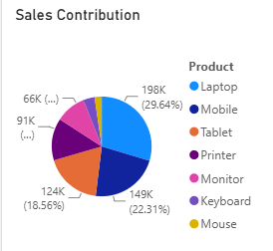
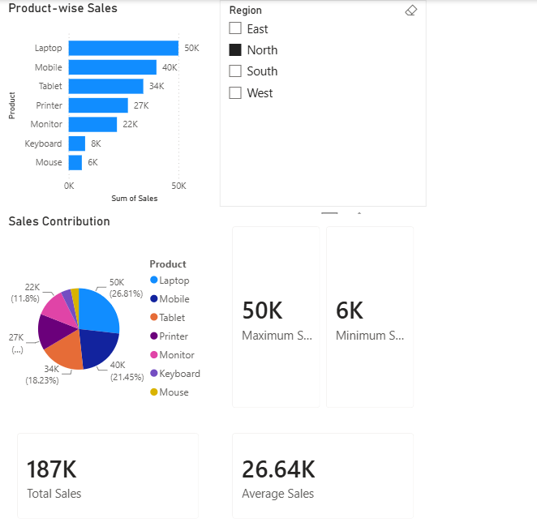

Result:
The data was successfully loaded into Power BI, transformed and analyzed, and visualized using charts and a dashboard to obtain meaningful insights from the sales data.

