Ex.no: 1a | Setting Up Python Environment And Libraries – Jupyter Notebook

AIM:
To install Python, configure Jupyter Notebook, understand the notebook environment, execute Python programs, create Markdown cells, and use basic Jupyter Notebook features for Data Analytics applications.

ALGORITHM:
- Download Python from the official Python website.
- Run the Python installer, select "Add Python to PATH", and complete the installation.
- Verify that Python is installed successfully.
- Open Command Prompt and install Jupyter Notebook.
- Launch Jupyter Notebook to open the Notebook Dashboard.
- Create a new Python 3 notebook from the dashboard.
- Rename the notebook.
- Create Code and Markdown cells.
- Execute the cells using Shift + Enter.
- Observe the output.

PROGRAM:
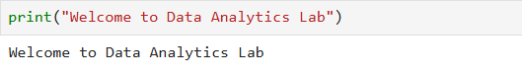
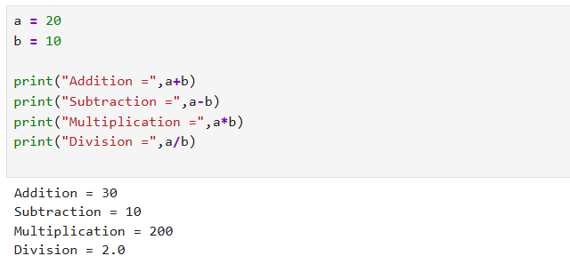
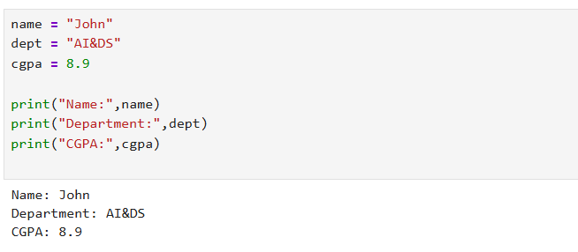
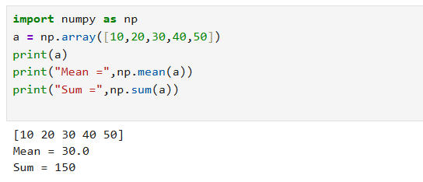
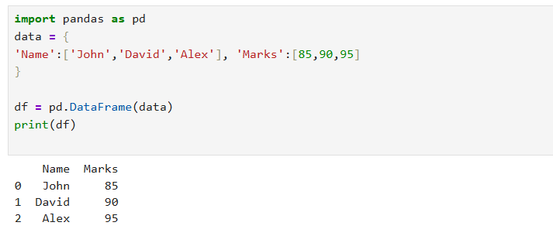
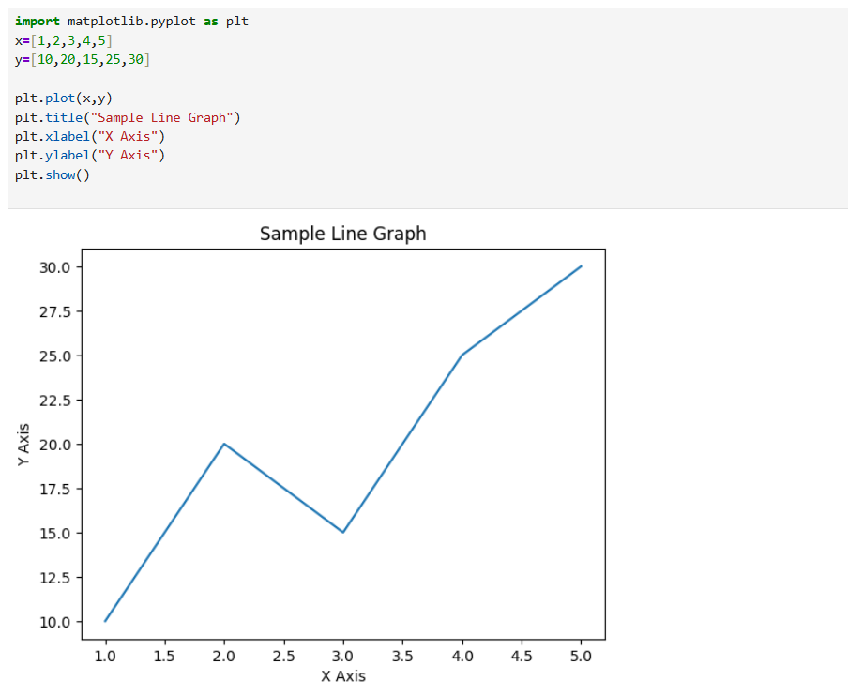
RESULT:
Thus, Python and Jupyter Notebook were successfully installed and configured. Basic Python programs and Markdown cells were executed successfully, and the Jupyter Notebook environment and its features were understood for Data Analytics applications.

