Ex.no: 1b | EDA – Data Science Frameworks(CRISPDM, SEMMA, KDD)

AIM:
To analyze insurance data using Exploratory Data Analysis (EDA), visualize important patterns in medical charges, preprocess the dataset, build a Machine Learning model to predict insurance charges, evaluate the model, and export the processed data to Excel.
ALGORITHM:
- Load the Insurance dataset using Pandas.
- Import the required Python libraries such as Pandas, Matplotlib, Seaborn, and Scikit-learn.
- Display the first few records, dataset shape, information, and missing values.
- Check and remove duplicate records.
- Analyze important features such as age, BMI, number of children, smoking status, sex, and region.
- Handle missing values in the dataset.
- Convert categorical features such as sex, smoker, and region into numerical form.
- Visualize the distribution of insurance charges using a histogram.
- Create a correlation heatmap to identify relationships between numerical features.
- Separate the input features (X) and target variable (y), where charges is the target.
- Split the dataset into training and testing data.
- Train a Machine Learning model using the training data.
- Predict insurance charges using the test data.
- Evaluate the model using Mean Absolute Error (MAE) and R² score.
- Export the processed insurance data to an Excel file.
- Display the analysis results.

PROGRAM:
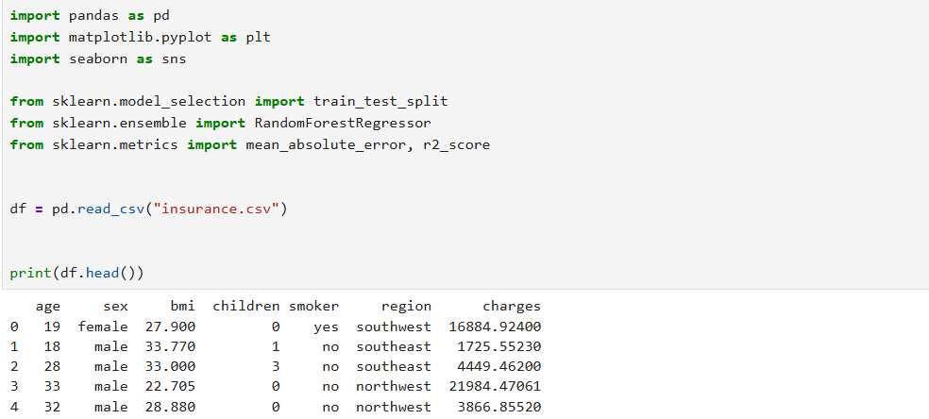
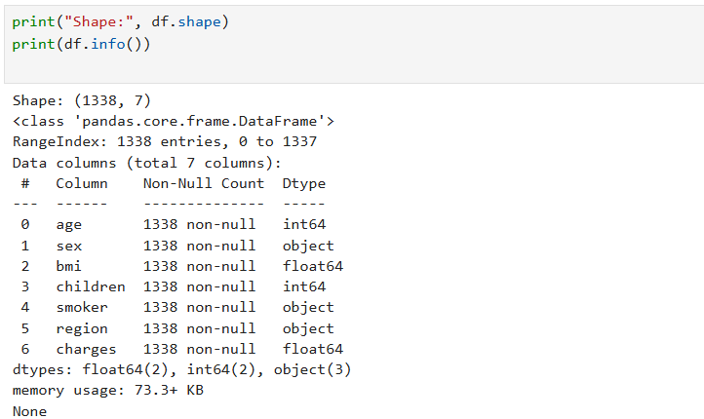
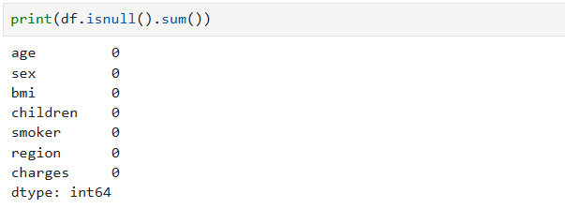
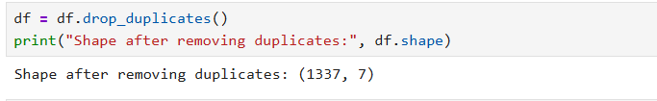
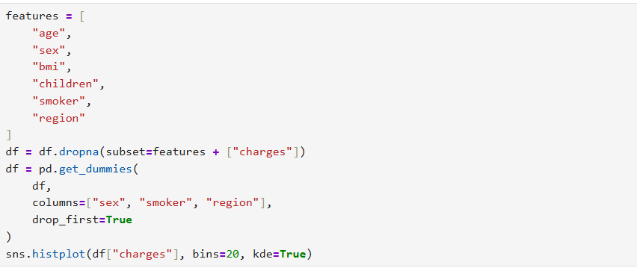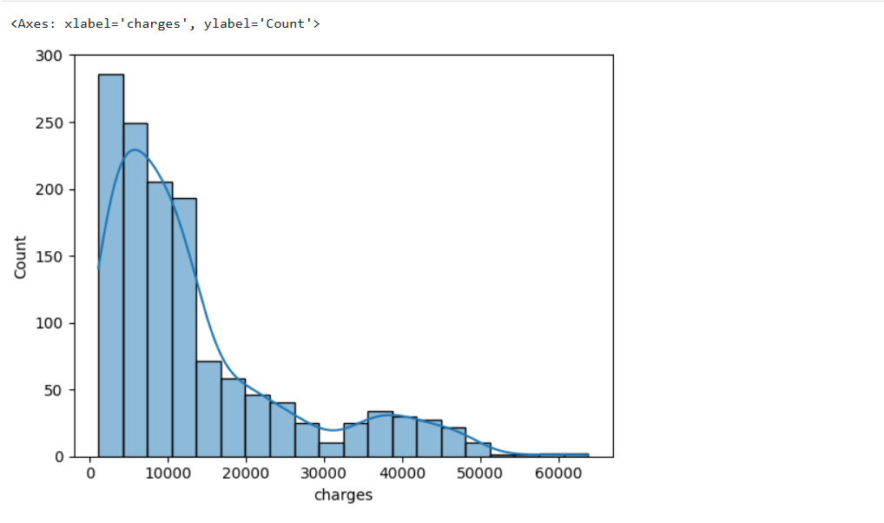
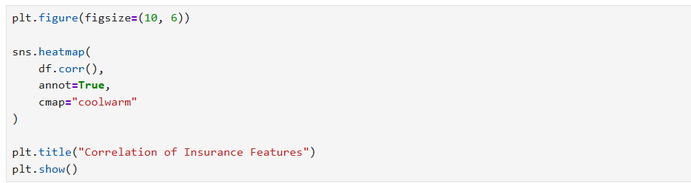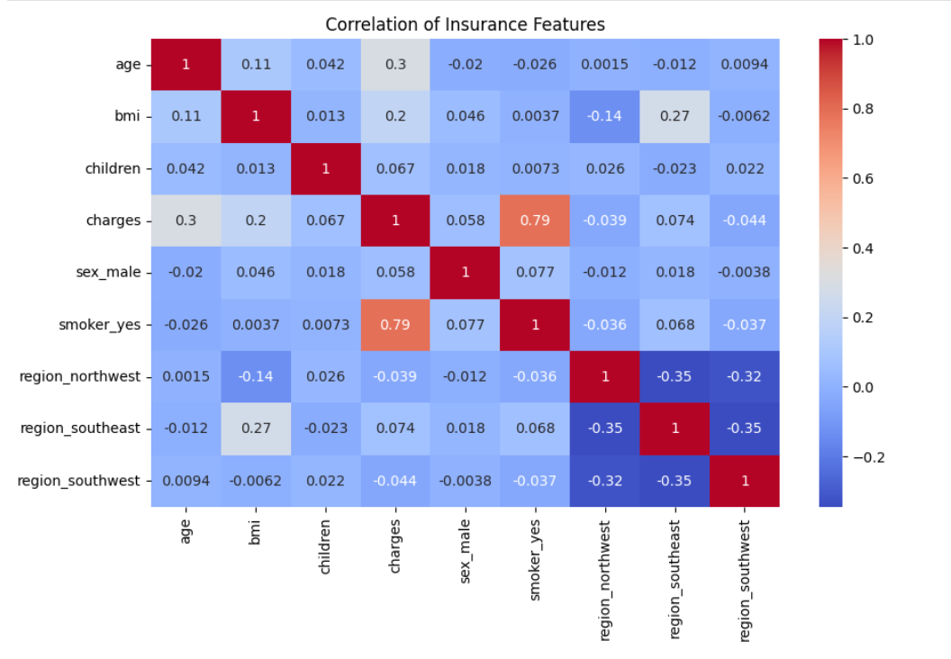
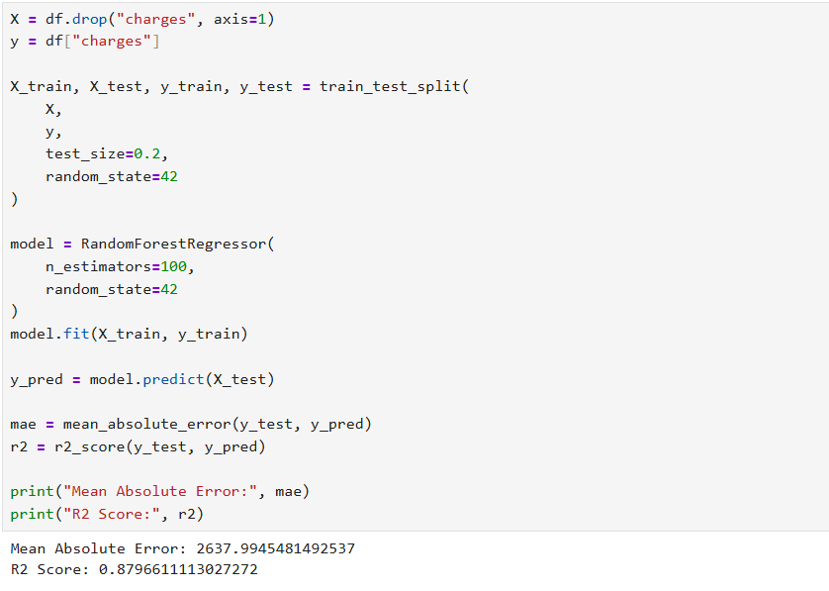

RESULT:
Thus, the insurance dataset was successfully analyzed using EDA, important patterns in medical charges were visualized, the data was preprocessed, and a Machine Learning model was built and evaluated to predict insurance charges. The processed dataset was also exported to Excel successfully.

