Ex.no: 2 | Exploratory Data Analysis (EDA) – Data Import and Export

AIM:
To install Python, configure Jupyter Notebook, understand the notebook environment, execute Python programs, create Markdown cells, and use basic Jupyter Notebook features for Data Analytics applications.
ALGORITHM:
- Download Python from the official Python website.
- Run the installer, enable "Add Python to PATH", and complete the installation.
- Verify that Python is installed successfully.
- Install Jupyter Notebook using the Python package manager.
- Launch Jupyter Notebook and open the Notebook Dashboard.
- Create a new Python 3 notebook.
- Rename the notebook.
- Create Code and Markdown cells.
- Enter the required code or text in the cells.
- Execute the cells and observe the output.
- Save the notebook.
PROGRAM:
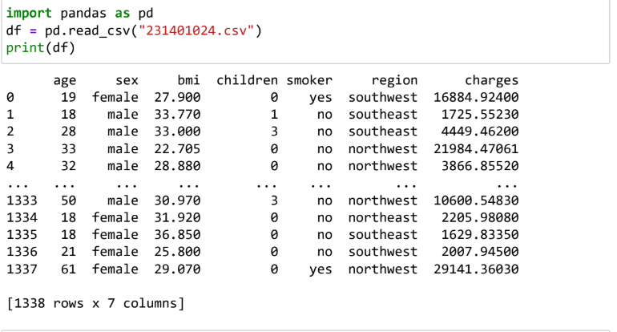
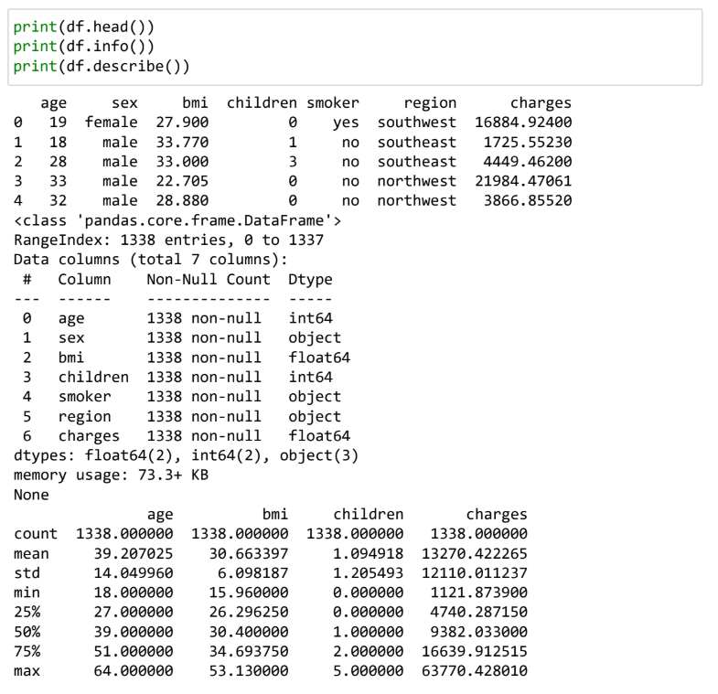
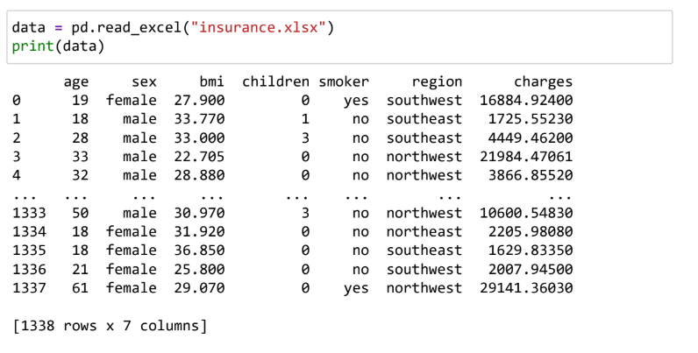
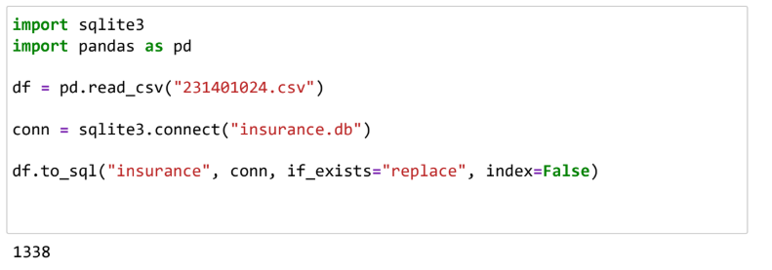
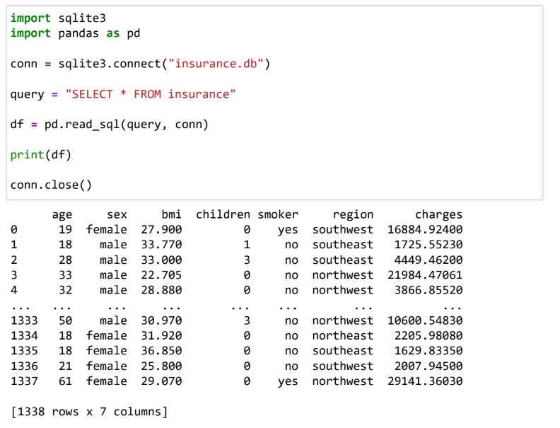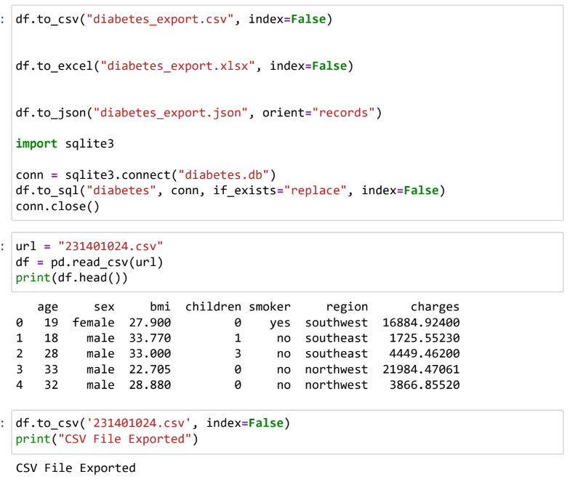

RESULT:
Thus, data was successfully imported from CSV, Excel, SQL, and Web sources using Pandas, and exported into different formats. The imported data was analyzed and visualized successfully.

