Ex.no: 3 | Exploratory Data Analysis (EDA) – Data Cleaning and Data Transformation

AIM:
To identify and handle missing values, duplicate records, outliers, inconsistent data, and perform data transformation techniques such as normalization and encoding using Python Pandas.

ALGORITHM:
- Import the required Python libraries.
- Load the dataset into a Data Frame.
- Identify missing values and count them.
- Calculate the mean (or appropriate statistic) and replace missing values.
- Verify that the missing values have been replaced.
- Identify duplicate records and count them.
- Remove duplicate records from the dataset.
- Verify that duplicates have been removed.
- Calculate the first quartile (Q1) and third quartile (Q3).
- Compute the Interquartile Range (IQR).
- Calculate the lower and upper bounds for outlier detection.
- Identify the outliers in the dataset.
- Display the cleaned dataset and the detected outliers.

PROGRAM:
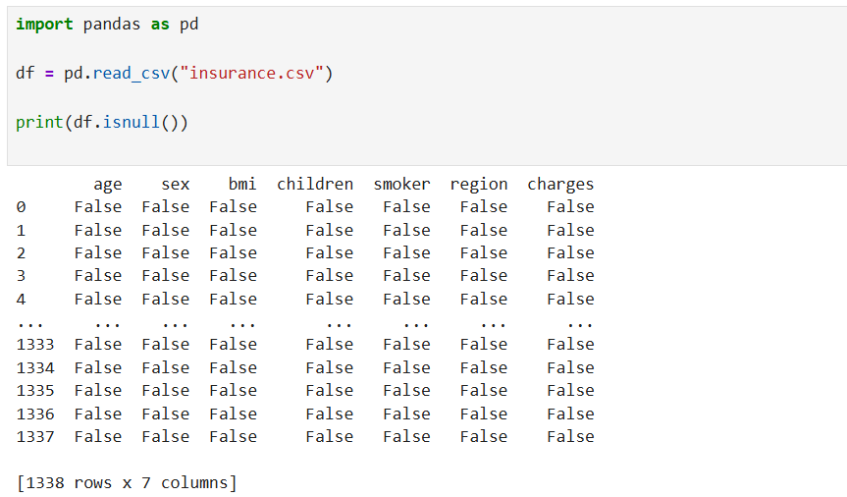
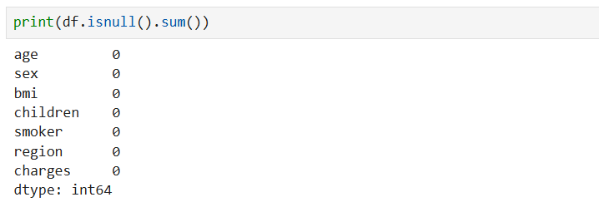
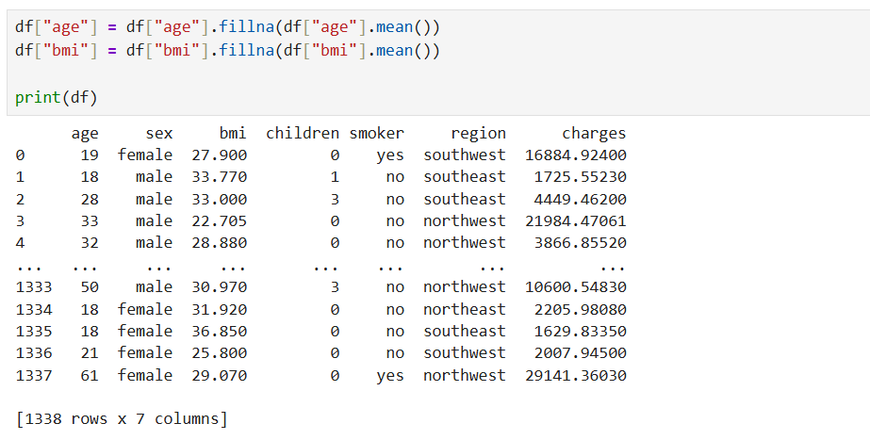
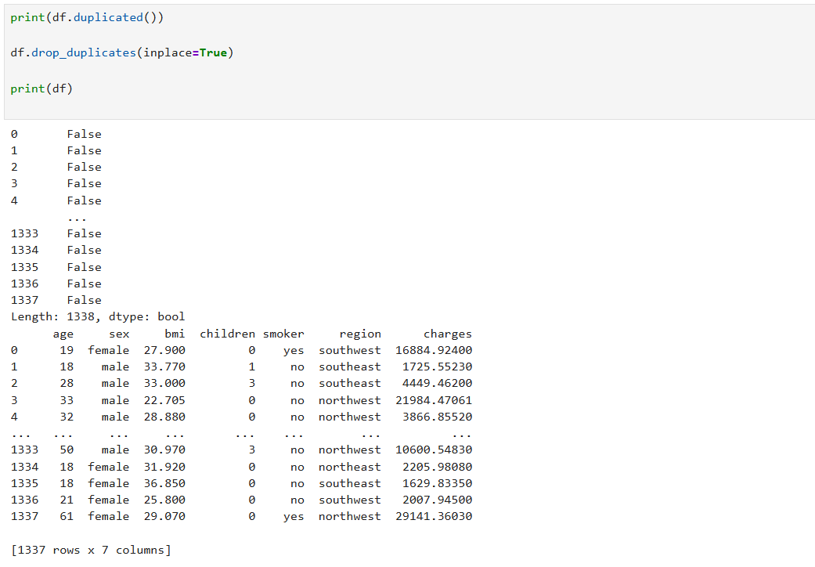
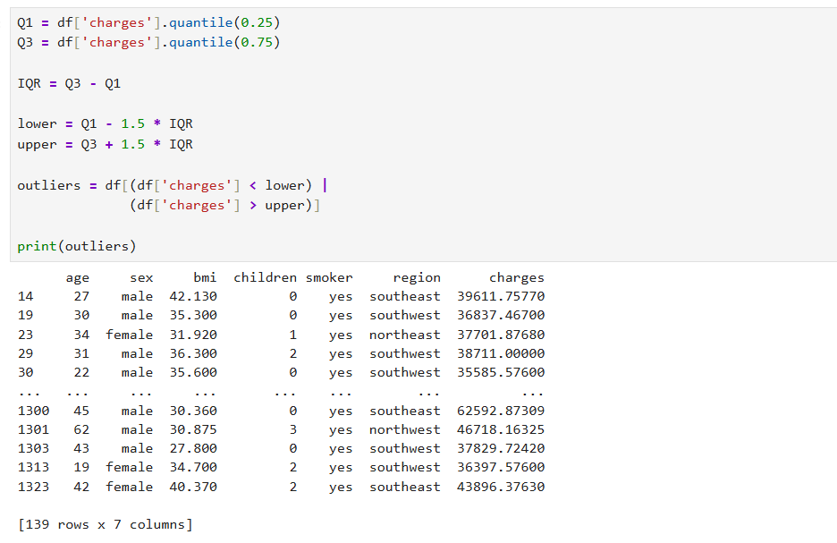
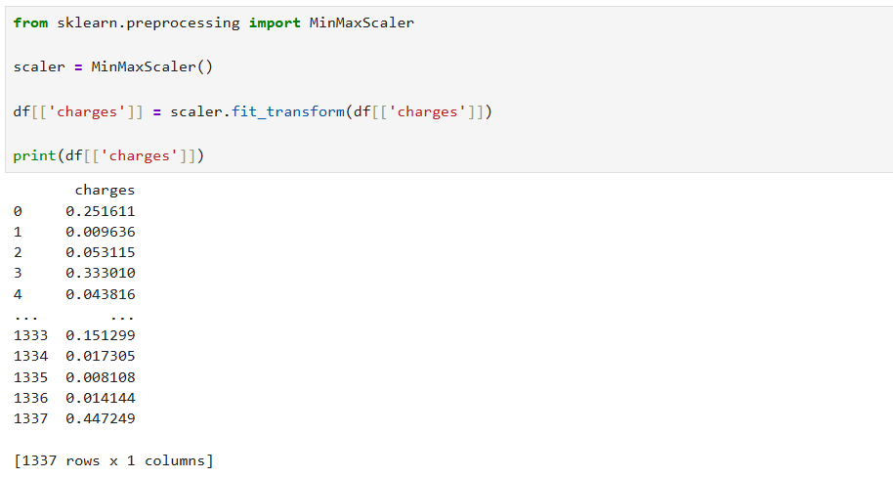
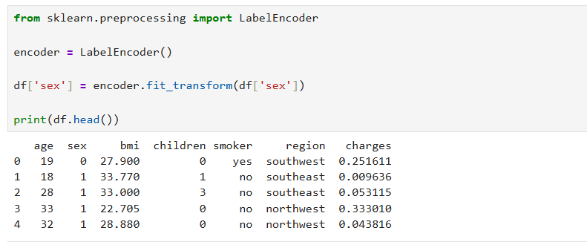

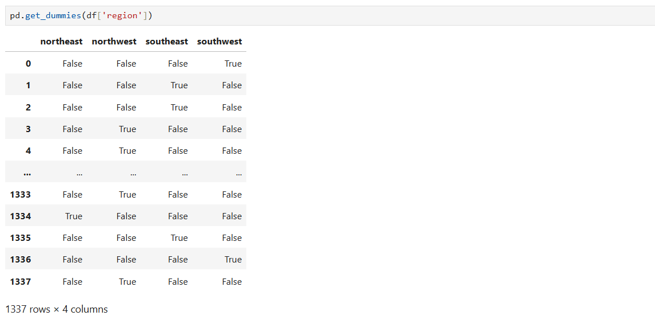

RESULT:
Thus, missing values, duplicate records, and outliers were identified and handled successfully. Data transformation techniques such as normalization and encoding were performed, and the dataset was prepared for further exploratory data analysis and machine learning applications.

