Ex.no: 4b | EXPLORATORY DATA ANALYSIS-DATA INSPECTION, FILTERING, STATISTICAL ANALYSIS AND CORRELATION

AIM:
To perform data inspection, filtering, grouping, aggregation, descriptive statistical analysis, and correlation analysis using Pandas and visualize the results using Matplotlib.
ALGORITHM:
- Import the dataset.
- Display the dataset.
- Check the dataset dimensions and data types.
- Generate a summary of the dataset.
- Filter the data based on the required condition and display the filtered records.
- Sort the data using the required column and display the sorted result.
- Perform statistical analysis by calculating the mean, median, mode, and standard deviation of numerical columns.
- Group the data using the required column and calculate the average values using aggregation.
- Perform correlation analysis between numerical columns.
- Display and interpret the results.

PROGRAM:
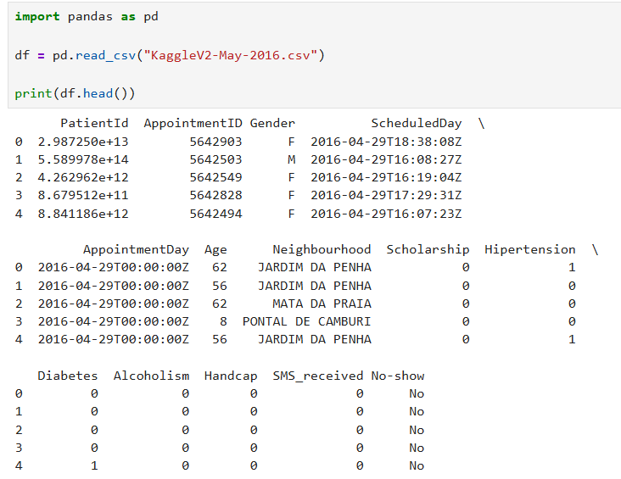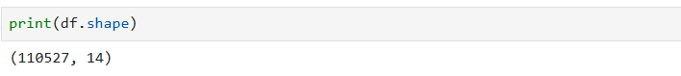
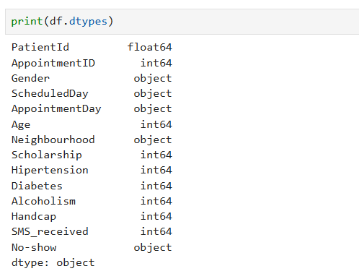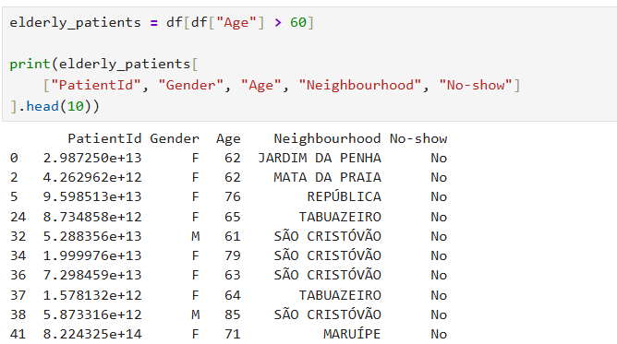
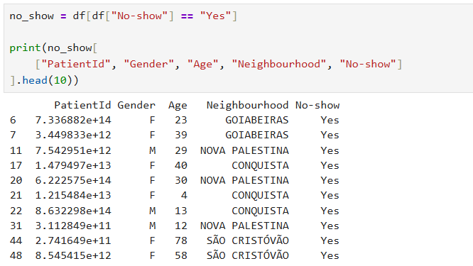
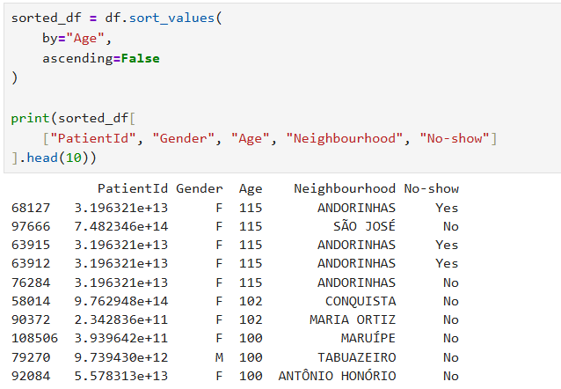
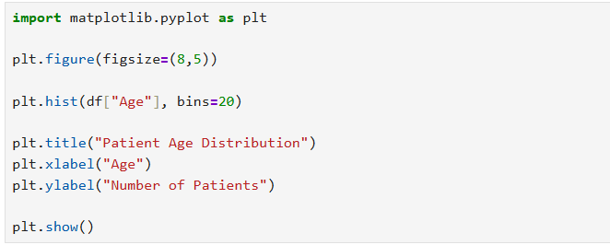
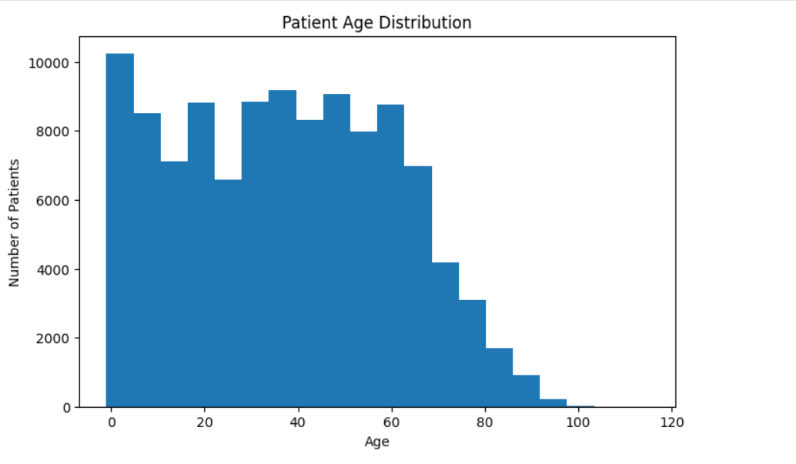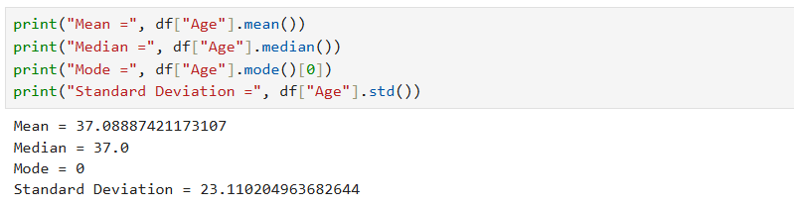
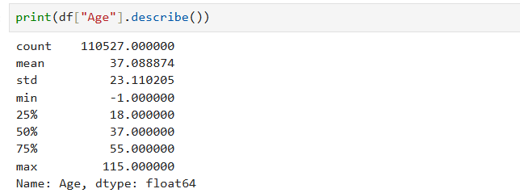
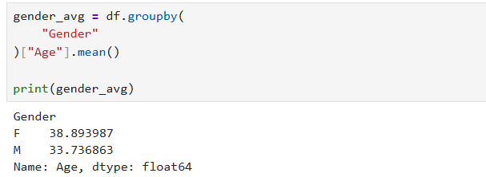
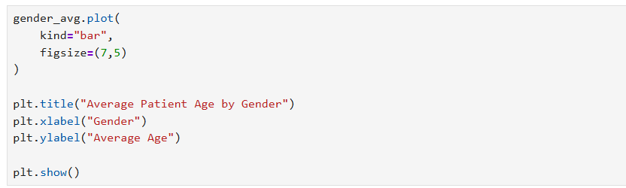
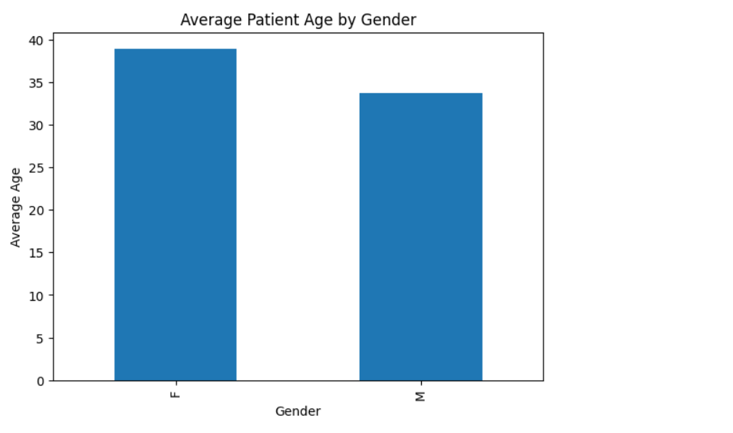
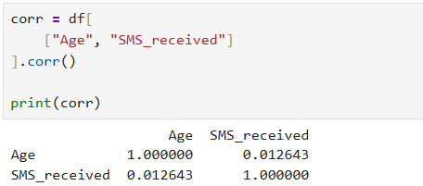

RESULT:
Thus, data inspection, filtering, grouping, aggregation, descriptive statistical analysis, and correlation analysis were successfully performed using Pandas. The results were effectively visualized using Matplotlib.

