Ex.no:6 c | DATA VISUALIZATION USING POWER BI

Aim:
To Load the data into PowerBI and transform the data and visualize it to get insights.

Algorithm:

- Open Power BI Desktop → Home → Get Data, select Excel/CSV, browse the dataset, load it, and verify the data.
- Select Transform Data, remove duplicates, handle null values, rename columns, and apply the changes.
- Create a Bar Chart using Product on Axis and Sales on Values, then format the chart.
- Create a Pie Chart using Product as Legend and Sales as Values, and enable data labels.
- Create a KPI Card using the Sales field and apply the required formatting.
- Create a Slicer using the Region field and apply the required filter settings.
- Create the DAX measure Average Sales = AVERAGE(Sales[Sales]).
- Combine the KPI Card, Bar Chart, Pie Chart, and Slicer into a dashboard, arrange the visuals, and save the report.
Output:
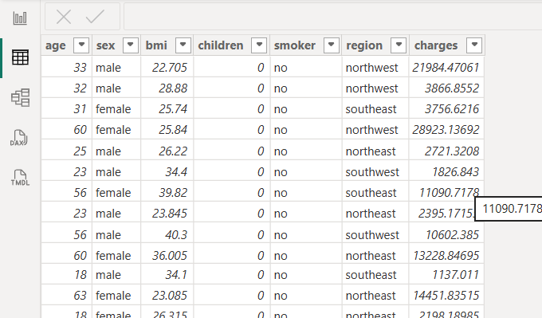
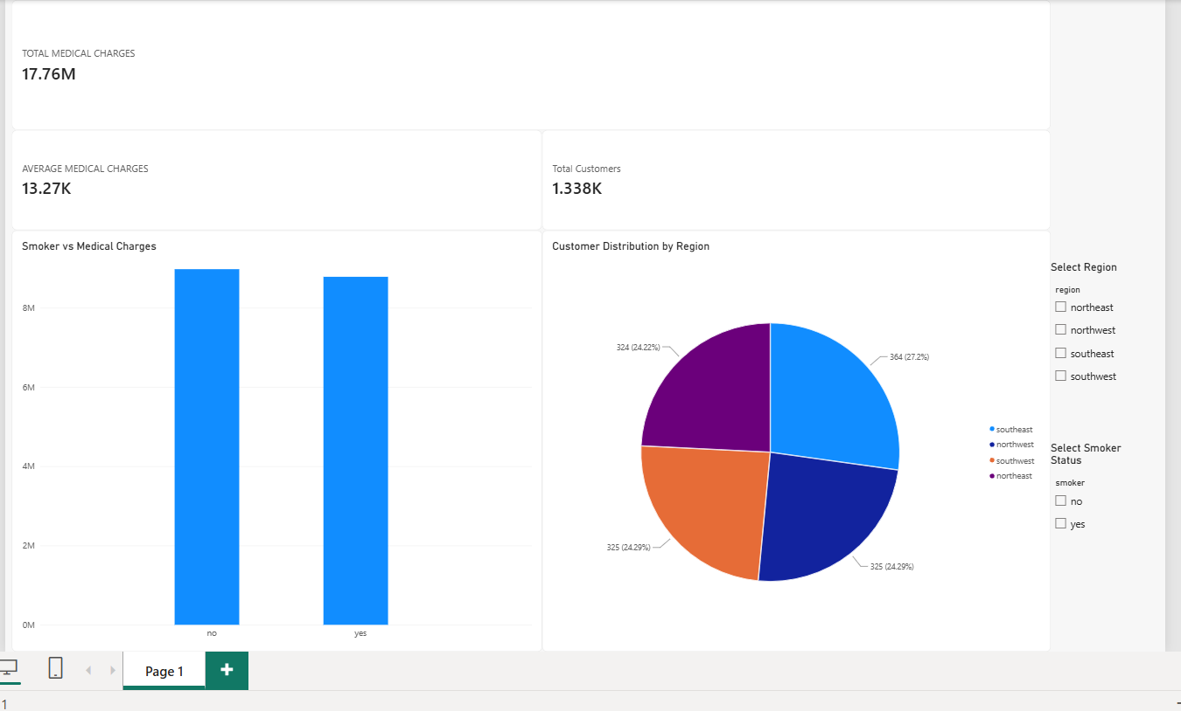

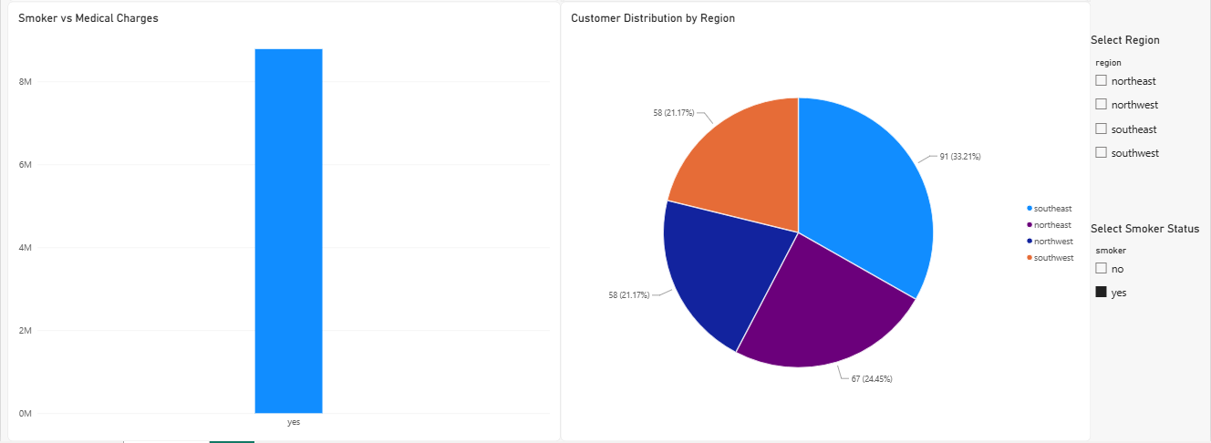

Result:
The data was successfully loaded into Power BI, transformed and analyzed, and visualized using charts and a dashboard to obtain meaningful insights from the sales data.

