AIM:
To connect, analyze, visualize, and create interactive dashboards using Tableau by performing data analysis on a sales dataset and creating worksheets, charts, calculated fields, filters, parameters, dashboards, and stories for effective business intelligence and data analytics.

ALGORITHM:
- Open Tableau Desktop/Tableau Public and connect the Sales.xlsx dataset.
- Verify the imported data containing Product, Category, Region, Sales, and Quantity fields.
- Create worksheets by dragging required fields to the Rows and Columns shelves.
- Create a bar chart to analyze product-wise sales.
- Create a pie chart to visualize category-wise sales contribution.
- Create a line chart to analyze the variation in sales among products.
- Create a calculated field named Sales with Tax using the formula [Sales] * 1.10.
- Apply a Region filter to analyze sales for individual regions.
- Create a Minimum Sales parameter and display products based on the selected minimum sales value.
- Combine the created worksheets into an interactive Sales Performance Dashboard.
- Add filters, parameters, charts, and KPI information to the dashboard for interactive analysis.
- Create a Tableau Story using the dashboard and worksheets to present overall sales performance, product-wise analysis, category-wise analysis, and regional analysis.
- Analyze the visualizations and identify important sales insights such as highest sales, lowest sales, average sales, and category contribution.

OUTPUT:
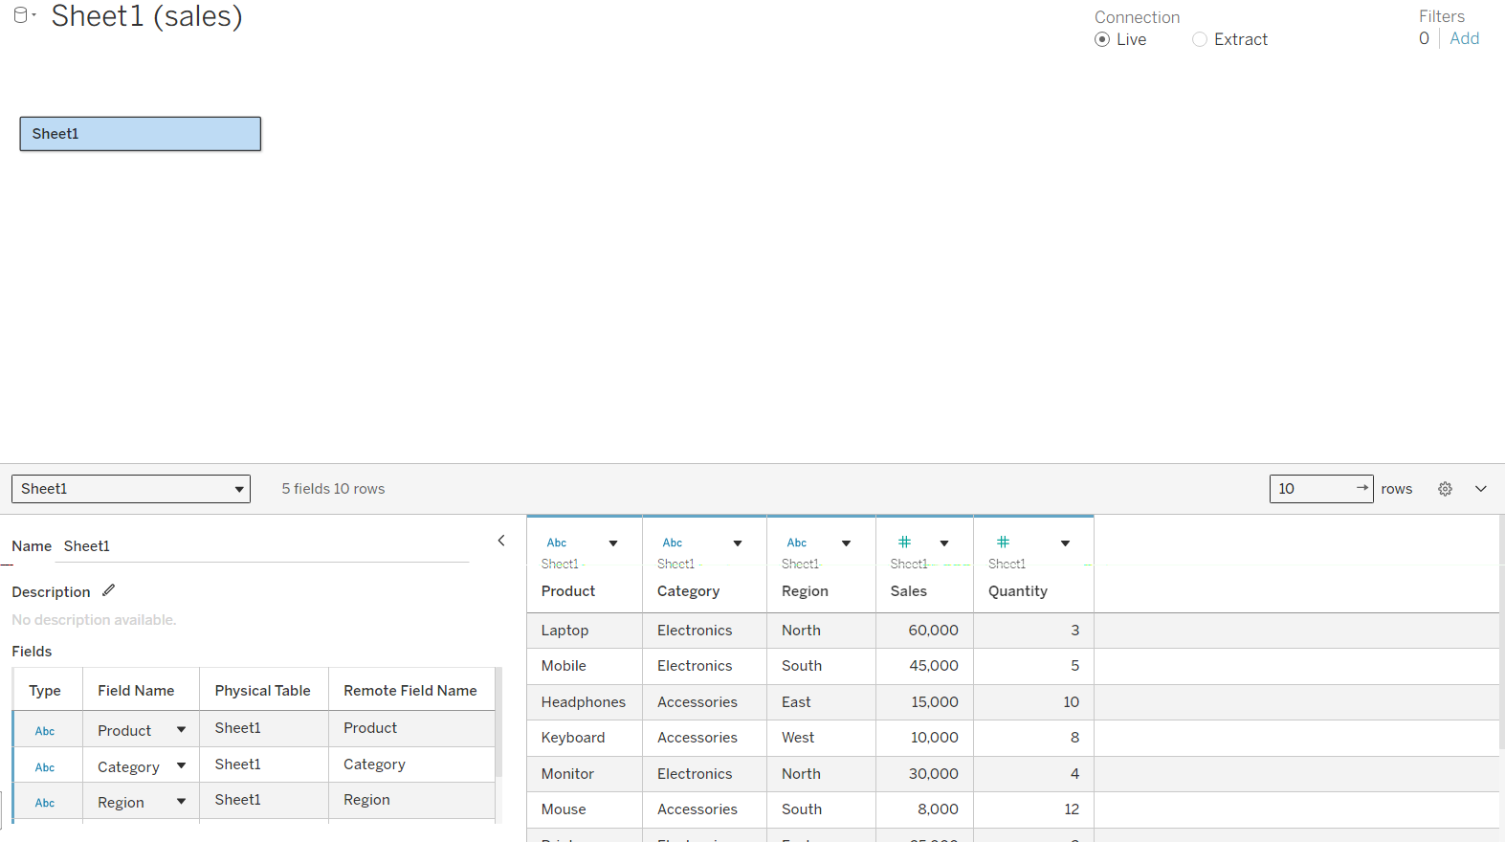
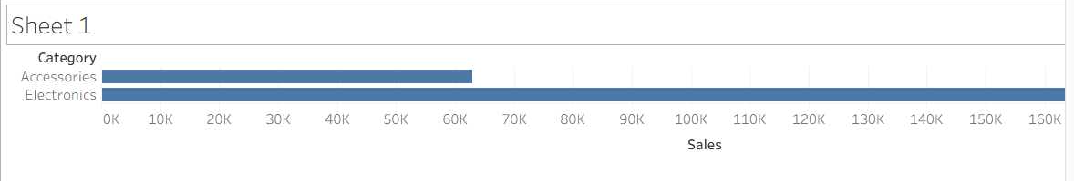
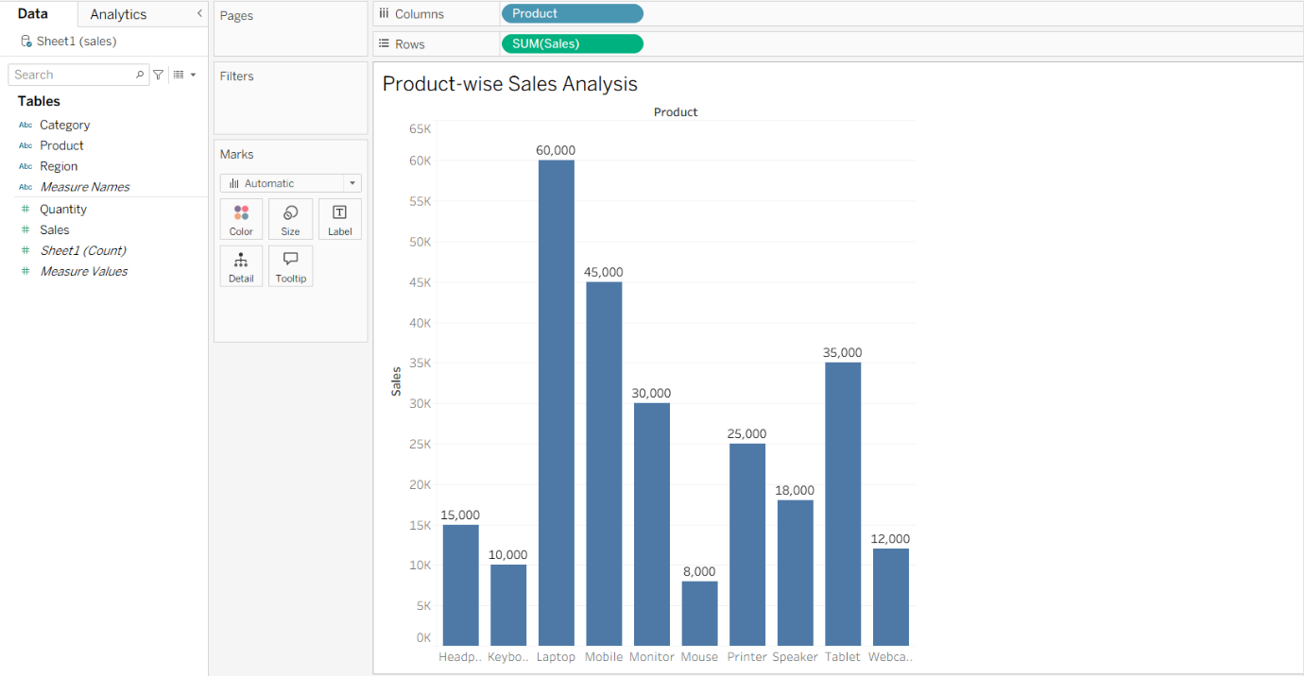
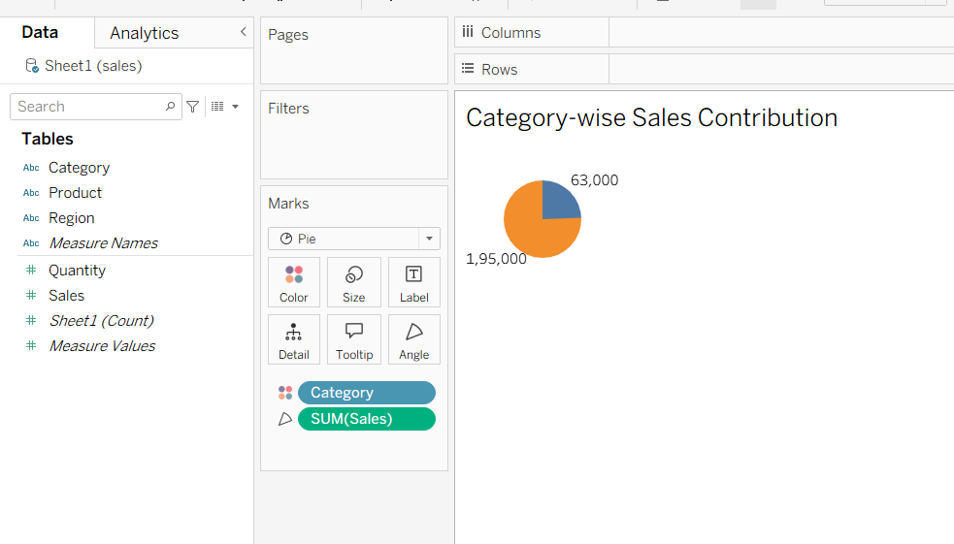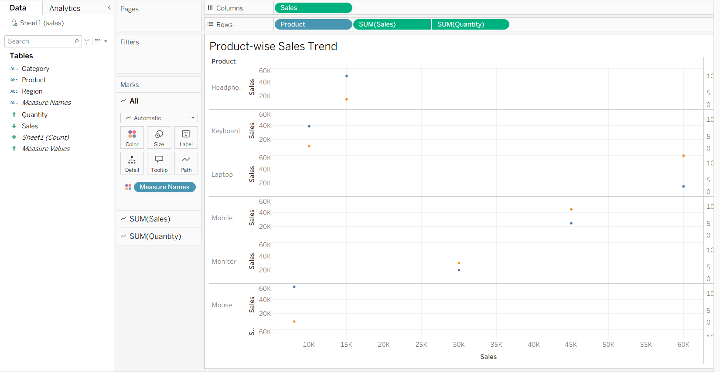
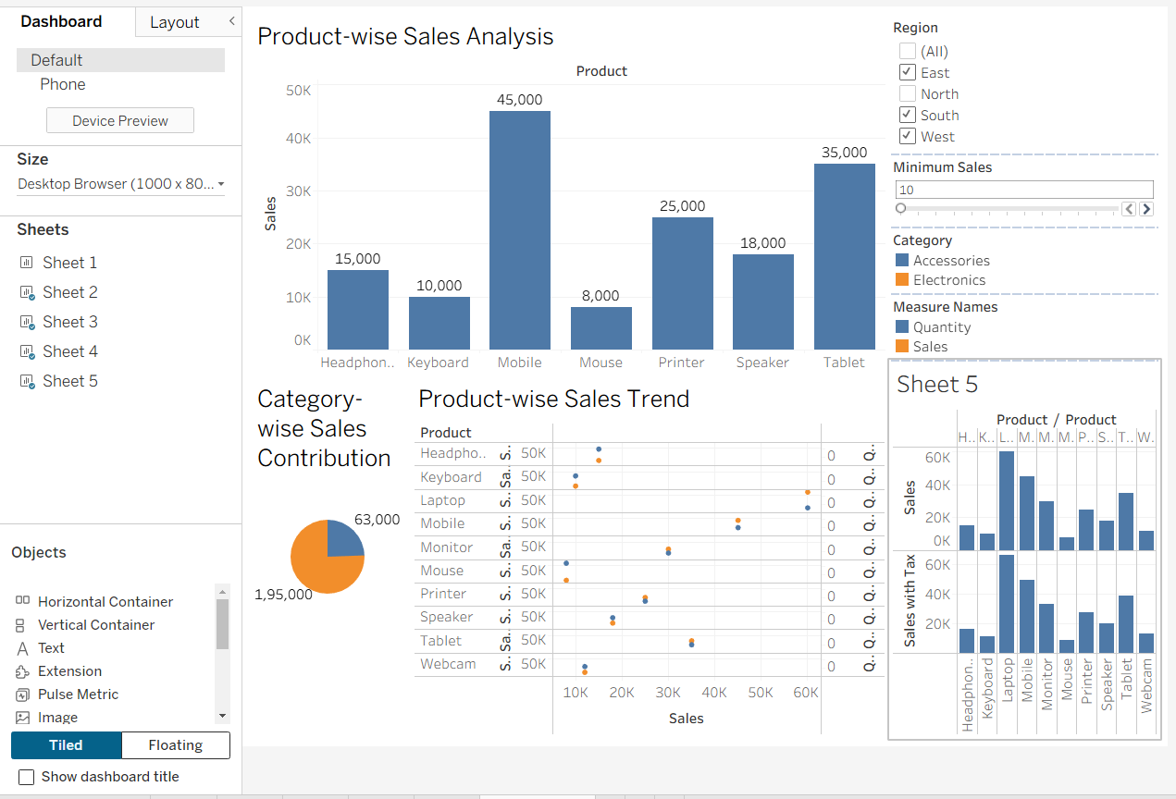

RESULT:
The sales dataset was successfully connected and analyzed using Tableau. Product-wise bar charts, category-wise pie charts, and sales trend line charts were created successfully. A calculated field, interactive filter, and minimum sales parameter were applied. An interactive Sales Performance Dashboard and Story were created to present the analyzed results effectively.

