AIM:
To connect, analyze, visualize, and create an interactive dashboard using Tableau for effective analysis of insurance data.
ALGORITHM:
- Open Tableau Desktop and connect to the insurance.csv dataset.
- Verify the imported data and data types such as Age, Sex, BMI, Children, Smoker, Region, and Charges.
- Create a worksheet to analyze region-wise insurance charges.
- Create a bar chart to compare insurance charges based on Smoker status.
- Create a pie chart to visualize the contribution of different Regions to total insurance charges.
- Create a line chart to analyze the relationship between Age and Charges.
- Create a calculated field named Charges in Thousands using the formula [Charges] / 1000.
- Apply Smoker and Region filters to analyze selected insurance records.
- Create a Minimum Charges parameter to display records based on the selected minimum insurance charge.
- Create a new dashboard and add the required worksheets and visualizations.
- Add KPI cards for Total Charges, Average Charges, and Number of Customers.
- Arrange and format the charts, KPI cards, filters, and parameter.
- Save the completed Insurance Analysis Dashboard.

OUTPUT:
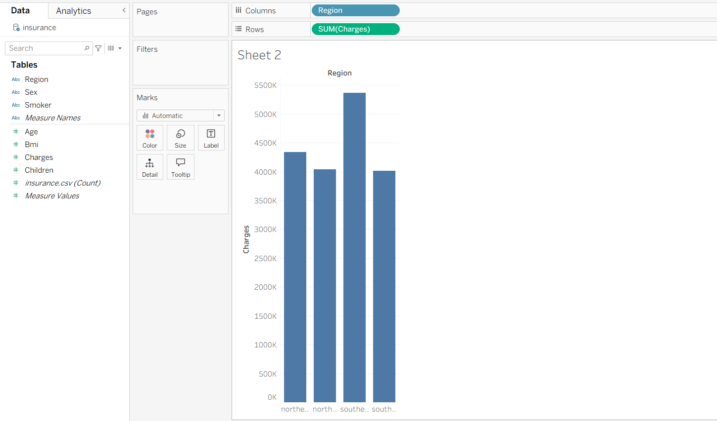
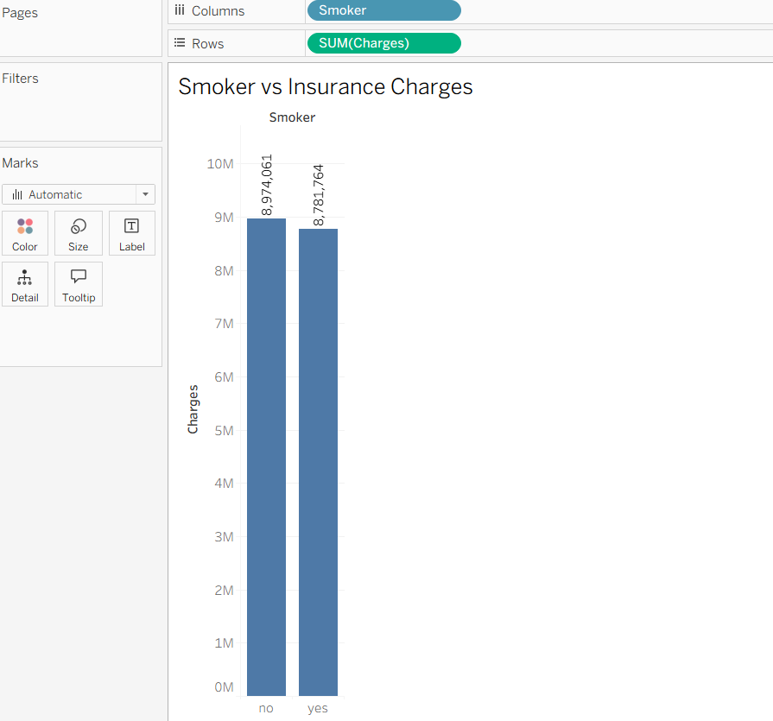
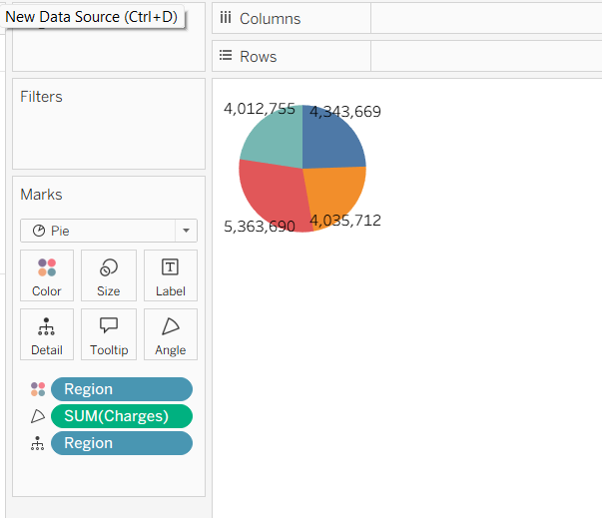
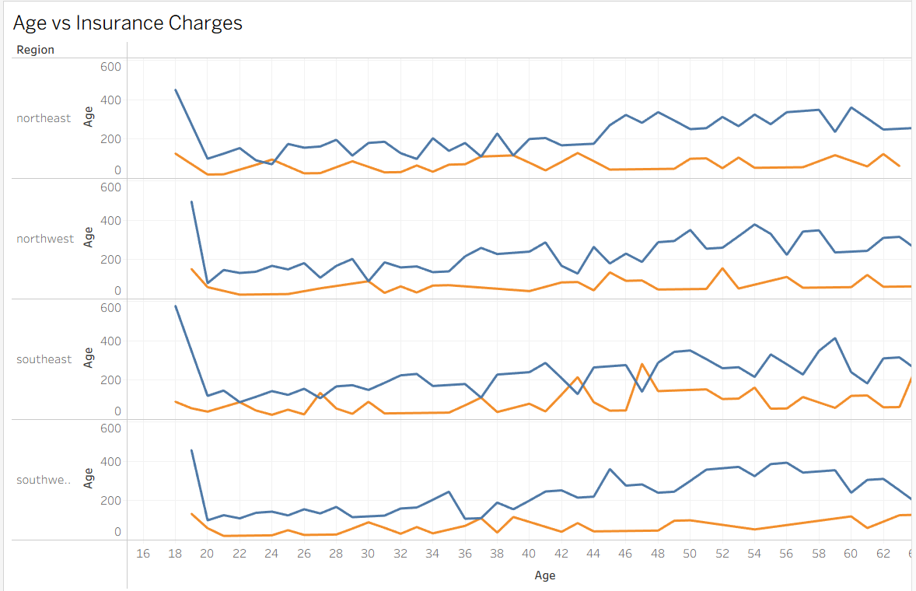
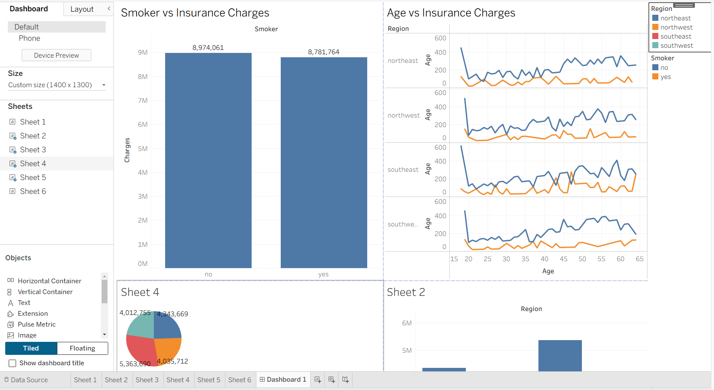

RESULT:
The insurance dataset was successfully connected, analyzed, and visualized using Tableau. An interactive Insurance Analysis Dashboard was created using charts, calculated fields, filters, parameters, and KPI cards to effectively analyze insurance charges and customer information.

