Ex.no:5 | DATA VISUALIZATION USING MATPLOTLIB

Aim:

Algorithm:
• Start.
• Import the matplotlib.pyplot library.
• Create sample data for the charts.
• Draw a Line Chart to show the trend.
• Draw a Bar Chart to compare values.
• Draw a Pie Chart to show percentage distribution.
• Draw a Box Plot to display data distribution.
• Draw a Multiple Line Chart to compare two datasets.
• Display each chart using plt.show().
• Stop.

Program:
import pandas as pd
import matplotlib.pyplot as plt

# Upload the CSV file in Google Colab
from google.colab import files
uploaded = files.upload()

# Replace this with the actual uploaded CSV filename if necessary
filename = list(uploaded.keys())[0]

# Read dataset
df = pd.read_csv(filename)

# Display first 5 rows
print("First 5 rows of the dataset:")
display(df.head())

# Convert columns to appropriate data types
df["transaction_date"] = pd.to_datetime(df["transaction_date"], errors="coerce")
df["stock_price"] = pd.to_numeric(df["stock_price"], errors="coerce")
df["asset_value_low"] = pd.to_numeric(df["asset_value_low"], errors="coerce")
df["asset_value_high"] = pd.to_numeric(df["asset_value_high"], errors="coerce")

# ---------------------------------------------------------
# 1. LINE CHART
# Number of transactions by year
# ---------------------------------------------------------

yearly_transactions = df["transaction_date"].dt.year.value_counts().sort_index()

plt.figure(figsize=(8, 5))
plt.plot(
yearly_transactions.index,
yearly_transactions.values,
marker="o"
)

plt.title("Number of Senate Stock Transactions by Year")
plt.xlabel("Year")
plt.ylabel("Number of Transactions")
plt.grid(True)
plt.show()

# ---------------------------------------------------------
# 2. BAR CHART
# Number of purchases vs sales
# ---------------------------------------------------------

transaction_counts = df["transaction"].value_counts()

plt.figure(figsize=(7, 5))
plt.bar(
transaction_counts.index,
transaction_counts.values
)

plt.title("Number of Purchases and Sales")
plt.xlabel("Transaction Type")
plt.ylabel("Number of Transactions")
plt.show()

# ---------------------------------------------------------
# 3. PIE CHART
# Transactions by owner
# ---------------------------------------------------------

owner_counts = df["owner"].value_counts()

plt.figure(figsize=(7, 7))
plt.pie(
owner_counts.values,
labels=owner_counts.index,
autopct="%1.1f%%"
)

plt.title("Transactions by Asset Owner")
plt.show()

# ---------------------------------------------------------
# 4. BOX PLOT
# Distribution of stock prices
# ---------------------------------------------------------

stock_prices = df["stock_price"].dropna()

plt.figure(figsize=(5, 6))
plt.boxplot(stock_prices)

plt.title("Box Plot of Stock Prices")
plt.ylabel("Stock Price")
plt.show()

# ---------------------------------------------------------
# 5. MULTIPLE LINE CHART
# Purchases and sales by year
# ---------------------------------------------------------

year_transaction = pd.crosstab(
df["transaction_date"].dt.year,
df["transaction"]
)

plt.figure(figsize=(9, 5))

for column in year_transaction.columns:
plt.plot(
year_transaction.index,
year_transaction[column],
marker="o",
label=column
)

plt.title("Purchases and Sales by Year")
plt.xlabel("Year")
plt.ylabel("Number of Transactions")
plt.legend()
plt.grid(True)
plt.show()

Output:

ticker asset_name asset_type stock_price transaction transaction_date asset_value_low asset_value_high last_name first_name owner additional_details
0 RTX RTX Corporation Common Stock Stock 100.99 Sale (Full) 04/09/2024 15001 50000 Whitehouse Sheldon Spouse --
1 DHR Danaher Corp Stock 249.80 Sale (Full) 04/09/2024 15001 50000 Whitehouse Sheldon Spouse --
2 UL Unilever Plc ADR Stock 47.99 Sale (Full) 04/09/2024 1001 15000 Whitehouse Sheldon Spouse --
3 IR Ingersoll Rand Inc Stock 93.48 Sale (Full) 04/09/2024 1001 15000 Whitehouse Sheldon Spouse --
4 NVS Novartis Ag ADR Stock 95.81 Sale (Partial) 04/09/2024 1001 15000 Whitehouse Sheldon Self --
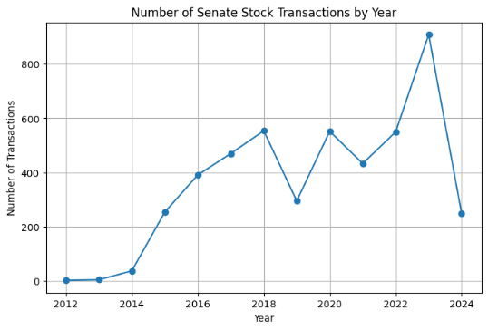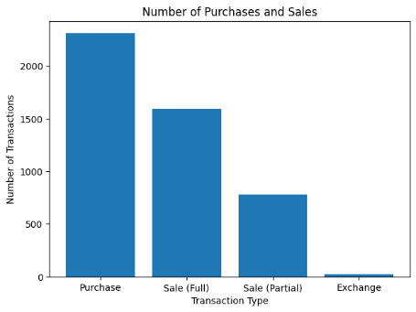
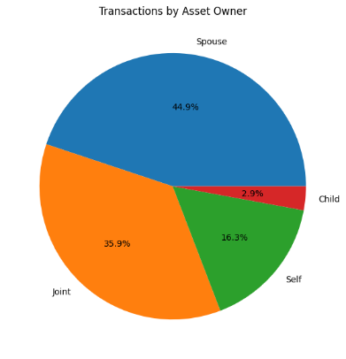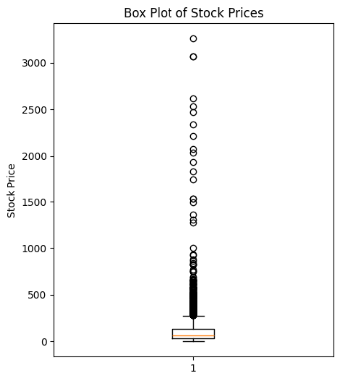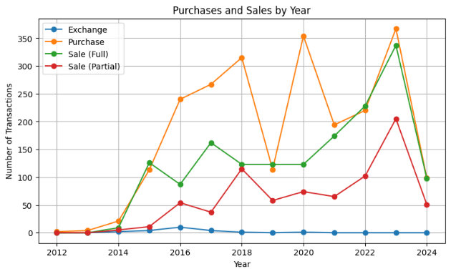

Algorithm:
• Start.
• Import the required libraries (pandas, matplotlib, and seaborn).
• Load the dataset and select the first few rows.
• Convert the required columns to numeric values.
• Select the columns needed for visualization.
• Create different charts:
- Line Chart
- Bar Chart
- Histogram
- Box Plot
- Scatter Plot
- Violin Plot
- Pie Chart
- 2×2 Subplots
- Pair Plot
- Heatmap
- Seaborn Multi-panel Plot
• Display each chart.
• Stop.
Program:
# Install seaborn
%pip install seaborn -q

import pandas as pd
import matplotlib.pyplot as plt
import seaborn as sns

# ---------------------------------------------------------
# LOAD DATASET
# ---------------------------------------------------------

from google.colab import files
uploaded = files.upload()

filename = list(uploaded.keys())[0]

df = pd.read_csv(filename)

# Read first 10 rows, matching the reference experiment
df = df.head(10).copy()

# ---------------------------------------------------------
# CONVERT NUMERIC / DATE COLUMNS
# ---------------------------------------------------------

df["stock_price"] = pd.to_numeric(
df["stock_price"],
errors="coerce"
)

df["asset_value_low"] = pd.to_numeric(
df["asset_value_low"],
errors="coerce"
)

df["asset_value_high"] = pd.to_numeric(
df["asset_value_high"],
errors="coerce"
)

df["transaction_date"] = pd.to_datetime(
df["transaction_date"],
errors="coerce"
)

# Create a senator name column
df["senator"] = (
df["first_name"].fillna("") + " " +
df["last_name"].fillna("")
).str.strip()

# ---------------------------------------------------------
# NUMERIC COLUMNS USED FOR ANALYSIS
# ---------------------------------------------------------

cols = [
"stock_price",
"asset_value_low",
"asset_value_high"
]

# ---------------------------------------------------------
# X-AXIS
# ---------------------------------------------------------

x = df["asset_name"].fillna("Unknown Asset")

# =========================================================
# 1. LINE CHART
# =========================================================

plt.figure(figsize=(8, 4))

plt.plot(
x,
df["stock_price"],
marker="o"
)

plt.title("Stock Price by Asset")
plt.xlabel("Asset")
plt.ylabel("Stock Price")

plt.xticks(rotation=45)

plt.tight_layout()
plt.show()

# =========================================================
# 2. BAR CHART
# =========================================================

plt.figure(figsize=(8, 4))

plt.bar(
x,
df["asset_value_high"]
)

plt.title("Maximum Transaction Value by Asset")
plt.xlabel("Asset")
plt.ylabel("Maximum Transaction Value")

plt.xticks(rotation=45)

plt.tight_layout()
plt.show()

# =========================================================
# 3. HISTOGRAM
# =========================================================

plt.figure(figsize=(6, 4))

plt.hist(
df["stock_price"].dropna(),
bins=5
)

plt.title("Distribution of Stock Prices")
plt.xlabel("Stock Price")
plt.ylabel("Frequency")

plt.tight_layout()
plt.show()

# =========================================================
# 4. BOX PLOT
# =========================================================

plt.figure(figsize=(5, 5))

plt.boxplot(
df["stock_price"].dropna()
)

plt.title("Box Plot of Stock Prices")
plt.ylabel("Stock Price")

plt.tight_layout()
plt.show()

# =========================================================
# 5. SCATTER PLOT
# =========================================================

plt.figure(figsize=(7, 4))

plt.scatter(
df["asset_value_high"],
df["stock_price"]
)

plt.xlabel("Maximum Transaction Value")
plt.ylabel("Stock Price")
plt.title("Transaction Value vs Stock Price")

plt.tight_layout()
plt.show()

# =========================================================
# 6. VIOLIN PLOT
# =========================================================

plt.figure(figsize=(5, 5))

sns.violinplot(
y=df["stock_price"].dropna()
)

plt.title("Violin Plot of Stock Prices")

plt.tight_layout()
plt.show()

# =========================================================
# 7. PIE CHART
# =========================================================

transaction_counts = df["transaction"].value_counts()

plt.figure(figsize=(6, 6))

plt.pie(
transaction_counts.values,
labels=transaction_counts.index,
autopct="%1.1f%%"
)

plt.title("Purchase vs Sale Transactions")

plt.show()

# =========================================================
# 8. SUBPLOTS (2 x 2)
# =========================================================

fig, ax = plt.subplots(
2,
2,
figsize=(12, 9)
)

# Line
ax[0, 0].plot(
x,
df["stock_price"],
marker="o"
)

ax[0, 0].set_title("Line Chart")
ax[0, 0].set_xlabel("Asset")
ax[0, 0].set_ylabel("Stock Price")

# Bar
ax[0, 1].bar(
x,
df["asset_value_high"]
)

ax[0, 1].set_title("Bar Chart")
ax[0, 1].set_xlabel("Asset")
ax[0, 1].set_ylabel("Maximum Transaction Value")

# Histogram
ax[1, 0].hist(
df["stock_price"].dropna(),
bins=5
)

ax[1, 0].set_title("Histogram")
ax[1, 0].set_xlabel("Stock Price")
ax[1, 0].set_ylabel("Frequency")

# Scatter
ax[1, 1].scatter(
df["asset_value_high"],
df["stock_price"]
)

ax[1, 1].set_title("Scatter Plot")
ax[1, 1].set_xlabel("Maximum Transaction Value")
ax[1, 1].set_ylabel("Stock Price")

for a in ax.flat:
a.tick_params(
axis="x",
rotation=45
)

plt.tight_layout()
plt.show()

# =========================================================
# 9. PAIR PLOT
# =========================================================

sns.pairplot(
df[cols]
)

plt.show()

# =========================================================
# 10. HEATMAP
# =========================================================

plt.figure(figsize=(6, 5))

sns.heatmap(
df[cols].corr(),
annot=True,
cmap="coolwarm"
)

plt.title("Correlation Heatmap")

plt.tight_layout()
plt.show()

# =========================================================
# 11. SEABORN 3-PANEL PLOT
# =========================================================

fig, ax = plt.subplots(
1,
3,
figsize=(15, 4)
)

# Histogram
sns.histplot(
df["stock_price"],
ax=ax[0]
)

ax[0].set_title("Histogram")
ax[0].set_xlabel("Stock Price")

# Box Plot
sns.boxplot(
y=df["stock_price"],
ax=ax[1]
)

ax[1].set_title("Box Plot")
ax[1].set_ylabel("Stock Price")

# Scatter Plot
sns.scatterplot(
x=df["asset_value_high"],
y=df["stock_price"],
ax=ax[2]
)

ax[2].set_title("Scatter Plot")
ax[2].set_xlabel("Maximum Transaction Value")
ax[2].set_ylabel("Stock Price")

plt.tight_layout()
plt.show()
Output:
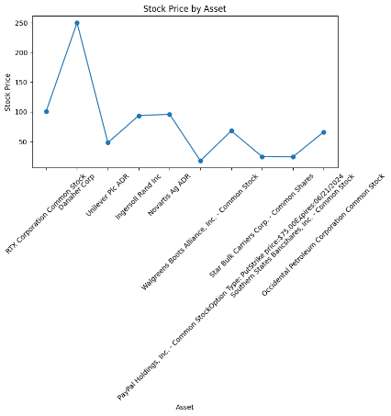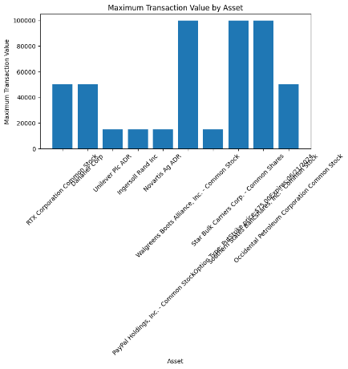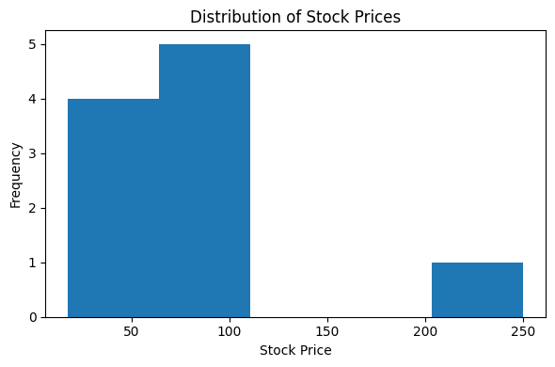
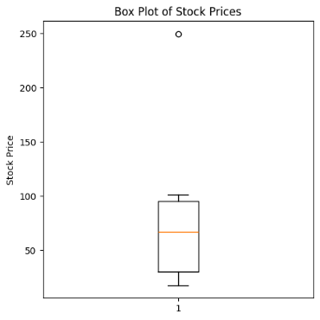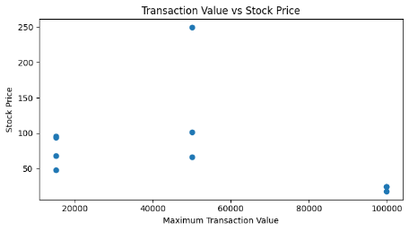
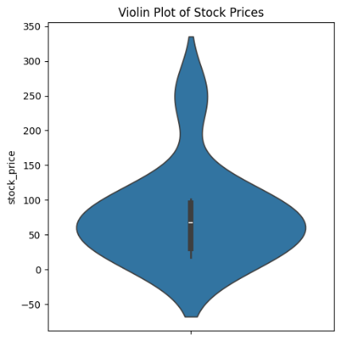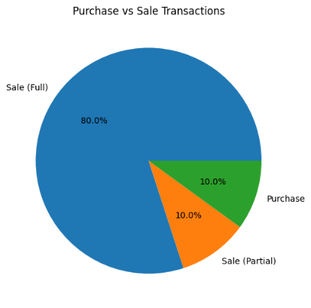
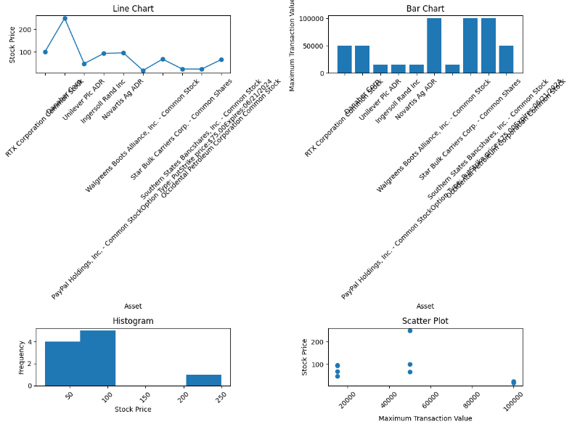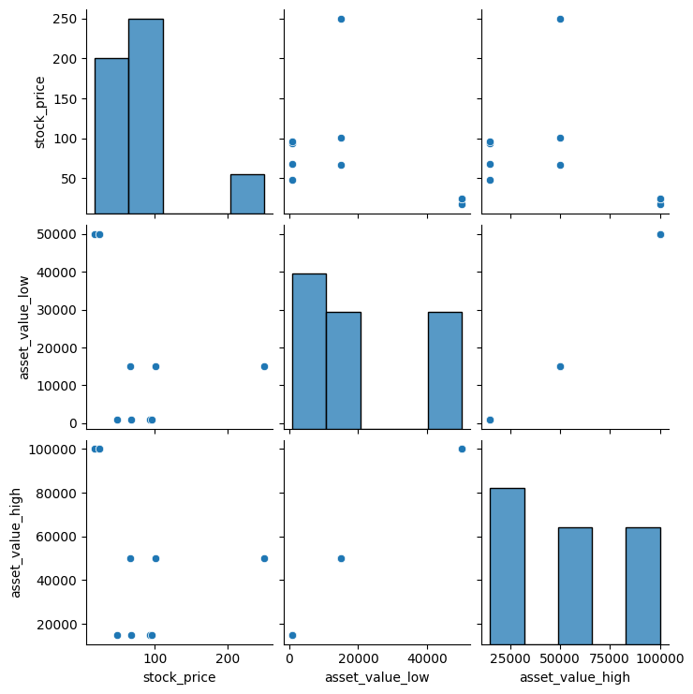
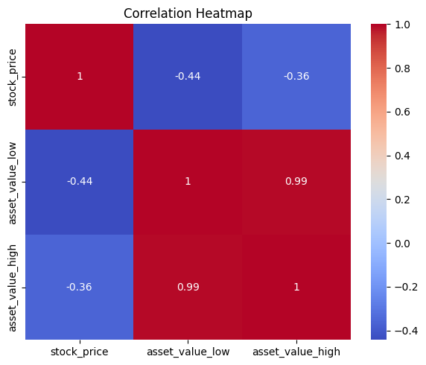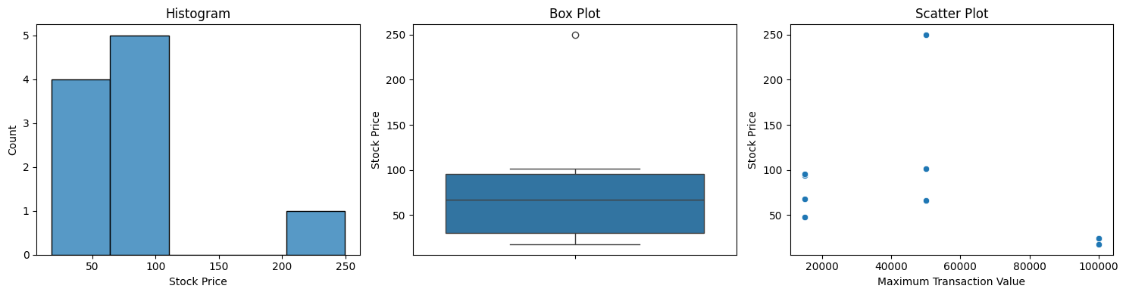

Result:

