Ex.no:4 | EXPLORATORY DATA ANALYSIS (EDA) – DATA INSPECTION, FILTERING, STATISTICAL ANALYSIS AND CORRELATION

Aim:
To perform data inspection, conditional filtering, sorting, statistical summary, group aggregation, correlation analysis, and data visualization on a hotel bookings dataset using Pandas and Matplotlib.

Algorithm:
- Start.
- Import the required Python libraries: pandas and matplotlib.pyplot.
- Load the dataset hotel_bookings.csv into a pandas DataFrame using pd.read_csv().
- Inspect the basic structure, initial records, shape, column data types, and numerical summaries using df.head(), df.shape, df.dtypes, and df.describe().
- Filter rows based on specific business conditions (e.g., adr > 100 and hotel == "Resort Hotel").
- Sort the dataset by adr in descending order using df.sort_values().
- Compute statistical metrics for adr including mean, median, mode, and standard deviation.
- Group data by hotel type and aggregate to find the average adr using df.groupby().
- Calculate the pairwise correlation matrix for numerical features using df.corr().
- Generate a bar plot for average adr by hotel type and a scatter plot of lead_time versus adr using Matplotlib.

Program:
import pandas as pd
import matplotlib.pyplot as plt

# 1. Read Dataset (Updated for Colab uploaded file)
file_path = "senate_stock_discosures.csv"
df = pd.read_csv(file_path)

# 2. Use only first 10 rows
df = df.head(10)

# 3. Convert numeric columns
num = [
"stock_price",
"asset_value_low",
"asset_value_high"
]
for col in num:
df[col] = pd.to_numeric(df[col], errors="coerce")

# 4. View Data
print("First 5 Rows")
print(df.head())

print("\nShape")
print(df.shape)

print("\nData Types")
print(df.dtypes)

# 5. Filter Stock Price > 100
print("\nTransactions with Stock Price > 100")
high_price = df[df["stock_price"] > 100]
print(high_price)

# 6. Filter Purchase Transactions
print("\nPurchase Transactions")
purchases = df[df["transaction"] == "Purchase"]
print(purchases)

# 7. Sort by Stock Price
print("\nSorted by Stock Price")
sorted_df = df.sort_values(by="stock_price", ascending=False)
print(sorted_df)

# 8. Statistics on Stock Price
print("\nMean =", df["stock_price"].mean())
print("Median =", df["stock_price"].median())
print("Mode =")
print(df["stock_price"].mode())
print("Standard Deviation =", df["stock_price"].std())

# 9. Summary
print("\nSummary Statistics")
print(df.describe())

# 10. Group By Senator Last Name
print("\nAverage Stock Price by Senator")
senator_avg = df.groupby("last_name")["stock_price"].mean()
print(senator_avg)

# 11. Correlation
print("\nCorrelation")
corr = df[["stock_price", "asset_value_low"]].corr()
print(corr)

# 12. Scatter Plot
plt.scatter(df["asset_value_low"], df["stock_price"])
plt.title("Stock Price vs Asset Value (Low Range)")
plt.xlabel("Asset Value Low (USD)")
plt.ylabel("Stock Price (USD)")
plt.grid(True)
plt.show()

# 13. Bar Plot
senator_avg.plot(kind="bar")
plt.title("Average Stock Price by Senator")
plt.xlabel("Senator Last Name")
plt.ylabel("Average Stock Price (USD)")
plt.show()
Output:
First 5 Rows
ticker asset_name asset_type stock_price \
0 RTX RTX Corporation Common Stock Stock 100.99
1 DHR Danaher Corp Stock 249.80
2 UL Unilever Plc ADR Stock 47.99
3 IR Ingersoll Rand Inc Stock 93.48
4 NVS Novartis Ag ADR Stock 95.81

transaction transaction_date asset_value_low asset_value_high \
0 Sale (Full) 04/09/2024 15001 50000
1 Sale (Full) 04/09/2024 15001 50000
2 Sale (Full) 04/09/2024 1001 15000
3 Sale (Full) 04/09/2024 1001 15000
4 Sale (Partial) 04/09/2024 1001 15000

last_name first_name owner additional_details
0 Whitehouse Sheldon Spouse --
1 Whitehouse Sheldon Spouse --
2 Whitehouse Sheldon Spouse --
3 Whitehouse Sheldon Spouse --
4 Whitehouse Sheldon Self --

Shape
(10, 12)

Data Types
ticker object
asset_name object
asset_type object
stock_price float64
transaction object
transaction_date object
asset_value_low int64
asset_value_high int64
last_name object
first_name object
owner object
additional_details object
dtype: object

Transactions with Stock Price > 100
ticker asset_name asset_type stock_price transaction \
0 RTX RTX Corporation Common Stock Stock 100.99 Sale (Full)
1 DHR Danaher Corp Stock 249.80 Sale (Full)

transaction_date asset_value_low asset_value_high last_name first_name \
0 04/09/2024 15001 50000 Whitehouse Sheldon
1 04/09/2024 15001 50000 Whitehouse Sheldon

owner additional_details
0 Spouse --
1 Spouse --

Purchase Transactions
ticker asset_name asset_type \
6 PYPL PayPal Holdings, Inc. - Common StockOption Typ... Stock Option

stock_price transaction transaction_date asset_value_low \
6 67.92 Purchase 04/30/2024 1001

asset_value_high last_name first_name owner additional_details
6 15000 Tuberville Thomas H Joint --

Sorted by Stock Price
ticker asset_name asset_type \
1 DHR Danaher Corp Stock
0 RTX RTX Corporation Common Stock Stock
4 NVS Novartis Ag ADR Stock
3 IR Ingersoll Rand Inc Stock
6 PYPL PayPal Holdings, Inc. - Common StockOption Typ... Stock Option
9 OXY Occidental Petroleum Corporation Common Stock Stock
2 UL Unilever Plc ADR Stock
7 SBLK Star Bulk Carriers Corp. - Common Shares Stock
8 SSBK Southern States Bancshares, Inc. - Common Stock Stock
5 WBA Walgreens Boots Alliance, Inc. - Common Stock Stock

stock_price transaction transaction_date asset_value_low \
1 249.80 Sale (Full) 04/09/2024 15001
0 100.99 Sale (Full) 04/09/2024 15001
4 95.81 Sale (Partial) 04/09/2024 1001
3 93.48 Sale (Full) 04/09/2024 1001
6 67.92 Purchase 04/30/2024 1001
9 66.14 Sale (Full) 04/30/2024 15001
2 47.99 Sale (Full) 04/09/2024 1001
7 24.32 Sale (Full) 04/30/2024 50001
8 24.08 Sale (Full) 04/30/2024 50001
5 17.49 Sale (Full) 04/30/2024 50001

asset_value_high last_name first_name owner additional_details
1 50000 Whitehouse Sheldon Spouse --
0 50000 Whitehouse Sheldon Spouse --
4 15000 Whitehouse Sheldon Self --
3 15000 Whitehouse Sheldon Spouse --
6 15000 Tuberville Thomas H Joint --
9 50000 Tuberville Thomas H Joint --
2 15000 Whitehouse Sheldon Spouse --
7 100000 Tuberville Thomas H Joint --
8 100000 Tuberville Thomas H Joint --
5 100000 Tuberville Thomas H Joint --

Mean = 78.80199999999999
Median = 67.03
Mode =
0 17.49
1 24.08
2 24.32
3 47.99
4 66.14
5 67.92
6 93.48
7 95.81
8 100.99
9 249.80
Name: stock_price, dtype: float64
Standard Deviation = 67.64893820304944

Summary Statistics
stock_price asset_value_low asset_value_high
count 10.000000 10.000000 10.000000
mean 78.802000 19901.000000 51000.000000
std 67.648938 21651.019991 37103.458958
min 17.490000 1001.000000 15000.000000
25% 30.237500 1001.000000 15000.000000
50% 67.030000 15001.000000 50000.000000
75% 95.227500 41251.000000 87500.000000
max 249.800000 50001.000000 100000.000000

Average Stock Price by Senator
last_name
Tuberville 39.990
Whitehouse 117.614
Name: stock_price, dtype: float64

Correlation
stock_price asset_value_low
stock_price 1.000000 -0.442114
asset_value_low -0.442114 1.000000
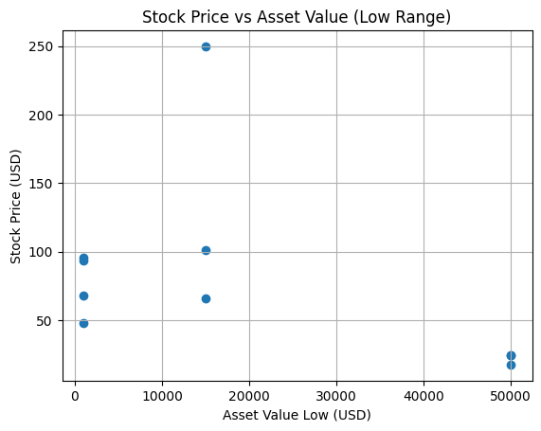
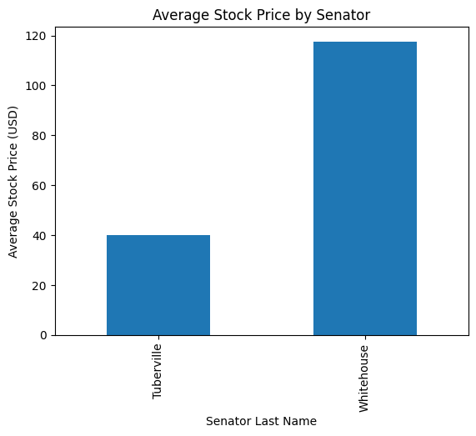

Result:

