Ex.no:4 | EXPLORATORY DATA ANALYSIS (EDA) – DATA INSPECTION, FILTERING, STATISTICAL ANALYSIS AND CORRELATION

Aim:
To perform data inspection, filtering, grouping, aggregation, descriptive statistical analysis, and correlation analysis using Pandas and visualize the results using Matplotlib.
Algorithm:
- Import the required Pandas, NumPy and Matplotlib libraries.
- Read the stud_data.csv file using Pandas.
- Display the dataset and inspect the first few records.
- Find the number of rows and columns and display the data types.
- Generate the statistical summary of the dataset.
- Filter the students based on marks and attendance conditions.
- Sort the student records based on marks and attendance.
- Group the data based on department and calculate average marks and attendance.
- Calculate mean, median, minimum, maximum and standard deviation of marks.
- Calculate the correlation between marks and attendance.
- Create bar chart, line chart, scatter plot, histogram and box plot using Matplotlib.
- Display the results and interpret the obtained data.

Program:
import pandas as pd
import matplotlib.pyplot as plt

# Load dataset directly using your Windows path
df = pd.read_csv(r"C:\Users\AI_LAB\Downloads\archive\senate_stock_disclosures_cleaned.csv")

# 1. Dataset Overview & Schema
print("--- Dataset Preview ---")
print(df.head())

print("\n--- Dataset Info & Data Types ---")
print(df.info())

print("\n--- Missing Values Count ---")
print(df.isnull().sum())

# 2. Categorical Analysis (Senators, Tickers, Transaction Types, etc.)
categorical_cols = df.select_dtypes(include=["object", "category"]).columns

print("\n--- Top Entries per Categorical Column ---")
for col in categorical_cols:
print(f"\nTop 5 in '{col}':")
print(df[col].value_counts().head(5))

# 3. Numerical Summary Statistics
numeric_cols = df.select_dtypes(include=["number"]).columns
if len(numeric_cols) > 0:
print("\n--- Summary Statistics (Numeric) ---")
print(df[numeric_cols].describe())

# 4. Data Visualizations
# Visual 1: Top 10 Frequency Chart for the Primary Categorical Column (e.g. Senator or Ticker)
if len(categorical_cols) > 0:
target_cat = categorical_cols[0]
plt.figure(figsize=(10, 5))
df[target_cat].value_counts().head(10).plot(kind="bar", color="navy", edgecolor="black")
plt.title(f"Top 10 Most Frequent Entries in '{target_cat}'")
plt.xlabel(target_cat)
plt.ylabel("Count")
plt.xticks(rotation=45, ha="right")
plt.grid(axis="y", linestyle="--", alpha=0.6)
plt.tight_layout()
plt.show()

# Visual 2: Distribution of First Numeric Column (if present)
if len(numeric_cols) > 0:
target_num = numeric_cols[0]
plt.figure(figsize=(8, 4))
df[target_num].hist(bins=20, color="teal", edgecolor="black")
plt.title(f"Distribution of '{target_num}'")
plt.xlabel(target_num)
plt.ylabel("Frequency")
plt.grid(True, linestyle="--", alpha=0.5)
plt.tight_layout()
plt.show()

Output:
--- Dataset Preview ---
ticker asset_name asset_type stock_price \
0 RTX RTX Corporation Common Stock Stock 100.99
1 DHR Danaher Corp Stock 249.80
2 UL Unilever Plc ADR Stock 47.99
3 IR Ingersoll Rand Inc Stock 93.48
4 NVS Novartis Ag ADR Stock 95.81

transaction transaction_date asset_value_low asset_value_high \
0 Sale (Full) 04/09/2024 15001 50000
1 Sale (Full) 04/09/2024 15001 50000
2 Sale (Full) 04/09/2024 1001 15000
3 Sale (Full) 04/09/2024 1001 15000
4 Sale (Partial) 04/09/2024 1001 15000

last_name first_name owner additional_details
0 Whitehouse Sheldon Spouse --
1 Whitehouse Sheldon Spouse --
2 Whitehouse Sheldon Spouse --
3 Whitehouse Sheldon Spouse --
4 Whitehouse Sheldon Self --

--- Dataset Info & Data Types ---
<class 'pandas.core.frame.DataFrame'>
RangeIndex: 4699 entries, 0 to 4698
Data columns (total 12 columns):
# Column Non-Null Count Dtype
--- ------ -------------- -----
0 ticker 4699 non-null object
1 asset_name 4699 non-null object
2 asset_type 4699 non-null object
3 stock_price 4699 non-null float64
4 transaction 4699 non-null object
5 transaction_date 4699 non-null object
6 asset_value_low 4699 non-null int64
7 asset_value_high 4699 non-null int64
8 last_name 4699 non-null object
9 first_name 4699 non-null object
10 owner 4699 non-null object
11 additional_details 4699 non-null object
dtypes: float64(1), int64(2), object(9)
memory usage: 440.7+ KB
None

--- Missing Values Count ---
ticker 0
asset_name 0
asset_type 0
stock_price 0
transaction 0
transaction_date 0
asset_value_low 0
asset_value_high 0
last_name 0
first_name 0
owner 0
additional_details 0
dtype: int64

--- Top Entries per Categorical Column ---

Top 5 in 'ticker':
AAPL 109
MSFT 94
CLF 91
PYPL 63
INTC 62
Name: ticker, dtype: int64

Top 5 in 'asset_name':
Apple Inc. 63
Wells Fargo & Company 41
Microsoft Corporation 40
The Walt Disney Company 40
CVS Health Corporation 37
Name: asset_name, dtype: int64

Top 5 in 'asset_type':
Stock 4325
Stock Option 374
Name: asset_type, dtype: int64

Top 5 in 'transaction':
Purchase 2310
Sale (Full) 1590
Sale (Partial) 777
Exchange 22
Name: transaction, dtype: int64

Top 5 in 'transaction_date':
04/24/2018 116
04/03/2023 101
09/25/2019 76
06/15/2017 76
04/05/2018 72
Name: transaction_date, dtype: int64

Top 5 in 'last_name':
Tuberville 1094
Capito 571
Whitehouse 532
Carper 499
Wyden 255
Name: last_name, dtype: int64

Top 5 in 'first_name':
Thomas H 1094
Shelley M 571
Thomas R 561
Sheldon 532
Ron L 255
Name: first_name, dtype: int64

Top 5 in 'owner':
Spouse 2109
Joint 1689
Self 765
Child 136
Name: owner, dtype: int64

Top 5 in 'additional_details':
-- 4465
Sale part of investment strategy of 3rd party investment professional to exchange individual stocks received after death of filer’s parents for EIFs. 30
Dividend Reinvestment 25
Exercised stock option. 11
Asset held by Roundstone Ventures, LLC. 8
Name: additional_details, dtype: int64

--- Summary Statistics (Numeric) ---
stock_price asset_value_low asset_value_high
count 4699.000000 4.699000e+03 4.699000e+03
mean 110.136095 1.683926e+04 4.924878e+04
std 171.319777 3.664223e+05 7.387854e+05
min 0.690000 1.001000e+03 1.500000e+04
25% 35.100000 1.001000e+03 1.500000e+04
50% 66.550000 1.001000e+03 1.500000e+04
75% 131.870000 1.001000e+03 1.500000e+04
max 3259.200000 2.500000e+07 5.000000e+07
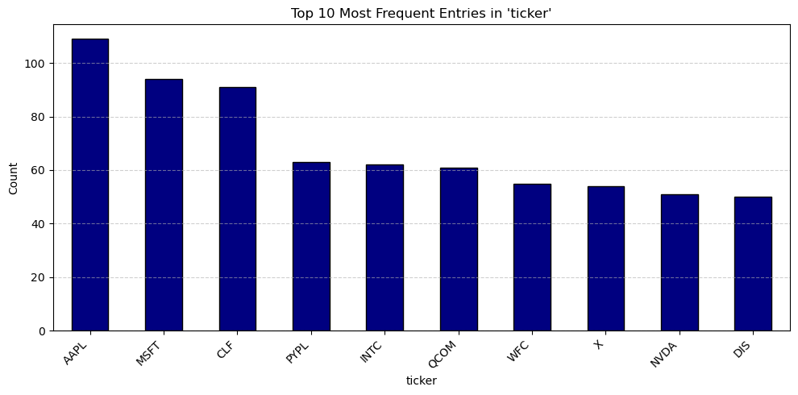

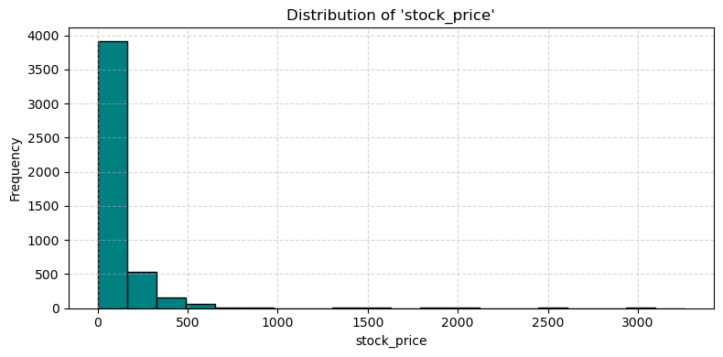

Result:

