Ex.no:4 | EDA – DATA INSPECTION, FILTERING, STATISTICAL ANALYSIS AND CORRELATION

Aim:

Algorithm:
• Start.
• Import libraries.
• Read/Create the dataset.
• Display dataset information.
• Filter required records.
• Sort the data.
• Calculate statistical measures.
• Generate summary statistics.
• Group data and calculate averages.
• Find correlation.
• Create graphs (Scatter Plot and Bar Chart).
• Stop.

Program:
import pandas as pd
import matplotlib.pyplot as plt

# Load dataset directly using your Windows path
df = pd.read_csv(r"C:\Users\AI_LAB\Downloads\archive\senate_stock_disclosures_cleaned.csv")

# 1. Dataset Overview & Schema
print("--- Dataset Preview ---")
print(df.head())

print("\n--- Dataset Info & Data Types ---")
print(df.info())

print("\n--- Missing Values Count ---")
print(df.isnull().sum())

# 2. Categorical Analysis (Senators, Tickers, Transaction Types, etc.)
categorical_cols = df.select_dtypes(include=["object", "category"]).columns

print("\n--- Top Entries per Categorical Column ---")
for col in categorical_cols:
print(f"\nTop 5 in '{col}':")
print(df[col].value_counts().head(5))

# 3. Numerical Summary Statistics
numeric_cols = df.select_dtypes(include=["number"]).columns
if len(numeric_cols) > 0:
print("\n--- Summary Statistics (Numeric) ---")
print(df[numeric_cols].describe())

# 4. Data Visualizations
# Visual 1: Top 10 Frequency Chart for the Primary Categorical Column (e.g. Senator or Ticker)
if len(categorical_cols) > 0:
target_cat = categorical_cols[0]
plt.figure(figsize=(10, 5))
df[target_cat].value_counts().head(10).plot(kind="bar", color="navy", edgecolor="black")
plt.title(f"Top 10 Most Frequent Entries in '{target_cat}'")
plt.xlabel(target_cat)
plt.ylabel("Count")
plt.xticks(rotation=45, ha="right")
plt.grid(axis="y", linestyle="--", alpha=0.6)
plt.tight_layout()
plt.show()

# Visual 2: Distribution of First Numeric Column (if present)
if len(numeric_cols) > 0:
target_num = numeric_cols[0]
plt.figure(figsize=(8, 4))
df[target_num].hist(bins=20, color="teal", edgecolor="black")
plt.title(f"Distribution of '{target_num}'")
plt.xlabel(target_num)
plt.ylabel("Frequency")
plt.grid(True, linestyle="--", alpha=0.5)
plt.tight_layout()
plt.show()

Output:
--- Dataset Preview ---
ticker asset_name asset_type stock_price \
0 RTX RTX Corporation Common Stock Stock 100.99
1 DHR Danaher Corp Stock 249.80
2 UL Unilever Plc ADR Stock 47.99
3 IR Ingersoll Rand Inc Stock 93.48
4 NVS Novartis Ag ADR Stock 95.81

transaction transaction_date asset_value_low asset_value_high \
0 Sale (Full) 04/09/2024 15001 50000
1 Sale (Full) 04/09/2024 15001 50000
2 Sale (Full) 04/09/2024 1001 15000
3 Sale (Full) 04/09/2024 1001 15000
4 Sale (Partial) 04/09/2024 1001 15000

last_name first_name owner additional_details
0 Whitehouse Sheldon Spouse --
1 Whitehouse Sheldon Spouse --
2 Whitehouse Sheldon Spouse --
3 Whitehouse Sheldon Spouse --
4 Whitehouse Sheldon Self --

--- Dataset Info & Data Types ---
<class 'pandas.core.frame.DataFrame'>
RangeIndex: 4699 entries, 0 to 4698
Data columns (total 12 columns):
# Column Non-Null Count Dtype
--- ------ -------------- -----
0 ticker 4699 non-null object
1 asset_name 4699 non-null object
2 asset_type 4699 non-null object
3 stock_price 4699 non-null float64
4 transaction 4699 non-null object
5 transaction_date 4699 non-null object
6 asset_value_low 4699 non-null int64
7 asset_value_high 4699 non-null int64
8 last_name 4699 non-null object
9 first_name 4699 non-null object
10 owner 4699 non-null object
11 additional_details 4699 non-null object
dtypes: float64(1), int64(2), object(9)
memory usage: 440.7+ KB
None

--- Missing Values Count ---
ticker 0
asset_name 0
asset_type 0
stock_price 0
transaction 0
transaction_date 0
asset_value_low 0
asset_value_high 0
last_name 0
first_name 0
owner 0
additional_details 0
dtype: int64

--- Top Entries per Categorical Column ---

Top 5 in 'ticker':
AAPL 109
MSFT 94
CLF 91
PYPL 63
INTC 62
Name: ticker, dtype: int64

Top 5 in 'asset_name':
Apple Inc. 63
Wells Fargo & Company 41
Microsoft Corporation 40
The Walt Disney Company 40
CVS Health Corporation 37
Name: asset_name, dtype: int64

Top 5 in 'asset_type':
Stock 4325
Stock Option 374
Name: asset_type, dtype: int64

Top 5 in 'transaction':
Purchase 2310
Sale (Full) 1590
Sale (Partial) 777
Exchange 22
Name: transaction, dtype: int64

Top 5 in 'transaction_date':
04/24/2018 116
04/03/2023 101
09/25/2019 76
06/15/2017 76
04/05/2018 72
Name: transaction_date, dtype: int64

Top 5 in 'last_name':
Tuberville 1094
Capito 571
Whitehouse 532
Carper 499
Wyden 255
Name: last_name, dtype: int64

Top 5 in 'first_name':
Thomas H 1094
Shelley M 571
Thomas R 561
Sheldon 532
Ron L 255
Name: first_name, dtype: int64

Top 5 in 'owner':
Spouse 2109
Joint 1689
Self 765
Child 136
Name: owner, dtype: int64

Top 5 in 'additional_details':
-- 4465
Sale part of investment strategy of 3rd party investment professional to exchange individual stocks received after death of filer’s parents for EIFs. 30
Dividend Reinvestment 25
Exercised stock option. 11
Asset held by Roundstone Ventures, LLC. 8
Name: additional_details, dtype: int64

--- Summary Statistics (Numeric) ---
stock_price asset_value_low asset_value_high
count 4699.000000 4.699000e+03 4.699000e+03
mean 110.136095 1.683926e+04 4.924878e+04
std 171.319777 3.664223e+05 7.387854e+05
min 0.690000 1.001000e+03 1.500000e+04
25% 35.100000 1.001000e+03 1.500000e+04
50% 66.550000 1.001000e+03 1.500000e+04
75% 131.870000 1.001000e+03 1.500000e+04
max 3259.200000 2.500000e+07 5.000000e+07

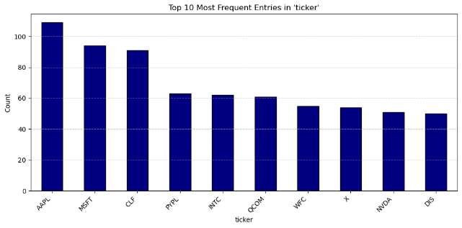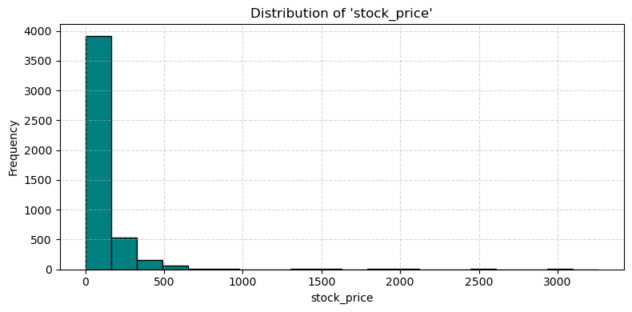

Program:
import pandas as pd
import matplotlib.pyplot as plt
# Create DataFrame
data = {
"Roll No": [101,102,103,104,105,106],
"Name": ["Arun","Bala","Divya","Priya","Ravi","Karthik"],
"Department": ["CSE","IT","CSE","AI&DS","IT","AI&DS"],
"Marks": [85,78,95,90,72,88],
"Attendance": [92,88,96,94,85,91]
}
df = pd.DataFrame(data)
# View Data
print("First 5 Rows")
print(df.head())
print("\nShape")
print(df.shape)
print("\nData Types")
print(df.dtypes)
# Filter Marks > 85
print("\nStudents with Marks > 85")
high_marks = df[df["Marks"] > 85]
print(high_marks)
# Filter IT Department
print("\nIT Department Students")
it_students = df[df["Department"] == "IT"]
print(it_students)
# Sort by Marks
print("\nSorted by Marks")
sorted_df = df.sort_values(by="Marks", ascending=False)
print(sorted_df)
# Statistics
print("\nMean =", df["Marks"].mean())
print("Median =", df["Marks"].median())
print("Mode =")
print(df["Marks"].mode())
print("Standard Deviation =", df["Marks"].std())
# Summary
print("\nSummary Statistics")
print(df.describe())
# Group By
print("\nAverage Marks by Department")
dept_avg = df.groupby("Department")["Marks"].mean()
print(dept_avg)
# Correlation
print("\nCorrelation")
corr = df[["Marks","Attendance"]].corr()
print(corr)
# Scatter Plot
plt.scatter(df["Attendance"], df["Marks"])
plt.title("Marks vs Attendance")
plt.xlabel("Attendance")
plt.ylabel("Marks")
plt.grid(True)
plt.show()
# Bar Plot
dept_avg.plot(kind="bar")
plt.title("Average Marks by Department")
plt.xlabel("Department")
plt.ylabel("Average Marks")
plt.show()

Output:
First 5 Rows
ticker asset_name asset_type stock_price \
0 RTX RTX Corporation Common Stock Stock 100.99
1 DHR Danaher Corp Stock 249.80
2 UL Unilever Plc ADR Stock 47.99
3 IR Ingersoll Rand Inc Stock 93.48
4 NVS Novartis Ag ADR Stock 95.81

transaction transaction_date asset_value_low asset_value_high \
0 Sale (Full) 04/09/2024 15001 50000
1 Sale (Full) 04/09/2024 15001 50000
2 Sale (Full) 04/09/2024 1001 15000
3 Sale (Full) 04/09/2024 1001 15000
4 Sale (Partial) 04/09/2024 1001 15000

last_name first_name owner additional_details
0 Whitehouse Sheldon Spouse --
1 Whitehouse Sheldon Spouse --
2 Whitehouse Sheldon Spouse --
3 Whitehouse Sheldon Spouse --
4 Whitehouse Sheldon Self --

Shape
(10, 12)

Data Types
ticker object
asset_name object
asset_type object
stock_price float64
transaction object
transaction_date object
asset_value_low int64
asset_value_high int64
last_name object
first_name object
owner object
additional_details object
dtype: object

Transactions with Stock Price > 100
ticker asset_name asset_type stock_price transaction \
0 RTX RTX Corporation Common Stock Stock 100.99 Sale (Full)
1 DHR Danaher Corp Stock 249.80 Sale (Full)

transaction_date asset_value_low asset_value_high last_name first_name \
0 04/09/2024 15001 50000 Whitehouse Sheldon
1 04/09/2024 15001 50000 Whitehouse Sheldon

owner additional_details
0 Spouse --
1 Spouse --

Purchase Transactions
ticker asset_name asset_type \
6 PYPL PayPal Holdings, Inc. - Common StockOption Typ... Stock Option

stock_price transaction transaction_date asset_value_low \
6 67.92 Purchase 04/30/2024 1001

asset_value_high last_name first_name owner additional_details
6 15000 Tuberville Thomas H Joint --

Sorted by Stock Price
ticker asset_name asset_type \
1 DHR Danaher Corp Stock
0 RTX RTX Corporation Common Stock Stock
4 NVS Novartis Ag ADR Stock
3 IR Ingersoll Rand Inc Stock
6 PYPL PayPal Holdings, Inc. - Common StockOption Typ... Stock Option
9 OXY Occidental Petroleum Corporation Common Stock Stock
2 UL Unilever Plc ADR Stock
7 SBLK Star Bulk Carriers Corp. - Common Shares Stock
8 SSBK Southern States Bancshares, Inc. - Common Stock Stock
5 WBA Walgreens Boots Alliance, Inc. - Common Stock Stock

stock_price transaction transaction_date asset_value_low \
1 249.80 Sale (Full) 04/09/2024 15001
0 100.99 Sale (Full) 04/09/2024 15001
4 95.81 Sale (Partial) 04/09/2024 1001
3 93.48 Sale (Full) 04/09/2024 1001
6 67.92 Purchase 04/30/2024 1001
9 66.14 Sale (Full) 04/30/2024 15001
2 47.99 Sale (Full) 04/09/2024 1001
7 24.32 Sale (Full) 04/30/2024 50001
8 24.08 Sale (Full) 04/30/2024 50001
5 17.49 Sale (Full) 04/30/2024 50001

asset_value_high last_name first_name owner additional_details
1 50000 Whitehouse Sheldon Spouse --
0 50000 Whitehouse Sheldon Spouse --
4 15000 Whitehouse Sheldon Self --
3 15000 Whitehouse Sheldon Spouse --
6 15000 Tuberville Thomas H Joint --
9 50000 Tuberville Thomas H Joint --
2 15000 Whitehouse Sheldon Spouse --
7 100000 Tuberville Thomas H Joint --
8 100000 Tuberville Thomas H Joint --
5 100000 Tuberville Thomas H Joint --

Mean = 78.80199999999999
Median = 67.03
Mode =
0 17.49
1 24.08
2 24.32
3 47.99
4 66.14
5 67.92
6 93.48
7 95.81
8 100.99
9 249.80
Name: stock_price, dtype: float64
Standard Deviation = 67.64893820304944

Summary Statistics
stock_price asset_value_low asset_value_high
count 10.000000 10.000000 10.000000
mean 78.802000 19901.000000 51000.000000
std 67.648938 21651.019991 37103.458958
min 17.490000 1001.000000 15000.000000
25% 30.237500 1001.000000 15000.000000
50% 67.030000 15001.000000 50000.000000
75% 95.227500 41251.000000 87500.000000
max 249.800000 50001.000000 100000.000000

Average Stock Price by Senator
last_name
Tuberville 39.990
Whitehouse 117.614
Name: stock_price, dtype: float64

Correlation
stock_price asset_value_low
stock_price 1.000000 -0.442114
asset_value_low -0.442114 1.000000Attendance 0.978226 1.000000

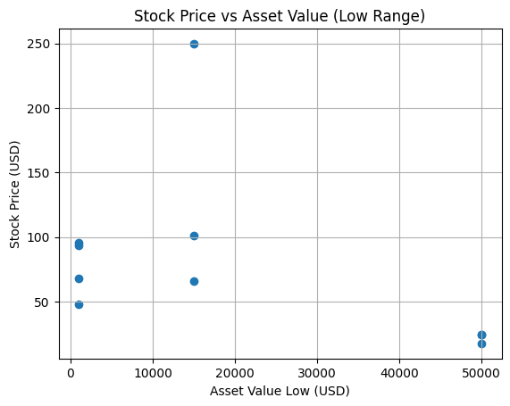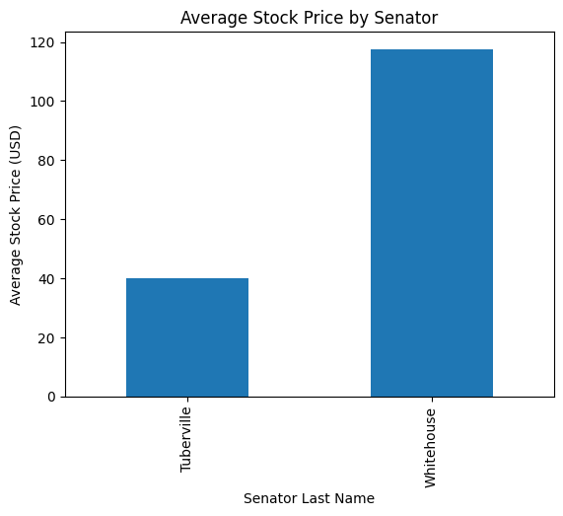

Result:

