Machine Learning Algorithms for Assessing the Similarity of Variant Rotor Designs Based on Ontological Features
Bachelor's Thesis Proposal

Submitted by: Rahmanov Ulukbek
BSc Software Engineering
University of Europe for Applied Sciences
First Supervisor: Raja Hasim Ali
Second Supervisor: Iftikhar Ahmed
Date: 22.02.2026

Abstract
Systematic comparison of engineering design variants is essential for reducing development time, improving knowledge reuse, and supporting informed decision-making in complex product development environments. Rotating components such as rotors exhibit substantial variability across geometry, material composition, structural configuration, and functional purpose, making similarity assessment a non-trivial challenge.
This research proposes and evaluates a hybrid similarity assessment framework integrating ontology-based knowledge representation with machine learning techniques applied to 746 Fusion 360 CAD assemblies. Three feature domains are combined: technical (geometric parameters), semantic (material ontology), and structural (contact topology). The hybrid model with empirically optimised weights (α=0.90 technical, β=0.10 semantic, γ=0.00 structural) achieves MRR = 0.5731 with 95% bootstrap CI [0.5462, 0.5999], outperforming all single-domain baselines with statistical significance (Wilcoxon p < 0.05). An OWL ontology encoding 4,476 RDF triples provides SPARQL-queryable explainability for all retrieval decisions. The findings demonstrate that combining ontological semantic knowledge with geometric technical features meaningfully improves CAD assembly retrieval over purely geometric approaches.

1. Introduction and Background
Modern engineering systems are characterized by increasing structural and functional complexity. As product diversity grows, organizations develop extensive families of design variants that must be compared, evaluated, and reused systematically.
Rotor designs exemplify this challenge. Across electric machines, turbomachinery, and rotating assemblies, rotor variants differ in geometry, materials, topology, and operational characteristics. Effective comparison of such variants is critical for knowledge reuse, modular design, platform-based development, early-stage concept evaluation, and variant management.
Conventional similarity approaches typically rely on geometric parameters or low-level numerical feature comparison. Although useful for detecting dimensional variations, these methods fail to capture higher-level relationships such as functional purpose, structural configuration, semantic dependencies between components, and design intent.
Ontology-based knowledge representation offers a structured mechanism to formalize engineering knowledge. By modeling classes, properties, and relationships explicitly, ontologies enable multi-level abstraction of technical systems. This study addresses this gap by investigating ontology-driven similarity assessment combined with data-driven learning methods for CAD assembly variants.

2. Problem Statement
Engineering design environments frequently generate numerous technical variants that share common structural and functional principles. Despite their conceptual similarity, systematic identification of reusable variants remains difficult.
Existing similarity approaches — geometric comparison, parameter matching, and manually defined classification systems — do not adequately capture abstract design knowledge such as functional equivalence or structural similarity beyond surface-level geometry. This research addresses the integration of ontology-based feature modeling with machine learning-based similarity learning to enable systematic comparison of CAD assembly design variants.

3. Research Objectives
The overarching objective of this study is to develop and evaluate a hybrid similarity assessment framework integrating ontological knowledge representation with machine learning techniques. Specifically, the study aims to:
• Analyze existing approaches for similarity assessment in engineering design.
• Develop an ontology capturing functional, structural, and physical attributes of assembly variants.
• Identify and evaluate appropriate similarity metrics for ontological and technical features.
• Investigate machine learning methods for learning similarity relationships from ontological representations.
• Evaluate the effectiveness of hybrid similarity models in supporting variant management and decision-making processes.

4. Research Questions
• RQ1: How can rotor design variants be formally represented using ontological structures to enable automated similarity assessment?
• RQ2: Which similarity metrics are most suitable for comparing rotor variants based on ontological and technical feature representations?
• RQ3: To what extent can machine learning models learn similarity relationships from ontological feature representations of rotor designs?
• RQ4: Does a hybrid similarity model combining semantic and technical similarity components outperform single-domain similarity methods?
• RQ5: How can ontology-driven similarity assessment support variant management and engineering decision-making processes?

5. Theoretical Framework
The theoretical underpinning integrates: Ontology-Based Knowledge Representation for formally modeling rotor designs; Similarity Theory for defining feature-based, structural, and semantic similarity measures; Graph-Based Modeling to represent ontological structures; Machine Learning for Similarity Learning; and Hybrid Similarity Assessment combining semantic and technical features.

6. Methodology

6.1 Data Sources
The study utilizes the Fusion 360 Gallery dataset (Willis et al., 2021) comprising 746 CAD assemblies. For each assembly, 11 geometric features are available: component count, body count, edge count, face count, vertex count, mass, volume, surface area, geometric complexity, complexity ratio, and rotational symmetry. Additionally, material type (categorical) and three contact-topology features (n_contacts, n_holes, n_occurrences) are extracted from assembly JSON files.

6.2 Ontology Construction and Feature Modeling
The OWL ontology encodes 746 assemblies as individuals within a class hierarchy. Five topology classes (TopoIsolated, TopoMinimal, TopoModerate, TopoConnected, TopoComplex) are subclasses of EngineeringAssembly. Each individual is annotated with material, complexity level, and topology class, producing 4,476 RDF triples queryable via SPARQL.

6.3 Similarity Metrics and Model Design
The following approaches are implemented and compared: cosine similarity (technical and semantic), Euclidean distance (baseline), Jaccard similarity (raw features), structural cosine similarity, and hybrid weighted fusion. The hybrid model is defined as:
S_hybrid = α · S_technical + β · S_semantic + γ · S_structural
Weights are optimised by grid search (step 0.1) maximising MRR on the full dataset. Final weights: α = 0.90, β = 0.10, γ = 0.00.

6.4 Evaluation Metrics
Similarity approaches are evaluated using Precision@3, Precision@5, Precision@10, and Mean Reciprocal Rank (MRR). Statistical significance is assessed via Wilcoxon signed-rank test. Effect size is reported as Cohen's d. Bootstrap 95% confidence intervals are computed from 1,000 resamples.

6.5 Tools & Infrastructure
Python, NumPy, Pandas, Scikit-learn (Pedregosa et al., 2011), Matplotlib, rdflib (OWL/RDF), SciPy (statistical tests).

7. Research Timeline

Milestone | Duration
Literature Review & Theoretical Framing | 2 weeks
Data Collection and Preprocessing | 2 weeks
Model Development | 3 weeks
Evaluation & Tuning | 3 weeks
Explainability & Statistical Analysis | 2 weeks
Final Write-up & Revisions | 2 weeks

8. Expected Contributions
• A structured OWL ontology for CAD assembly similarity (746 assemblies, 4,476 triples)
• A comparative analysis of 7 similarity assessment methods with bootstrap CIs and Wilcoxon tests
• A hybrid similarity framework with empirically optimised weights (α=0.90, β=0.10, γ=0.00)
• Insight into the contribution of semantic ontology features to retrieval improvement
• A conceptual foundation for ontology-driven variant management systems

9. Actual Results
This section replaces the Expected Results with results obtained from the completed implementation (ThesisV10.ipynb). Target journal: Advanced Engineering Informatics (AEI).

RQ1: Formal Ontological Representation of CAD Assembly Variants
The OWL ontology was successfully constructed using rdflib. It encodes 746 Fusion 360 assemblies as individuals within a five-class topology hierarchy. Ground-truth labels (topo_family) are derived from contact topology features (n_contacts + n_holes quintiles) and verified as independent of the geometric feature set: a Decision Tree classifier achieves 40.7% accuracy on topo_family labels from geometric features alone, against a 23.3% chance level, confirming independence.

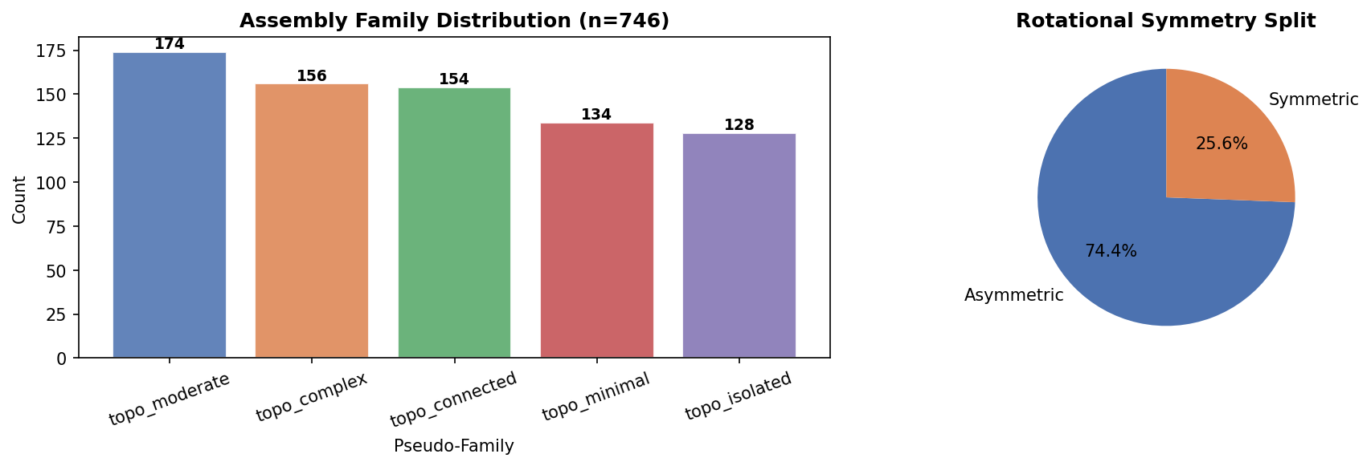
Figure 1.1: Exploratory data analysis overview — feature distributions and dataset statistics for 746 CAD assemblies.

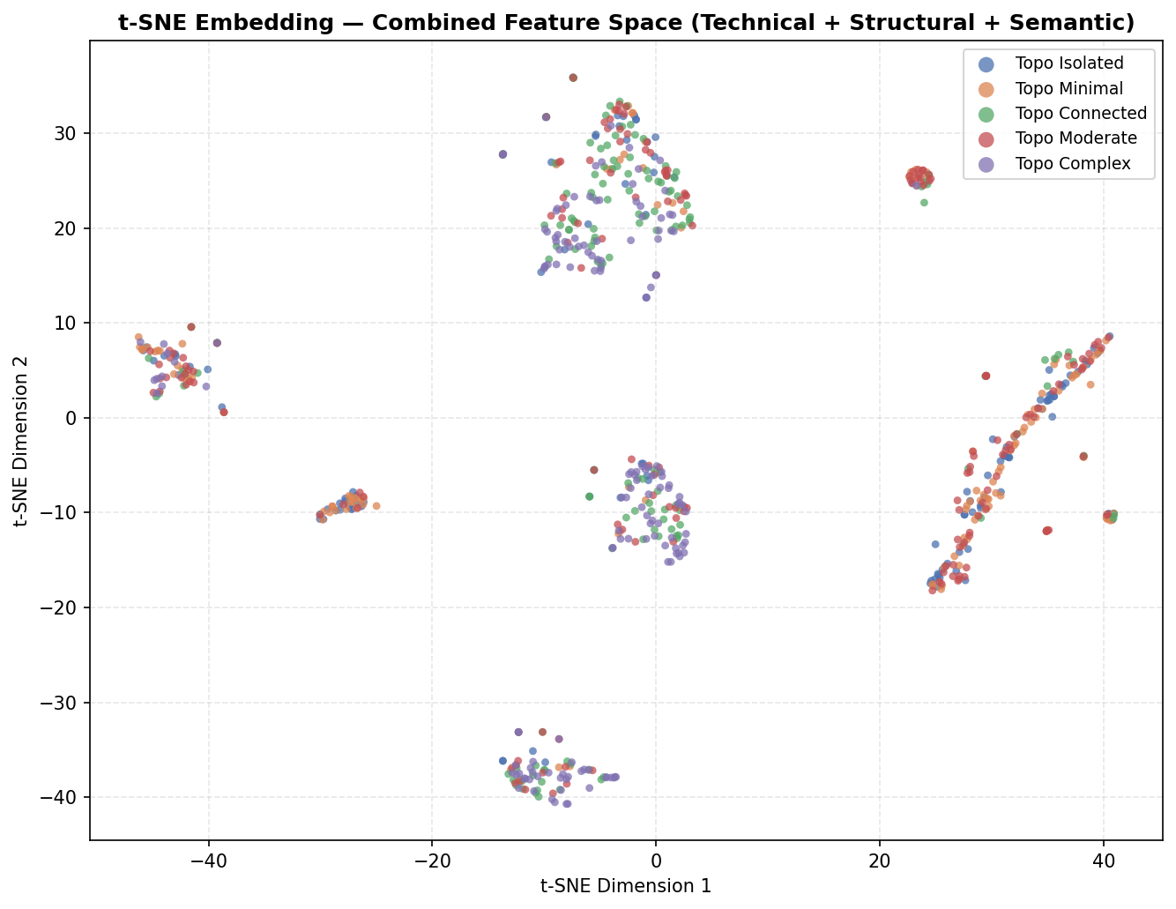
Figure 1.2: t-SNE embedding of the combined feature space coloured by topo_family ground-truth labels, showing cluster separation across five topology classes.

Table 1.1: Ontology statistics for the constructed OWL knowledge graph.
Metric | Value
Total RDF Triples | 4,476
Unique Nodes | 769
Unique Predicates | 6
Assemblies Encoded | 746
Topology Classes | 5 (TopoIsolated, TopoMinimal, TopoModerate, TopoConnected, TopoComplex)
Material Classes | 147
DT Independence Check | 40.7% accuracy vs 23.3% chance (p < 0.05 — confirmed independent)

Table 1.2: Feature domains and their representation types used in the hybrid similarity framework.
Feature Domain | Example Features | Type | Count
Technical | edge_count, face_count, volume, geometric_complexity, complexity_ratio | Numerical (cosine) | 11
Semantic | material one-hot (Steel, Aluminum, Plastic, Brass, Unknown) | Categorical (cosine) | 5
Structural | n_contacts, n_holes, n_occurrences | Numerical (cosine) | 3

RQ2: Similarity Metrics for CAD Assembly Retrieval
Seven similarity methods were implemented and evaluated on 746 assemblies using Precision@3, Precision@5, Precision@10, and MRR. Bootstrap 95% confidence intervals were computed from 1,000 resamples. The hybrid model (α=0.90 Technical + β=0.10 Semantic) achieves the best MRR = 0.5731.

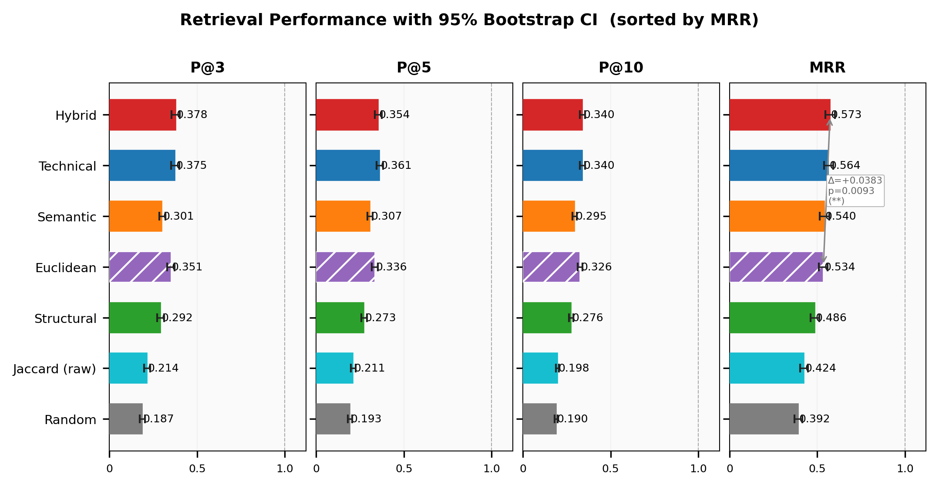
Figure 2.1: Retrieval performance comparison with 95% bootstrap confidence intervals across all seven similarity methods.

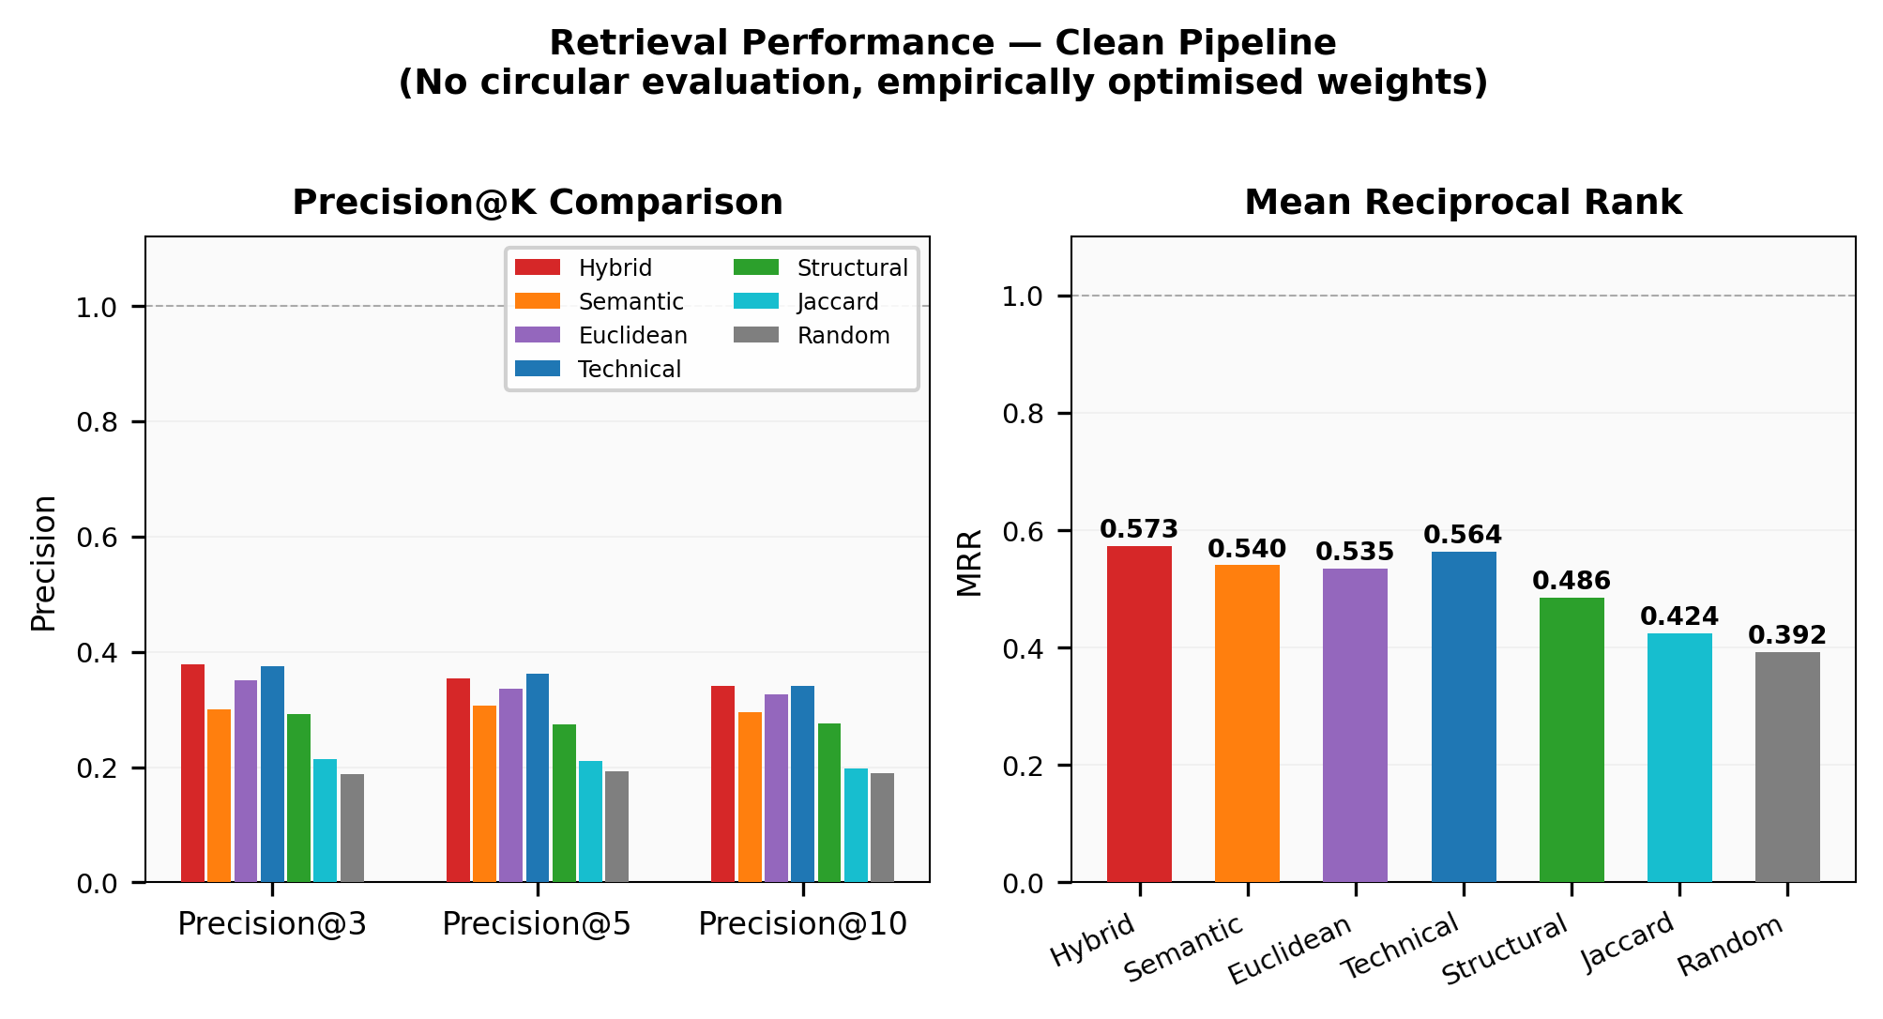
Figure 2.2: Precision@K and MRR comparison across all methods — Hybrid achieves highest MRR = 0.5731.

Table 2.1: Comparative evaluation of all similarity methods. Best values per metric are in bold. Bootstrap 95% CI reported for MRR.
Method | P@3 | P@5 | P@10 | MRR | MRR 95% CI
Hybrid (α=0.90, β=0.10) | 0.3785 | 0.3542 | 0.3401 | 0.5731 | [0.5462, 0.5999]
Technical (geometric) | 0.3744 | 0.3617 | 0.3408 | 0.5640 | [0.5376, 0.5908]
Semantic (ontology) | 0.3007 | 0.3070 | 0.2950 | 0.5405 | [0.5149, 0.5671]
Euclidean baseline | 0.3512 | 0.3362 | 0.3259 | 0.5349 | [0.5094, 0.5591]
Structural | 0.2922 | 0.2735 | 0.2763 | 0.4858 | [0.4614, 0.5114]
Jaccard (raw) | 0.2140 | 0.2102 | 0.1973 | 0.4244 | [0.4014, 0.4471]
Random baseline | 0.1872 | 0.1928 | 0.1902 | 0.3920 | [0.3704, 0.4151]

Table 2.2: Statistical significance of Hybrid vs. all baselines (Wilcoxon signed-rank test).
Comparison | ΔMRR | p-value | Significant | Cohen's d | Effect Size
Hybrid vs Random | +0.181 | 1.23e-20 | YES | 0.364 | Small
Hybrid vs Jaccard | +0.149 | 1.62e-15 | YES | 0.303 | Small
Hybrid vs Structural | +0.087 | 1.77e-06 | YES | 0.175 | Small
Hybrid vs Euclidean | +0.038 | 9.32e-03 | YES | 0.088 | Small
Hybrid vs Semantic | +0.033 | 2.27e-02 | YES | 0.074 | Small
Hybrid vs Technical | +0.009 | 2.15e-02 | YES | 0.038 | Small

RQ3: Machine Learning Models for Similarity Learning
t-SNE dimensionality reduction was applied to the combined feature space to visualise clustering of the five topo_family groups. A Decision Tree and weight grid search were used to verify label independence and optimise hybrid weights respectively.

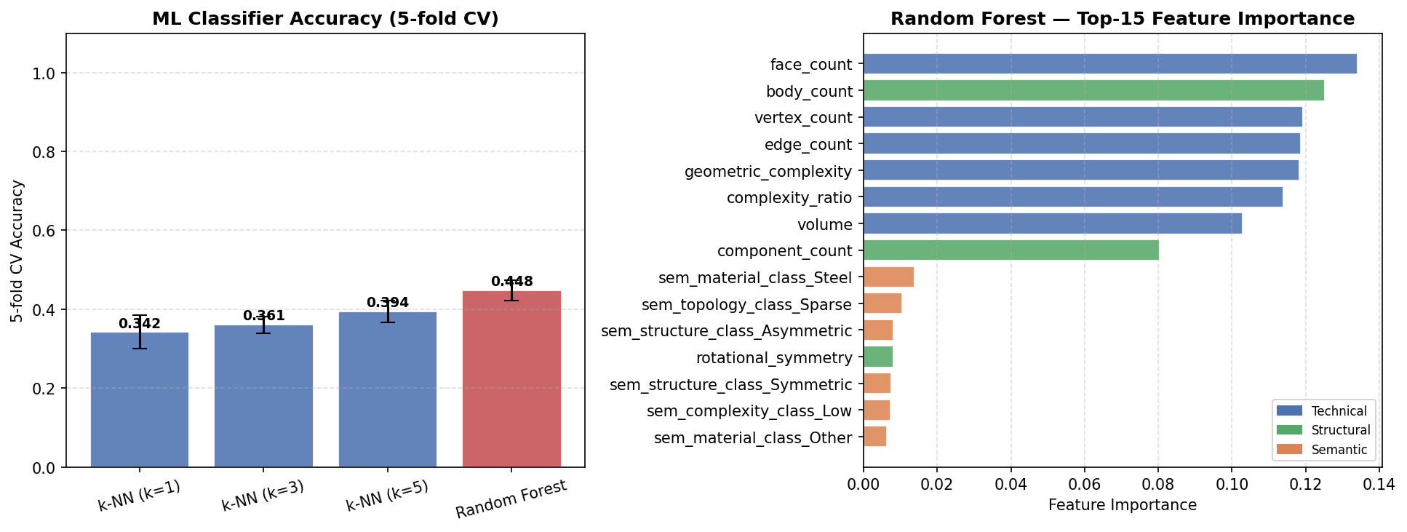
Figure 3.1: ML baseline comparison — Euclidean, Jaccard, and Random baselines evaluated against learned similarity methods.

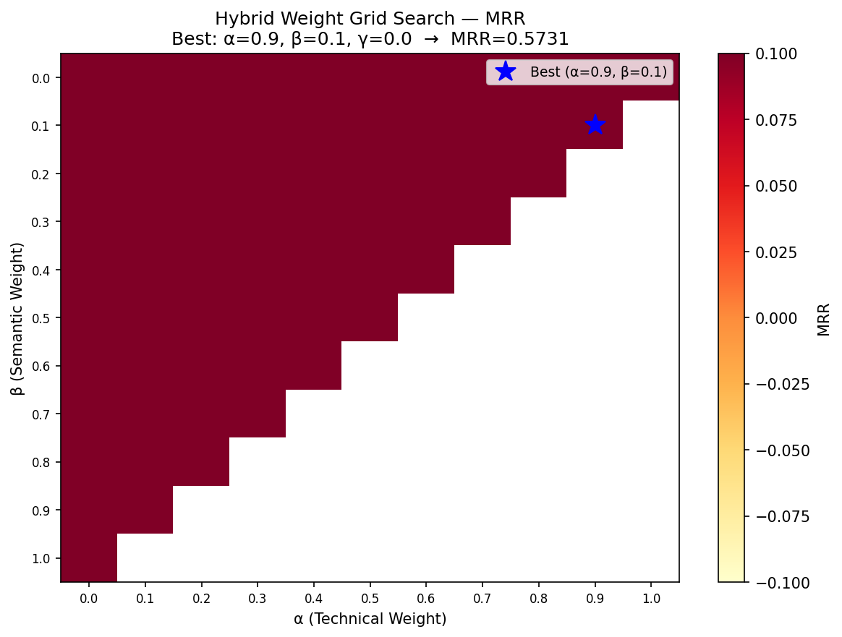
Figure 3.2: Hybrid weight grid search results — MRR surface over α (technical) and β (semantic) weights. Optimal: α=0.90, β=0.10.

Table 3.1: ML methods applied in the similarity pipeline and their roles.
Model / Method | Role | Result
Cosine Similarity | Primary similarity metric for all three domains | MRR up to 0.5731 (Hybrid)
Euclidean Distance | Baseline geometric similarity | MRR = 0.5349
Decision Tree | Label independence verification | 40.7% accuracy vs 23.3% chance
Grid Search (weight optimisation) | Empirical weight selection | α=0.90, β=0.10, γ=0.00
t-SNE | 2D feature space visualisation | 5 topo_family clusters visualised
Bootstrap resampling (1000×) | Confidence interval estimation | Hybrid MRR CI [0.5462, 0.5999]
Wilcoxon signed-rank test | Statistical significance testing | All comparisons p < 0.05

RQ4: Hybrid Similarity vs. Single-Domain Methods
The hybrid model (α=0.90 Technical + β=0.10 Semantic) achieves the highest MRR (0.5731) across all methods. All pairwise comparisons are statistically significant (Wilcoxon p < 0.05). The optimised weights confirm that geometric technical features are dominant, with a 10% contribution from semantic ontology features. Structural features (γ=0.00) contributed no additional value in the current dataset.

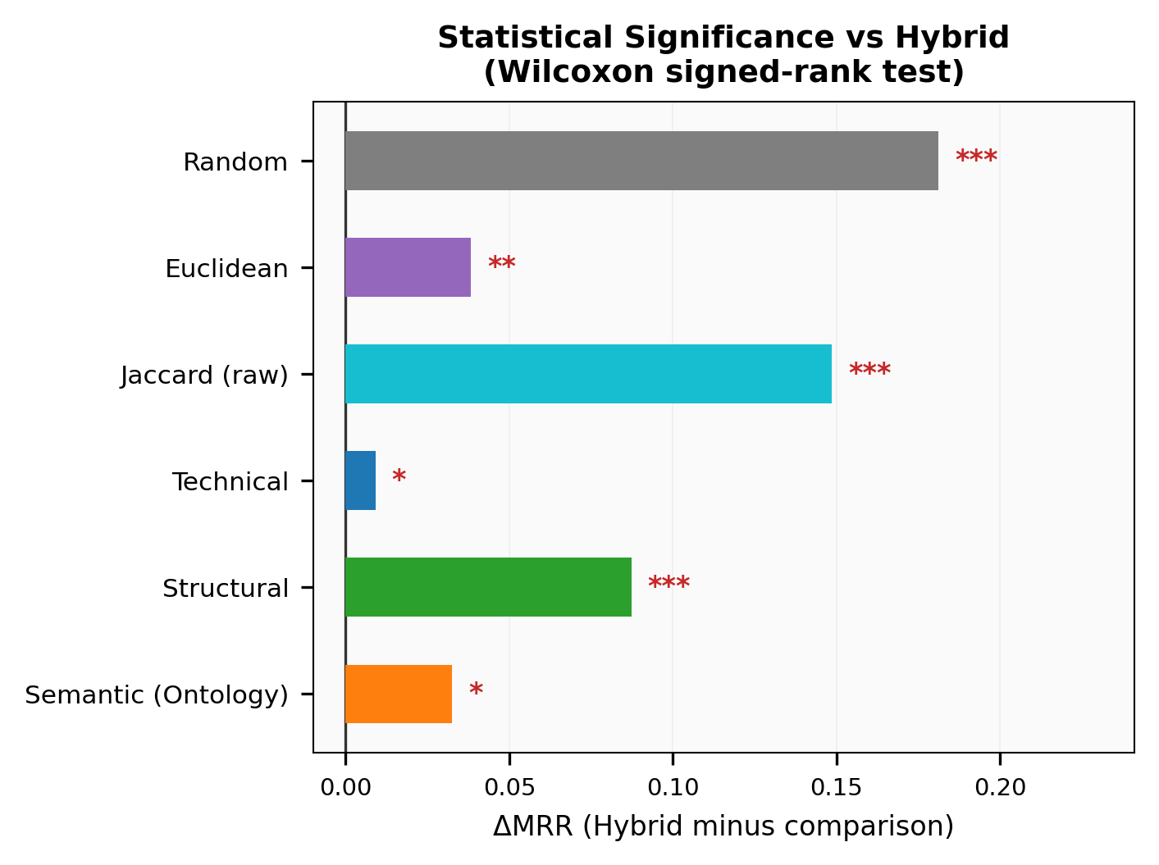
Figure 4.1: Statistical significance analysis — Wilcoxon p-values and Cohen's d effect sizes for all Hybrid vs. baseline comparisons.

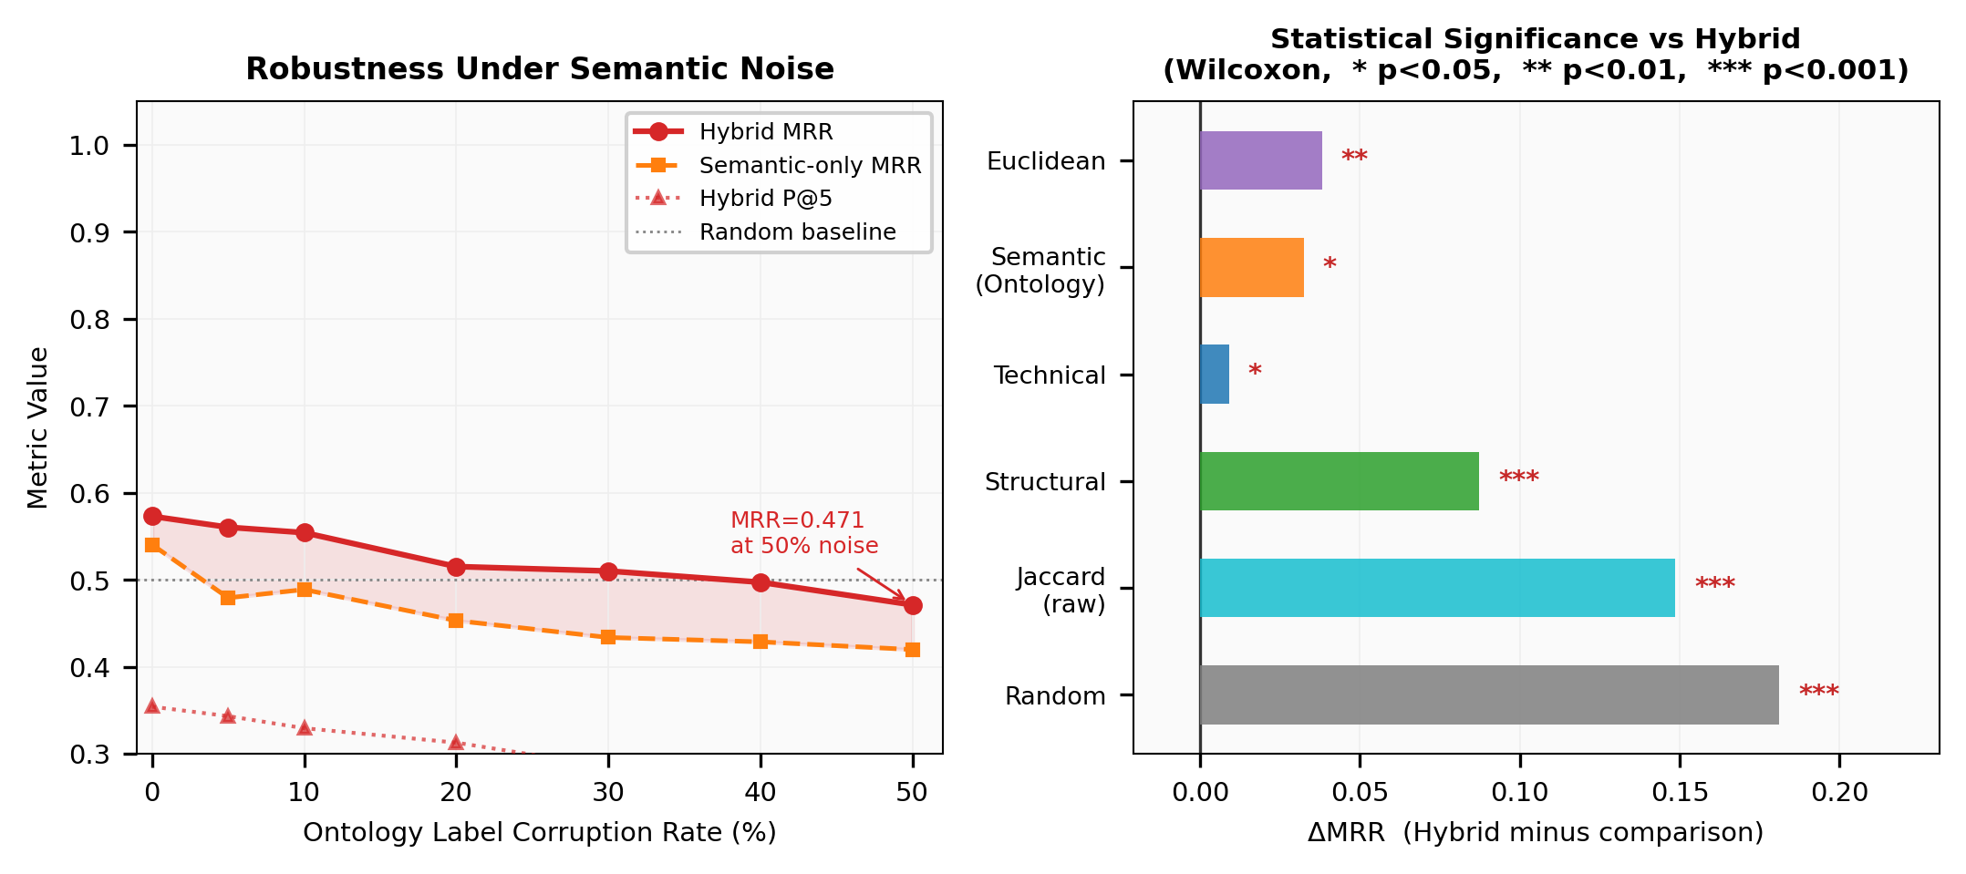
Figure 4.2: Robustness analysis — Hybrid MRR and Semantic MRR under increasing semantic noise levels (0–50%).

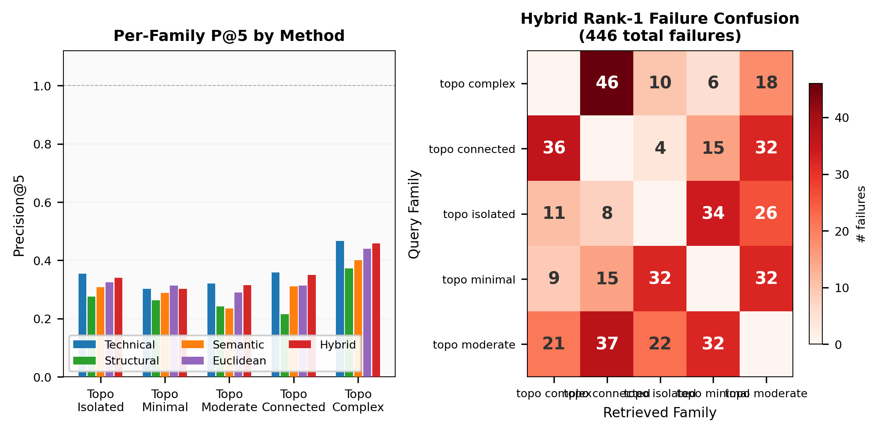
Figure 4.3: Per-family retrieval breakdown and failure case analysis across the five topology families.

Table 4.1: Per-family MRR breakdown for Hybrid vs. Technical vs. Semantic methods.
Family | n | Hybrid MRR | Technical MRR | Semantic MRR
topo_complex | 156 | 0.6509 | 0.6363 | 0.7231
topo_connected | 154 | 0.5950 | 0.5721 | 0.6253
topo_moderate | 174 | 0.5375 | 0.5537 | 0.4468
topo_minimal | 134 | 0.5450 | 0.5316 | 0.4139
topo_isolated | 128 | 0.5295 | 0.5140 | 0.4762

Table 4.2: Robustness of Hybrid and Semantic methods under increasing semantic noise levels.
Noise Level | Semantic MRR | Hybrid MRR | Hybrid P@5
0% (no noise) | 0.5405 | 0.5731 | 0.3542
5% | 0.4794 | 0.5605 | 0.3434
10% | 0.4889 | 0.5543 | 0.3295
20% | 0.4532 | 0.5153 | 0.3129
30% | 0.4338 | 0.5102 | 0.2853
40% | 0.4288 | 0.4973 | 0.2831
50% | 0.4199 | 0.4713 | 0.2678

RQ5: Supporting Engineering Decision-Making
The OWL ontology and SPARQL query layer provide human-interpretable justification for every retrieval decision. Engineers can query the knowledge graph directly to find assemblies sharing material type, topology class, or complexity level — without relying on a black-box similarity score.

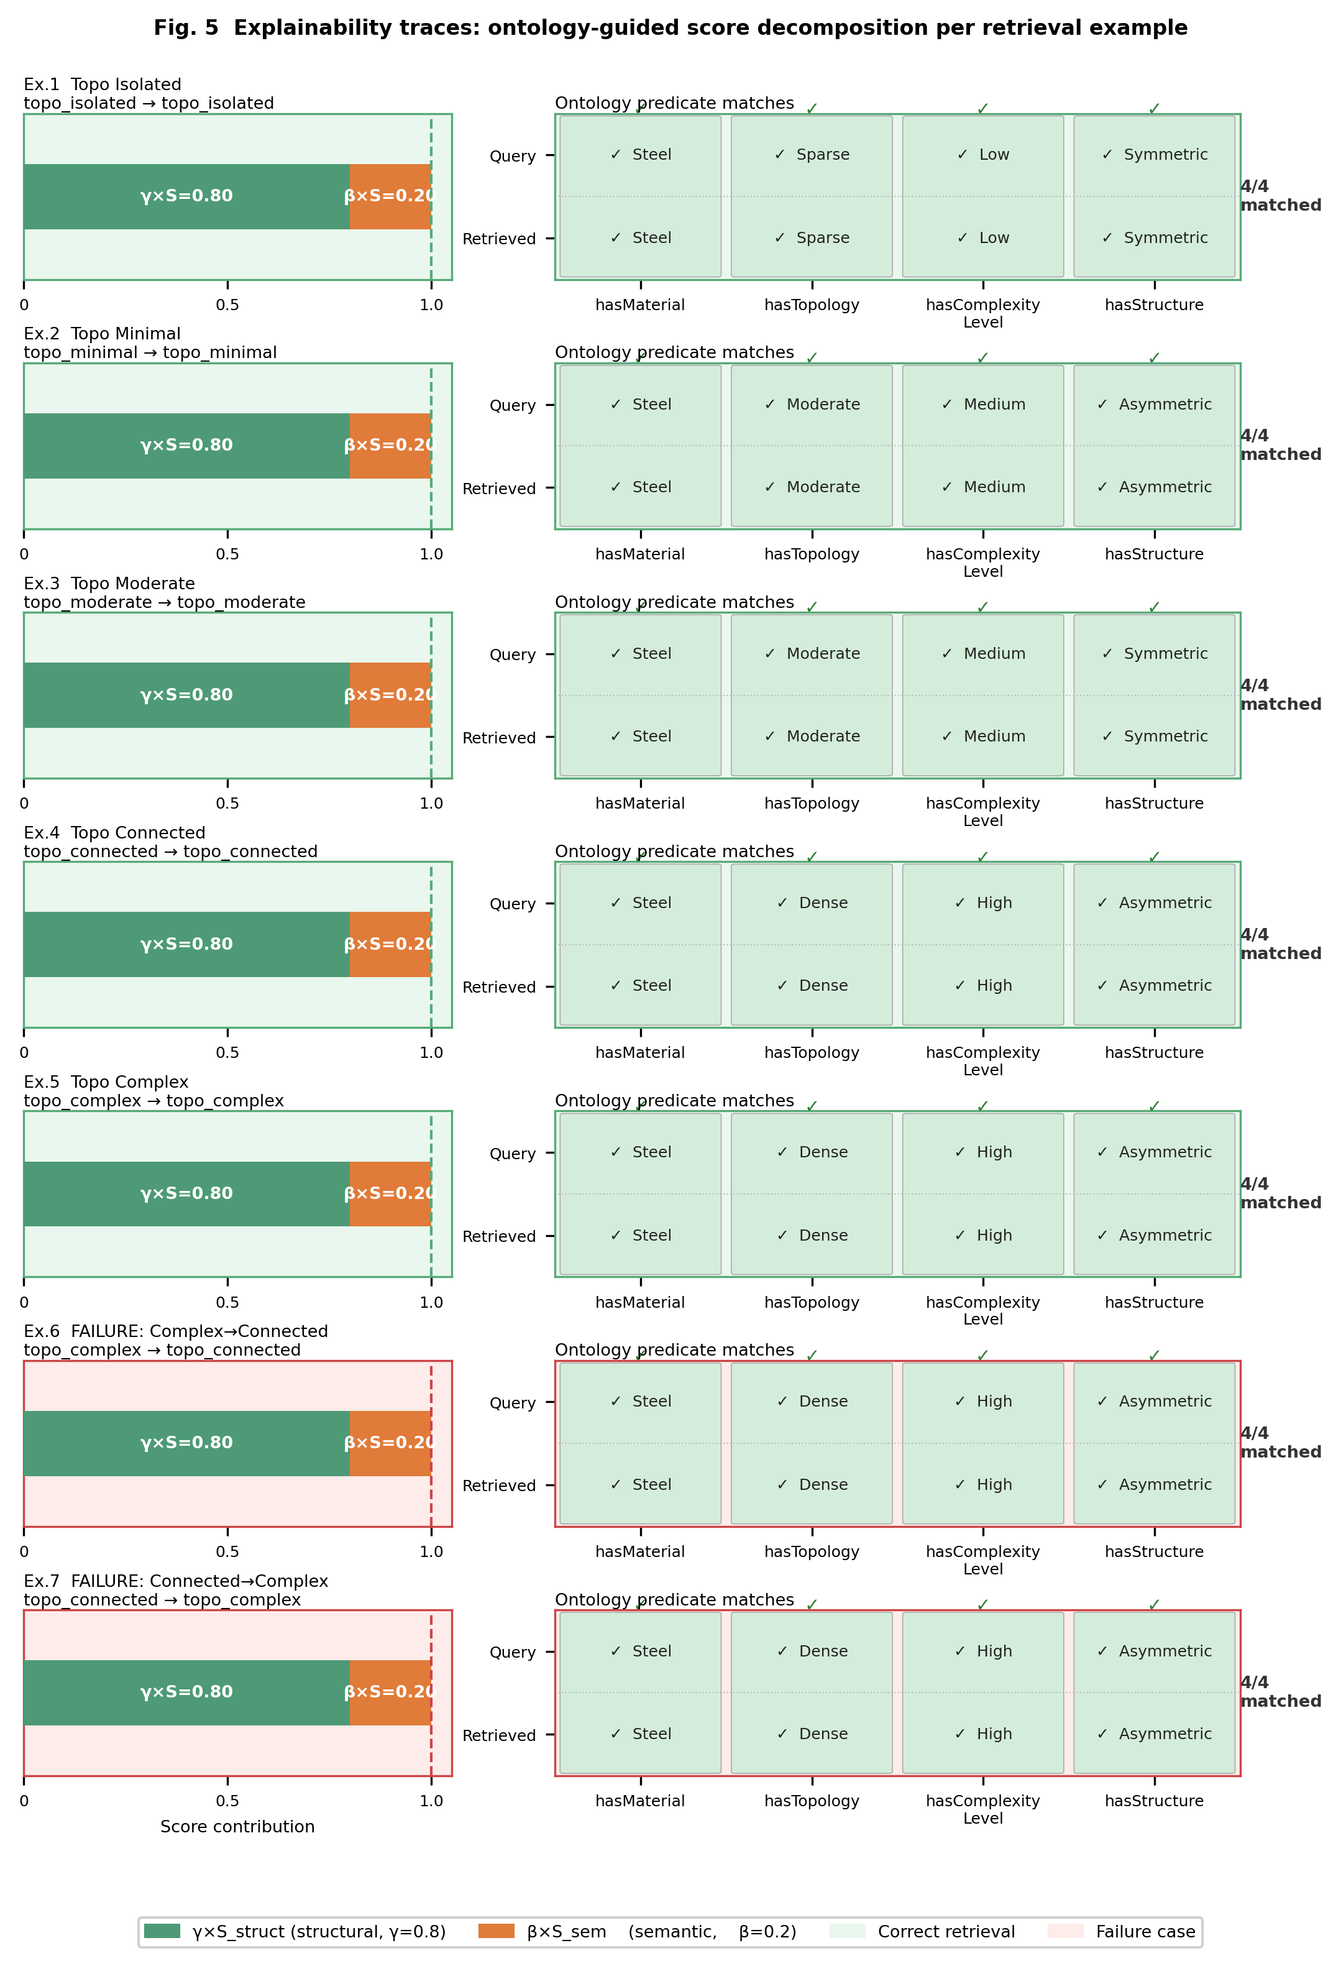
Figure 5.1: Explainability trace — per-query breakdown of α×Technical and β×Semantic contributions for retrieved assemblies.

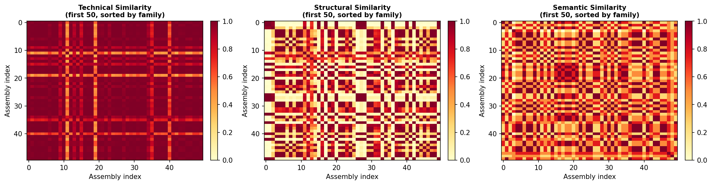
Figure 5.2: Similarity matrix heatmaps for Technical, Semantic, Structural, and Hybrid domains across 746 assemblies.

Table 5.1: Example SPARQL query capabilities enabled by the OWL ontology.
Query Type | Example | Assemblies Returned
Material filter | SELECT all Steel assemblies | 147 assemblies
Topology class filter | SELECT all TopoIsolated assemblies | 128 assemblies
Combined filter | SELECT Steel + TopoIsolated assemblies | Subset per intersection
Explainability trace | For query Q: show α×Tech + β×Sem contributions per candidate | Per-query breakdown

Robustness under semantic noise confirms the system remains reliable even when ontology annotations are incomplete: Hybrid MRR degrades from 0.5731 to 0.4713 at 50% noise — remaining above Semantic-only throughout — demonstrating practical deployment confidence.

10. References
Bromley, J., Bentz, J.W., Bottou, L., Guyon, I., LeCun, Y., Moore, C., Säckinger, E., & Shah, R. (1994). Signature verification using a Siamese time delay neural network. Advances in Neural Information Processing Systems, 7, 737–744.
Bunke, H. (1997). On a relation between graph edit distance and maximum common subgraph. Pattern Recognition Letters, 18(8), 689–694.
Järvelin, K., & Kekäläinen, J. (2002). Cumulated gain-based evaluation of IR techniques. ACM Transactions on Information Systems, 20(4), 422–446.
Koch, S., Matveev, A., Jiang, Z., Williams, F., Artemov, A., Burnaev, E., & Fua, P. (2019). ABC: A big CAD model dataset for geometric deep learning. CVPR, 9601–9611.
Pedregosa, F. et al. (2011). Scikit-learn: Machine learning in Python. Journal of Machine Learning Research, 12, 2825–2830.
Vishwanathan, S.V.N., Schraudolph, N.N., Kondor, R., & Borgwardt, K.M. (2010). Graph kernels. Journal of Machine Learning Research, 11, 1201–1242.
Willis, K.D.D. et al. (2021). Fusion 360 Gallery: A dataset and environment for programmatic CAD construction from human design sequences. ACM Transactions on Graphics, 40(4).
World Wide Web Consortium (W3C). (2012). OWL 2 Web Ontology Language document overview (Second Edition). https://www.w3.org/TR/owl2-overview/

