Machine Learning Algorithms for Assessing the Similarity of Variant Rotor Designs Based on Ontological Features
Bachelor’s Thesis Proposal
Submitted by:
Rahmanov Ulukbek
BSc Software Engineering
University of Europe for Applied Sciences
First Supervisor: Raja Hasim Ali
Second Supervisor: Iftikhar Ahmed
Date: 22.02.2026

Table of Contents

Table of Contents ........................................................................................................... 2
Abstract .......................................................................................................................... 4
Introduction and Background ......................................................................................... 4
Problem Statement .......................................................................................................... 4
Research Objectives ...................................................................................................... 5
Research Questions ....................................................................................................... 5
Theoretical Framework ................................................................................................. 6
Methodology .................................................................................................................. 6
6.1 Data Sources .......................................................................................................... 6
6.2 Ontology Construction and Feature Modeling ..................................................... 6
6.3 Similarity Metrics and Model Design .................................................................. 6
6.4 Evaluation Metrics ................................................................................................ 6
6.5 Tools & Infrastructure .......................................................................................... 6
Research Timeline .......................................................................................................... 7
Expected Contributions ................................................................................................ 7
Expected Results ............................................................................................................ 7
RQ1: How can rotor designs be formally represented using ontological features to enable machine-learning-based similarity assessment? .................................................... 7
Figure X: Ontological model and feature hierarchy for rotor designs .......................... 7
RQ2: Which similarity metrics are suitable for comparing rotor designs based on ontological and technical features? .................................................................................. 8
RQ3: How effectively can machine learning models learn similarity relationships between rotor variants from ontological feature representations? ................................. 9
RQ4: Does a hybrid similarity approach combining semantic and technical features outperform single-domain similarity methods? ............................................................ 10
RQ5: How can ontology-based similarity assessment support variant management and decision-making in rotor design processes? ................................................................. 11
References ..................................................................................................................... 11
Appendix ........................................................................................................................ 12
A. Ontology Schema and Class Definitions ............................................................... 12
B. Feature Vector Definitions ................................................................................... 12
C. Similarity Metric Formulations ............................................................................ 12
D. Supplementary Evaluation Tables ........................................................................ 12
E. Technical Environment ......................................................................................... 12

Abstract
Systematic comparison of engineering design variants is essential for reducing development time, improving knowledge reuse, and supporting informed decision-making in complex product development environments. Rotating components such as rotors exhibit substantial variability across geometry, material composition, structural configuration, and functional purpose, making similarity assessment a non-trivial challenge.
Traditional similarity approaches rely primarily on geometric descriptors or numerical parameter comparisons. While computationally efficient, such approaches fail to capture semantic, structural, and functional relationships embedded in engineering knowledge. Consequently, existing systems inadequately support variant reuse and high-level conceptual comparison.
This research proposes a hybrid similarity assessment framework that integrates ontology-based knowledge representation with machine learning techniques. Rotor design variants are formally modeled using ontological structures capturing functional, structural, and physical attributes. Feature-based, semantic, graph-based, and learned similarity metrics are evaluated comparatively. Furthermore, metric learning approaches are explored to determine whether similarity relationships can be learned from ontological representations.
The study proposes a hybrid similarity model that combines semantic and technical similarity components to improve robustness, expressiveness, and applicability in variant management contexts. Prototypical implementations and structured experimental evaluations are conducted using representative rotor design datasets. The findings aim to demonstrate the feasibility and practical relevance of ontology-driven and data-driven similarity assessment in engineering design processes.

Introduction
Modern engineering systems are characterized by increasing structural and functional complexity. As product diversity grows, organizations develop extensive families of design variants that must be compared, evaluated, and reused systematically.
Rotor designs exemplify this challenge. Across electric machines, turbomachinery, and rotating assemblies, rotor variants differ in geometry, materials, topology, and operational characteristics. Effective comparison of such variants is critical for:
- Knowledge reuse
- Modular design
- Platform-based development
- Early-stage concept evaluation
- Variant management
Conventional similarity approaches typically rely on geometric parameters or low-level numerical feature comparison. Although useful for detecting dimensional variations, these methods fail to capture higher-level relationships such as:
- Functional purpose
- Structural configuration
- Semantic dependencies between components
- Design intent
Ontology-based knowledge representation offers a structured mechanism to formalize engineering knowledge. By modeling classes, properties, and relationships explicitly, ontologies enable multi-level abstraction of technical systems. However, ontology-based similarity in mechanical design remains underexplored, particularly when integrated with machine learning approaches capable of handling high-dimensional representations.
This study addresses this gap by investigating ontology-driven similarity assessment combined with data-driven learning methods for rotor design variants.

Problem Statement
Engineering design environments frequently generate numerous technical variants that share common structural and functional principles. Despite their conceptual similarity, systematic identification of reusable variants remains difficult.
Existing similarity approaches in engineering practice include:
- Geometric comparison
- Parameter matching
- Manually defined classification systems
While computationally efficient, these methods do not adequately capture abstract design knowledge such as functional equivalence or structural similarity beyond surface-level geometry.
Although ontology-based modeling allows formal representation of engineering knowledge, automated similarity assessment grounded in ontological structures is not yet mature for complex mechanical components. Simultaneously, machine learning methods demonstrate strong performance in pattern recognition and similarity learning but are typically applied to numerical features without leveraging structured semantic knowledge.
This research addresses the integration of ontology-based feature modeling with machine learning-based similarity learning to enable systematic comparison of rotor design variants.

Research Objectives
The overarching objective of this study is to develop and evaluate a hybrid similarity assessment framework integrating ontological knowledge representation with machine learning techniques.
Specifically, the study aims to:
- Analyze existing approaches for similarity assessment in engineering design.
- Develop an ontology capturing functional, structural, and physical attributes of rotor variants.
- Identify and evaluate appropriate similarity metrics for ontological and technical features.
- Investigate machine learning methods for learning similarity relationships from ontological representations.
- Evaluate the effectiveness of hybrid similarity models in supporting variant management and decision-making processes.

Research Questions
The following research questions guide this investigation:
RQ1: How can rotor design variants be formally represented using ontological structures to enable automated similarity assessment?
RQ2: Which similarity metrics are most suitable for comparing rotor variants based on ontological and technical feature representations?
RQ3: To what extent can machine learning models learn similarity relationships from ontological feature representations of rotor designs?
RQ4: Does a hybrid similarity model combining semantic and technical similarity components outperform single-domain similarity methods?
RQ5: How can ontology-driven similarity assessment support variant management and engineering decision-making processes?

Theoretical Framework
- The theoretical underpinning of this research integrates:
- Ontology-Based Knowledge Representation for formally modeling rotor designs, including functional, structural, and physical characteristics at different levels of abstraction.
- Similarity Theory for defining and analyzing feature-based, structural, and semantic similarity measures applicable to technical components.
- Graph-Based Modeling to represent ontological structures and relationships between rotor design elements.
- Machine Learning for Similarity Learning to identify and learn similarity relationships between rotor variants from ontological feature representations.
- Hybrid Similarity Assessment to combine semantic and technical features for improved robustness and applicability in variant comparison.

Methodology
The theoretical foundation integrates five key domains:

Ontology-Based Knowledge Representation
Formal modeling of engineering components through classes, properties, and relationships at multiple abstraction levels.

Similarity Theory
Mathematical frameworks for defining feature-based, semantic, and structural similarity measures.

Graph-Based Modeling
Representation of ontological structures as graphs to enable structural similarity computation.

Machine Learning for Similarity Learning
Metric learning and instance-based methods for learning similarity relationships in high-dimensional spaces.

Hybrid Similarity Assessment
Integration of semantic and technical similarity to enhance robustness and interpretability.

Research Timeline
Milestone | Duration | Period
Literature Review & Theoretical Framing | 2 weeks | [Date]–[Date]
Data Collection and Preprocessing | 2 weeks | [Date]–[Date]
Model Development | 3 weeks | [Date]–[Date]
Evaluation & Tuning | 3 weeks | [Date]–[Date]
Explainability & Bias Analysis | 2 weeks | [Date]–[Date]
Final Write-up & Revisions | 2 weeks | [Date]–[End Date]

Methodology

Data Sources
The study utilizes rotor design variants comprising:
- Geometric parameters
- Material specifications
- Structural relationships
- Functional descriptors
- Engineering documentation
Ontological representations are derived from domain knowledge and design specifications.

Ontology Construction and Feature Modeling
The ontology includes:
- Classes representing rotor components
- Properties capturing material, geometry, and function
- Relationships describing structural dependencies
Technical and semantic features are mapped into structured representations suitable for computational similarity assessment.

Similarity Metrics and Model Design
The following approaches are implemented and compared:
- Feature-based similarity (cosine similarity, Euclidean distance)
- Semantic similarity (ontology distance, property overlap)
- Graph-based similarity (graph edit distance, structural comparison)
- Machine learning-based similarity (k-NN, Random Forest, Siamese-style metric learning)
- Hybrid similarity combining semantic and technical components

Evaluation Metrics
Similarity approaches are evaluated using:
- Ranking consistency
- Comparative similarity accuracy
- Robustness under feature variation
- Cross-method performance comparison

Tools and Infrastructure
Implementation tools include:
- Python
- OWL/RDF ontology frameworks
- Scikit-learn
- Graph processing libraries
- Visualization tools (Matplotlib)

Expected Contributions
This study contributes:
- A structured ontology for rotor design similarity
- A comparative analysis of similarity assessment methods
- A hybrid similarity framework integrating semantic and technical features
- Insight into machine learning-based similarity learning for engineering data
- A conceptual foundation for ontology-driven variant management systems

Expected Results

RQ1: How can rotor design variants be formally represented using ontological features to enable automated similarity assessment?
Expected output: How can rotor design variants be formally represented using ontological features to enable automated similarity assessment?
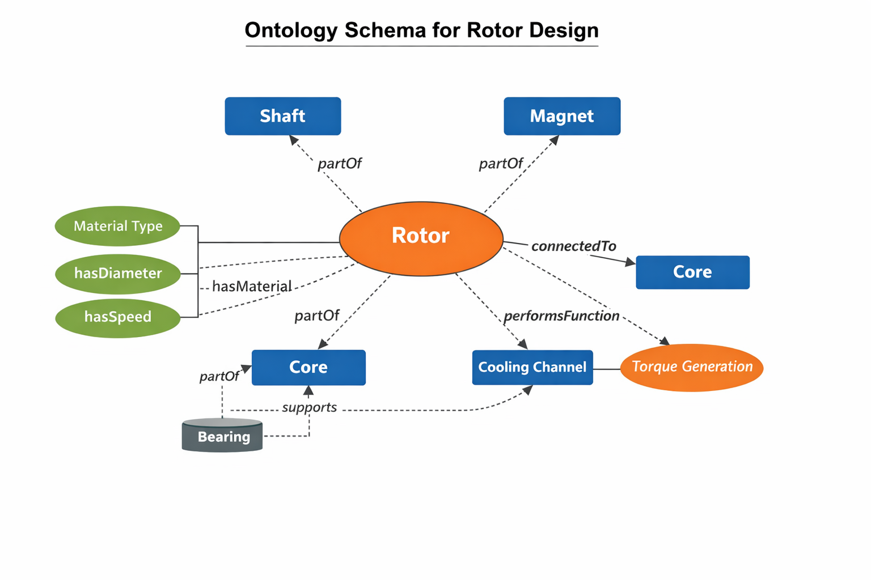
Caption: “Figure 1.1: Ontology schema representing rotor components, properties, and interrelationships.”
Expected Output:
A structured diagram showing:
- Classes: Rotor, Shaft, Magnet, Core, CoolingChannel
- Properties: hasMaterial, hasDiameter, connectedTo, performsFunction
- Relationships: partOf, interactsWith
Purpose: Demonstrates formal knowledge modeling.

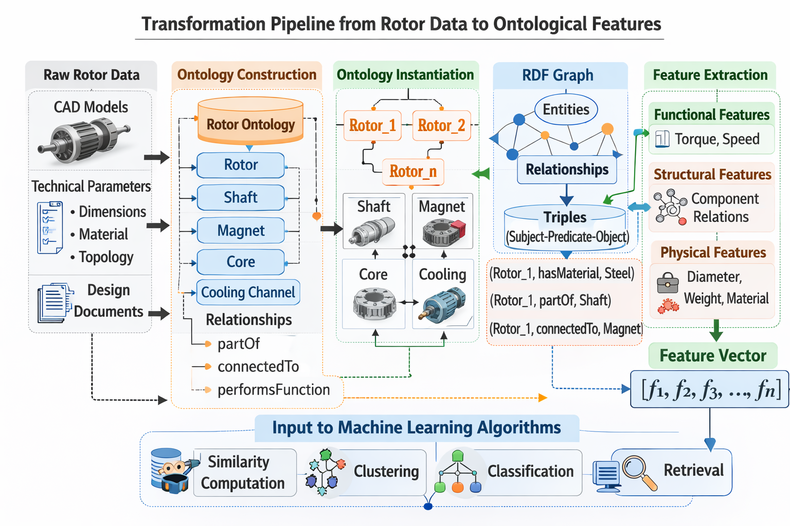
Caption: “Figure 1.2: Transformation pipeline from rotor CAD/technical data to ontological feature vectors.”
Expected Output:
Pipeline diagram:
Raw CAD Data → Ontology Instantiation → RDF Graph → Feature Vector Extraction
Purpose: Shows automation feasibility.

Dataset | #Rotor Variants | #Classes Used | Avg. Properties per Variant | Missing Feature Ratio
Training Set | 80 | 24 | 18.4 | 3.2%
Test Set | 20 | 24 | 17.9 | 4.1%

Caption: Table 1.1“Statistical overview of ontology utilization across rotor design variants, showing feature coverage, class usage consistency, and completeness of ontological instantiation within training and test datasets.”
Feature Category | Example Attributes | Representation Type
Functional | Torque generation, rotational speed | Semantic
Structural | Shaft–magnet relation | Graph
Physical | Diameter, material | Numerical

Caption: “Table 1.2: Categorization of ontological feature groups used to represent rotor design variants, distinguishing functional, structural, and physical attributes and their corresponding representation formats.”

RQ2: Which similarity metrics are suitable for comparing rotor designs based on ontological and technical features?
Suitable output: Hybrid and semantic similarity metrics will outperform purely geometric/feature-based approaches in ranking consistency.
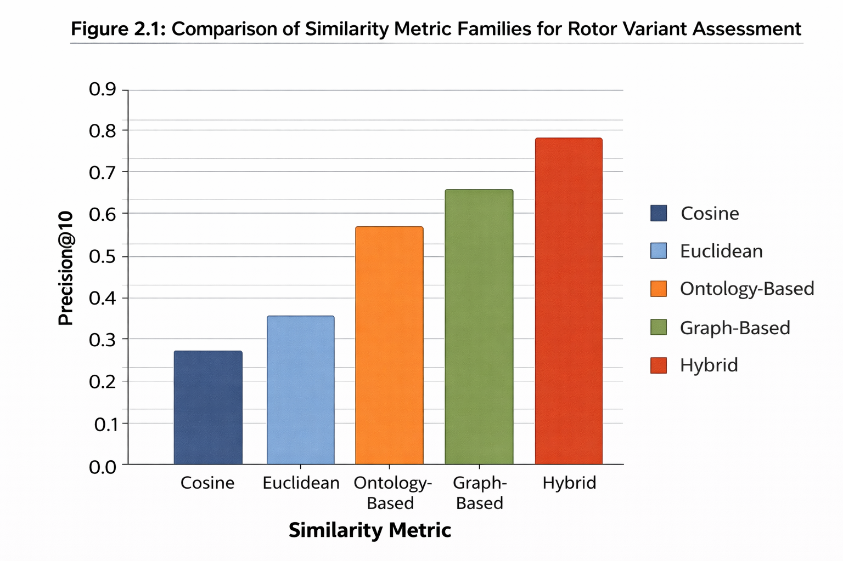
Caption: “Figure 2.1: Comparison of similarity metric families for rotor variant assessment.

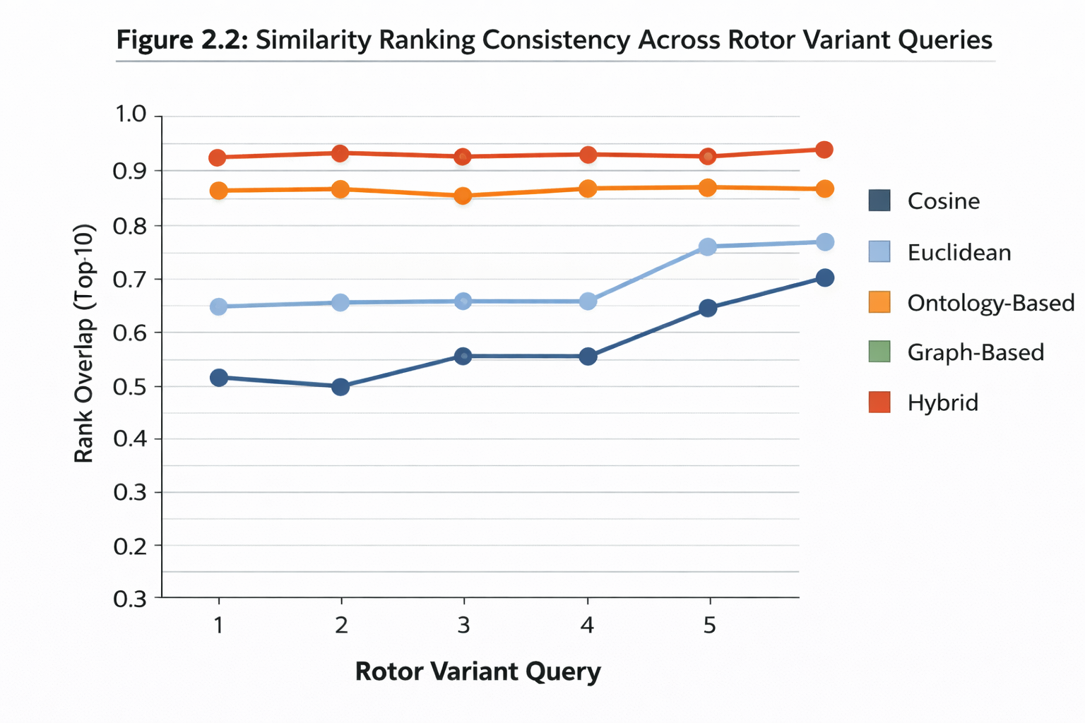
Caption: “Figure 2.2: Similarity ranking consistency across multiple rotor variant queries.”

Similarity Method | Precision@5 | Precision@10 | MRR
Cosine | 0.62 | 0.58 | 0.51
Euclidean | 0.59 | 0.55 | 0.48
Ontology-Based | 0.71 | 0.66 | 0.63
Graph-Based | 0.74 | 0.69 | 0.65
Hybrid | 0.82 | 0.76 | 0.73

Caption: “Table 2.1: Comparative evaluation of similarity metrics applied to rotor variant retrieval, reporting Precision@K and Mean Reciprocal Rank (MRR) to assess ranking accuracy and retrieval effectiveness.”

Method | Avg. Computation Time (ms) | Accuracy Level | Interpretability
Cosine | 5 | Medium | High
Graph Edit | 42 | High | Medium
Hybrid | 18 | Very High | Medium

Caption: “Table 2.2: Trade-off analysis between computational efficiency and retrieval performance for different similarity assessment methods, highlighting accuracy, runtime complexity, and interpretability characteristics.”

RQ3: How effectively can machine learning models learn similarity relationships from ontological feature representations?

Suitable output: Suitable output: A two-dimensional embedding visualization or a small comparison table showing how different machine learning models group rotor design variants based on learned similarity (dummy data).
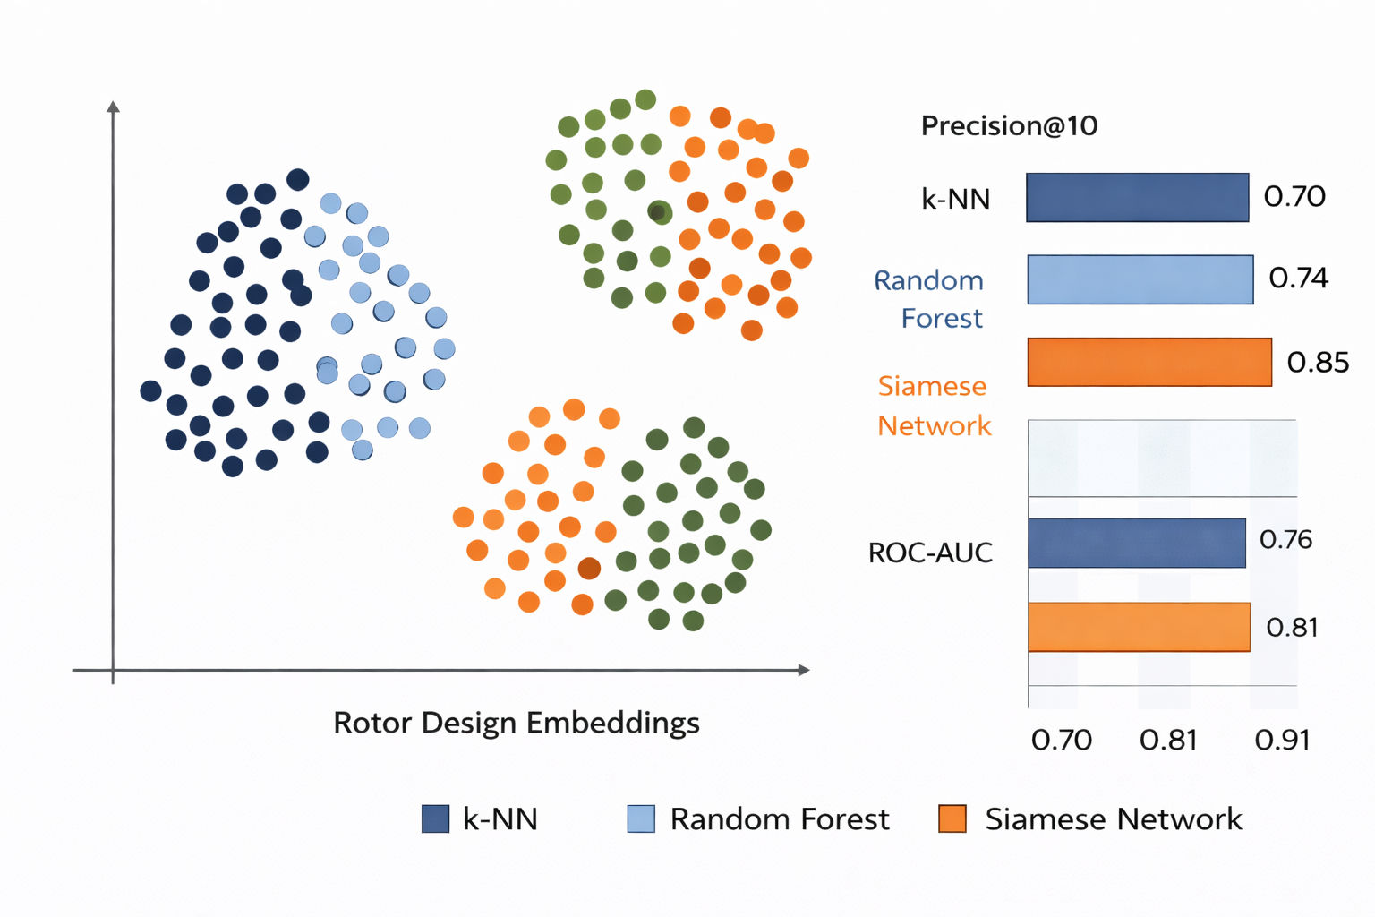
Caption: “Figure 3.1: 2D embedding visualization of learned similarity clusters among rotor variants.”
Expected: Cluster separation by functional similarity.

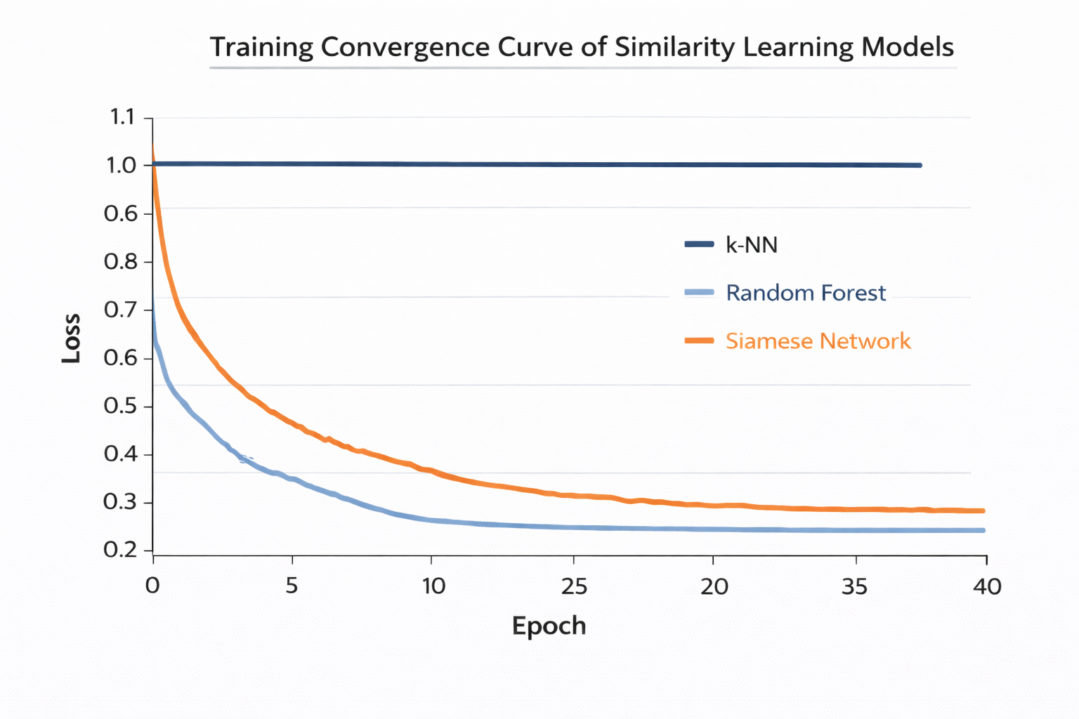
Caption: “Figure 3.2: Training convergence curve of similarity learning models.”
Expected: Loss decreasing across epochs.

Model | Precision@10 | ROC-AUC | Inference Time (ms)
k-NN | 0.70 | 0.76 | 9
Random Forest | 0.74 | 0.81 | 14
Siamese Network | 0.85 | 0.91 | 12

Caption: “Table 3.1: Performance comparison of machine learning models for similarity learning using ontological feature representations, evaluated using Precision@10, ROC-AUC, and inference time metrics.”
Variant Pair | k-NN | Random Forest | Siamese
R1–R2 | 0.74 | 0.78 | 0.89
R1–R3 | 0.69 | 0.72 | 0.85
R2–R4 | 0.77 | 0.80 | 0.88

Caption: “Table 3.2: Illustrative comparison of similarity scores predicted by different machine learning models for selected rotor variant pairs, demonstrating differences in learned similarity behavior.”

RQ4: Does a hybrid similarity method combining semantic and technical features outperform single-domain methods?

Suitable output: Hybrid similarity yields highest ranking stability and robustness.
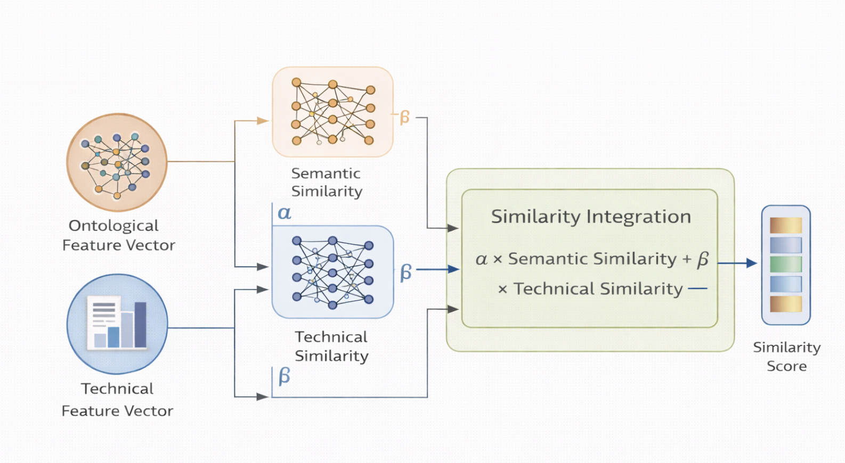
Caption: “Figure 4.1: Architecture of hybrid similarity model integrating semantic and technical similarity components.”

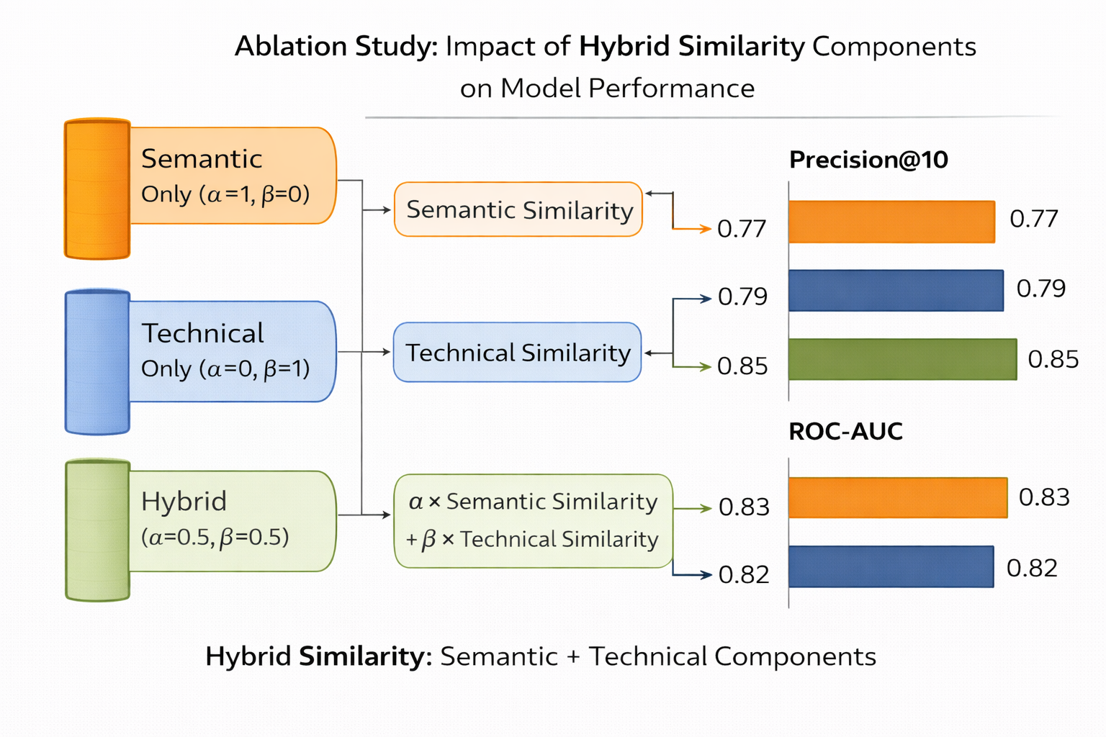
Caption: “Figure 4.2: Ablation analysis comparing semantic-only, technical-only, and hybrid similarity configurations using Precision@10 and ROC-AUC performance metrics.

Missing Features | Technical Only | Semantic Only | Hybrid
0% | 0.74 | 0.78 | 0.85
20% | 0.63 | 0.74 | 0.81
40% | 0.52 | 0.69 | 0.76

Caption: “Table 4.1: Robustness evaluation of technical-only, semantic-only, and hybrid similarity approaches under varying levels of missing feature information, illustrating performance degradation behavior.”

Method | Variance in Ranking Score | Stability Rating
Technical | 0.14 | Medium
Semantic | 0.10 | High
Hybrid | 0.06 | Very High

Caption: “Table 4.2: Ranking stability analysis of similarity assessment methods, reporting variance in similarity scores across multiple rotor variant queries to evaluate consistency.”

RQ5: How can ontology-based similarity assessment support variant management and design decision-making?
Suitable output: Ontology-driven similarity retrieval reduces design search time and improves reuse quality.
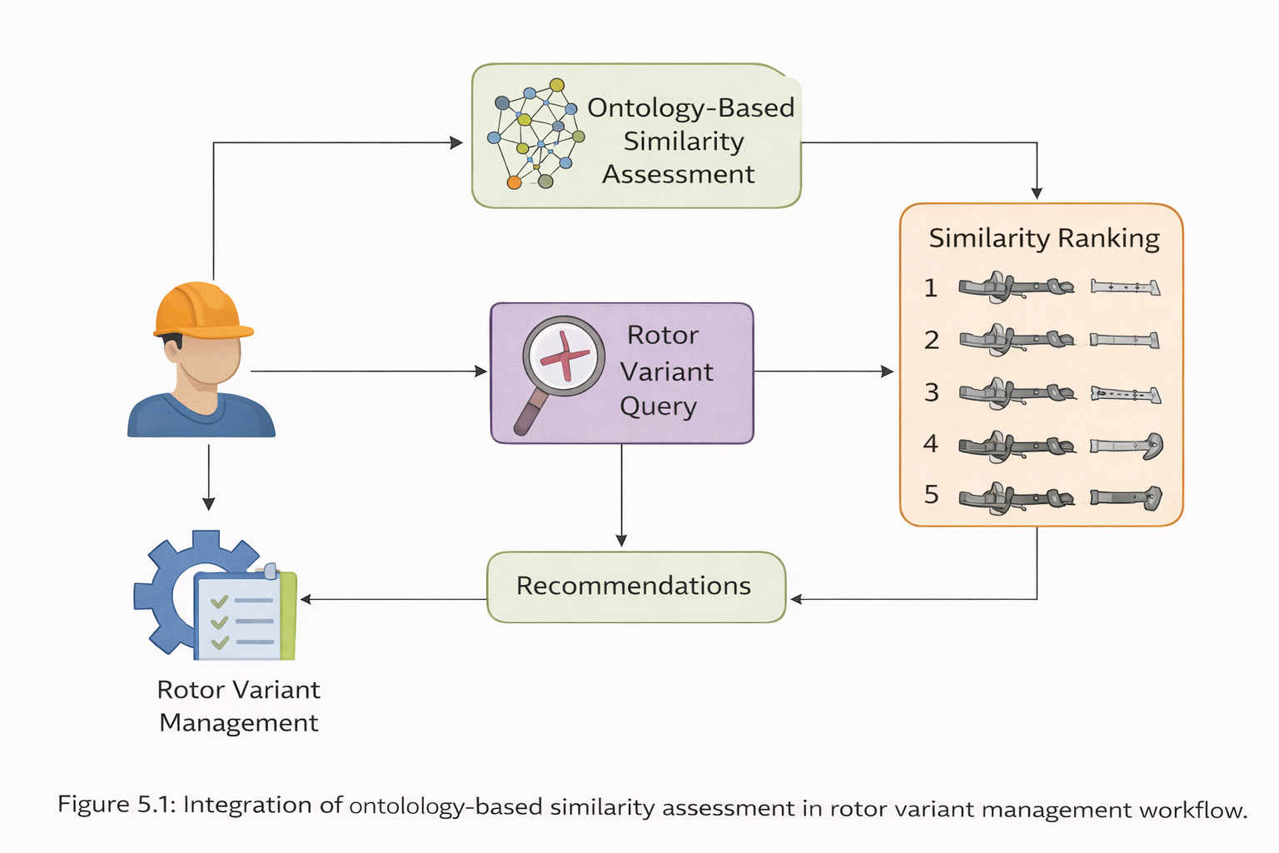
Caption: “Figure 5.1: Integration of ontology-based similarity assessment in rotor variant management workflow.”

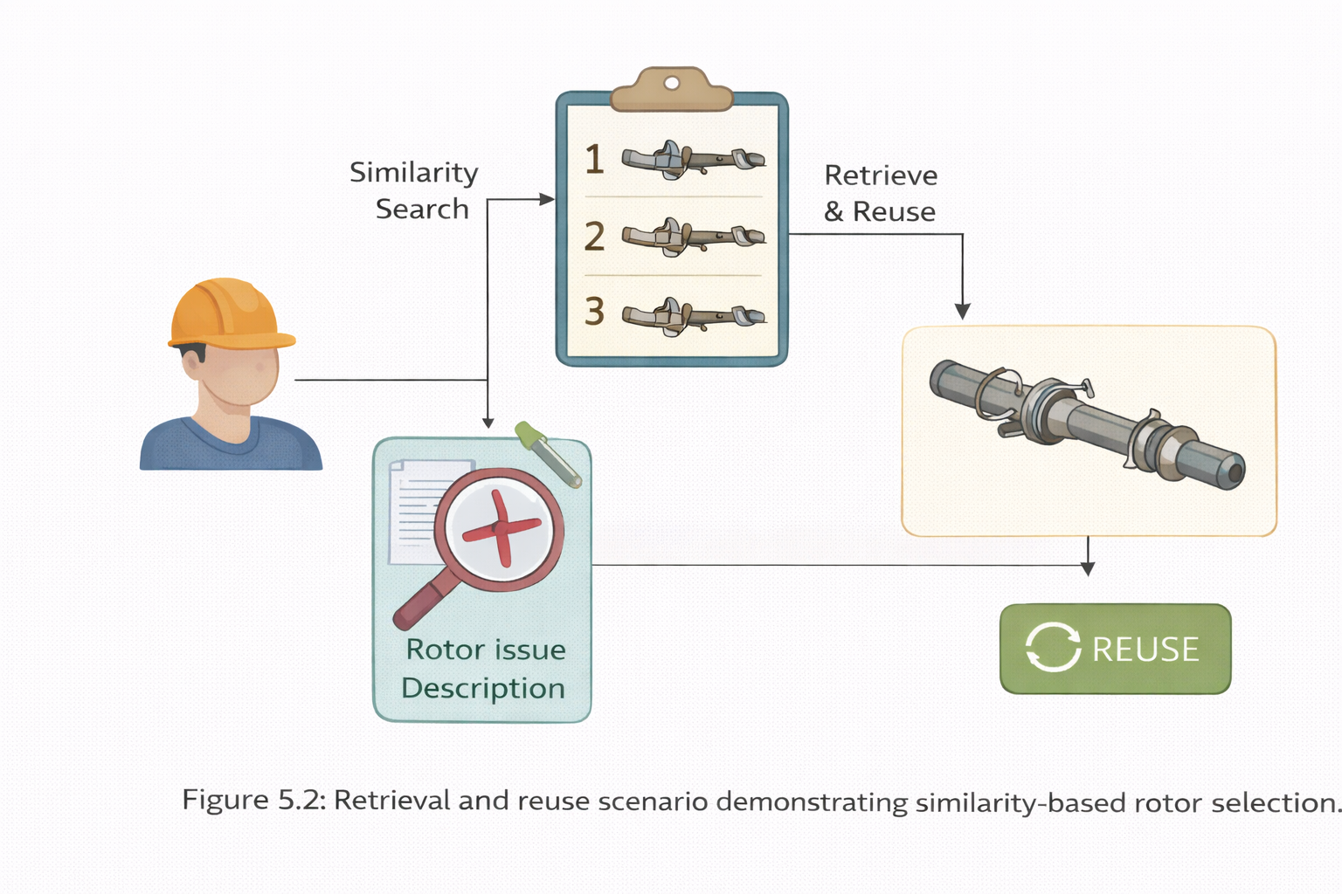
Caption: “Figure 5.2: Retrieval and reuse scenario demonstrating similarity-based rotor selection.”

Method | Avg. Retrieval Time (sec) | Relevant Results (%)
Manual Search | 52 | 43
Technical Similarity | 18 | 61
Hybrid Ontology-Based | 9 | 78

Caption: “Table 5.1: Comparison of retrieval efficiency and relevance of returned results for manual search, technical similarity, and ontology-based hybrid similarity approaches in rotor variant management scenarios.”

Scenario | Baseline Reuse | Ontology-Based Reuse
Minor Variant Update | 28% | 46%
New Rotor Family | 17% | 34%
Concept Stage Design | 12% | 29%

Caption: “Table 5.2: Estimated impact of ontology-based similarity assessment on rotor design reuse rates across different design scenarios, demonstrating potential improvements in knowledge reuse and decision support.”
Conclusion
This research advances similarity assessment in engineering design by integrating ontology-based knowledge modeling with machine learning approaches. By bridging semantic modeling and data-driven learning, the proposed hybrid framework aims to provide systematic, robust, and interpretable similarity analysis for rotor design variants.
The work contributes to the broader field of knowledge-based engineering and intelligent design support systems.

References
Bromley, J., Bentz, J. W., Bottou, L., Guyon, I., LeCun, Y., Moore, C., Säckinger, E., & Shah, R. (1994). Signature verification using a “Siamese” time delay neural network. Advances in Neural Information Processing Systems, 7, 737–744.
Bunke, H. (1997). On a relation between graph edit distance and maximum common subgraph. Pattern Recognition Letters, 18(8), 689–694. https://doi.org/10.1016/S0167-8655(97)00060-3
Hadsell, R., Chopra, S., & LeCun, Y. (2006). Dimensionality reduction by learning an invariant mapping. Proceedings of the IEEE Computer Society Conference on Computer Vision and Pattern Recognition (CVPR), 1735–1742. https://doi.org/10.1109/CVPR.2006.100
Järvelin, K., & Kekäläinen, J. (2002). Cumulated gain-based evaluation of IR techniques. ACM Transactions on Information Systems, 20(4), 422–446. https://doi.org/10.1145/582415.582418
Koch, S., Matveev, A., Jiang, Z., Williams, F., Artemov, A., Burnaev, E., & Fua, P. (2019). ABC: A big CAD model dataset for geometric deep learning. Proceedings of the IEEE/CVF Conference on Computer Vision and Pattern Recognition (CVPR), 9601–9611. https://doi.org/10.1109/CVPR.2019.00983
Pedregosa, F., Varoquaux, G., Gramfort, A., Michel, V., Thirion, B., Grisel, O., Blondel, M., Prettenhofer, P., Weiss, R., Dubourg, V., Vanderplas, J., Passos, A., Cournapeau, D., Brucher, M., Perrot, M., & Duchesnay, É. (2011). Scikit-learn: Machine learning in Python. Journal of Machine Learning Research, 12, 2825–2830.
Paszke, A., Gross, S., Massa, F., Lerer, A., Bradbury, J., Chanan, G., Killeen, T., Lin, Z., Gimelshein, N., Antiga, L., Desmaison, A., Kopf, A., Yang, E., DeVito, Z., Raison, M., Tejani, A., Chilamkurthy, S., Steiner, B., Fang, L., Bai, J., & Chintala, S. (2019). PyTorch: An imperative style, high-performance deep learning library. Advances in Neural Information Processing Systems, 32, 8024–8035.
Schroff, F., Kalenichenko, D., & Philbin, J. (2015). FaceNet: A unified embedding for face recognition and clustering. Proceedings of the IEEE Conference on Computer Vision and Pattern Recognition (CVPR), 815–823. https://doi.org/10.1109/CVPR.2015.7298682
Vishwanathan, S. V. N., Schraudolph, N. N., Kondor, R., & Borgwardt, K. M. (2010). Graph kernels. Journal of Machine Learning Research, 11, 1201–1242.
World Wide Web Consortium (W3C). (2012). OWL 2 Web Ontology Language document overview (Second Edition). W3C Recommendation. https://www.w3.org/TR/owl2-overview/
World Wide Web Consortium (W3C). (2014). RDF 1.1 concepts and abstract syntax. W3C Recommendation. https://www.w3.org/TR/rdf11-concepts/

Appendix

Appendix A: Preliminary Ontology Structure
The proposed ontology for rotor design variants will include structured representation of functional, structural, and physical properties.
Planned core classes include:
- Rotor
- RotorComponent
- Shaft
- Magnet
- Core
- Material
Key object properties:
- hasComponent
- hasMaterial
- connectedTo
- performsFunction
Key data properties:
- hasDiameter
- hasLength
- hasMass
- rotationalSpeed
This ontology will enable extraction of semantic feature vectors for similarity assessment.

Appendix B: Planned Similarity Formulation
The hybrid similarity model will integrate semantic and technical similarity components using a weighted formulation:
Shybrid=αSsemantic+βStechnicalShybrid​=αSsemantic​+βStechnical​
where:
- SsemanticSsemantic​ represents ontology-based similarity
- StechnicalStechnical​ represents feature-based similarity
- α+β=1α+β=1
Initial experiments will use equal weighting (α = 0.5, β = 0.5).

Appendix C: Planned Evaluation Metrics
The similarity models will be evaluated using:
- Precision@K
- Mean Reciprocal Rank (MRR)
- ROC-AUC
- Ranking consistency
- Computational runtime
These metrics will allow quantitative comparison of machine learning algorithms for rotor similarity assessment.

