INTELLIGENT DEMENTIA DETECTION USING CLINICAL INFORMATION AND MACHINE LEARNING

Aswini G
Student
Department of AIML Rajalakshmi Engineering College 231501028@rajalakshmi.edu.in
Sai Senthil M Student
Department of AIML Rajalakshmi Engineering College 231501140@rajalakshmi.edu.in
Vijay M
Student
Department of AIML Rajalakshmi Engineering College 231501182@rajalakshmi.edu.in

Dr. J. Jasmine Gabriel
Professor
Department of AIML
Rajalakshmi Engineering College
.@rajalakshmi.edu.in

Abstract—Dementia is a progressive neurological condition that can affect cognitive and functional abilities, making early identification an important clinical objective. Machine learning techniques can assist in dementia prediction by learning patterns from structured clinical information. However, the performance of machine learning models depends strongly on the selection of suitable hyperparameters, and the resulting predictions may be difficult to interpret without appropriate explainability techniques.This paper presents an intelligent dementia detection framework using structured clinical information and a Light Gradient Boosting Machine (LightGBM) classifier. The proposed approach performs data preprocessing, feature preparation, binary target transformation, and train-test data preparation before model development. A baseline LightGBM model is first established, followed by Particle Swarm Optimization (PSO) for hyperparameter optimization. The optimized model is evaluated using Accuracy, F1-Score, and Receiver Operating Characteristic–Area Under the Curve (ROC-AUC), together with confusion matrix and ROC curve analysis. Feature importance and SHapley Additive exPlanations (SHAP) are incorporated to improve the interpretability of the model predictions.On the evaluated test data, the baseline LightGBM model achieved an accuracy of 86.67%, an F1-Score of 0.8529, and a ROC-AUC of 0.9455. After PSO-based hyperparameter optimization, the LightGBM model achieved an accuracy of 88.00%, an F1-Score of 0.8615, and a ROC-AUC of 0.9491. The results demonstrate an improvement in the reported evaluation measures after PSO optimization while maintaining an interpretable machine learning workflow for clinical dementia classification.
Keywords— Dementia detection, clinical data, machine learning, LightGBM, Particle Swarm Optimization, hyperparameter optimization, explainable artificial intelligence, SHAP, ROC-AUC.
I. INTRODUCTION
Dementia is a progressive condition associated with decline in cognitive abilities and can affect memory, reasoning, and everyday functioning. Identification of dementia commonly involves clinical assessment and cognitive information, making structured clinical data a useful source for developing computational prediction approaches. Machine learning provides a means of analysing multiple clinical variables simultaneously and identifying patterns associated with dementia status.Clinical datasets can contain demographic, cognitive, and other structured measurements that can be processed using conventional machine learning algorithms. Compared with approaches that directly process medical images, speech, or other unstructured information, tabular clinical modelling provides a comparatively straightforward framework for experimentation and prediction. However, the effectiveness of a machine learning model depends not only on the selected algorithm but also on the configuration of its hyperparameters.Light Gradient Boosting Machine (LightGBM) is a gradient boosting framework designed for efficient tree-based learning. Its performance is influenced by parameters controlling aspects such as tree complexity, learning behaviour, and the number of boosting iterations. Selecting suitable hyperparameter values manually can therefore be difficult, particularly when several parameters interact with one another.Hyperparameter optimization provides a systematic way to search for improved model configurations. In this work, Particle Swarm Optimization (PSO) is used to optimize the LightGBM model. PSO represents candidate parameter configurations as particles that explore the search space iteratively. The optimized configuration is then used to construct the final LightGBM model for dementia classification.Another important consideration in clinical machine learning is model interpretability. A prediction alone does not explain why a particular classification was produced. SHapley Additive exPlanations (SHAP) can be used to examine the contribution of individual input features to model predictions and thereby provide an interpretable view of the trained model.This paper presents a machine learning framework for binary dementia detection using structured clinical information. The target variable is represented by two classes: Nondemented (0) and Demented (1). The methodology includes clinical data preprocessing, feature preparation, target transformation, train-test data preparation, baseline LightGBM training, PSO-based hyperparameter optimization, model evaluation, and SHAP-based explainability.
The experimental results show that the baseline LightGBM model achieved an accuracy of 86.67%, an F1-Score of 0.8529, and a ROC-AUC of 0.9455. After PSO-based hyperparameter optimization, the model achieved an accuracy of 88.00%, an F1-Score of 0.8615, and a ROC-AUC of 0.9491 on the evaluated test data. These results provide the basis for analysing the effect of PSO optimization on LightGBM-based dementia classification.
The main contributions of this work are:
- Development of a structured clinical-data framework for binary dementia classification.
- Implementation of LightGBM as the primary classification model for dementia prediction.
- Application of Particle Swarm Optimization for LightGBM hyperparameter optimization.
- Quantitative evaluation of the baseline and PSO-optimized models using Accuracy, F1-Score, and ROC-AUC, supported by confusion matrix and ROC curve analysis.
- Integration of feature importance and SHAP analysis to improve the interpretability of the model predictions.
- Development of an end-to-end workflow that combines prediction, optimization, evaluation, and explainability within a single clinical machine learning framework.
II. RELATED WORK
Kumar et al. [1] presented a systematic literature review of machine learning approaches for modelling the progression of Alzheimer’s disease using clinical data. Their review showed the increasing use of machine learning with clinical and electronic health record data for dementia-related prediction tasks. The study also highlighted the importance of reproducibility, appropriate validation, and availability of clinical datasets when developing reliable prediction models. These findings demonstrate the potential of structured clinical information for dementia prediction while also emphasizing the need for robust evaluation procedures [1].Dhakal et al. [2] investigated dementia prediction using machine learning techniques on the OASIS dataset. Several conventional machine learning algorithms, including Support Vector Machine, Random Forest, Decision Tree, Gradient Boosting, K-Nearest Neighbors, Logistic Regression, Naive Bayes, and Extra Trees, were evaluated. LASSO-based feature selection was also investigated to identify relevant predictors. The study demonstrated that machine learning models can effectively identify dementia-related patterns from structured clinical information [2].A comparative study of machine learning algorithms for Alzheimer’s disease prediction using OASIS data examined clinical and demographic attributes such as age, education, socioeconomic status, MMSE score, estimated total intracranial volume, and normalized whole-brain volume. The study compared multiple machine learning approaches and demonstrated that structured clinical and neuropsychological variables can provide useful information for distinguishing individuals with different cognitive conditions [3].Govindarajan et al. [4] developed an explainable machine learning framework for Alzheimer’s disease prediction using clinical and behavioural features. Multiple machine learning models were compared, and SHAP was used to identify the contribution of individual features to model predictions. The study demonstrated that explainability techniques can improve the interpretation of machine learning models by showing which clinical variables have greater influence on the prediction outcome [4].Lu et al. [5] conducted a systematic review of electronic health record-based prediction models for dementia detection. The review analysed a large body of published prediction models and identified challenges related to outcome definitions, missing data, model validation, calibration, and risk of bias. The study emphasized that reliable dementia prediction requires not only good predictive performance but also appropriate methodology and external validation [5].Recent research has also highlighted the importance of preventing information leakage when developing dementia prediction models. Ghiasi et al. [6] investigated longitudinal dementia prediction using OASIS-2 data and demonstrated that inappropriate use of label-related information and subject-level data splitting can lead to overly optimistic performance estimates. Their work emphasizes the importance of leakage-free preprocessing and evaluation when developing machine learning models for clinical prediction [6].Although previous studies have demonstrated the effectiveness of different machine learning algorithms for dementia prediction, several works focus primarily on model comparison or clinical feature analysis. Explainability is also not consistently incorporated into the complete prediction workflow. Therefore, the present work focuses on an end-to-end framework using structured clinical information for binary dementia classification. A LightGBM model is developed as the baseline classifier, and Particle Swarm Optimization (PSO) is applied specifically for hyperparameter optimization. Model performance is evaluated using Accuracy, F1-Score, and ROC-AUC, while confusion matrices and ROC curves provide additional evaluation. Feature importance and SHAP analysis are incorporated to improve the interpretability of the optimized model [1]–[6].
.

TABLE I. Comparative Analysis of Related Work on Lateral-Movement Detection
Author & Year | Method | Data | Contribution | Limitation
Kumar et al. (2021) [1] | Machine learning approaches | Clinical / EHR data | Systematic review of ML methods for Alzheimer’s disease progression | Variation in datasets and validation methods
Dhakal et al. (2023) [2] | SVM, RF, DT, GB, KNN, LR, NB, Extra Trees + LASSO | OASIS | Comparative evaluation of multiple ML algorithms for dementia prediction | Performance depends on dataset and feature configuration
Comparative ML Study (2021) [3] | Multiple machine learning algorithms | OASIS | Evaluated clinical and demographic predictors for Alzheimer’s disease | Limited dataset and study-specific evaluation
Govindarajan et al. (2025) [4] | ML models + SHAP | Clinical and behavioural data | Developed an explainable ML framework for Alzheimer’s prediction | Model performance depends on available clinical features
Lu et al. (2026) [5] | Prediction models | Structured EHR data | Systematic review of dementia prediction models and methodological quality | Identified concerns regarding validation, calibration, and bias
Ghiasi et al. (2026) [6] | Explainable ML | OASIS-2 longitudinal data | Demonstrated the importance of leakage-free dementia prediction | Focused on longitudinal prediction rather than a simple binary clinical classification
This Work | LightGBM + PSO + SHAP | Structured clinical data | Binary dementia classification with PSO optimization and explainable prediction | Evaluation is based on the available study dataset

III. PROBLEM FORMULATION AND OBJECTIVES

A. Problem Statement
Dementia prediction using structured clinical information is a challenging classification problem because cognitive status can be influenced by multiple demographic, clinical, and neuropsychological factors. Traditional assessment may require the combined interpretation of several clinical measurements, making automated analysis useful as a supporting research approach. Machine learning can identify relationships among these variables and classify individuals according to their dementia status.In this work, the problem is formulated as a binary classification task, where each subject is assigned to either the Nondemented (0) or Demented (1) class. Let the input clinical feature vector be represented as:[X=[x_1,x_2,\ldots,x_n]]where (x_i) represents an individual clinical or demographic feature. The corresponding target variable is represented as:[y\in{0,1}]The objective is to learn a classification function:[f(X)\rightarrowy]that can accurately distinguish between the two dementia-status classes.A LightGBM classifier is initially developed as the baseline model. Since the predictive performance of LightGBM depends on its hyperparameter configuration, Particle Swarm Optimization (PSO) is employed to search for an improved set of model parameters. The optimized model is then evaluated using Accuracy, F1-Score, and ROC-AUC, together with confusion matrix and ROC-curve analysis. In addition, feature importance and SHAP-based explanations are used to understand the contribution of clinical features to the model predictions.
B. Research Objectives
The main objectives of the proposed dementia detection framework are:
- To preprocess structured clinical data and prepare it for binary dementia classification.
- To develop a LightGBM baseline model for distinguishing Nondemented and Demented subjects.
- To optimize the LightGBM hyperparameters using Particle Swarm Optimization (PSO) in order to improve classification performance.
- To evaluate the baseline and PSO-optimized models using Accuracy, F1-Score, and ROC-AUC.
- To analyze classification performance using confusion matrices and ROC curves.
- To identify influential clinical features using LightGBM feature importance analysis.
- To incorporate SHAP-based explainability to understand how individual features contribute to dementia predictions.
- To compare the baseline and PSO-optimized models and determine the effect of hyperparameter optimization on the overall prediction performance.
VII. SYSTEM ARCHITECTURE

A. Dataset

The proposed system uses structured clinical information for dementia classification. The dataset contains demographic and clinical attributes that provide information related to the cognitive and physical characteristics of the subjects. The data is used to formulate a binary classification problem consisting of two target classes: Nondemented (0) and Demented (1).The dataset is first examined for missing values, inconsistent entries, and unsuitable attributes. The target information is transformed into the required binary representation, and the resulting data is prepared for machine learning. Only structured tabular information is considered in the proposed framework, while image, audio, and other unstructured modalities are outside the scope of this work.

B. Data Preprocessing

Data preprocessing is performed to convert the raw clinical information into a suitable format for model training. The preprocessing stage includes data inspection, handling of missing values, encoding of categorical variables, selection of relevant attributes, and preparation of the target variable.Categorical information is converted into numerical representations where required, while numerical attributes are retained in an appropriate numerical format. The dementia-status target is transformed into two classes, Nondemented and Demented. The preprocessing stage is performed before model training to ensure that the LightGBM classifier receives consistent and usable input data.The processed dataset is subsequently divided into training and testing subsets. The training data is used for model development and PSO-based hyperparameter optimization, while the test data is reserved for final performance evaluation.

C. Feature Preparation
Feature preparation involves organizing the processed clinical variables into an input feature matrix suitable for LightGBM. The selected clinical and demographic attributes are represented as:[X=[x_1,x_2,\ldots,x_n]]where each (x_i) represents an input feature associated with a subject.The target vector is represented as:[Y=[y_1,y_2,\ldots,y_m]]where each target value belongs to either the Nondemented or Demented class. The prepared features are supplied to the baseline LightGBM model and subsequently to the PSO-optimized LightGBM model.

D. System Architecture

The overall architecture consists of sequential stages beginning with structured clinical data and ending with dementia prediction and model explanation. The raw dataset is first processed through the Data Preprocessing stage, followed by Feature Preparation and Target Transformation. The resulting data is divided into training and testing sets.A baseline LightGBM classifier is then trained to establish the initial prediction performance. Particle Swarm Optimization (PSO) is subsequently applied to search for an improved LightGBM hyperparameter configuration. The optimized parameters are used to construct the PSO-optimized LightGBM model.The trained model is evaluated using Accuracy, F1-Score, and ROC-AUC. Confusion matrix and ROC-curve analysis are also performed to provide a detailed assessment of classification behaviour. Finally, feature importance and SHAP analysis are applied to interpret the model and identify the contribution of individual clinical features.The complete workflow can be represented as:
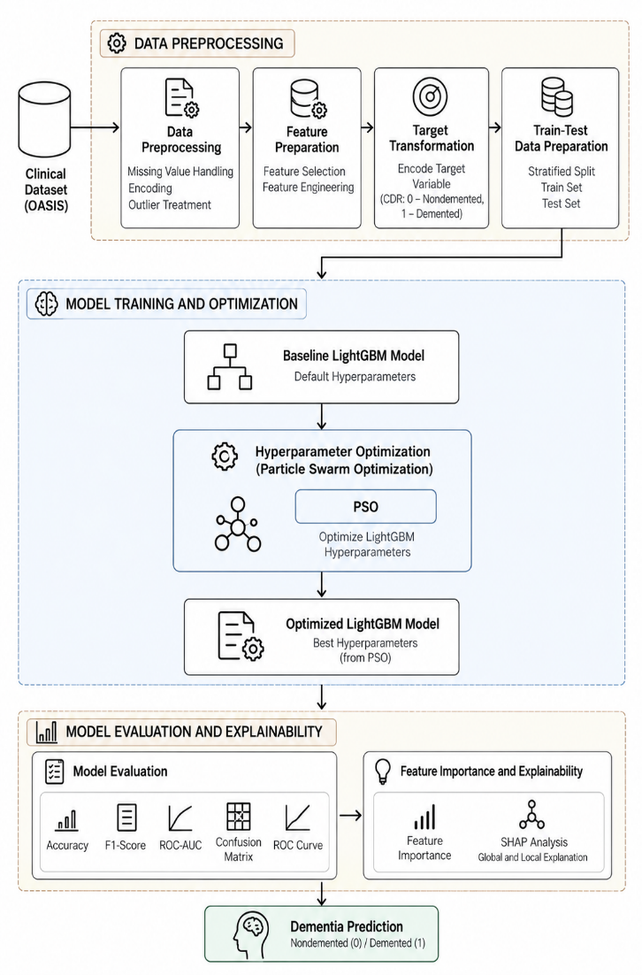

V. MODEL BUILDING

A. Baseline LightGBM

Light Gradient Boosting Machine (LightGBM) is used as the baseline classification model for dementia prediction. LightGBM is a gradient boosting framework that constructs an ensemble of decision trees sequentially, where each new tree attempts to reduce the errors produced by the existing ensemble.For an input feature vector (X), the prediction of the LightGBM model can be represented as:[\hat{y}=f(X)]where (f) represents the ensemble of decision trees and (\hat{y}) represents the predicted dementia class.The baseline LightGBM model is trained using the prepared training dataset without PSO-based hyperparameter optimization. Its performance provides a reference point for evaluating the effect of the proposed optimization stage. The baseline model is evaluated on the test dataset using Accuracy, F1-Score, and ROC-AUC.

B. Particle Swarm Optimization

Particle Swarm Optimization (PSO) is a population-based optimization technique inspired by the collective movement of groups such as birds and fish. In the proposed framework, PSO is used to identify a suitable hyperparameter configuration for the LightGBM classifier.Each particle represents one possible set of LightGBM hyperparameters. During optimization, particles move through the search space according to their individual best-known position and the best position identified by the complete swarm.The velocity of particle (i) at iteration (t) is updated as:
[v_i^{t+1}=wv_i^t+c_1r_1(p_i-x_i^t)+c_2r_2(g-x_i^t)]
where (v_i^t) is the current velocity, (w) is the inertia weight, (c_1) and (c_2) are acceleration coefficients, (r_1) and (r_2) are random values, (p_i) represents the particle's personal best position, (g) represents the global best position, and (x_i^t) represents the current particle position.The particle position is subsequently updated using:
[x_i^{t+1}=x_i^t+v_i^{t+1}]
For every candidate configuration, a LightGBM model is trained and evaluated using the selected fitness criterion. The optimization process continues until the specified stopping condition is reached, and the best-performing hyperparameter configuration is selected.

C. PSO-Optimized LightGBM

The optimized LightGBM model is constructed using the hyperparameter configuration identified by PSO. The optimization stage aims to improve the predictive performance of the baseline LightGBM model by systematically searching the predefined hyperparameter space.The overall optimization process consists of the following steps:
- Initialize a population of PSO particles.
- Assign a LightGBM hyperparameter configuration to each particle.
- Train a LightGBM model using the particle's configuration.
- Evaluate the model using the selected fitness criterion.
- Update the personal best and global best positions.
- Update particle velocities and positions.
- Repeat the optimization process until the stopping condition is reached.
- Select the best hyperparameter configuration.
- Train the final PSO-optimized LightGBM model using the selected configuration.
The optimized model is then evaluated on the held-out test data. This ensures that the final reported performance is obtained from data that was not used for selecting the optimized configuration.
D. Model Evaluation
The performance of both the baseline and PSO-optimized LightGBM models is evaluated using multiple classification metrics.Accuracy measures the proportion of correctly classified instances:
[Accuracy=\frac{TP+TN}{TP+TN+FP+FN}]
where (TP), (TN), (FP), and (FN) represent true positives, true negatives, false positives, and false negatives, respectively.
F1-Score combines precision and recall into a single metric:[F1=2\times\frac{Precision\timesRecall}{Precision+Recall}]
ROC-AUC measures the model's ability to distinguish between the two dementia-status classes across different classification thresholds. A higher ROC-AUC indicates better class discrimination.
In addition to numerical metrics, confusion matrices are used to analyse the distribution of correct and incorrect predictions, while ROC curves provide a graphical representation of the classification performance.

E. Explainable AI Using SHAP
To improve the interpretability of the prediction model, SHapley Additive exPlanations (SHAP) is applied to the trained LightGBM model. SHAP provides an explanation of model predictions by estimating the contribution of individual features to each prediction.For a prediction, the SHAP explanation can be represented as:[f(x)=\phi_0+\sum_{i=1}^{n}\phi_i]where (f(x)) represents the model output, (\phi_0) is the base value, and (\phi_i) represents the contribution of feature (i).SHAP analysis is used at both the global and individual levels. Global SHAP analysis identifies features that have a larger overall influence on model predictions, while individual explanations show how feature values contribute toward a particular prediction.Feature importance obtained from the LightGBM model is also analysed to identify influential clinical variables. Combining feature importance with SHAP provides a more interpretable view of the PSO-optimized dementia prediction model.

VI. RESULTS AND DISCUSSION

A. Experimental Setup

The proposed dementia detection framework was evaluated using structured clinical information and a binary classification setting. The experimental workflow consisted of data preprocessing, feature preparation, training of a baseline LightGBM classifier, Particle Swarm Optimization (PSO)-based hyperparameter optimization, and evaluation of the optimized model.The baseline LightGBM model was first trained to establish a reference performance. PSO was then applied to optimize the LightGBM hyperparameters, and the resulting model was evaluated using the same test data. Accuracy, F1-Score, and ROC-AUC were selected as the primary evaluation metrics. Confusion matrices and ROC curves were additionally used to analyse classification behaviour.

B. Dataset Analysis

Before model training, the clinical dataset was analysed to understand the distribution of the available subjects and features. Exploratory analysis was performed to examine the distribution of age, dementia classes, MMSE scores, and relationships among the numerical clinical variables.The analysis provides an overview of the characteristics of the study cohort and supports the subsequent machine learning modelling process. The dementia-status distribution was also examined to understand the representation of the two classes used for binary classification.
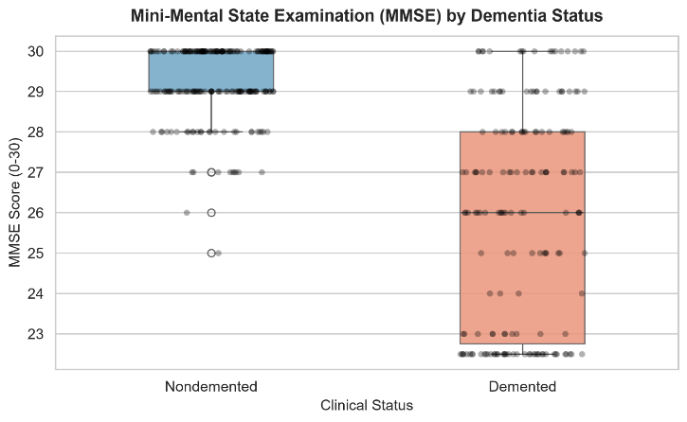

C. Baseline and PSO-Optimized Results

The baseline LightGBM model achieved an Accuracy of 86.67%, an F1-Score of 0.8529, and a ROC-AUC of 0.9455 on the test data.After applying Particle Swarm Optimizationfor LightGBM hyperparameter optimization, the PSO-optimized model achieved an Accuracy of 88.00%, an F1-Score of 0.8615, and a ROC-AUC of 0.9491.
TABLE II. PERFORMANCE COMPARISON OF BASELINE AND PSO-OPTIMIZED LIGHTGBM:
Model | Accuracy (%) | F1-Score | ROC-AUC
Baseline LightGBM | 86.67 | 0.8529 | 0.9455
PSO-Optimized LightGBM | 88.00 | 0.8615 | 0.9491
The results show an improvement in all three evaluated metrics after PSO-based hyperparameter optimization. Accuracy increased from 86.67% to 88.00%, while F1-Score increased from 0.8529 to 0.8615. ROC-AUC also increased from 0.9455 to 0.9491, indicating improved discrimination between the Nondemented and Demented classes on the evaluated test data.

D. Confusion Matrix Analysis

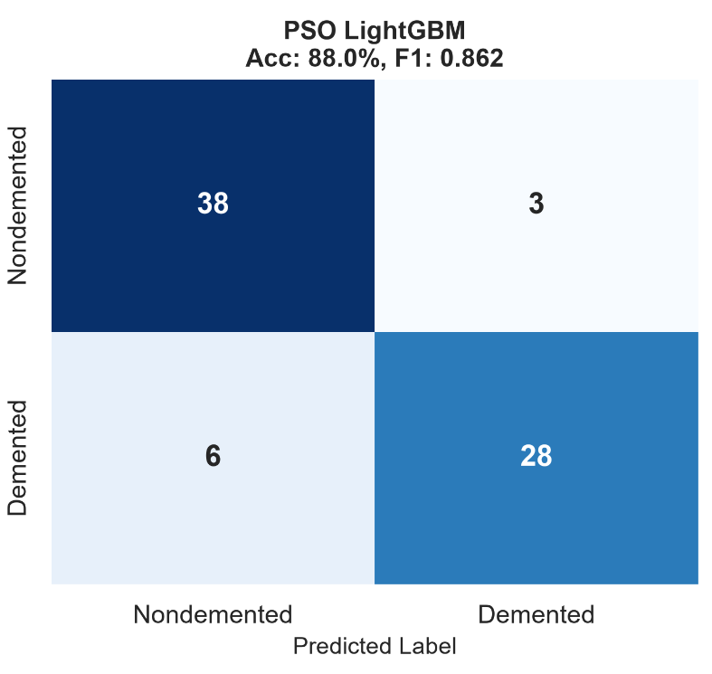
Confusion matrices are used to examine the classification outcomes of the baseline and PSO-optimized LightGBM models. The matrices represent the number of correctly and incorrectly classified subjects for the Nondemented and Demented classes.The comparison of the two confusion matrices provides an understanding of how the PSO optimization affects classification errors. Correct predictions are represented by the diagonal elements, while incorrect predictions are represented by the off-diagonal elements.The confusion matrix analysis complements the numerical performance metrics by showing the class-level prediction behaviour of the models.
Figure 6.1: Confusion Matrices of Baseline and PSO-Optimized LightGBM

E. ROC-AUC Analysis

Receiver Operating Characteristic (ROC) curves are used to analyse the ability of the models to distinguish between Nondemented and Demented subjects across different classification thresholds.The baseline LightGBM model obtained a ROC-AUC of 0.9455, while the PSO-optimized LightGBM model obtained a ROC-AUC of 0.9491. The increase in ROC-AUC indicates improved class discrimination for the optimized model on the test dataset.
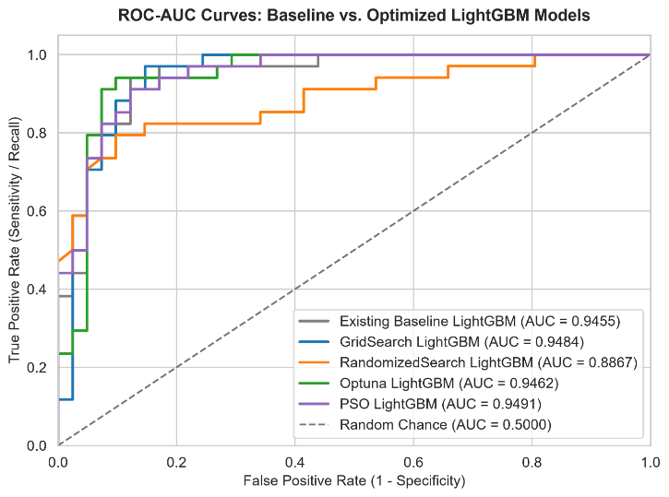
Figure 6.2: ROC Curves of Baseline and PSO-Optimized LightGBM
The ROC curves provide a threshold-independent view of the classification performance and support the numerical comparison between the baseline and optimized models.

F. Feature Importance Analysis
Feature importance analysis is performed using the trained LightGBM model to identify the clinical variables that contribute most strongly to the model's predictions. The importance values provide a global view of the relative contribution of the input features used by the model.
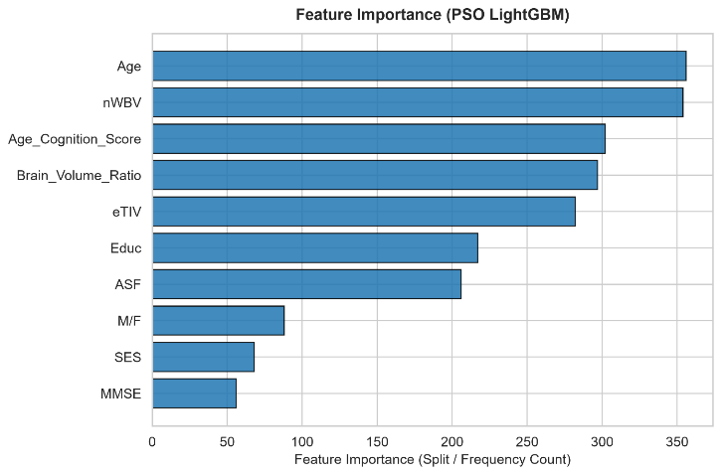
Figure 6.3: Feature Importance of PSO-Optimized LightGBM
The feature-importance analysis helps identify the variables that the trained model relies on most strongly when distinguishing between the two dementia-status classes. These results provide useful information for interpreting the behaviour of the machine learning model.

G. SHAP Analysis

SHAP is used to provide an additional explanation of the PSO-optimized LightGBM predictions. The SHAP summary plot represents both the importance and direction of feature contributions across the evaluated samples.
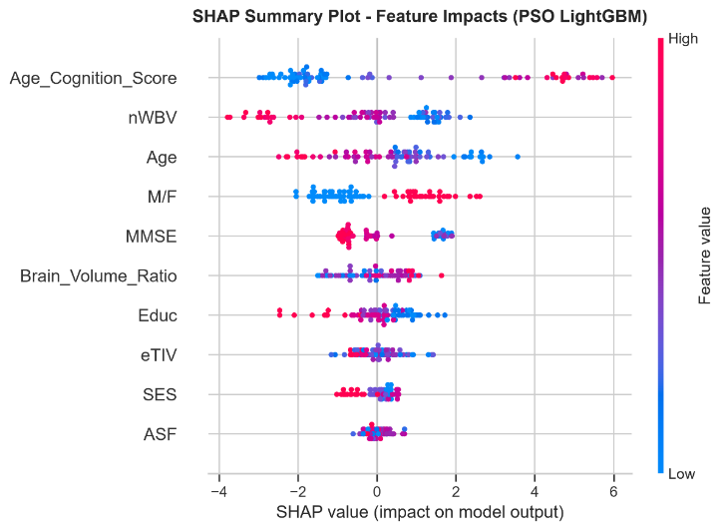
Figure 6.4: SHAP Summary Plot of PSO-Optimized LightGBM
Positive SHAP values indicate a contribution toward the model's positive prediction, while negative SHAP values indicate a contribution in the opposite direction. The magnitude of the SHAP value represents the strength of the feature's contribution to an individual prediction.SHAP analysis therefore provides a more detailed interpretation than conventional feature importance by showing how individual feature values influence model outputs.

H. Discussion

The experimental results demonstrate that PSO-based hyperparameter optimization improved the performance of the LightGBM classifier across all three primary evaluation metrics. Accuracy increased by 1.33 percentage points, from 86.67% to 88.00%. The F1-Score increased from 0.8529 to 0.8615, while ROC-AUC increased from 0.9455 to 0.9491.The improvement indicates that the selected PSO optimization process identified a LightGBM configuration that performed better than the baseline configuration on the evaluated test data. However, these results should be interpreted within the scope of the available dataset and experimental setup rather than being considered evidence of clinical diagnostic performance.The integration of feature importance and SHAP further improves the interpretability of the model. Instead of providing only a final class prediction, the framework provides information about the features influencing the model's decisions.

I. LimitationsThe proposed study has several limitations. First, the experiments are based on the available structured clinical dataset, which limits the generalizability of the findings to other populations and clinical settings. Second, the framework uses only structured tabular information and does not incorporate medical imaging, speech, or other unstructured clinical modalities.Third, the reported performance is based on the evaluated test set and therefore requires validation on independent external datasets before broader conclusions can be drawn. Finally, the proposed framework is intended as a machine learning research prototype and should not be interpreted as a standalone clinical diagnostic system.

CONCLUSION AND FUTURE WORK

Conclusion

This work presented an intelligent dementia detection framework based on structured clinical information and machine learning. The problem was formulated as a binary classification task for distinguishing between Nondemented and Demented subjects. A LightGBM classifier was initially developed as the baseline model, followed by Particle Swarm Optimization (PSO) for hyperparameter optimization.The experimental results demonstrated an improvement after PSO optimization. The baseline LightGBM model achieved an Accuracy of 86.67%, an F1-Score of 0.8529, and a ROC-AUC of 0.9455. The PSO-optimized LightGBM model achieved an Accuracy of 88.00%, an F1-Score of 0.8615, and a ROC-AUC of 0.9491. These results show that PSO-based hyperparameter optimization improved the evaluated performance of the LightGBM model.In addition to predictive performance, the proposed framework incorporates feature importance and SHAP-based explainability. These techniques provide information about the contribution of individual clinical features and improve the interpretability of the machine learning predictions. The combination of prediction, optimization, evaluation, and explainability provides an integrated framework for structured clinical dementia classification.However, the proposed system is a research prototype and should not be considered a standalone clinical diagnostic system. Further validation using larger and independent clinical datasets is required to establish the generalizability and reliability of the approach.

B. Future Work
Several directions can be explored to extend the proposed work. First, the model can be evaluated using larger and more diverse clinical datasets to improve the generalizability of the prediction framework.Second, additional clinical and cognitive variables can be incorporated to provide a more comprehensive representation of dementia-related characteristics. Future studies can also investigate the integration of multimodal information, including medical imaging, speech, and other clinical data sources.Third, more advanced explainability approaches can be investigated to provide both global and patient-specific explanations. External validation across different datasets and healthcare populations can also be performed to evaluate the robustness of the model.Future work can additionally explore deployment of the optimized model through a clinical decision-support interface for research and screening applications. Continuous model monitoring, calibration, and evaluation on newly collected data can further support reliable deployment.Finally, other optimization strategies and machine learning architectures can be investigated in future studies to determine whether further improvements can be obtained while maintaining model interpretability and computational efficiency.

REFERENCES
[1] S. Kumar, M. Wang, J. Z. Lee, and S. W. Kim, “Machine learning for modeling the progression of Alzheimer disease dementia using clinical data: A systematic literature review,” JAMIA Open, vol. 4, no. 3, 2021, doi: 10.1093/jamiaopen/ooab052.
[2] P. Dhakal, A. R. Al-Ali, and others, “Dementia prediction using machine learning,” Procedia Computer Science, vol. 219, pp. 1297–1308, 2023, doi: 10.1016/j.procs.2023.01.414.
[3] “A comparative analysis of machine learning algorithms to predict Alzheimer's disease,” BMC Medical Informatics and Decision Making, 2021.
[4] S. Govindarajan et al., “Development of an explainable machine learning model for Alzheimer’s disease prediction using clinical and behavioural features,” MethodsX, vol. 14, 2025, Art. no. 103491, doi: 10.1016/j.mex.2025.103491.
[5] L. Lu et al., “Electronic health record-based prediction models for dementia detection: A systematic review of model performance and quality,” Journal of the American Medical Informatics Association, 2026, doi: 10.1093/jamia/ocag048.
[6] M. Ghiasi et al., “Explainable machine learning for predicting longitudinal dementia status: Establishing a leakage-free benchmark,” PLOS Digital Health, 2026, doi: 10.1371/journal.pdig.0001409.
[7] G. Ke et al., “LightGBM: A highly efficient gradient boosting decision tree,” in Advances in Neural Information Processing Systems, vol. 30, 2017.
[8] J. Kennedy and R. Eberhart, “Particle swarm optimization,” in Proc. IEEE International Conference on Neural Networks, Perth, Australia, 1995, pp. 1942–1948.
[9] S. M. Lundberg and S.-I. Lee, “A unified approach to interpreting model predictions,” in Advances in Neural Information Processing Systems, vol. 30, 2017.
[10] G. V. et al., “OASIS: Cross-sectional and longitudinal studies of the aging brain,” Journal of Alzheimer's Disease, 2007.

.

