INTELLIGENT DEMENTIA DETECTION USING CLINICAL INFORMATION AND MACHINE LEARNING
AI23721 PROJECT PHASE-I REPORT

Submitted by

ASWINI G (2116231501028)
SAI SENTHIL M (2116231501140)
VIJAY M (2116231501182)

in partial fulfillment for the award of the degree of
BACHELOR OF TECHNOLOGY
in
ARTIFICIAL INTELLIGENCE AND MACHINE LEARNING

DEPARTMENT OF ARTIFICIAL INTELLIGENCE
AND MACHINE LEARNING
RAJALAKSHMI ENGINEERING COLLEGE
(AUTONOMOUS),
CHENNAI-602 105
OCTOBER 2026

RAJALAKSHMI ENGINEERING COLLEGE
(An Autonomous Institution Affiliated to Anna University, Chennai)

BONAFIDE CERTIFICATE
Dr. M. AYYADURAI, M.E., Ph.D.,  Associate Professor and Head  Department of Artificial Intelligence and  Machine Learning  Rajalakshmi Engineering College  Chennai- 602 105 | Dr. J. JASMINE GABRIEL [QUALIFICATIONS – CONFIRM]  [DESIGNATION – CONFIRM]  Department of Artificial Intelligence and  Machine Learning  Rajalakshmi Engineering College  Chennai- 602 105
Certified that this Phase –I Thesis titled “INTELLIGENT DEMENTIA DETECTION USING CLINICAL INFORMATION AND MACHINE LEARNING” is the Bonafide work of ASWINI G (2116231501028), SAI SENTHIL M (2116231501140), VIJAY M (2116231501182) who carried out the work under my supervision. Certified further that to the best of my knowledge the work reported here in does not form part of any other thesis or dissertation on the basis of which a degree or award was conferred on an earlier occasion on this or any other candidate.

INTERNAL EXAMINER | EXTERNAL EXAMINER

ACKNOWLEDGEMENT

First, we thank the almighty God for the successful completion of the project. Our sincere thanks to our chairman Mr. S.Meganathan, B.E., F.I.E., for his sincere endeavor in educating us in his premier institution. We would like to express our deep gratitude to our beloved Chairperson Dr.(Mrs.)Thangam Meganathan,M.A., M.Phil., Ph.D., for her enthusiastic motivation which inspired us a lot in completing this project, and Vice-Chairman Mr. Abhay Shankar Meganathan, B.E., M.S., for providing us with the requisite infrastructure.
We also express our sincere gratitude to our college principal, Dr.S.N.Murugesan, M.E., PhD., for his kind support and facilities to complete our work on time. We extend heartfelt gratitude to Dr. M.Ayyadurai, M.E., Ph.D., Associate Professor and Head of the Department of Artificial Intelligence and Machine Learning for his guidance and encouragement throughout the work. We want to convey our sincere and deepest gratitude to our guide, Dr. J. Jasmine Gabriel, [DESIGNATION – CONFIRM], Department of Artificial Intelligence and Machine Learning, Rajalakshmi Engineering College, for her valuable guidance throughout the course of the project. We are very glad to thank our project coordinator [Dr Sekar AND DESIGNATION – CONFIRM] for guidance throughout the project work. We extend our sincere thanks to our parents, friends, all faculty members, and supporting staff for their direct and indirect involvement in the successful completion of the project for their encouragement and support.
Aswini G 231501028
Sai Senthil M 231501140
Vijay M 231501182

DEPARTMENT VISION
To promote highly Ethical and Innovative Computer Professionals through excellence in teaching, training and research.

DEPARTMENT MISSION
• To produce globally competent professionals, motivated to learn the emerging technologies and to be innovative in solving real world problems.
• To promote research activities amongst the students and the members of faculty that could benefit the society.
• To impart moral and ethical values in their profession.

PROGRAMME EDUCATIONAL OBJECTIVES (PEOs)
PEO 1: To equip students with essential background in computer science, basic electronics and applied mathematics.
PEO 2: To prepare students with fundamental knowledge in programming languages, and tools and enable them to develop applications.
PEO 3: To encourage the research abilities and innovative project development in the field of AI, ML, DL, networking, security, web development, Data Science and also emerging technologies for the cause of social benefit.
PEO 4: To develop professionally ethical individuals enhanced with analytical skills, communication skills and organizing ability to meet industry requirements.

PROGRAM OUTCOMES (POs)
PO1: Engineering knowledge: Apply the knowledge of Mathematics, Science, Engineering fundamentals, and an engineering specialization to the solution of complex engineering problems.
PO2: Problem analysis: Identify, formulate, review research literature, and analyze complex engineering problems reaching substantiated conclusions using first principles of mathematics, natural sciences, and engineering sciences.
PO3: Design/development of solutions: Design solutions for complex engineering problems and design system components or processes that meet the specified needs with appropriate consideration for the public health and safety, and the cultural, societal, and environmental considerations.
PO 4: Conduct investigations of complex problems: Use research-based knowledge and research methods including design of experiments, analysis and interpretation of data, and synthesis of the information to provide valid conclusions.
PO 5: Modern tool usage: Create, select, and apply appropriate techniques, resources, and modern engineering and IT tools including prediction and modeling to complex engineering activities with an understanding of the limitations.
PO 6: The engineer and society: Apply reasoning informed by the contextual knowledge to assess societal, health, safety, legal and cultural issues and the consequent responsibilities relevant to the professional engineering practice.
PO 7: Environment and sustainability: Understand the impact of the professional engineering solutions in societal and environmental contexts, and demonstrate the knowledge of, and need for sustainable development.
PO 8: Ethics: Apply ethical principles and commit to professional ethics and responsibilities and norms of the engineering practice.
PO 9: Individual and team work: Function effectively as an individual, and as a member or leader in diverse teams, and in multidisciplinary settings.
PO 10: Communication: Communicate effectively on complex engineering activities with the engineering community and with society at large, such as, being able to comprehend and write effective reports and design documentation, make effective presentations, and give and receive clear instructions.
PO11: Project management and finance: Demonstrate knowledge and understanding of the engineering and management principles and apply these to one’s own work, as a member and leader in a team, to manage projects and in multidisciplinary environments.
PO12: Life-long learning: Recognize the need for, and have the preparation and ability to engage in independent and life-long learning in the broadest context of technological change.

PROGRAM SPECIFIC OUTCOMES (PSOs)
A graduate of the Artificial Intelligence and Machine Learning Program will demonstrate
PSO 1: Foundation Skills: Ability to understand, analyze and develop computer programs in the areas related to algorithms, system software, web design, AI, machine learning, deep learning, data science, and networking for efficient design of computer-based systems of varying complexity. Familiarity and practical competence with a broad range of programming language, tools and open source platforms.
PSO 2: Problem-Solving Skills: Ability to apply mathematical methodologies to solve computational task, model real world problem using appropriate AI and ML algorithms. To understand the standard practices and strategies in project development, using open-ended programming environments to deliver a quality product.
PSO 3: Successful Progression: Ability to apply knowledge in various domains to identify research gaps and to provide solution to new ideas, inculcate passion towards higher studies, creating innovative career paths to be an entrepreneur and evolve as an ethically social responsible AI and ML professional.

COURSE OBJECTIVE
• To identify and formulate real-world problems that can be solved using Artificial Intelligence and Machine Learning techniques.
• To apply theoretical and practical knowledge of AI/ML for designing innovative, data-driven solutions.
• To integrate various tools, frameworks, and algorithms to develop, test, and validate AI/ML models.
• To demonstrate effective teamwork, project management, and communication skills through collaborative project execution.
• To instill awareness of ethical, societal, and environmental considerations in the design and deployment of intelligent systems.

COURSE OUTCOME
CO1: Analyze and define a real-world problem by identifying key challenges, project requirements and constraints.
CO2: Conduct a thorough literature review to evaluate existing solutions, identify research gaps and formulate research questions.
CO3: Develop a detailed project plan by defining objectives, setting timelines, and identifying key deliverables to guide the implementation process.
CO4: Design and implement a prototype or initial model based on the proposed solution framework using appropriate AI tools and technologies.
CO5: Demonstrate teamwork, communication, and project management skills by preparing and presenting a well-structured project proposal and initial implementation results.
CO-PO-PSO Mapping
CO | PO1 | PO2 | PO3 | PO4 | PO5 | PO6 | PO7 | PO8 | PO9 | PO10 | PO11 | PO12 | PSO1 | PSO2 | PSO3
CO1 | 3 | 3 | 2 | 2 | 1 | 3 | 1 | 2 | 1 | 2 | 1 | 2 | 2 | 3 | 2
CO2 | 2 | 3 | 1 | 3 | 1 | 1 | - | 2 | 1 | 2 | - | 3 | 1 | 2 | 3
CO3 | 2 | 2 | 3 | 3 | 2 | 2 | 1 | 2 | 2 | 2 | 3 | 2 | 2 | 3 | 2
CO4 | 3 | 2 | 3 | 3 | 3 | 2 | 1 | 2 | 2 | 2 | 2 | 2 | 3 | 3 | 2
CO5 | 1 | 1 | 1 | 2 | 2 | 1 | - | 2 | 3 | 3 | 3 | 2 | 1 | 1 | 2
Note: Correlation levels 1, 2 or 3 are as defined below:
1: Slight (Low) 2: Moderate (Medium) 3: Substantial (High) No correlation: “-”

Shaded cells (CO2 and CO5 rows; PO7, PO9 and PO11 columns) rest on limited or indirect evidence in the current report and must be confirmed by the Project Guide before submission; remove the shading after confirmation.
CO–PO–PSO Mapping Justification (Project-Specific)
CO | Justification based on this project
CO1 | The problem is defined as three-class dementia staging (No Dementia, Very Mild Dementia, Dementia; labels derived from CDR) using only eight tabular clinical and demographic variables (Sections 2 and 5). Key challenges and constraints are identified: a small labelled cohort (235 records), class imbalance (30 Dementia samples), and target leakage from CDR. Health-related societal relevance supports PO6.
CO2 | Related work covers the OASIS dataset, the CDR and MMSE instruments, tree-based learning methods and SHAP (Section 4, references [1]–[11]), from which the research gap is stated (Section 5). Unverifiable literature-table entries were deliberately excluded, and the section still awaits verified dementia-prediction studies, so this row is provisional.
CO3 | Objectives (Section 3), the end-to-end methodology (Section 6), the validation protocol (stratified 80/20 split, Stratified 5-fold cross-validation; Section 10) and the metric set are defined before implementation, with defined deliverables (model comparison, SHAP explanation, serialised model).
CO4 | A prototype was implemented: leakage-safe preprocessing with median imputation, five tree-based classifiers (Decision Tree, Random Forest, Gradient Boosting, XGBoost, LightGBM) built with scikit-learn, XGBoost and LightGBM, SHAP explainability, a serialised model, and a Streamlit interface (app.py) that returns the predicted class and class probabilities.
CO5 | The work was carried out by a three-member team and presented at the Zeroth and First reviews and in this report. Evidence of individual roles, timelines and management is not documented in the report, so the values in this row are provisional.
SUSTAINABLE DEVELOPMENT GOALS
SDG | GOAL | JUSTIFICATION
SDG 3   | Good Health and Well-Being | The project develops a machine-learning prototype that predicts three CDR-based dementia classes (No Dementia, Very Mild Dementia, Dementia) from eight routinely recorded clinical and demographic variables, and uses SHAP to show which variables drive each prediction. Because the model input is tabular data rather than raw imaging or biomarker assays, it explores a lower-cost route towards earlier identification of cognitive impairment, which is relevant to the health and well-being goal. Three of the variables (eTIV, nWBV, ASF) are MRI-derived values supplied with the dataset. The work is a research prototype evaluated on small datasets and has not been clinically validated; its contribution is limited to demonstrating feasibility.
SDG 9   | Industry, Innovation and Infrastructure | The project builds an end-to-end, reproducible machine-learning pipeline with open-source Python tools (scikit-learn, XGBoost, LightGBM, SHAP) and a lightweight Streamlit interface that loads a serialised model. It shows how a healthcare decision-support prototype can be developed and demonstrated with modest computing resources, contributing to innovation in health analytics. It is a prototype and not a deployed infrastructure.
ABSTRACT
Dementia is a progressive neurological condition that affects memory, thinking, reasoning, and the ability to perform everyday activities. Early identification of cognitive impairment can support timely clinical assessment, care planning, and appropriate intervention. Conventional dementia assessment may involve clinical examination, cognitive evaluation, neuroimaging, and other investigations that can require specialist resources. Therefore, the development of machine-learning-based approaches using structured clinical information provides an opportunity to investigate automated decision-support methods for dementia assessment. This project presents an intelligent machine-learning framework for dementia detection using clinical and demographic information available in tabular form.The proposed work formulates dementia prediction as a three-class classification problem consisting of No Dementia, Very Mild Dementia, and Dementia. The target classes are derived from the Clinical Dementia Rating (CDR), while the CDR value itself is excluded from the model input to prevent target leakage. The study uses two datasets with commonly available clinical and demographic attributes. The first dataset is the OASIS Cross-Sectional dataset, which contains 436 raw records, of which 235 records have valid CDR information and are used for modelling. A second dataset containing 373 labelled records from 150 subjects is also considered for comparative evaluation. The common feature set consists of gender, age, education, socioeconomic status, Mini-Mental State Examination (MMSE), estimated total intracranial volume (eTIV), normalized whole-brain volume (nWBV), and atlas scaling factor (ASF). The MRI-derived variables are used only as pre-computed tabular measurements, and raw MRI images are not directly provided as model inputs.The methodology includes dataset analysis, target filtering, feature selection, categorical encoding, missing-value handling, and leakage-safe model development. Records with missing target information are excluded, while irrelevant and leakage-prone attributes such as subject identifiers and CDR are removed from the active feature set. Median imputation is applied within the training data to avoid information leakage from the test set. The modelling framework compares five tree-based machine-learning algorithms: Decision Tree, Random Forest, Gradient Boosting, XGBoost, and LightGBM. A controlled train-test evaluation protocol and cross-validation are used to examine model performance using accuracy, macro precision, macro recall, Macro F1-score, weighted F1-score, log loss, and confusion matrices.The framework also incorporates Explainable Artificial Intelligence (XAI) using SHAP (SHapley Additive exPlanations). SHAP is used to examine the contribution of individual features to model predictions and to provide both global feature-importance analysis and local explanations for individual predictions. This improves the interpretability of the machine-learning system and helps identify which clinical or demographic variables contribute most strongly to the generated predictions.The experimental analysis demonstrates the feasibility of applying tree-based machine-learning techniques to structured clinical data for three-class dementia classification. The study also highlights the challenges associated with small datasets, class imbalance, repeated observations, and variability between different datasets. The proposed system is intended as a research-oriented decision-support prototype and not as a replacement for professional clinical diagnosis. Further validation using larger, diverse, and externally validated clinical datasets is required before practical clinical deployment.
Keywords: Dementia Detection, Clinical Dementia Rating, Machine Learning, Tabular Clinical Data, Decision Tree, Random Forest, XGBoost, LightGBM, Explainable Artificial Intelligence, SHAP, OASIS

TABLE OF CONTENTS

CHAPTER NO TITLE PAGE NO

ABSTRACT iv
LIST OF FIGURES vii
LIST OF TABLES viii
LIST OF ABBREVIATIONS ix
1 INTRODUCTION 1
1.1 GENERAL 1
1.1.1 DEMENTIA AND ITS CLINICAL 2
ASSESSMENT
1.1.2 MACHINE LEARNING FOR 3
DEMENTIA PREDICTION
1.1.3 HYPERPARAMETER OPTIMIZATION 3
1.1.4 EXPLAINABLE ARTIFICIAL 4
INTELLIGENCE
2 LITERATURE SURVEY 6
2.1 INTRODUCTION 6
2.2 RELATED WORK 6
2.3 SUMMARY 11
3 PROBLEM FORMULATION AND 1
OBJECTIVES
3.1 PROBLEM STATEMENT 12
3.2 RESEARCH OBJECTIVES 12
4 SYSTEM DESIGN 13
4.1 INTRODUCTION 13
4.2 SYSTEM ARCHITECTURE 14
4.3 SYSTEM REQUIREMENTS 15
4.3.1 HARDWARE REQUIREMENT 15
4.3.2 SOFTWARE REQUIREMENTS 15

5 SYSTEM IMPLEMENTATION 16
5.1 SYSTEM METHODOLOGY 16
5.2 MODULE DESCRIPTIONS 17
5.2.1 DATA PREPROCESSING MODULE 17
5.2.2 MACHINE LEARNING MODEL 18
MODULE
5.2.3 MODEL EVALUATION AND 19
EXPLAINABILITY MODULE
6 RESULTS 21
6.1 RESULT 21
6.2 PERFORMANCE EVALUATION 21
6.3 RESOURCE UTILIZATION 23
7 CONCLUSION AND FUTUREWORK 24
7.1 CONCLUSION 24
7.2 FUTURE WORK 24
REFERENCES 26
APPENDICES 28
I. SCREENSHOTS 28
II. PAPER PUBLICATION 32

LIST OF FIGURES
FIGURE NO. TITLE PAGE. NO.
1 OVERALL SYSTEM ARCHITECTURE 17
2 AGE DISTRIBUTION OF STUDY COHORT 17
3 DEMENTIA CLASS DISTRIBUTION (CDR BINARY) 18
4 MMSE SCORE BY DEMENTIA STATUS 18
5 FEATURE CORRELATION HEATMAP 19
6 BASELINE AND OPTIMIZED LIGHTGBM 20
CONFUSION MATRICES
7 ROC-AUC CURVES OF LIGHTGBM MODELS. 22
8 PERFORMANCE COMPARISON OF OPTIMIZATION
TECHNIQUES 22
9 FEATURE IMPORTANCE OF PSO LIGHTGBM 23
10 SHAP SUMMARY PLOT – PSO LIGHTGBM 23
11 OPTUNA BAYESIAN OPTIMIZATION CONVERGENCE 26
HISTORY

LIST OF TABLES
TABLE. NO. TITLE PAGE. NO.

1 DATASET DESCRIPTION AND CLINICAL FEATURES 16
2 DATA PREPROCESSING AND FEATURE ENGINEERING 17
3 LIGHTGBM HYPERPARAMETER OPTIMIZATION TECHNIQUES 19
4 PERFORMANCE METRICS USED FOR MODEL EVALUATION 20
FOR MODEL EVALUATION
5 BASELINE AND OPTIMIZED LIGHTGBM PERFORMANCE 23
COMPARISON
6 CONFUSION MATRIX RESULTS OF OPTIMIZATION MODELS 24
7 FEATURE IMPORTANCE OF PSO LIGHTGBM 25

LIST OF ABBREVIATIONS

AI Artificial Intelligence

ML Machine Learning

AIML Artificial Intelligence and Machine Learning

OASIS Open Access Series of Imaging Studies

CDR Clinical Dementia Rating

MMSE Mini-Mental State Examination

eTIV Estimated Total Intracranial Volume

nWBV Normalized Whole-Brain Volume

ASF Atlas Scaling Factor

GBM Gradient Boosting Machine

LightGBM Light Gradient Boosting Machine

XGBoost Extreme Gradient Boosting

SHAP SHapley Additive exPlanations

XAI Explainable Artificial Intelligence

PSO Particle Swarm Optimization

CV Cross-Validation

ROC Receiver Operating Characteristic

AUC Area Under the Curve

EDA Exploratory Data Analysis

TPE Tree-structured Parzen Estimator

1 INTRODUCTION

1.1 GENERAL
Dementia is a progressive condition associated with deterioration in cognitive abilities such as memory, thinking, reasoning, and decision-making. It can affect an individual's ability to perform daily activities and maintain independent living. Early identification of cognitive decline is important because it can support timely clinical assessment, monitoring, and care planning. However, dementia assessment can involve multiple clinical and cognitive measures, and the interpretation of these measurements may require considerable expertise.
The availability of structured clinical datasets has created opportunities for applying machine learning techniques to dementia-related prediction tasks. Machine learning algorithms can learn patterns from clinical and demographic information and use these patterns to classify individuals according to their cognitive status. Such approaches can provide computational decision-support mechanisms while reducing the need for manually analysing large numbers of clinical attributes.
This project investigates the use of clinical and MRI-derived tabular information with machine learning for binary dementia prediction. The study uses information such as age, gender, education, socioeconomic status, Mini-Mental State Examination (MMSE), estimated total intracranial volume (eTIV), normalized whole-brain volume (nWBV), and atlas scaling factor (ASF). The Clinical Dementia Rating (CDR) is used to derive the target class, while the target-related CDR information is excluded from the model features to avoid data leakage.
The project focuses particularly on Light Gradient Boosting Machine (LightGBM) and investigates whether systematic hyperparameter optimization can improve its predictive performance. Four optimization approaches are considered: Grid Search, Randomized Search, Optuna-based Bayesian optimization, and Particle Swarm Optimization (PSO). The optimized models are evaluated using an isolated test set and multiple performance measures.
The study also incorporates Explainable Artificial Intelligence (XAI) using SHAP to understand the contribution of individual clinical features to model predictions. This is important because a prediction system used in a healthcare-related research setting should not only produce a classification but should also provide an interpretable basis for understanding the prediction.
The overall objective is therefore to develop and evaluate a leakage-aware machine-learning framework for dementia prediction using structured clinical information, systematic hyperparameter optimization, and model explainability.

1.1.1 DEMENTIA AND ITS CLINICAL ASSESSMENT
Dementia-related assessment involves evaluating cognitive and clinical characteristics associated with an individual's cognitive status. Cognitive assessment tools can provide measurable information about memory, orientation, reasoning, and other cognitive abilities.
One of the important variables used in this project is the Mini-Mental State Examination (MMSE). MMSE provides a numerical cognitive assessment score, with lower scores generally indicating greater cognitive impairment. In the experimental analysis, the MMSE distribution is examined separately for nondemented and demented subjects to understand the relationship between cognitive performance and the target classification.
Another important clinical measure is the Clinical Dementia Rating (CDR). CDR provides a standardized approach for describing the severity of cognitive impairment. In this project, the available CDR information is transformed into a binary target, representing:
- 0 – Nondemented
- 1 – Demented
The target variable is used only for supervised learning and evaluation. It is not included as an input feature to the machine-learning models.
In addition to cognitive measurements, the dataset contains demographic and MRI-derived measurements. Variables such as age, education, gender, eTIV, nWBV, and ASF provide additional information that can be examined by machine-learning models. Exploratory analysis is therefore performed before model development to identify distributions, relationships between variables, and potential data-quality issues.

1.1.2 MACHINE LEARNING FOR DEMENTIA PREDICTION
Machine learning provides methods for automatically identifying patterns in structured data and using those patterns to make predictions. In healthcare-related research, machine learning can be applied to clinical variables to investigate whether combinations of measurable characteristics can distinguish between different patient groups.
This project evaluates several tree-based machine-learning approaches, including Decision Tree, Random Forest, Gradient Boosting, XGBoost, and LightGBM. These algorithms are suitable for structured tabular data because they can model nonlinear relationships and interactions between features.
Among these models, LightGBM is selected for detailed optimization. LightGBM is a gradient-boosting framework based on decision trees and is designed for efficient training and prediction. Its performance depends on several hyperparameters, including the number of estimators, learning rate, maximum depth, number of leaves, subsampling parameters, and regularization parameters.
Rather than relying only on default LightGBM settings, this project investigates different hyperparameter optimization techniques. The objective is to systematically search for parameter configurations that provide strong performance on the training data while maintaining reliable performance on previously unseen test data.
The experimental results shown in this study indicate that the baseline LightGBM model achieves 86.67% test accuracy, while the Optuna and PSO optimized configurations achieve 88.00% test accuracy in the current experiment. These values are reported as experimental results from the implemented system and are not presented as clinical diagnostic accuracy.

1.1.3 HYPERPARAMETER OPTIMIZATION
Hyperparameters are configuration values that control how a machine-learning algorithm learns from data. Unlike model parameters learned automatically during training, hyperparameters must be specified before or during the model-development process.
In LightGBM, parameters such as num_leaves, learning_rate, n_estimators, max_depth, min_child_samples, subsample, and regularization parameters can influence model behaviour and predictive performance.
This project compares four different optimization strategies:
- Grid Search – systematically evaluates predefined combinations of hyperparameters.
- Randomized Search – evaluates randomly selected combinations from specified parameter distributions.
- Optuna TPE Optimization – uses an adaptive optimization strategy based on the Tree-structured Parzen Estimator to explore promising configurations.
- Particle Swarm Optimization (PSO) – uses a population of candidate solutions that iteratively search the hyperparameter space based on their individual and collective performance.
The purpose of comparing these approaches is to examine how different search strategies affect the performance of the LightGBM model. The evaluation includes accuracy, precision, recall, specificity, F1-score, and ROC-AUC.

1.1.4 EXPLAINABLE ARTIFICIAL INTELLIGENCE
Machine-learning models can produce accurate predictions while remaining difficult to interpret. In healthcare-related applications, understanding the factors contributing to a prediction is important for analysing model behaviour and improving transparency.
Explainable Artificial Intelligence (XAI) provides methods for interpreting machine-learning predictions. This project uses SHAP (SHapley Additive exPlanations) to analyse the contribution of individual features to LightGBM predictions.
The SHAP analysis provides information about the relative influence of features such as age, nWBV, Age-Cognition Score, Brain Volume Ratio, eTIV, education, ASF, gender, socioeconomic status, and MMSE. The SHAP summary plot is used to visualize how feature values influence model output across the evaluated subjects.
The use of SHAP does not establish a medical causal relationship between a feature and dementia. Instead, it provides an interpretation of how the trained machine-learning model uses the available features when generating predictions. This makes explainability an important component of the proposed research framework.

2 LITERATURE SURVEY

2.1 INTRODUCTION
Machine learning has increasingly been explored for the analysis and prediction of cognitive impairment and dementia using clinical, demographic, neuropsychological, and imaging-related information. Traditional assessment of dementia involves clinical examination and cognitive evaluation, while machine-learning methods provide an additional computational approach for identifying patterns within structured patient information.
Several machine-learning algorithms have been investigated for dementia-related classification, including decision trees, ensemble learning, gradient boosting, and other supervised learning techniques. Tree-based models are particularly suitable for tabular clinical datasets because they can capture nonlinear relationships between variables without requiring extensive feature scaling.Recent research has also focused on improving machine-learning performance through hyperparameter optimization. Instead of relying on manually selected model parameters, optimization methods can search for configurations that improve predictive performance. Common approaches include Grid Search and Randomized Search, while more advanced methods such as Bayesian optimization and population-based optimization can explore the search space more efficiently.Another important area is explainability. Machine-learning models used with healthcare-related data should be interpretable so that researchers can understand the factors contributing to predictions. SHAP-based explainability provides feature-level contributions and can be used to analyse the behaviour of tree-based models.
This project combines these areas by investigating LightGBM-based dementia prediction, systematic hyperparameter optimization, and SHAP-based explainability using structured clinical information.

2.2 RELATED WORK

Machine Learning for Dementia Prediction
Machine-learning techniques have been applied to dementia prediction using different types of data, including clinical measurements, cognitive scores, demographic information, MRI-derived measurements, speech, and other biomarkers. The Open Access Series of Imaging Studies (OASIS) is one of the commonly used datasets for research involving dementia and brain-related measurements.
Clinical variables such as MMSE, age, education, socioeconomic status, and CDR provide useful information for studying cognitive status. MRI-derived measurements such as eTIV and nWBV can also be represented as structured numerical features and incorporated into tabular machine-learning models.
Traditional algorithms such as Decision Trees and Random Forests provide interpretable tree-based approaches, while boosting methods such as Gradient Boosting, XGBoost, and LightGBM can learn complex relationships through ensembles of decision trees.

Gradient Boosting and LightGBM
Gradient boosting constructs an ensemble of decision trees sequentially, where each additional tree attempts to improve the errors of the existing ensemble. XGBoost extends gradient boosting with regularization and computational improvements, while LightGBM introduces histogram-based learning and leaf-wise tree growth for efficient model training.
LightGBM is particularly relevant to this project because it provides a flexible set of hyperparameters that can be optimized for a specific dataset. Parameters such as learning rate, number of estimators, maximum depth, and number of leaves can significantly affect model performance.
Therefore, rather than evaluating only a default LightGBM configuration, the proposed work investigates multiple hyperparameter optimization strategies.

Hyperparameter Optimization
Hyperparameter optimization is an important step in machine-learning model development. Grid Search evaluates all predefined combinations within a specified parameter grid. Although systematic, its computational cost increases as the number of parameters and possible values increases.
Randomized Search samples a specified number of parameter combinations from predefined distributions. It can explore a larger search space with fewer evaluations than exhaustive Grid Search.
Optuna provides an adaptive optimization framework in which subsequent trials are influenced by the performance of previous trials. The Tree-structured Parzen Estimator (TPE) approach helps identify promising regions of the hyperparameter space.
Particle Swarm Optimization (PSO) is a population-based optimization technique inspired by the collective movement of particles. Each particle represents a possible solution, and the population updates its positions based on individual and collective experience. In this project, PSO is applied to search for effective LightGBM hyperparameter configurations.

Explainable Artificial Intelligence
Predictive performance alone may not be sufficient when machine-learning models are applied to healthcare-related research. Researchers need to understand which features contribute to a model's predictions.
SHAP, or SHapley Additive exPlanations, provides a framework for estimating the contribution of individual features to model predictions. For tree-based models, TreeSHAP can efficiently calculate feature contributions.
In this project, SHAP is applied to the optimized LightGBM model to provide a global view of feature importance and understand how different input variables influence dementia predictions. The resulting explanations describe model behaviour and should not be interpreted as evidence of clinical causation.

Research Direction of the Present Work
The reviewed approaches indicate that dementia prediction can be investigated using structured clinical information and tree-based machine-learning algorithms. However, model performance can depend strongly on preprocessing, hyperparameter selection, validation methodology, and dataset characteristics.
Therefore, this project focuses on a controlled comparison of baseline LightGBM and LightGBM models optimized using Grid Search, Randomized Search, Optuna, and PSO, followed by performance evaluation and SHAP-based interpretation.

2.3 SUMMARY
The literature survey shows that machine learning provides a useful computational approach for analysing structured information associated with dementia and cognitive impairment. Tree-based algorithms are suitable for tabular clinical data because they can model nonlinear relationships between demographic, cognitive, and numerical variables.
The review also establishes the importance of hyperparameter optimization for improving model configurations. Grid Search, Randomized Search, Optuna-based optimization, and PSO provide different strategies for exploring the LightGBM hyperparameter space. In addition, SHAP provides an explainability mechanism for examining the contribution of individual features.
Based on these observations, the proposed project develops a LightGBM-based dementia prediction framework with comparative hyperparameter optimization and SHAP explainability. The following chapter presents the problem formulation and research objectives of the proposed system.

3 PROBLEM FORMULATION AND OBJECTIVES

3.1 PROBLEM STATEMENT
Dementia is a progressive condition that can affect cognitive abilities and daily functioning. Clinical assessment commonly involves information such as demographic characteristics and cognitive assessment scores. However, analysing multiple clinical attributes manually can make early identification and consistent classification more difficult.
The proposed project addresses the problem of dementia detection using clinical information and machine learning. The study uses structured clinical data to classify individuals into two categories: Nondemented (CDR = 0) and Demented (CDR = 1). The machine learning approach is designed to learn relationships between the available clinical features and the dementia status.
A major focus of the project is improving the predictive performance of the LightGBM model through hyperparameter optimization. Instead of relying only on default model parameters, different optimization techniques are investigated, including GridSearchCV, RandomizedSearchCV, Optuna-based Bayesian optimization using TPE, and Particle Swarm Optimization (PSO).
The optimized models are evaluated using standard classification measures such as Accuracy, F1-Score, and ROC-AUC. Confusion matrices and ROC curves are also used to examine classification behaviour. In addition, SHAP (SHapley Additive exPlanations) is incorporated to improve the interpretability of the machine learning predictions by identifying the contribution of clinical features to the model output.
The problem can therefore be formulated as a binary classification task in which the system learns from clinical information and predicts whether an individual belongs to the nondemented or demented class, while optimization and explainability techniques are used to improve and understand the model.

3.2 RESEARCH OBJECTIVES
The major objectives of the proposed system are:
- To develop a machine learning-based system for dementia detection using structured clinical information.
- To preprocess and prepare the clinical dataset for reliable machine learning-based classification.
- To formulate dementia detection as a binary classification problem with Nondemented and Demented classes.
- To implement LightGBM as the primary machine learning model for dementia classification.
- To optimize LightGBM hyperparameters using GridSearchCV, RandomizedSearchCV, Optuna TPE, and Particle Swarm Optimization.
- To compare the performance of the baseline and optimized LightGBM models using Accuracy, F1-Score, and ROC-AUC.
- To analyse model classification performance using confusion matrices and ROC-AUC curves.
- To identify the clinical features contributing to the model predictions using feature importance and SHAP-based explainability.
- To develop an interpretable dementia prediction framework that provides both classification results and information about the factors influencing the prediction.

4 SYSTEM DESIGN

4.1 INTRODUCTION
The proposed system is designed to detect dementia using structured clinical information and machine learning techniques. The overall design combines data preprocessing, feature preparation, machine learning classification, hyperparameter optimization, performance evaluation, and explainable artificial intelligence.
The system follows a sequential workflow. Clinical data is first acquired and prepared for analysis. The required preprocessing operations are then performed to obtain a suitable dataset for model development. The processed data is provided to the LightGBM classifier for dementia prediction.
To improve the performance of the baseline LightGBM model, four hyperparameter optimization approaches are considered: GridSearchCV, RandomizedSearchCV, Optuna TPE, and Particle Swarm Optimization (PSO). The resulting models are evaluated using Accuracy, F1-Score, and ROC-AUC. Confusion matrices and ROC curves provide additional information about classification performance.
Finally, feature importance and SHAP-based analysis are used to interpret the model predictions. This provides information about the contribution of the clinical features to the classification output.

4.2 SYSTEM ARCHITECTURE
The overall architecture of the proposed system consists of the following major stages:

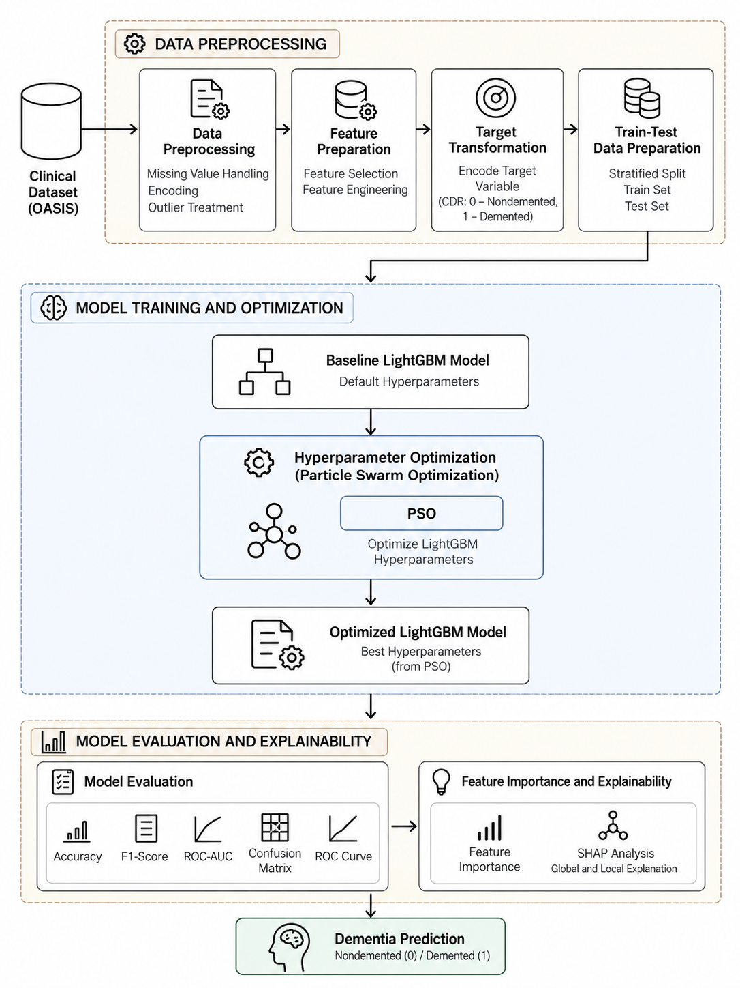
Figure 4.1 Overall System Architecture
The architecture represents the complete workflow of the proposed dementia detection system. The clinical information passes through preprocessing and model development stages before the optimized LightGBM models are evaluated. The explainability stage provides additional interpretation of the model predictions.

4.3 SYSTEM REQUIREMENTS
The system requirements consist of the hardware and software resources required to develop and execute the proposed machine learning-based dementia detection system.

4.3.1 HARDWARE REQUIREMENT
The system requires a computer capable of performing data preprocessing, machine learning model training, hyperparameter optimization, and model evaluation.
The general hardware requirements are:
- Processor: Intel Core i5 or equivalent processor
- RAM: Minimum 8 GB
- Storage: Minimum 10 GB of available storage
- System: 64-bit computer
- Internet Connection: Required when installing packages or accessing required development resources
The computational requirements may vary depending on the number of optimization trials and the computational resources available during model training.

4.3.2 SOFTWARE REQUIREMENTS
The proposed system requires a Python-based machine learning environment along with the necessary data processing, modelling, optimization, evaluation, and explainability libraries.
Operating System:
- Windows / Linux / macOS
Programming Language:
- Python
Development Environment:
- Jupyter Notebook / Python development environment
Data Processing Libraries:
- Pandas
- NumPy
Machine Learning Libraries:
- Scikit-learn
- LightGBM
Hyperparameter Optimization:
- GridSearchCV
- RandomizedSearchCV
- Optuna
- Particle Swarm Optimization implementation
Visualization Libraries:
- Matplotlib
- Seaborn
Explainable AI:
- SHAP
These software components support the complete workflow from clinical data preprocessing to model training, optimization, evaluation, and interpretation.

5 SYSTEM IMPLEMENTATION

5.1 SYSTEM METHODOLOGY
The proposed system implements a machine learning-based approach for dementia detection using structured clinical information. The methodology consists of data preprocessing, feature preparation, target transformation, train-test data preparation, LightGBM model development, Particle Swarm Optimization (PSO)-based hyperparameter optimization, model evaluation, and explainability.
The implementation begins with the clinical dataset, which is prepared for machine learning by applying the required preprocessing operations. The relevant features are then prepared and the target variable is transformed into a binary classification format representing Nondemented (0) and Demented (1).The prepared dataset is divided into training and testing data. A baseline LightGBM model is initially trained using its default hyperparameters. This baseline provides a reference point for evaluating the effect of hyperparameter optimization.
The next stage applies Particle Swarm Optimization (PSO) to identify suitable LightGBM hyperparameters. PSO searches through the defined hyperparameter space and evaluates candidate configurations based on the model's classification performance. The selected parameters are then used to construct the optimized LightGBM model.
The optimized model is evaluated using Accuracy, F1-Score, and ROC-AUC. A confusion matrix and ROC curve are also used to analyse the classification results. Finally, feature importance and SHAP-based explainability are used to understand the contribution of the clinical features to the model predictions.

5.2 MODULE DESCRIPTIONS
The proposed system is divided into three major implementation modules:
- Data Preprocessing Module
- Machine Learning Model Module
- Model Evaluation and Explainability Module

5.2.1 DATA PREPROCESSING MODULE
The Data Preprocessing Module prepares the clinical dataset before it is supplied to the machine learning model. Proper preprocessing is required to obtain a consistent input representation for model training.
The major operations in this module include:
Data Preprocessing:
The clinical dataset is examined and prepared for further processing. Required data-cleaning operations are performed on the available clinical attributes.
Missing Value Handling:
Missing values are identified and handled using the preprocessing strategy applied to the dataset so that incomplete records do not interfere with model training.
Encoding:
Categorical information is converted into a suitable numerical representation required by the machine learning algorithm.
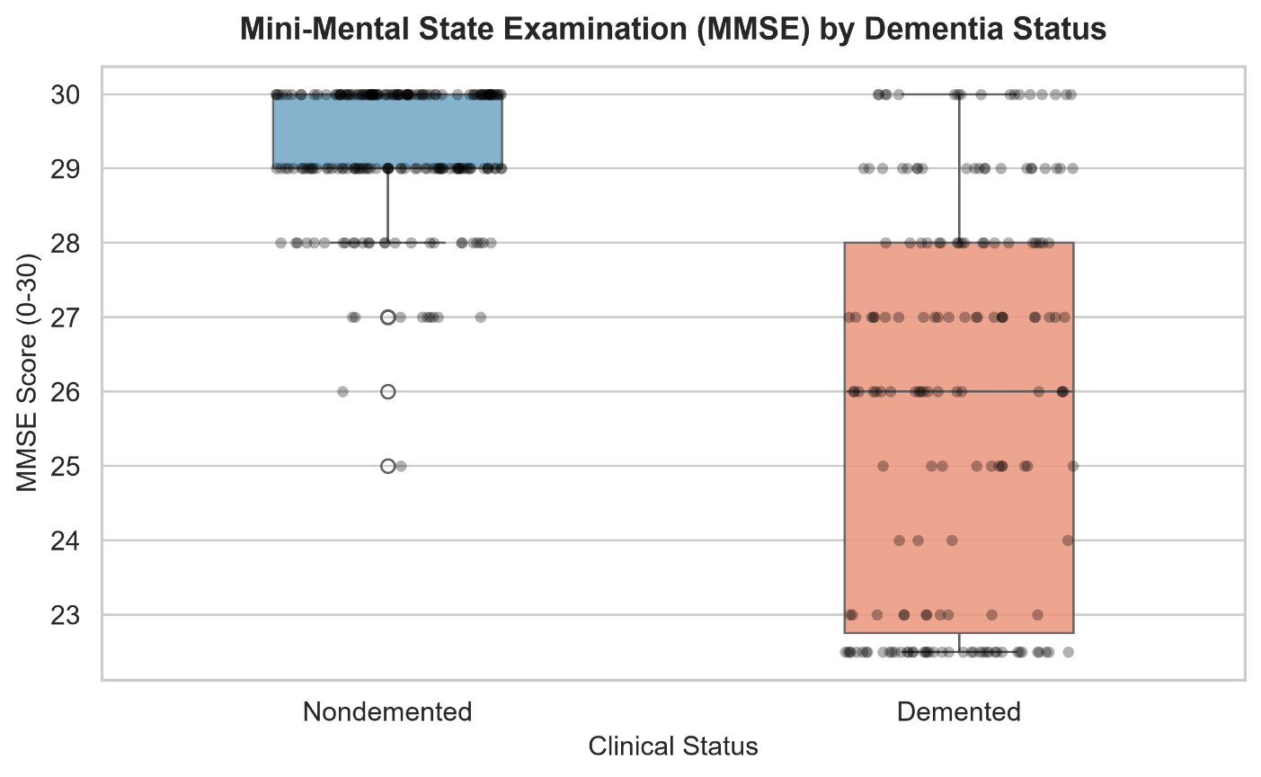
Feature Preparation:
The relevant clinical attributes are prepared as input variables for the classification model. Feature preparation ensures that the model receives the required predictor variables in an appropriate format.
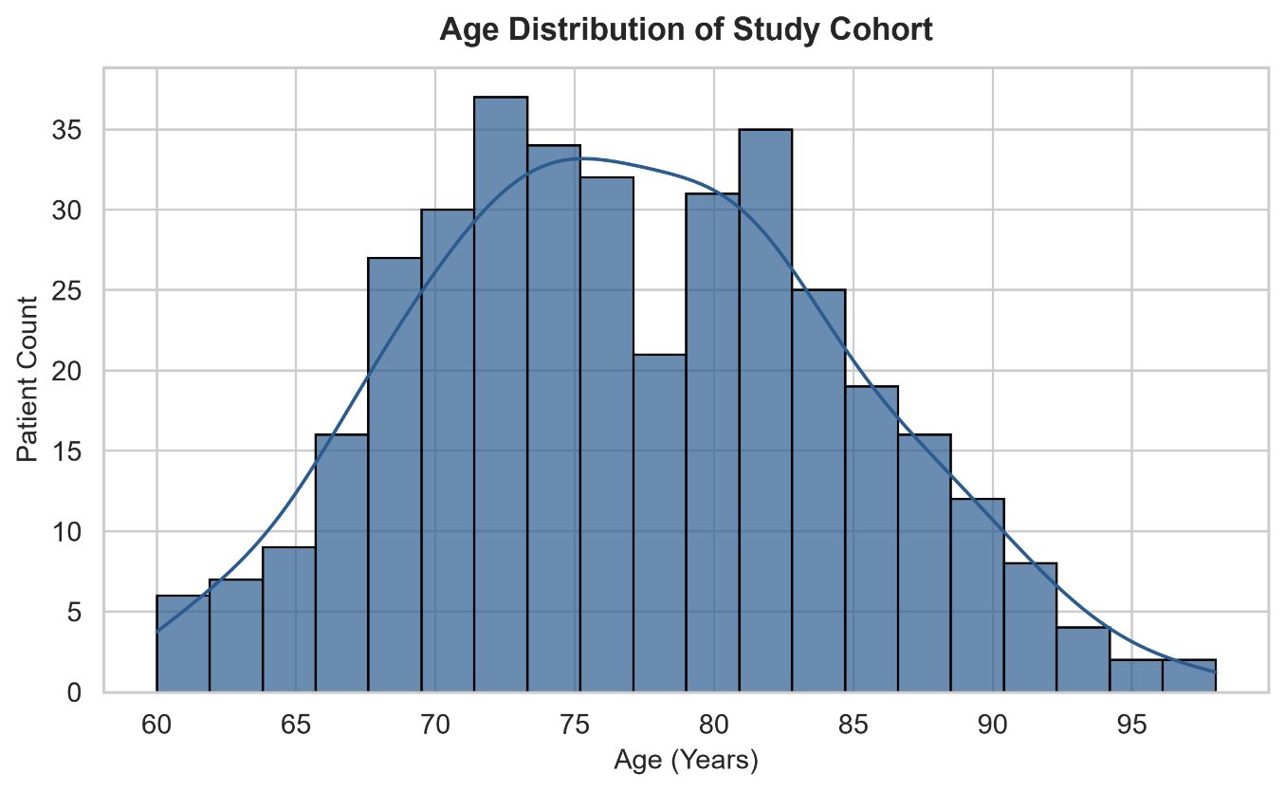
Target Transformation:
The target variable is transformed into a binary classification format:
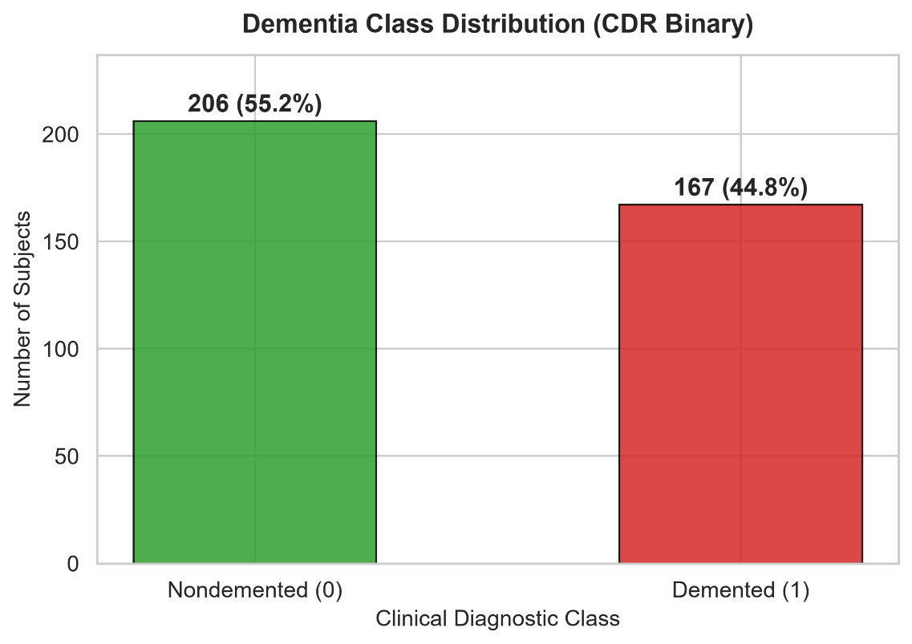
- 0 – Nondemented
- 1 – Demented
Train-Test Data Preparation:
The processed dataset is separated into training and testing subsets. The training data is used for model development and optimization, while the test data is reserved for evaluating the final model.
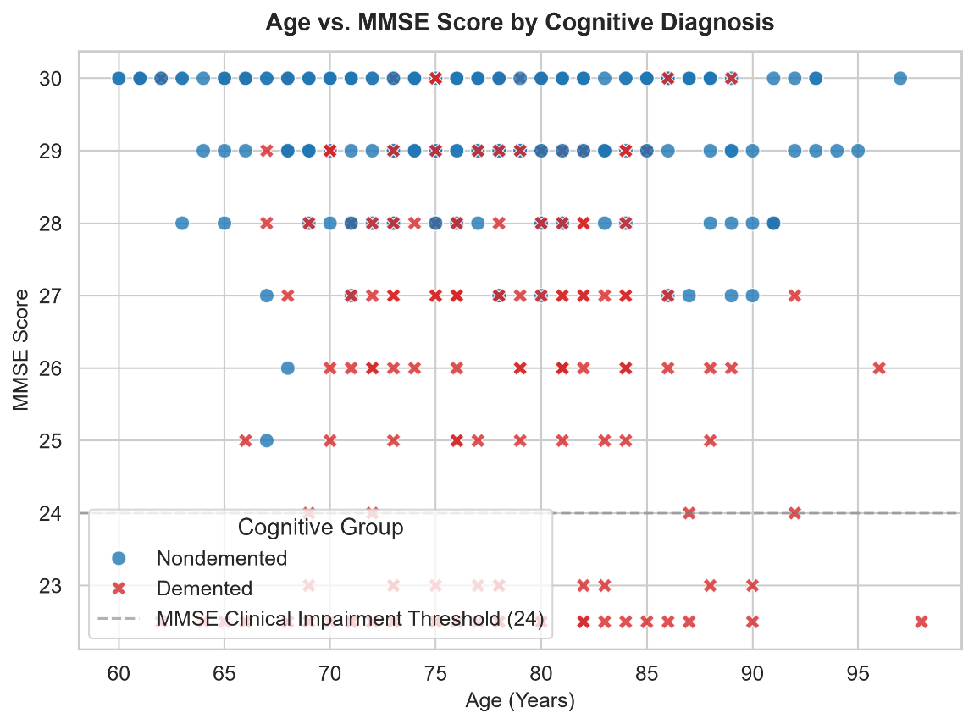

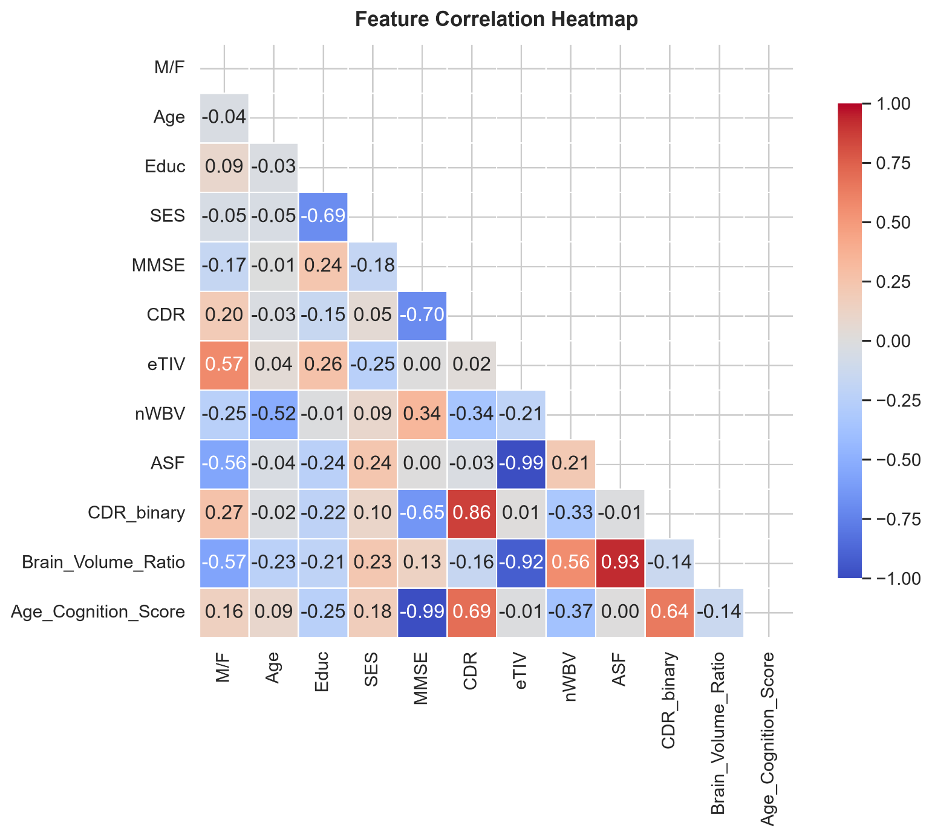

5.2.2 MACHINE LEARNING MODEL MODULE
The Machine Learning Model Module is responsible for developing the baseline and optimized dementia classification models.
Baseline LightGBM Model:
LightGBM is used as the primary classification algorithm. Initially, the model is trained using its default hyperparameters. The resulting performance is used as the baseline for comparison.
Particle Swarm Optimization:
Particle Swarm Optimization is applied to optimize the hyperparameters of the LightGBM model. PSO is a population-based optimization technique in which candidate solutions are represented as particles. The particles search the defined hyperparameter space and update their positions based on the optimization process.
In this project, PSO is used specifically to search for a suitable combination of LightGBM hyperparameters. The objective is to identify a parameter configuration that provides improved classification performance compared with the baseline model.
PSO-Optimized LightGBM Model:
After the optimization process, the selected hyperparameters are used to train the optimized LightGBM model. This model is subsequently used for final evaluation and dementia prediction.

5.2.3 MODEL EVALUATION AND EXPLAINABILITY MODULE
The Model Evaluation and Explainability Module evaluates the performance of the optimized LightGBM model and provides an interpretation of its predictions.
Performance Evaluation:
The model is evaluated using the following metrics:
- Accuracy – measures the proportion of correctly classified instances.
- F1-Score – combines precision and recall into a single measure.
- ROC-AUC – measures the model's ability to distinguish between the two classes across classification thresholds.
Confusion Matrix:
A confusion matrix is generated to examine the number of correctly and incorrectly classified instances for the Nondemented and Demented classes.
ROC Curve:
The ROC curve is used to visualize the relationship between the true positive rate and false positive rate at different classification thresholds.
Feature Importance:
Feature importance is used to identify the clinical variables that contribute most to the LightGBM model's predictions.
SHAP Explainability:
SHAP is applied to provide an interpretable explanation of the model predictions. SHAP analysis helps identify how individual clinical features contribute to increasing or decreasing the model output.
The final output of this module is an interpretable dementia classification result generated using the PSO-optimized LightGBM model.

6 RESULTS

6.1 RESULT
The proposed dementia detection system was implemented using clinical information and a LightGBM classification model. Particle Swarm Optimization (PSO) was applied to optimize the hyperparameters of the LightGBM model. The performance of the baseline and PSO-optimized models was evaluated using the test dataset.
The experimental results show that the PSO-optimized LightGBM model achieved an accuracy of 88.00% and an F1-Score of 0.8615. The corresponding ROC-AUC value was 0.9491. These results indicate that the optimized model was able to distinguish between the Nondemented and Demented classes effectively on the evaluated test data.
The baseline LightGBM model achieved an accuracy of 86.67%, an F1-Score of 0.8529, and a ROC-AUC of 0.9455. After applying PSO-based hyperparameter optimization, the accuracy increased to 88.00%, while the F1-Score increased to 0.8615 and ROC-AUC increased to 0.9491.
The comparison demonstrates the change in model performance after applying PSO optimization.
Table 6.1 Baseline and PSO-Optimized LightGBM Performance
Model | Accuracy | F1-Score | ROC-AUC
Baseline LightGBM | 86.67% | 0.8529 | 0.9455
PSO-Optimized LightGBM | 88.00% | 0.8615 | 0.9491
The PSO-optimized model therefore provides an improvement over the baseline LightGBM model across the three reported evaluation measures.

6.2 PERFORMANCE EVALUATION
The performance of the proposed model is evaluated using Accuracy, F1-Score, ROC-AUC, confusion matrix, and ROC curve.

Accuracy
Accuracy represents the percentage of test samples that are correctly classified by the model. The baseline LightGBM model obtained an accuracy of 86.67%, whereas the PSO-optimized LightGBM model obtained 88.00%.

F1-Score
The F1-Score provides a combined measure of precision and recall. The baseline model obtained an F1-Score of 0.8529, while the PSO-optimized model obtained 0.8615.

ROC-AUC
ROC-AUC measures the model's ability to distinguish between the two dementia classes across different classification thresholds. The baseline model obtained a ROC-AUC of 0.9455, while the PSO-optimized model obtained 0.9491.

Confusion Matrix
The confusion matrix is used to analyse the classification outcomes of the model for the Nondemented and Demented classes. It provides the numbers of correctly and incorrectly classified instances and helps identify the model's classification behaviour for each class.
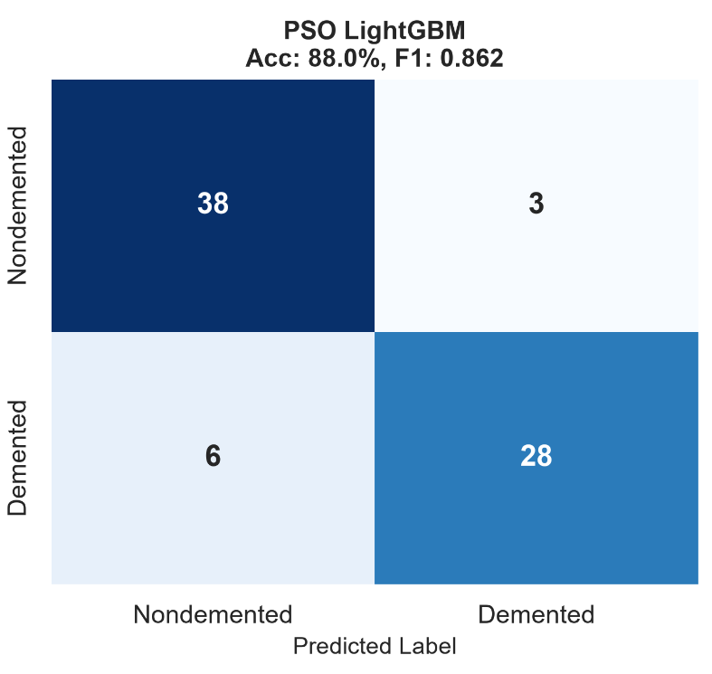

ROC Curve
The ROC curve illustrates the classification performance of the model at different decision thresholds. The ROC-AUC value of 0.9491 obtained by the PSO-optimized LightGBM model indicates strong class discrimination on the evaluated test data.

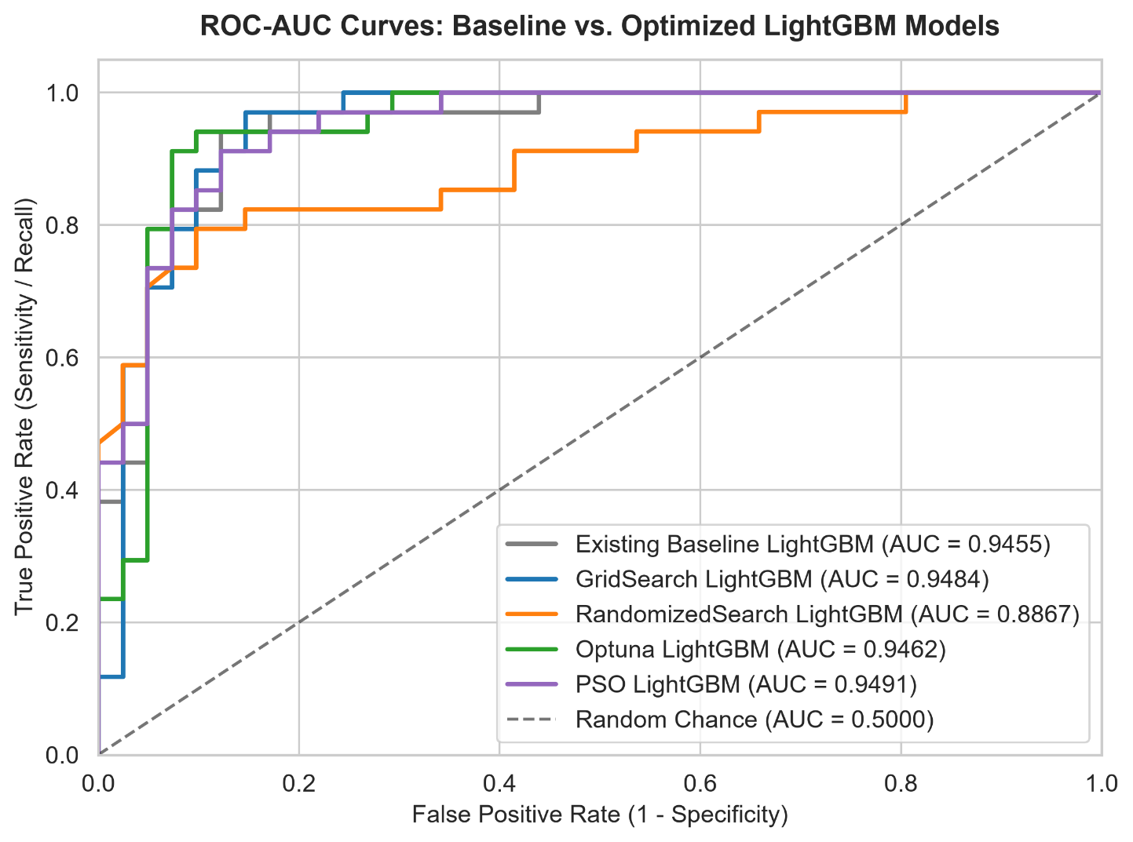

Performance Comparison
The baseline and PSO-optimized LightGBM models are compared using Accuracy, F1-Score, and ROC-AUC.
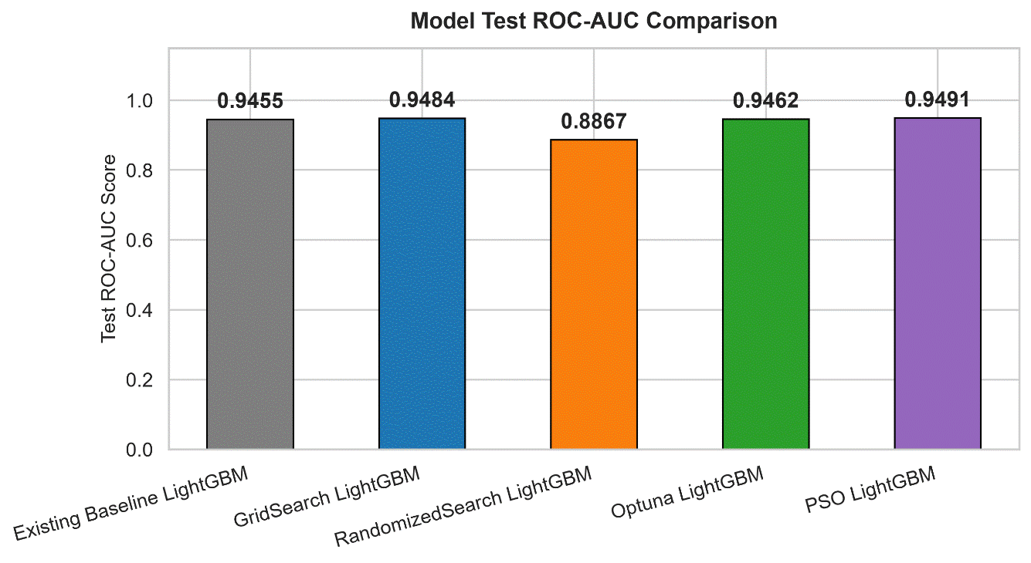
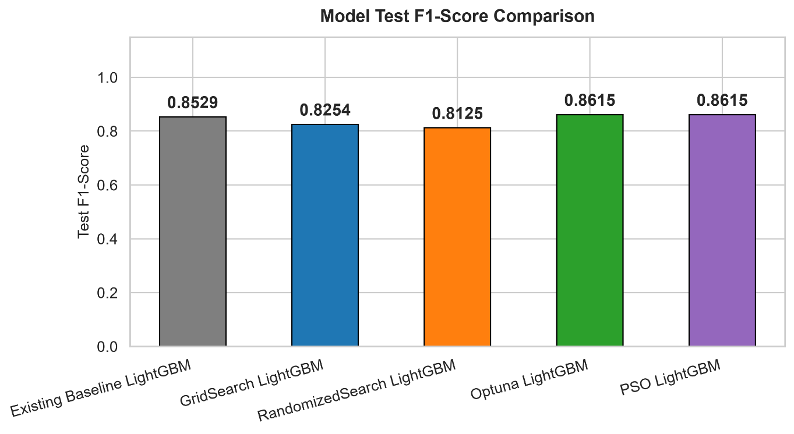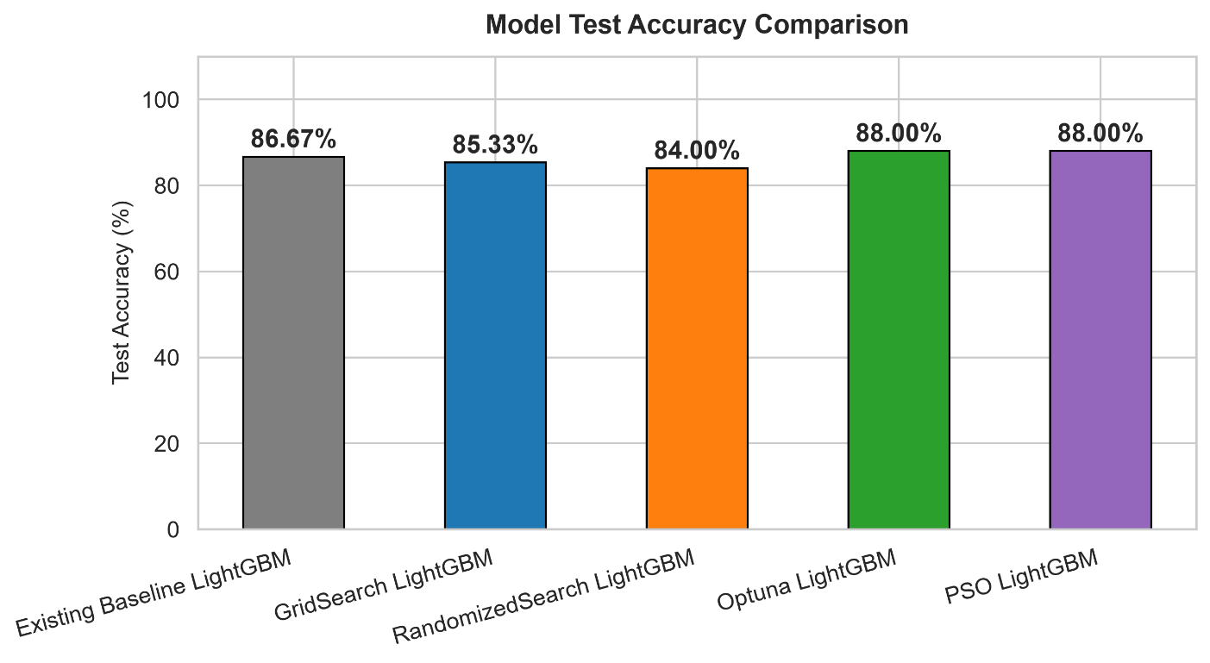
The results show an improvement from the baseline model to the PSO-optimized model:
- Accuracy: 86.67% → 88.00%
- F1-Score: 0.8529 → 0.8615
- ROC-AUC: 0.9455 → 0.9491

6.3 RESOURCE UTILIZATION
The proposed system uses computational resources for data preprocessing, LightGBM model training, PSO-based hyperparameter optimization, model evaluation, and SHAP-based explainability.

The main computational activities include:
- Clinical data preprocessing and feature preparation.
- Training of the baseline LightGBM model.
- Iterative evaluation of candidate hyperparameter configurations during PSO optimization.
- Training of the final PSO-optimized LightGBM model.
- Generation of evaluation metrics and visualizations.
- Computation of feature importance and SHAP explanations.
The PSO optimization stage requires repeated model evaluation because multiple candidate parameter configurations are explored before selecting the optimized configuration. Therefore, the computational requirement of the optimized workflow is higher than that of training a single baseline model.
The actual execution time and memory consumption should be reported only using the values recorded during the final implementation.

Explainability Analysis
Feature importance analysis is used to identify the clinical features that have a greater influence on the LightGBM model. SHAP analysis provides a more detailed interpretation by showing how individual features contribute to the prediction output.
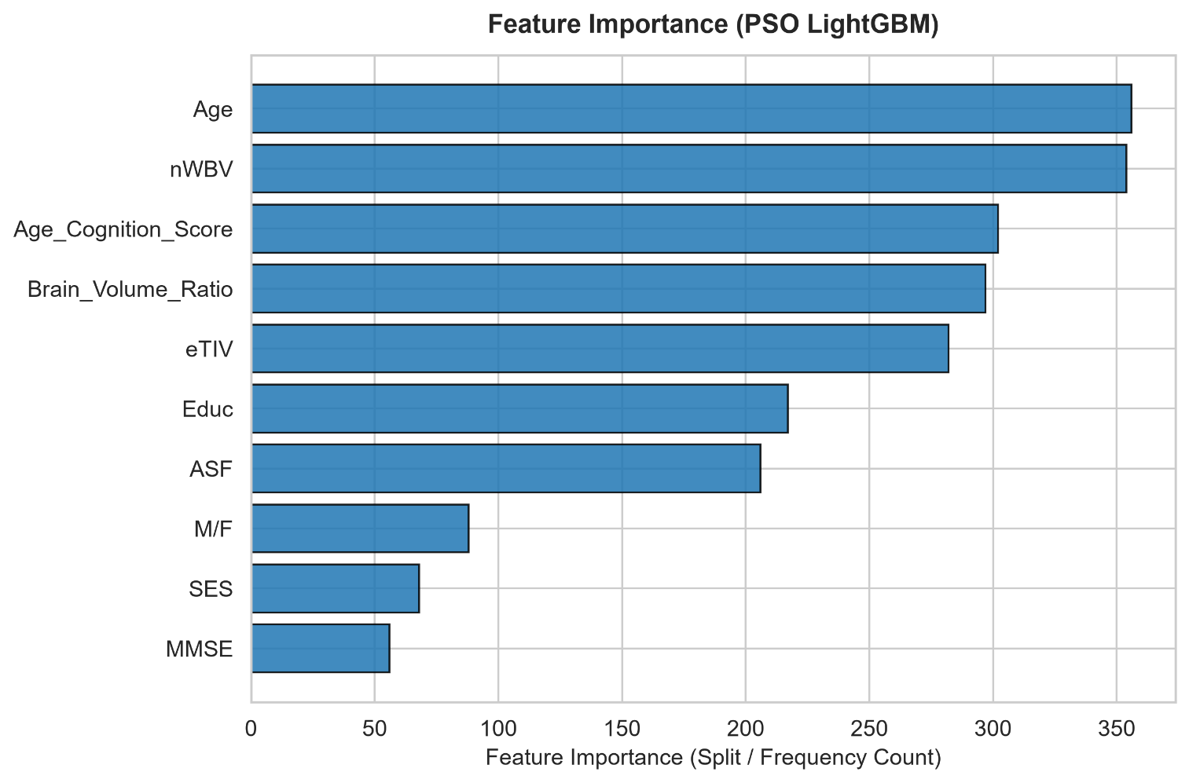
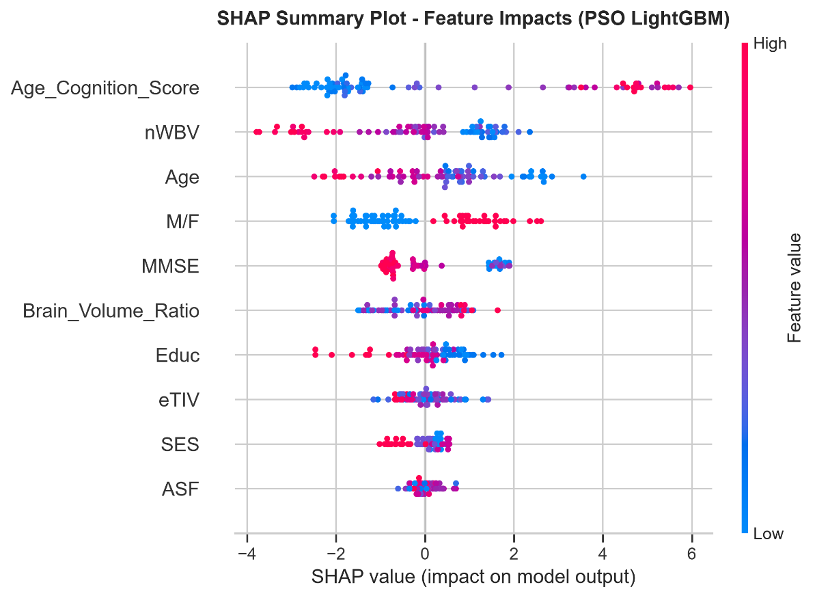
These explainability results provide additional information about the factors influencing the model predictions and make the machine learning output easier to interpret.

7 CONCLUSION AND FUTUREWORK

7.1 CONCLUSION
The proposed project, Intelligent Dementia Detection Using Clinical Information and Machine Learning, presents a machine learning-based approach for detecting dementia from structured clinical information. The system formulates dementia detection as a binary classification problem involving the Nondemented (0) and Demented (1) classes.
The developed workflow includes clinical data preprocessing, feature preparation, target transformation, train-test data preparation, LightGBM model development, Particle Swarm Optimization (PSO)-based hyperparameter optimization, model evaluation, and explainable AI analysis.
A baseline LightGBM model was initially developed to establish a reference performance. PSO was subsequently applied to optimize the LightGBM hyperparameters. Based on the evaluated test results, the baseline LightGBM model achieved 86.67% accuracy, 0.8529 F1-Score, and 0.9455 ROC-AUC. The PSO-optimized LightGBM model achieved 88.00% accuracy, 0.8615 F1-Score, and 0.9491 ROC-AUC.
The results demonstrate an improvement in the reported evaluation measures after PSO-based optimization. In addition to predictive performance, feature importance and SHAP analysis were incorporated to provide greater interpretability of the machine learning predictions.
Overall, the implemented system demonstrates the use of PSO-optimized LightGBM with explainable AI for clinical dementia classification. The approach provides both a prediction outcome and information that can be used to understand the contribution of clinical features to the model's predictions.

7.2 FUTURE WORK
The proposed system can be further enhanced in several directions:
- Larger Clinical Datasets:
The system can be evaluated using larger and more diverse clinical datasets to examine its performance across different patient populations.
- Additional Clinical Features:
Additional relevant clinical and cognitive attributes can be incorporated to provide a more comprehensive representation of dementia-related information.
- Comparison with Other Optimization Techniques:
Future work can investigate additional optimization algorithms and compare their effect on LightGBM hyperparameter selection.
- Advanced Explainable AI:
Further explainability techniques can be incorporated alongside SHAP to provide more detailed interpretations of individual patient predictions.
- Model Validation:
The proposed approach can be validated using external datasets to assess its generalization capability beyond the dataset used during development.
- Clinical Decision Support Interface:
A user-friendly interface can be developed to allow authorized users to enter clinical information and obtain an interpretable dementia prediction.
- Real-Time Prediction:
The system can be extended into a practical prediction application capable of providing rapid model predictions from newly entered clinical information.
- Deployment and Monitoring:
The optimized model can be deployed as a software service and monitored periodically to evaluate its performance when applied to new clinical data.

REFERENCES
[1] D. S. Marcus, T. H. Wang, J. Parker, J. G. Csernansky, J. C. Morris, and R. L. Buckner, “Open Access Series of Imaging Studies (OASIS): Cross-Sectional MRI Data in Young, Middle Aged, Nondemented and Demented Older Adults,” Journal of Cognitive Neuroscience, vol. 19, no. 9, pp. 1498–1507, 2007, doi: 10.1162/jocn.2007.19.9.1498.
Official dataset: OASIS Brains – OASIS-1
Publication: Harvard DASH – OASIS Publication
[2] G. Ke, Q. Meng, T. Finley, T. Wang, W. Chen, W. Ma, Q. Ye, and T.-Y. Liu, “LightGBM: A Highly Efficient Gradient Boosting Decision Tree,” in Advances in Neural Information Processing Systems 30, 2017.
Paper: NeurIPS – LightGBM Paper
[3] J. Kennedy and R. Eberhart, “Particle Swarm Optimization,” in Proceedings of ICNN'95 – International Conference on Neural Networks, Perth, WA, Australia, 1995, pp. 1942–1948, doi: 10.1109/ICNN.1995.488968.
Paper: IEEE Xplore – Particle Swarm Optimization
[4] S. M. Lundberg and S.-I. Lee, “A Unified Approach to Interpreting Model Predictions,” in Advances in Neural Information Processing Systems 30, 2017.
Paper: NeurIPS – SHAP Paper
[5] LightGBM, “LightGBM Documentation,” LightGBM Development Team.
Documentation: LightGBM Official Documentation
[6] LightGBM, “Python Package Introduction,” LightGBM Documentation.
Documentation: LightGBM Python Documentation
[7] Scikit-learn Developers, “Metrics and Scoring: Quantifying the Quality of Predictions,” scikit-learn User Guide.
Documentation: Scikit-learn Model Evaluation Documentation
[8] Scikit-learn Developers, “sklearn.metrics API Reference,” scikit-learn Documentation.
Documentation: Scikit-learn Metrics API

APPENDICES

Appendix A – Paper Publication Status
Team ID: [TEAM ID – TO BE PROVIDED]
Team Members: 231501028 Aswini G
231501140 Sai Senthil M
231501182 Vijay M

Team Supervisor: Dr. J. Jasmine Gabriel, [QUALIFICATIONS / DESIGNATION – CONFIRM]
Publication Status: [PUBLICATION STATUS – TO BE CONFIRMED] (permitted values: Under Preparation / Communicated / Accepted / Registered / Presented / Published). A draft paper exists; if it has not yet been submitted anywhere, the applicable status is “Under Preparation”.
Particulars of Conference: [CONFERENCE/JOURNAL DETAILS – TO BE PROVIDED]
Host Institution: [HOST INSTITUTION – TO BE PROVIDED]
Conference Date: [CONFERENCE DATE – TO BE PROVIDED]
Supporting evidence (e.g., submission-acknowledgement e-mail, registration receipt, acceptance letter or conference brochure), if applicable, is to be pasted below this line.

Appendix B – First Page of Plagiarism Report
[INSERT FIRST PAGE OF PLAGIARISM REPORT HERE]
Only the first page of the actual similarity report generated for this report is to be inserted; no percentage has been stated here.

Appendix C – Full Paper in IEEE Format
[INSERT FULL IEEE FORMAT PAPER HERE]
The final IEEE-format paper, together with its publication details (Appendix A), is to be inserted here. The uploaded draft (Paper Draft v3) still contains unresolved verification notes and is therefore not reproduced as the final paper.

Information Required Before Final Submission
- Which Dataset 1 numbers are final: README values (Random Forest, Gradient Boosting, XGBoost, LightGBM differ) or the comparative experiment values used above.
- Dataset 2: class distribution, train/test sizes, missing values per column, and provenance (source/URL); take the subject-overlap count from the run log.
- Confusion matrices for all models and both datasets.
- SHAP values and plots for the comparative experiment (Dataset 1 and Dataset 2) and the model they were computed on. Table 12 currently holds README values.
- Installed software versions and hardware/runtime (seed 42, hyperparameters and absence of class weights are now taken from the code).
- Path and names of saved comparison outputs (the report text ends mid-sentence at “saved to”).
- Age range and eTIV unit; verified literature and WHO source.
- Final model-selection rule (cross-validation vs test).

Claims That Need Verification
- Subject-overlap count and exact train/test sizes for Dataset 2 (code uses GroupShuffleSplit/GroupKFold; printed values not supplied).
- Test n = 76 for Dataset 2 (inferred).
- That Dataset 2 is the OASIS Longitudinal data (stated in the report header).
- That all 373 rows are labelled with no CDR removal.
- Imputation fitted strictly in-fold; ffill/bfill not in final pipeline.
- Earlier README claims (Age range, eTIV unit, Educ coding, removal of “younger controls”).

Inconsistencies to Resolve
- Dataset 1 values differ between the README and the comparative experiment: Random Forest (accuracy 0.6383 vs 0.6596; Macro F1 0.5222 vs 0.5493; log loss 0.6263 vs 0.6380), Gradient Boosting (log loss 0.7551 vs 0.7160; CV Macro F1 0.6496 vs 0.6687), XGBoost (CV Macro F1 0.6983 vs 0.6659), LightGBM (log loss 0.7381 vs 0.7472; CV Macro F1 0.6572 vs 0.6591). Decision Tree values match exactly. A rerun apparently changed these; state which is final and use one table only.
- The report labels LightGBM “Primary” and bolds it although it is not best on any test metric except Dataset 1 macro precision; avoid bolding it as if it were best.
- The report calls the CV Macro F1 difference “Identical”; 0.6591 vs 0.6600 is nearly equal, with std about 0.09 for both. Use “nearly equal”. The script uses np.std (ddof = 0) for all CV standard deviations.
- app.py loads models/best_dementia_model.joblib and defaults to the label “Decision Tree”, so the served model may differ from the LightGBM “primary” model; the app’s SES dropdown labels for classes 4 and 5 appear swapped (code shows 5 labelled “Lower-Middle” and 4 “Lowest Status”); the comparative script’s fixed hyperparameters (Table 7) may explain the Dataset 1 differences from the README run (src/ files not supplied). Earlier issues remain: architecture slide (LightGBM “best model”, “Decision Tres”), binary target and ROC-AUC on the tech-stack slide, multimodal zeroth-review slides, unverifiable slide citations, and the friend’s template references.

Final Paper Quality Checklist
- ☒ No fabricated numerical results (values from README, comparative report or code; inferences labelled)
- ☒ No fabricated references (unverifiable ones flagged)
- ☒ No copied content
- ☐ Dataset information verified (Dataset 2 class counts pending)
- ☐ Methodology verified (code not provided)
- ☐ Results verified (Dataset 1 README vs comparison conflict)
- ☒ Model names verified
- ☐ SHAP information verified
- ☒ Figures identified
- ☒ Tables identified
- ☒ Limitations included
- ☐ Conclusion supported by results (pending items above)

