同济大学计算机系

数字逻辑课程实验报告



学 号
姓 名
专 业
授课老师

- 实验内容
使用Verilog 实现行为级ALU的设计和仿真
ALU原理图如下
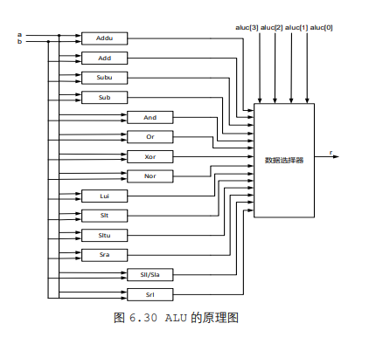
ALU对应运算
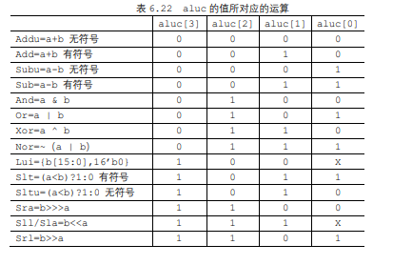
对应标识位要求
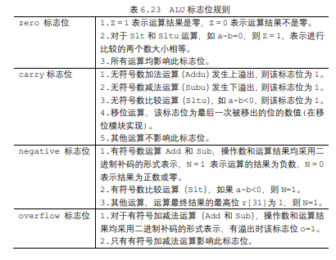
- 硬件逻辑图

- 模块建模

module alu(
input [31:0] a, // 操作数1
input [31:0] b, // 操作数2
input [3:0] aluc, // ALU控制信号
output reg [31:0] r, // 结果
output reg zero, // 零标志位
output reg carry, // 进位/借位标志位
output reg negative, // 负数标志位
output reg overflow // 溢出标志位
);
wire signed [31:0]a1;
wire signed [31:0]b1;
assign a1 = a ;
assign b1 = b ;

wire [31:0] r_addu; //无符号+
assign r_addu = a + b;
wire [31:0] r_add; //有符号+
assign r_add = a1 + b1;
wire [31:0] r_subu; //无符号-
assign r_subu= a - b;
wire [31:0] r_sub; //有符号-
assign r_sub = a1 - b1;
wire [31:0] r_and; //and
assign r_and = a & b;
wire [31:0] r_or; //or
assign r_or = a | b;
wire [31:0] r_xor; //xor
assign r_xor = a ^ b;
wire [31:0] r_nor; //nor
assign r_nor =~( a | b );
wire [31:0] r_lui; //高位置立即数
assign r_lui = {b[15:0],16'b0};
wire [31:0] r_slt; //slt
assign r_slt = (a1<b1)?1:0;
wire [31:0] r_sltu; //sltu
assign r_sltu = (a<b)?1:0;
wire [31:0] r_sra; //算数右移
assign r_sra = b1>>>a;

wire [31:0] r_sll; //逻辑左移
assign r_sll = b<<a;

wire [31:0] r_srl; //逻辑右移
assign r_srl = b>>a;
reg [33:0] tem_a,tem_b,tem_c;
always@(*) begin
zero=0;
carry=0;
negative=0;
overflow=0;
tem_a={1'b0,a,1'b0};
tem_b={1'b0,b,1'b0};

if(aluc== 4'b0000) begin //无符号加
r<=r_addu;
zero<=(r_addu==0?1'b1:1'b0);
tem_c<=tem_a+tem_b;
carry<=tem_c[33];
negative<=r_addu[31];
end
else if(aluc== 4'b0010) begin //有符号加
r<=r_add;
zero<=(r_add==0?1'b1:1'b0);
tem_c<=tem_a+tem_b;
negative=r_add[31];
if( a1[31]== 1 && b1[31]==1 && r_add[31] == 0)
overflow <= 1'b1;
else if ( a1[31]== 0 && b1[31]==0 && r_add[31] == 1)
overflow <= 1'b1;
else
overflow=1'b0;
end
else if(aluc== 4'b0001 ) begin //无符号减
r<=r_subu;
zero<=(r_subu==0?1'b1:1'b0);
tem_c<=tem_a-tem_b;
carry<=tem_c[33];
negative<=r_subu[31];
end
else if(aluc== 4'b0011) begin //有符号减
r<=r_sub;
zero<=(r_sub==0?1'b1:1'b0);
tem_c<=tem_a+tem_b;
negative=r_sub[31];
if( a1[31]== 0 && b1[31]==1 && r_sub[31] == 1)
overflow <= 1'b1;
else if ( a1[31]== 1 && b1[31]==0 && r_sub[31] == 0)
overflow <= 1'b1;
else
overflow <= 1'b0;
end
else if(aluc== 4'b0100) begin // &
r<=r_and;
zero<=(r_and==0?1'b1:1'b0);
negative<=r_and[31];

end
else if(aluc== 4'b0101) begin // |
r<=r_or;
zero<=(r_or==0?1'b1:1'b0);
negative<=r_or[31];

end
else if(aluc== 4'b0110) begin // ^
r<=r_xor;
zero<=(r_xor==0?1'b1:1'b0);
negative<=r_xor[31];

end
else if(aluc== 4'b0111) begin //~(a|b)
r<=r_nor;
zero<=(r_nor==0?1'b1:1'b0);
negative<=r_nor[31];

end
else if(aluc== 4'b100x) begin //{b[15:0],16'b0} 高位置立即数
r<=r_lui;
zero<=(r_lui==0?1'b1:1'b0);
negative<=r_lui[31];
end
else if(aluc== 4'b1001) begin //{b[15:0],16'b0} 高位置立即数
r<=r_lui;
zero<=(r_lui==0?1'b1:1'b0);
negative<=r_lui[31];
end
else if(aluc== 4'b1000) begin //{b[15:0],16'b0} 高位置立即数
r<=r_lui;
zero<=(r_lui==0?1'b1:1'b0);
negative<=r_lui[31];
end
else if(aluc== 4'b1011) begin //(a<b)?1:0 有符号
r<=r_slt;
zero<=(a==b?1'b1:1'b0);
negative<=r_slt;
end
else if(aluc== 4'b1010) begin //(a<b)?1:0 无符号
r<=r_sltu;
zero<=(a==b?1'b1:1'b0);

carry=r_sltu;
negative<=r_sltu[31];

end
else if(aluc== 4'b1100) begin //b>>>a算数右移
r<=r_sra;
zero<=(r_sra==0?1'b1:1'b0);
carry<=(a==0)?0:((a<33)?b[a-1]:b[31]);
negative<=r_sra[31];

end
else if(aluc== 4'b111x) begin //b<<a 逻辑左移
r<=r_sll;
zero<=(r_sll==0?1'b1:1'b0);
carry<=(a==0)?0:((a<33)?b[32-a]:1'b0);
negative<=r_sll[31];
end
else if(aluc== 4'b1110) begin //b<<a 逻辑左移
r<=r_sll;
zero<=(r_sll==0?1'b1:1'b0);
carry<=(a==0)?0:((a<33)?b[32-a]:1'b0);
negative<=r_sll[31];
end
else if(aluc== 4'b1111) begin //b<<a 逻辑左移
r<=r_sll;
zero<=(r_sll==0?1'b1:1'b0);
carry<=(a==0)?0:((a<33)?b[32-a]:1'b0);
negative<=r_sll[31];
end
else if(aluc== 4'b1101) begin //b>>a 逻辑右移
r<=r_srl;
zero<=(r_srl==0?1'b1:1'b0);
carry<=(a==0)?0:((a<33)?b[a-1]:0);
negative<=r_srl[31];

end
end

endmodule
- 测试模块建模
（要求列写各建模模块的test bench模块代码）
`timescale 1ns / 1ps

module alu_tb;
reg [31:0] a;
reg [31:0] b;
reg [3:0] aluc;
wire [31:0] r;
wire zero;
wire carry;
wire negative;
wire overflow;

// 实例化ALU模块
alu dut(
.a(a),
.b(b),
.aluc(aluc),
.r(r),
.zero(zero),
.carry(carry),
.negative(negative),
.overflow(overflow)
);

initial begin

a=32'h00000001;b=32'hffffffff;aluc=4'b0010;
#20 a=32'hffffffff;b=32'h80000000;aluc=4'b0010 ;
#20 a=32'hffffffff;b=32'h0000ffff;aluc=4'b0010 ;
#20 a=32'hffffffff;b=32'hffffffff;aluc=4'b0011;
#20 a=32'hffffffff;b=32'h80000000;aluc=4'b0011;
#20 a=32'h00000000;b=32'h00000000;aluc=4'b1000 ;
#20 a=32'h00000000;b=32'h00001234;aluc=4'b1000;
#20 a=32'h00000000;b=32'hffff1234;aluc=4'b1000 ;
#20 a=32'hffffffff;b=32'h80000000;aluc=4'b1010;
#20 a=32'h0000ffff;b=32'h00000000;aluc=4'b1010 ;
#20 a=32'hffffffff;b=32'h0000ffff;aluc=4'b1010 ;
#20 a=32'h00000001;b=32'hffffffff;aluc=4'b1011;
#20 a=32'hffffffff;b=32'h80000000;aluc=4'b1011;
#20 a=32'h0000ffff;b=32'h00000000;aluc=4'b1011 ;
#20 a=32'hffffffff;b=32'h0000ffff;aluc=4'b1011 ;
#20 a=32'h00000000;b=32'h00000000;aluc=4'b1100;
#20 a=32'h00000008;b=32'hffffffff;aluc=4'b1100 ;
#20 a=32'h00000010;b=32'h80000000;aluc=4'b1100 ;
#20 a=32'h00000000;b=32'h00000000;aluc=4'b1101 ;
#20 a=32'h00000000;b=32'h00000000;aluc=4'b1110;
#20 a=32'h00000001;b=32'hffffffff;aluc=4'b1110 ;
#20 a=32'h00000008;b=32'hffffffff;aluc=4'b1110 ;
#20 a=32'h00000010;b=32'h80000000;aluc=4'b1110;
#20 a=32'h00000011;b=32'h80000000;aluc=4'b1110 ;
#20 a=32'h0000001f;b=32'h0000ffff;aluc=4'b1110 ;
// 无符号加法
#10 a = 32'h00000001; b = 32'h00000001; aluc = 4'b0000;
// 有符号加法
#10 a = 32'h7FFFFFFF; b = 32'h00000001; aluc = 4'b0010;
// 无符号减法
#10 a = 32'h00000002; b = 32'h00000001; aluc = 4'b0001;
// 有符号减法
#10 a = 32'h80000000; b = 32'h00000001; aluc = 4'b0011;
// AND
#10 a = 32'hF0F0F0F0; b = 32'h0F0F0F0F; aluc = 4'b0100;
// OR
#10 a = 32'hF0F0F0F0; b = 32'h0F0F0F0F; aluc = 4'b0101;
// XOR
#10 a = 32'hFFFF0000; b = 32'h0000FFFF; aluc = 4'b0110;
// NOR
#10 a = 32'hFFFF0000; b = 32'h0000FFFF; aluc = 4'b0111;
// SLT (Set Less Than) 有符号
#10 a = 32'h00000002; b = 32'h00000003; aluc = 4'b1011;
// SLTU (Set Less Than Unsigned)
#10 a = 32'h00000003; b = 32'h00000002; aluc = 4'b1010;
// 算数右移
#10 a = 4; b = 32'hF0000000; aluc = 4'b1100;
// 逻辑左移
#10 a = 4; b = 32'h0F000000; aluc = 4'b1110; // 注意这里要使用 1110 而不是 111x
// 逻辑右移
#10 a = 4; b = 32'hF0000000; aluc = 4'b1101;
end

endmodule
- 实验结果
（该部分可截图说明，要求logisim逻辑验证图、modelsim仿真波形图、以及下板后的实验结果贴图（实验步骤中没有下板要求的实验，不需要下板贴图））

