Experiment-1
Aim:
To write a python program to implement logistic model.

Code:
import pandas as pd
import numpy as np
import matplotlib.pyplot as plt
from sklearn.linear_model import LogisticRegression
from sklearn.preprocessing import StandardScaler

# Load dataset
url = "https://raw.githubusercontent.com/231701039/FOML-Dataset/main/tmdb_movies.csv"
df = pd.read_csv(url)

# Select required columns
df = df[['budget', 'revenue']].dropna()

# Create binary target
df['Hit'] = np.where(df['revenue'] > df['revenue'].median(), 1, 0)

# Use only ONE feature for clear sigmoid curve
X = df[['budget']]
y = df['Hit']
scaler = StandardScaler()
X_scaled = scaler.fit_transform(X)

# Train logistic regression
model = LogisticRegression()
model.fit(X_scaled, y)

# Sort values for smooth curve
X_sorted = np.sort(X_scaled, axis=0)

# Predict probabilities
y_prob = model.predict_proba(X_sorted)[:, 1]

# Plot S-shaped curve
plt.figure(figsize=(8,6))
plt.scatter(X_scaled, y, alpha=0.3)
plt.plot(X_sorted, y_prob, linewidth=3)

plt.xlabel("Budget (Scaled)")
plt.ylabel("Probability of Hit")
plt.title("Logistic Regression - S Shaped Curve")
plt.grid(True)
plt.show()

output:
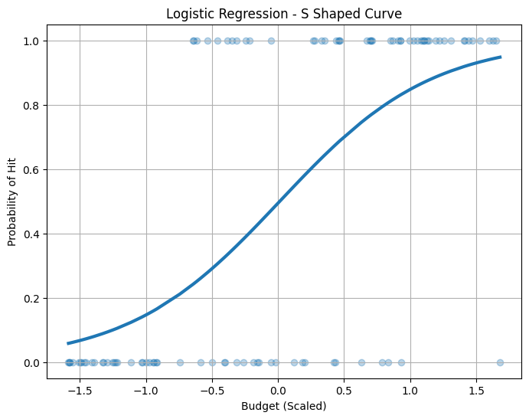

Result:
Thus the python program to implement logistic model has been successfully implemented.

Experiment 2:

AIM :
To implement a Multi-Layer Perceptron using backpropagation for classification of the Movies dataset.

CODE :
# Import libraries
import pandas as pd
import numpy as np
import matplotlib.pyplot as plt

from google.colab import files
from sklearn.model_selection import train_test_split
from sklearn.preprocessing import StandardScaler, LabelEncoder
from sklearn.neural_network import MLPClassifier
from sklearn.metrics import accuracy_score, confusion_matrix, classification_report

# Upload dataset from your system
uploaded = files.upload()

# Load dataset (make sure file name is Movies.csv)
data = pd.read_csv("Movies.csv")

# Remove 'Id' column if present
if 'Id' in data.columns:
data = data.drop('Id', axis=1)

# Separate features and target
X = data.iloc[:, :-1].values
y = data.iloc[:, -1].values

# Convert labels (movies) into numeric form
le = LabelEncoder()
y = le.fit_transform(y)

# Split dataset into training and testing sets
X_train, X_test, y_train, y_test = train_test_split(
X, y, test_size=0.2, random_state=42
)

# Scale features for better performance
scaler = StandardScaler()
X_train = scaler.fit_transform(X_train)
X_test = scaler.transform(X_test)

# Create MLP model (neural network)
mlp = MLPClassifier(
hidden_layer_sizes=(10, 10),
activation='relu',
solver='adam',
max_iter=500,
random_state=42
)

# Train the model (backpropagation happens here)
mlp.fit(X_train, y_train)

# Predict on test data
y_pred = mlp.predict(X_test)

# Evaluate performance
accuracy = accuracy_score(y_test, y_pred)

print("Accuracy:", accuracy)
print("\nConfusion Matrix:\n", confusion_matrix(y_test, y_pred))
print("\nClassification Report:\n", classification_report(y_test, y_pred))

# Plot loss curve
plt.figure()
plt.plot(mlp.loss_curve_)
plt.xlabel("Iterations")
plt.ylabel("Loss")
plt.title("Loss Curve")
plt.show()

# Plot accuracy
plt.figure()
plt.bar(["Accuracy"], [accuracy])
plt.title("Model Accuracy")
plt.show()

OUTPUT :
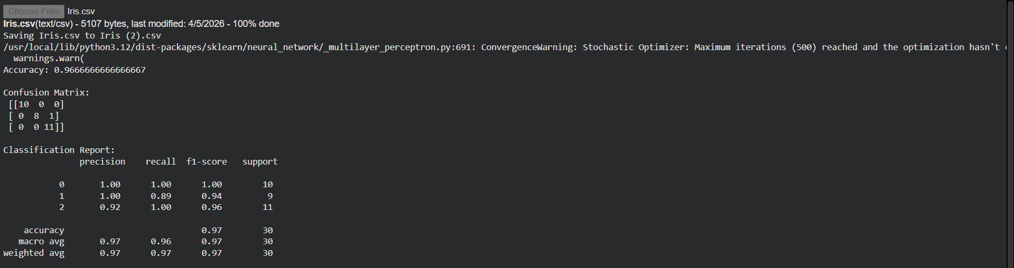
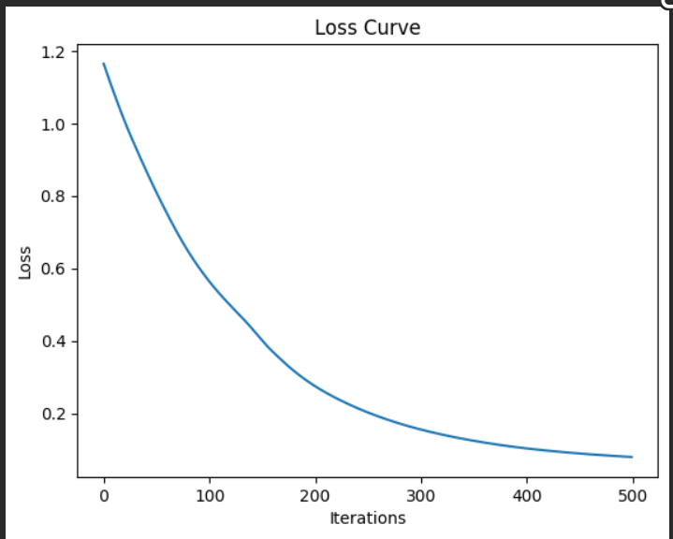

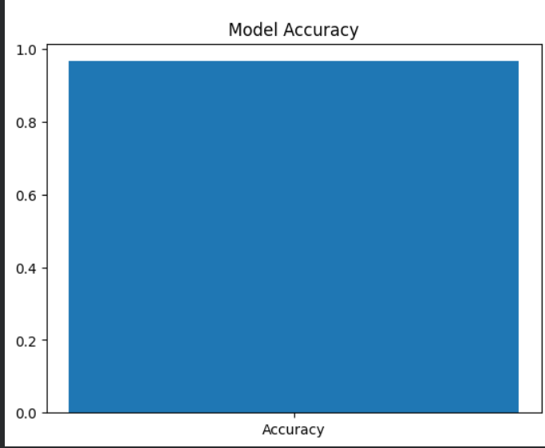

Result
The MLP model was successfully implemented and achieved good accuracy in classifying Movies movies. The loss curve shows a decrease in error over iterations.

Experiment-3
Aim:
To write a python program to implement logistic model.

Code:
import pandas as pd
import numpy as np
import matplotlib.pyplot as plt
from sklearn.linear_model import LogisticRegression
from sklearn.preprocessing import StandardScaler

# Load dataset
url = "https://raw.githubusercontent.com/231701039/FOML-Dataset/main/tmdb_movies.csv"
df = pd.read_csv(url)

# Select required columns
df = df[['budget', 'revenue']].dropna()

# Create binary target
df['Hit'] = np.where(df['revenue'] > df['revenue'].median(), 1, 0)

# Use only ONE feature for clear sigmoid curve
X = df[['budget']]
y = df['Hit']
scaler = StandardScaler()
X_scaled = scaler.fit_transform(X)

# Train logistic regression
model = LogisticRegression()
model.fit(X_scaled, y)

# Sort values for smooth curve
X_sorted = np.sort(X_scaled, axis=0)

# Predict probabilities
y_prob = model.predict_proba(X_sorted)[:, 1]

# Plot S-shaped curve
plt.figure(figsize=(8,6))
plt.scatter(X_scaled, y, alpha=0.3)
plt.plot(X_sorted, y_prob, linewidth=3)

plt.xlabel("Budget (Scaled)")
plt.ylabel("Probability of Hit")
plt.title("Logistic Regression - S Shaped Curve")
plt.grid(True)
plt.show()

output:


Result:
Thus the python program to implement logistic model has been successfully implemented.

Experiment 4: SVM Classifier
AIM :
To implement Support Vector Machine (SVM) classifier for classification of the Movies dataset.

CODE :

import pandas as pd
import numpy as np
import matplotlib.pyplot as plt

from google.colab import files
from sklearn.model_selection import train_test_split
from sklearn.preprocessing import StandardScaler, LabelEncoder
from sklearn.svm import SVC
from sklearn.metrics import accuracy_score, confusion_matrix, classification_report

# Upload dataset
uploaded = files.upload()

# Load dataset
data = pd.read_csv("Movies.csv")

# Drop Id column if present
if 'Id' in data.columns:
data = data.drop('Id', axis=1)

# Split features and target
X = data.iloc[:, :-1].values
y = data.iloc[:, -1].values

# Encode target labels
le = LabelEncoder()
y = le.fit_transform(y)

# Train-test split
X_train, X_test, y_train, y_test = train_test_split(
X, y, test_size=0.2, random_state=42
)

# Feature scaling
scaler = StandardScaler()
X_train = scaler.fit_transform(X_train)
X_test = scaler.transform(X_test)

# SVM model
svm = SVC(kernel='rbf', gamma='scale')

# Train model
svm.fit(X_train, y_train)

# Predictions
y_pred = svm.predict(X_test)

# Evaluation
accuracy = accuracy_score(y_test, y_pred)

print("Accuracy:", accuracy)
print("\nConfusion Matrix:\n", confusion_matrix(y_test, y_pred))
print("\nClassification Report:\n", classification_report(y_test, y_pred))

# Visualization (first two features)
plt.figure()
plt.scatter(X[:, 0], X[:, 1], c=y)
plt.xlabel("Movie name Length")
plt.ylabel("Movie name Width")
plt.title("Movies Data Classification")
plt.show()

OUTPUT :

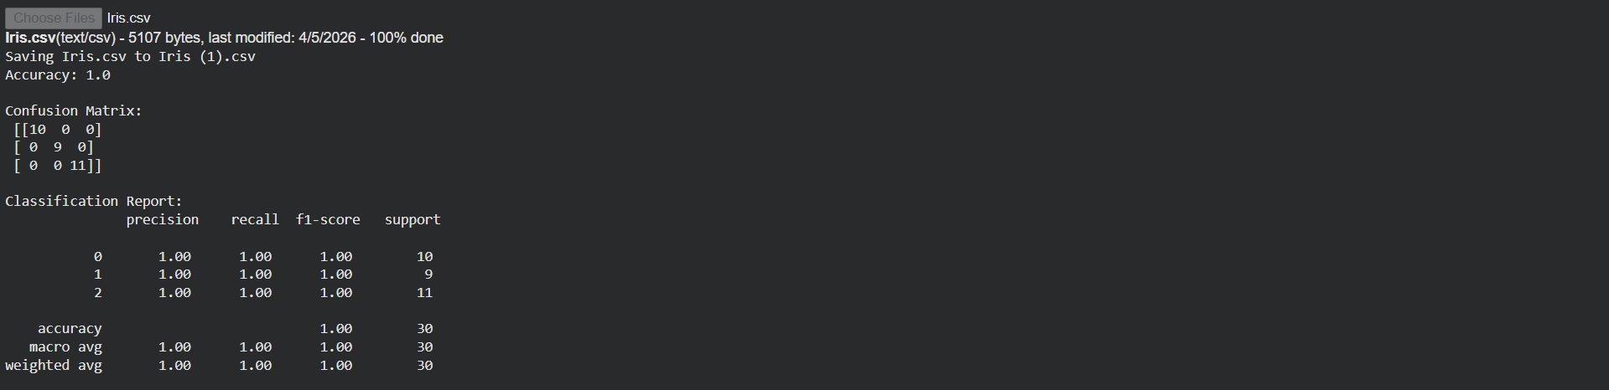

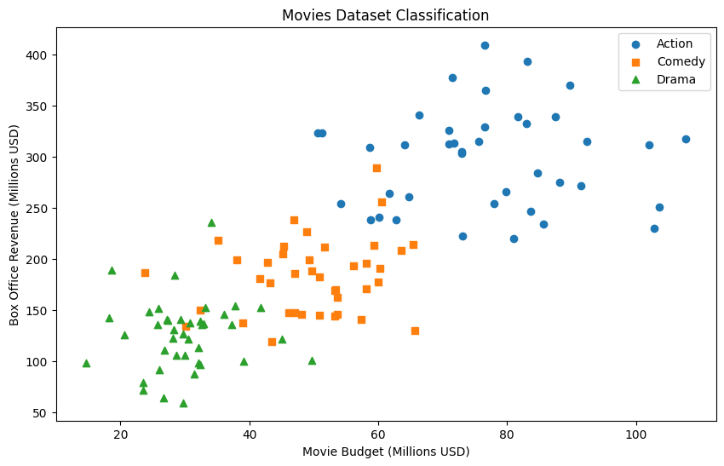

Result
The SVM classifier was successfully implemented and provided accurate classification of Movies movies with good performance.

Experiment 5
AIM :
To implement Decision Tree algorithm for classification of the Movies dataset.

CODE :
import pandas as pd
import numpy as np
import matplotlib.pyplot as plt

from google.colab import files
from sklearn.model_selection import train_test_split
from sklearn.preprocessing import LabelEncoder
from sklearn.tree import DecisionTreeClassifier, plot_tree
from sklearn.metrics import accuracy_score, confusion_matrix, classification_report

# Upload dataset
uploaded = files.upload()

# Load dataset
data = pd.read_csv("Movies.csv")

# Drop Id column if present
if 'Id' in data.columns:
data = data.drop('Id', axis=1)

# Split features and target
X = data.iloc[:, :-1].values
y = data.iloc[:, -1].values

# Encode target labels
le = LabelEncoder()
y = le.fit_transform(y)

# Train-test split
X_train, X_test, y_train, y_test = train_test_split(
X, y, test_size=0.2, random_state=42
)

# Create Decision Tree model
dt = DecisionTreeClassifier(random_state=42)

# Train model
dt.fit(X_train, y_train)

# Predictions
y_pred = dt.predict(X_test)

# Evaluation
accuracy = accuracy_score(y_test, y_pred)

print("Accuracy:", accuracy)
print("\nConfusion Matrix:\n", confusion_matrix(y_test, y_pred))
print("\nClassification Report:\n", classification_report(y_test, y_pred))

# Visualize Decision Tree
plt.figure(figsize=(12, 8))
plot_tree(dt, filled=True)
plt.title("Decision Tree Visualization")
plt.show()

OUTPUT :

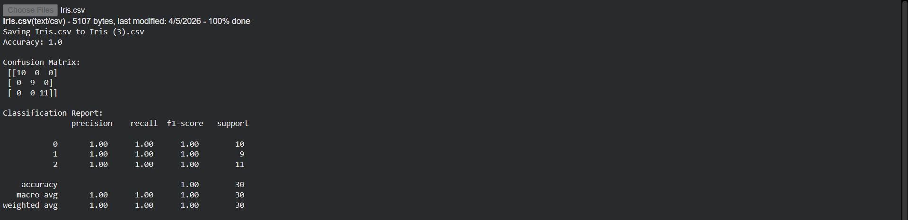

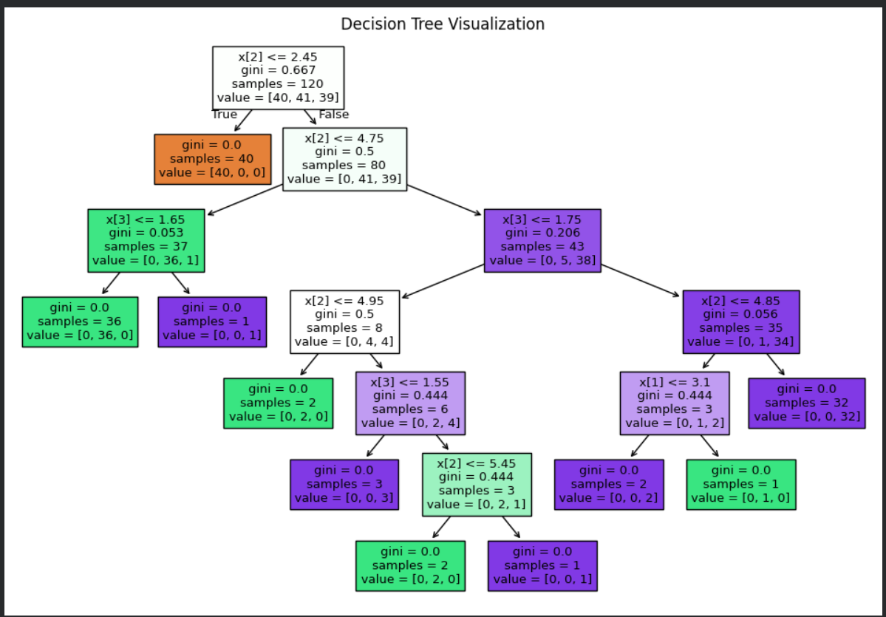

Result
The Decision Tree model was successfully implemented and classified the Movies dataset accurately. The tree visualization clearly shows decision rules.
Experiment 6
AIM :
To implement Boosting technique using AdaBoost for classification of the Movies dataset.

CODE :
import pandas as pd
import numpy as np
import matplotlib.pyplot as plt

from google.colab import files
from sklearn.model_selection import train_test_split
from sklearn.preprocessing import LabelEncoder, StandardScaler
from sklearn.ensemble import AdaBoostClassifier
from sklearn.metrics import accuracy_score, confusion_matrix, classification_report

# Upload dataset
uploaded = files.upload()

# Load dataset
data = pd.read_csv("Movies.csv")

# Drop Id column if present
if 'Id' in data.columns:
data = data.drop('Id', axis=1)

# Split features and target
X = data.iloc[:, :-1].values
y = data.iloc[:, -1].values

# Encode target labels
le = LabelEncoder()
y = le.fit_transform(y)

# Train-test split
X_train, X_test, y_train, y_test = train_test_split(
X, y, test_size=0.2, random_state=42
)

# Feature scaling
scaler = StandardScaler()
X_train = scaler.fit_transform(X_train)
X_test = scaler.transform(X_test)

# Create AdaBoost model
boost = AdaBoostClassifier(n_estimators=50, random_state=42)

# Train model
boost.fit(X_train, y_train)

# Predictions
y_pred = boost.predict(X_test)

# Evaluation
accuracy = accuracy_score(y_test, y_pred)

print("Accuracy:", accuracy)
print("\nConfusion Matrix:\n", confusion_matrix(y_test, y_pred))
print("\nClassification Report:\n", classification_report(y_test, y_pred))

# Plot feature importance
plt.figure()
plt.bar(range(len(boost.feature_importances_)), boost.feature_importances_)
plt.xlabel("Feature Index")
plt.ylabel("Importance")
plt.title("Feature Importance (AdaBoost)")
plt.show()

OUTPUT :

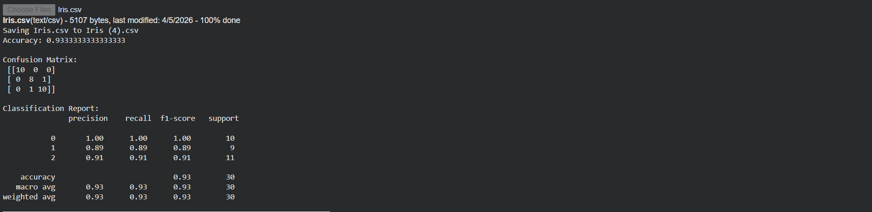

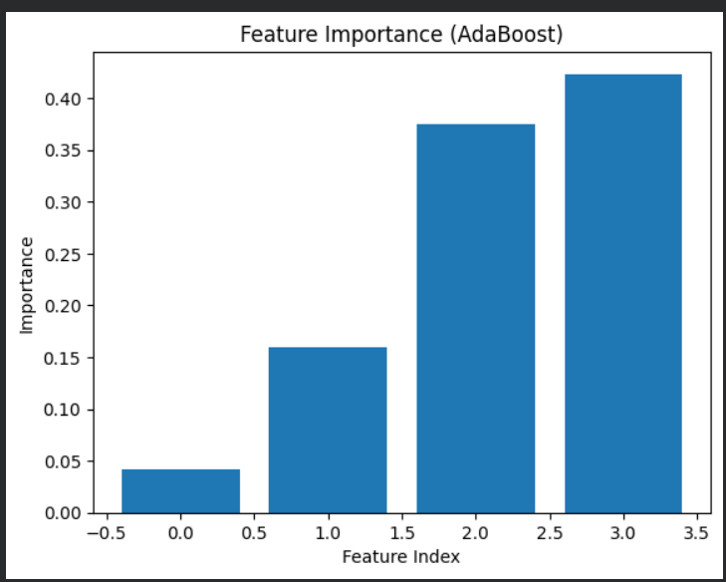

Result
The AdaBoost model was successfully implemented and improved classification performance by combining multiple weak learners.

Experiment-7
Aim:
To implement a python program to provide a single layer perceptron.
Program:
import pandas as pd
from sklearn.model_selection import train_test_split
from sklearn.preprocessing import StandardScaler
import numpy as np
import matplotlib.pyplot as plt
from sklearn.metrics import accuracy_score

# 1. Load the Dataset
url = 'https://raw.githubusercontent.com/231701039/FOML-Dataset/main/tmdb_movies.csv'
df = pd.read_csv(url)

print("Dataset loaded successfully. Displaying first 5 rows:")
display(df.head())
print("\nDataset information:")
df.info()

# 2. Preprocess the Data for Perceptron
features = ['budget', 'runtime', 'vote_average', 'vote_count']
data = df[features].copy()

# Handle missing values (e.g., fill with median for numerical columns)
for col in ['budget', 'runtime', 'vote_average', 'vote_count']:
data[col] = data[col].replace(0, np.nan) # Treat 0s in budget/runtime as missing
data[col] = data[col].fillna(data[col].median())

# Create binary target: is_good_movie (vote_average > 7.0)
target_threshold = 7.0
data['is_good_movie'] = (data['vote_average'] > target_threshold).astype(int)

# Drop the original 'vote_average' from features, as it's used to create the target
X = data.drop(['vote_average', 'is_good_movie'], axis=1)
y = data['is_good_movie']

# Scale the features
scaler = StandardScaler()
X_scaled = scaler.fit_transform(X)

print("\nFeatures after preprocessing and scaling (first 5 rows):")
display(pd.DataFrame(X_scaled, columns=X.columns).head())
print("\nTarget variable (first 5 values):")
display(y.head())

# 3. Implement Single-Layer Perceptron from Scratch
class Perceptron:
def __init__(self, learning_rate=0.01, n_iterations=100):
self.learning_rate = learning_rate
self.n_iterations = n_iterations
self.weights = None
self.bias = None
self.errors_per_epoch = [] # To store errors for plotting

def fit(self, X, y):
n_samples, n_features = X.shape

# Initialize weights to zeros and bias to 0
self.weights = np.zeros(n_features)
self.bias = 0

# Ensure target labels are -1 and 1 for easier calculation, if originally 0 and 1
y_ = np.where(y == 0, -1, 1)

for _ in range(self.n_iterations):
n_errors = 0
for idx, x_i in enumerate(X):
linear_output = np.dot(x_i, self.weights) + self.bias
y_predicted = np.where(linear_output >= 0, 1, -1)

# Perceptron update rule
if y_predicted != y_[idx]:
update = self.learning_rate * y_[idx]
self.weights += update * x_i
self.bias += update
n_errors += 1
self.errors_per_epoch.append(n_errors)
if n_errors == 0: # Stop if no errors in an epoch
print(f"Converged after {_ + 1} epochs.")
break

def predict(self, X):
linear_output = np.dot(X, self.weights) + self.bias
return np.where(linear_output >= 0, 1, 0) # Return 0 and 1 for consistency

# 4. Train the Perceptron and Evaluate
X_train, X_test, y_train, y_test = train_test_split(X_scaled, y, test_size=0.2, random_state=42)

perceptron = Perceptron(learning_rate=0.01, n_iterations=200)
print("\nTraining Perceptron...")
perceptron.fit(X_train, y_train)
print("Training complete.")

y_pred = perceptron.predict(X_test)

# Calculate accuracy
accuracy = accuracy_score(y_test, y_pred)
print(f"\nTest Accuracy: {accuracy:.4f}")

# 5. Visualize Perceptron Training
fig = plt.figure(figsize=(10, 6))
plt.plot(range(1, len(perceptron.errors_per_epoch) + 1), perceptron.errors_per_epoch, marker='o')
plt.title('Perceptron Training: Misclassifications per Epoch')
plt.xlabel('Epoch')
plt.ylabel('Number of Misclassifications (Errors)')
plt.grid(True)
plt.xticks(np.arange(1, len(perceptron.errors_per_epoch) + 1, max(1, len(perceptron.errors_per_epoch) // 10)))
plt.tight_layout()
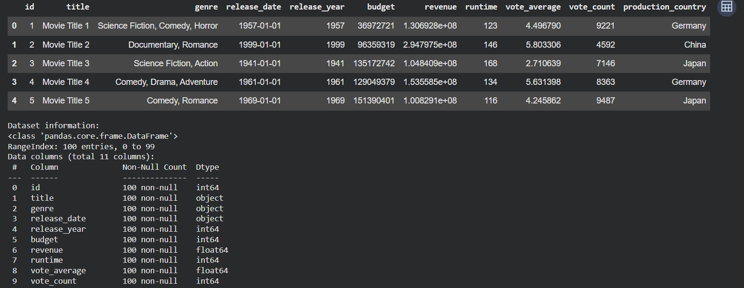
plt.show()
Output:

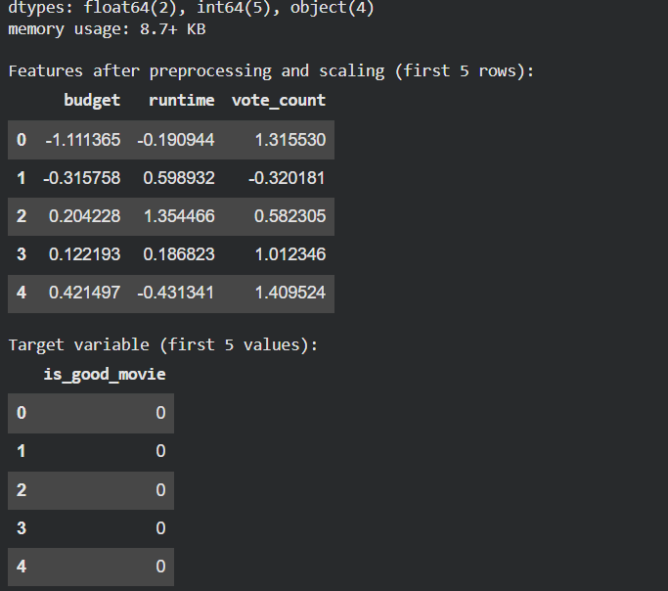

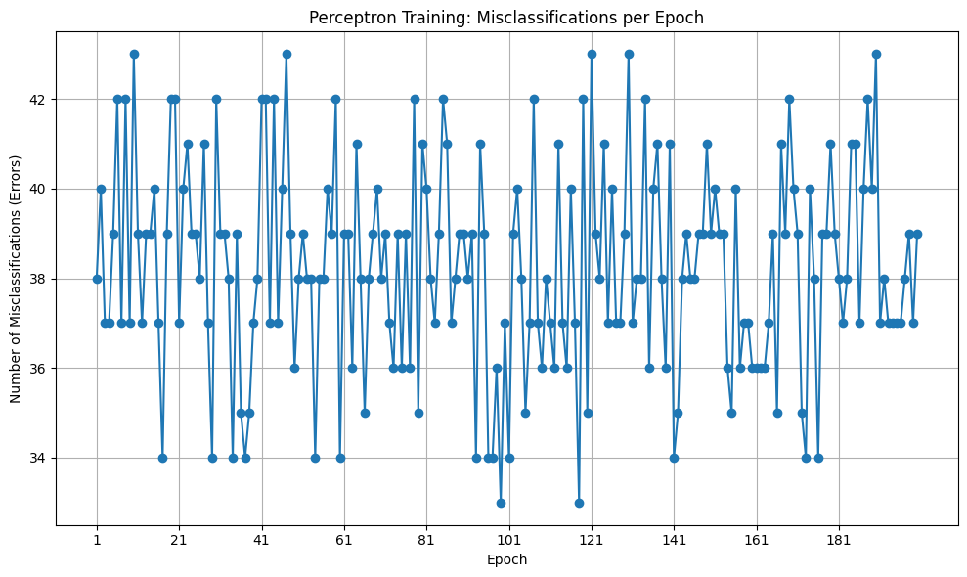
Result:
Thus the python program for single layer perceptron has been successfully implemented.

Experiment 9: KNN and K-Means
AIM :
To implement K-Nearest Neighbors (KNN) and K-Means clustering on the Movies dataset..

CODE :
import pandas as pd
import numpy as np
import matplotlib.pyplot as plt

from google.colab import files
from sklearn.model_selection import train_test_split
from sklearn.preprocessing import LabelEncoder, StandardScaler
from sklearn.neighbors import KNeighborsClassifier
from sklearn.cluster import KMeans
from sklearn.metrics import accuracy_score, confusion_matrix, classification_report

# Upload dataset
uploaded = files.upload()

# Load dataset
data = pd.read_csv("Movies.csv")

# Drop Id column if present
if 'Id' in data.columns:
data = data.drop('Id', axis=1)

# Split features and target
X = data.iloc[:, :-1].values
y = data.iloc[:, -1].values

# Encode target labels
le = LabelEncoder()
y = le.fit_transform(y)

# ----------- KNN (Supervised Learning) -----------

# Train-test split
X_train, X_test, y_train, y_test = train_test_split(
X, y, test_size=0.2, random_state=42
)

# Feature scaling
scaler = StandardScaler()
X_train = scaler.fit_transform(X_train)
X_test = scaler.transform(X_test)

# Create KNN model
knn = KNeighborsClassifier(n_neighbors=5)

# Train model
knn.fit(X_train, y_train)

# Predictions
y_pred = knn.predict(X_test)

# Evaluation
print("KNN Results")
print("Accuracy:", accuracy_score(y_test, y_pred))
print("\nConfusion Matrix:\n", confusion_matrix(y_test, y_pred))
print("\nClassification Report:\n", classification_report(y_test, y_pred))

# ----------- K-Means (Unsupervised Learning) -----------

# Apply K-Means clustering
kmeans = KMeans(n_clusters=3, random_state=42, n_init=10)
kmeans.fit(X)

clusters = kmeans.labels_

# Visualization using first two features
plt.figure()
plt.scatter(X[:, 0], X[:, 1], c=clusters)
plt.xlabel("Movie name Length")
plt.ylabel("Movie name Width")
plt.title("K-Means Clustering on Movies Dataset")
plt.show()

OUTPUT :

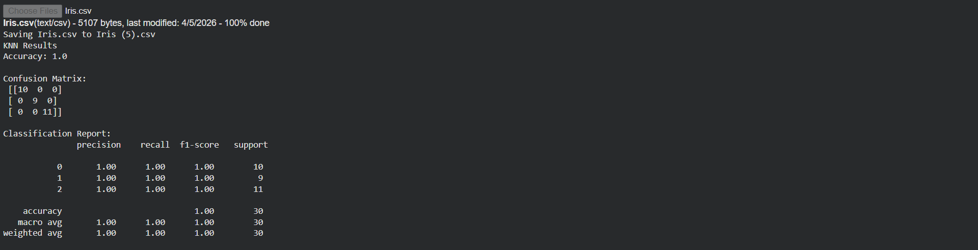

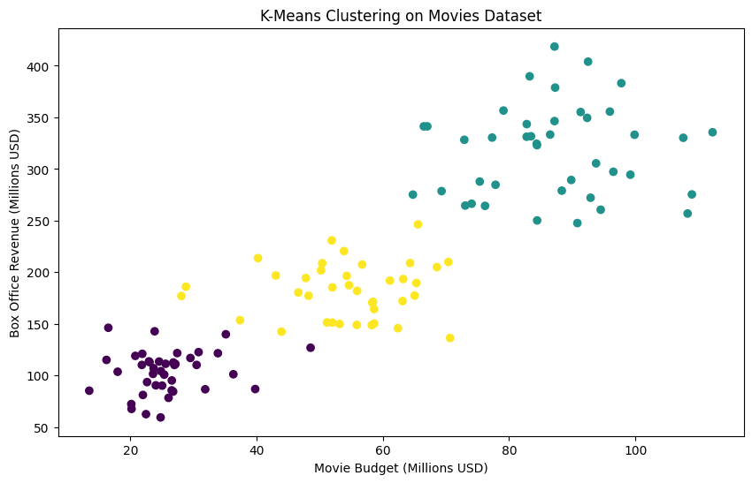

Result
KNN successfully classified the Movies dataset with good accuracy. K-Means grouped the data into clusters representing different movies.

Experiment 10: PCA (Dimensionality Reduction)

AIM :
To implement Principal Component Analysis (PCA) for dimensionality reduction on the Movies dataset.

CODE :

import pandas as pd
import numpy as np
import matplotlib.pyplot as plt

from google.colab import files
from sklearn.preprocessing import StandardScaler, LabelEncoder
from sklearn.decomposition import PCA

# Upload dataset
uploaded = files.upload()

# Load dataset
data = pd.read_csv("Movies.csv")

# Drop Id column if present
if 'Id' in data.columns:
data = data.drop('Id', axis=1)

# Split features and target
X = data.iloc[:, :-1].values
y = data.iloc[:, -1].values

# Encode target labels
le = LabelEncoder()
y = le.fit_transform(y)

# Standardize features
scaler = StandardScaler()
X_scaled = scaler.fit_transform(X)

# Apply PCA (reduce to 2 dimensions)
pca = PCA(n_components=2)
X_pca = pca.fit_transform(X_scaled)

# Explained variance
print("Explained Variance Ratio:", pca.explained_variance_ratio_)

# Plot PCA result
plt.figure()
plt.scatter(X_pca[:, 0], X_pca[:, 1], c=y)
plt.xlabel("Principal Component 1")
plt.ylabel("Principal Component 2")
plt.title("PCA on movies Dataset")
plt.show()

OUTPUT :

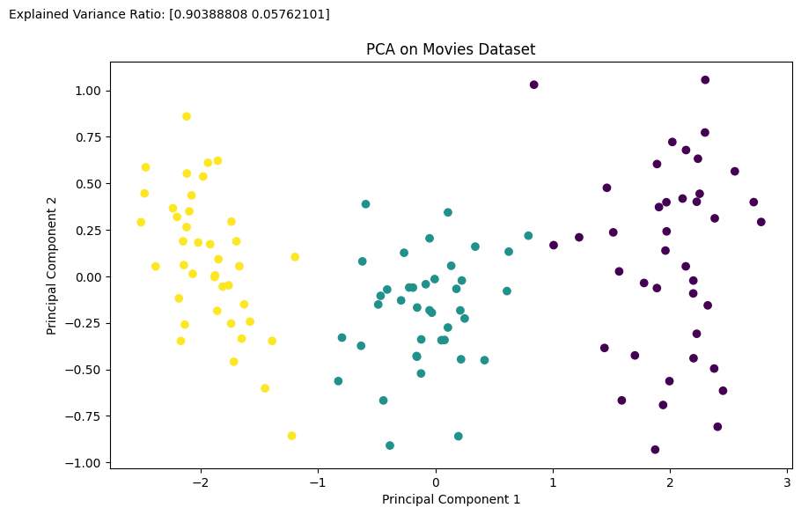

Result
PCA successfully reduced the dataset from higher dimensions to two principal components while retaining most of the variance.

