Exp. No.: 03

Name: R .PRASANNA
Reg. No.: 231701039

Aim:
To create a app for the donation application using figma .

Procedure:
- Decide what needs to be improved and gather input from users.
- Look at similar apps and gather feedback on the .
- Draw basic layout ideas on paper and create simple wireframes in Figma.
- Start a new Figma project, set up pages, and create reusable design elements.
- Design the grid with categories and item tiles, including images, names, descriptions, and prices and user details.
- Prototyping should be done to connect the frames to fulfill the app requirement.
- Show the app to users and make changes based on their feedback.

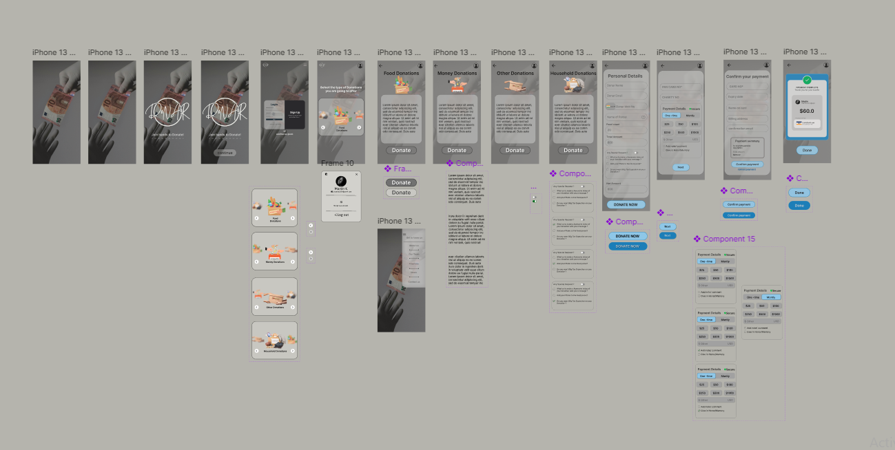

Result:
Using Figma created a app for the donation application .

