**Name: R.PRASANNA**

**Reg. No.: 231701039**

**Aim:**

To develop and design a mobile app for remote control.

**Procedure:**

1. Open Figma.
2. Start a new design file.
3. Choose the size for your design or frame size.
4. Add and arrange text, images, and other elements.
5. Select the frame.
6. Find the “Fill” option.
7. Choose a new color or enter a hex code.
8. Save your design elements in the desired format.

**Screenshots:**

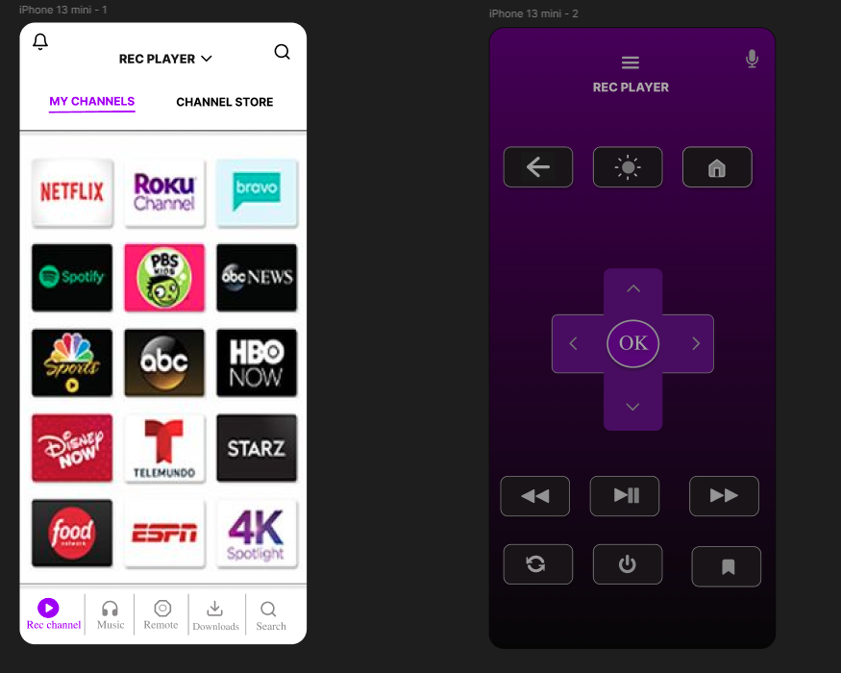

**Result:**

Using Figma, a remote has been developed and designed.