**Name: Y. BHARGAV**

**Reg. No.: 231701063**

**Aim:**

To develop and design a application for kids learning.

**Procedure:**

1. Open Figma.
2. Start a new design file.
3. Choose the size for your design or frame size.
4. Add and arrange text, images, and other elements.
5. Select the frame.
6. Find the “Fill” option.
7. Choose a new color or enter a hex code.
8. Save your design elements in the desired format.

**Screenshots:**

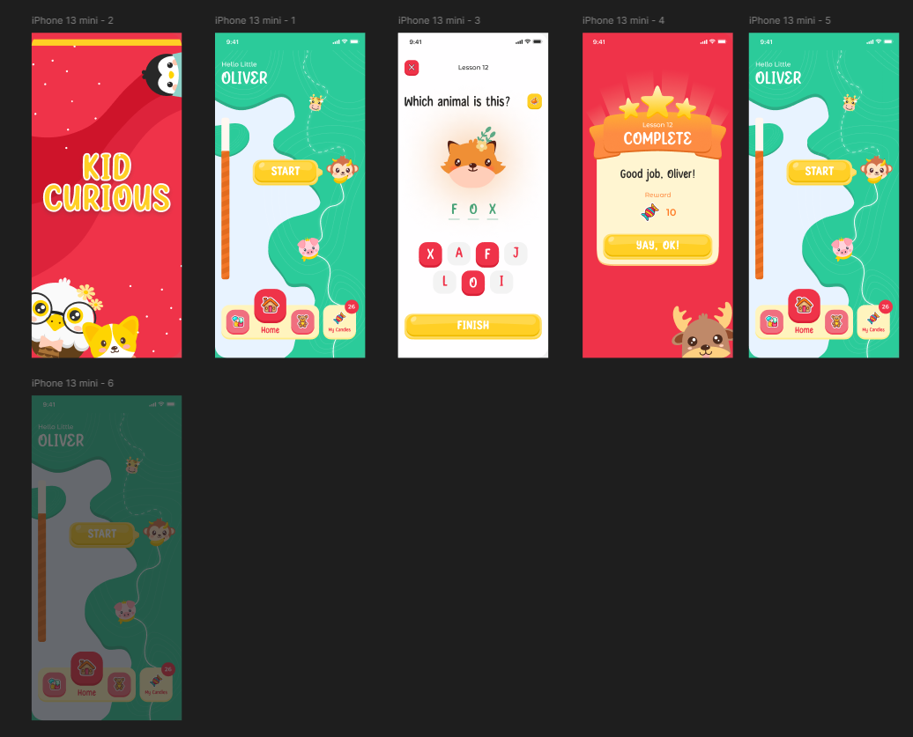

**Result:**

Using Figma, an application for kids learning that has been developed and designed.