Exp No: 4  Date: 27.2.25 | PERSONAL INFORMATION

AIM:
To create a web form that accepts a user’s name and age and to write a servlet to process the form data and display it back on the browser

PROGRAM:

User.html

<!DOCTYPE html>
<html>
<head>
<meta charset="ISO-8859-1">
<title>LOGIN</title>
</head>
<body>
<h1>Hello User!!</h1>
<form method="GET" action="/iraiyanbu_61/user_validate.jsp">
<p>
<label>Name:</label>
<input type="text" name = "name"/>
</p>
<p>
<label>Age:</label>
<input type="number" name = "age"/>
</p>
<input type="submit" value="submit"/>
</body>
</html>

User_validate.jsp

<%@ page language="java" contentType="text/html; charset=ISO-8859-1"
pageEncoding="ISO-8859-1"%>
<!DOCTYPE html>
<html>
<head>
<meta charset="ISO-8859-1">
<title>DETAILS</title>
</head>
<body>
<%
String a = request.getParameter("name");
int b = Integer.parseInt(request.getParameter("age"));
%>
<h1>Find your details</h1>
<p>Username:<%=a%></p>
<p>Age:<%=b%><p>
</body>
</html>

OUTPUT:
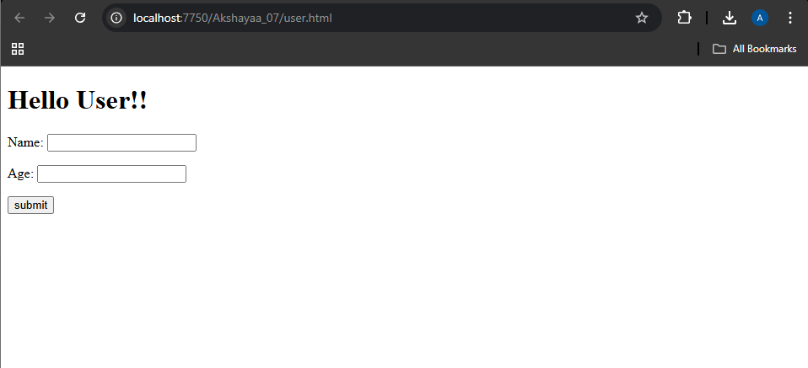

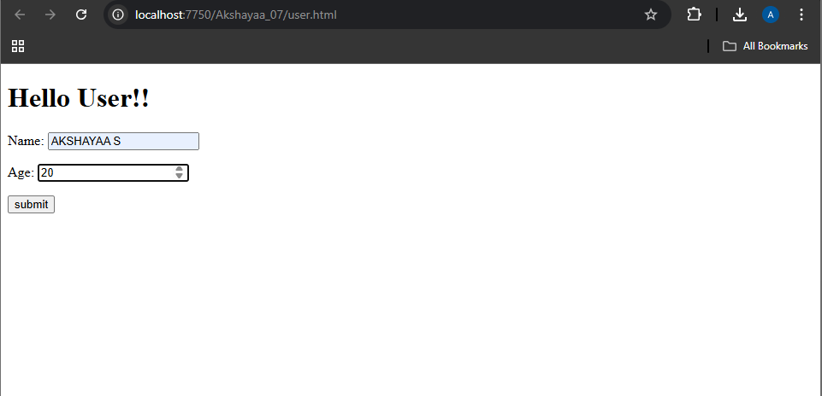

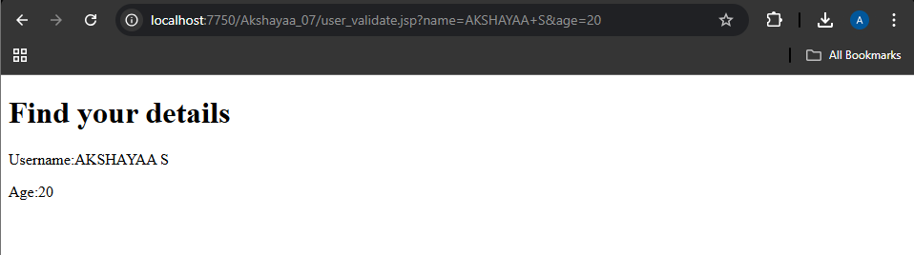

RESULT :
Thus the create a web form that accepts a user’s name and age and to write a servlet to process the form data and display it back on the browser has been implemented and verified successfully

