Exp No: 5  Date: 06.03.25 | HTTP PST AND GET

AIM:
To write a servlet to demonstrate the difference between HTTP GET and POST methods by creating a form and hadling requests accordingly

PROGRAM:

Login.java

Package com.iraiyanbu.servlet;

import java.io.IOException;
import java.io.PrintWriter;

import javax.servlet.ServletException;
import javax.servlet.annotation.WebServlet;
import javax.servlet.http.HttpServlet;
import javax.servlet.http.HttpServletRequest;
import javax.servlet.http.HttpServletResponse;

@WebServlet("/Login")
public class Login extends HttpServlet {
private static final long serialVersionUID = 1L;

/**
* @see HttpServlet#HttpServlet()
*/
public Login() {
super();
// TODO Auto-generated constructor stub
}
protected void doGet(HttpServletRequest request, HttpServletResponse response) throws ServletException, IOException {
String user="iraiyanbu";
String password="iraiyanbu";
String a= request.getParameter("username");
String b= request.getParameter("password");
PrintWriter p = response.getWriter();
if(a.equals(user)&&b.equals(password)){
p.println("Successfully");
}
else {
p.println("Try again");
}
}
protected void doPost(HttpServletRequest request, HttpServletResponse response) throws ServletException, IOException {
// TODO Auto-generated method stub
doGet(request, response);
}

}

SignupDetails.jsp

<%@ page language="java" contentType="text/html; charset=ISO-8859-1"
pageEncoding="ISO-8859-1"%>
<!DOCTYPE html>
<html>
<head>
<meta charset="ISO-8859-1">
<title>Details</title>
</head>
<body>
<%
String firstname = request.getParameter("First Name");
String lastname = request.getParameter("Last Name");
String dob =request.getParameter("Date of Birth");
String gender = request.getParameter("Gender");
String Address = request.getParameter("Address");
%>
<h1>Find your details</h1>
<p>First Name:<%=firstname%></p>
<p>Last Name:<%=lastname%><p>
<p>date of birth:<%=dob%></p>
<p>Gender:<%=gender%><p>
<p>Address:<%=Address%><p>
</body>
</html>

Signup.html

<!DOCTYPE html>
<html>
<head>
<meta charset="ISO-8859-1">
<title>LOGIN</title>
</head>
<body>
<h1>Hello User!!</h1>
<form method="POST" action="/Akshayaa_07/SignupDetails.jsp">
<p>
<label>First Name:</label>
<input type="text" name = "First Name"/>
</p>
<p>
<label>Last Name:</label>
<input type="text" name = "Last Name"/>
</p>
<p>
<label>Date of birth:</label>
<input type="date" name = "Date of Birth"/>
</p>
<p>
<label>Gender:</label>
<input type="radio" name = "Gender" value="Male">Male
<input type="radio" name = "Gender" value="Female">Female
</p>
<p>
<label for="Address">Address:</label>
<textarea id="Address" name = "Address"></textarea>
</p>
<input type="Submit" value="Sign in"/>
</body>
</html>

OUTPUT:

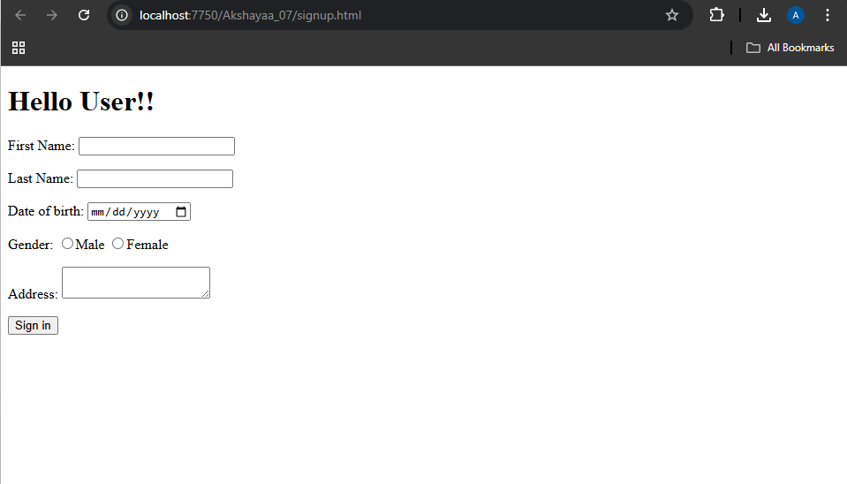

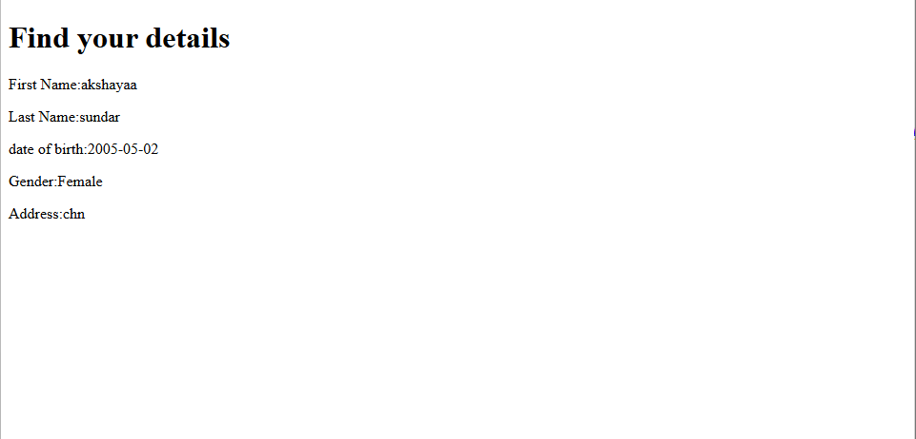
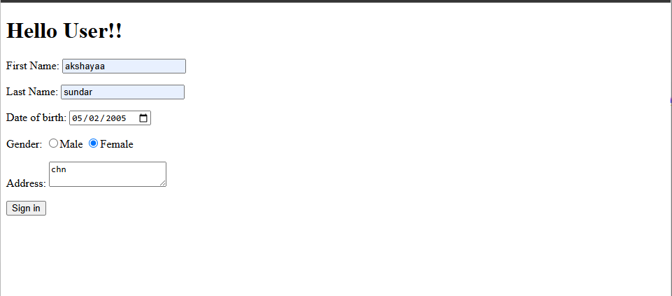

RESULT :
Thus the experiment to write a servlet to demonstrate the difference between HTTP GET and POST methods by creating a form and hadling requests accordingly has been implemented and verified successfully

