**EXP-3**

**Create Epic, Features, User Stories, Task**

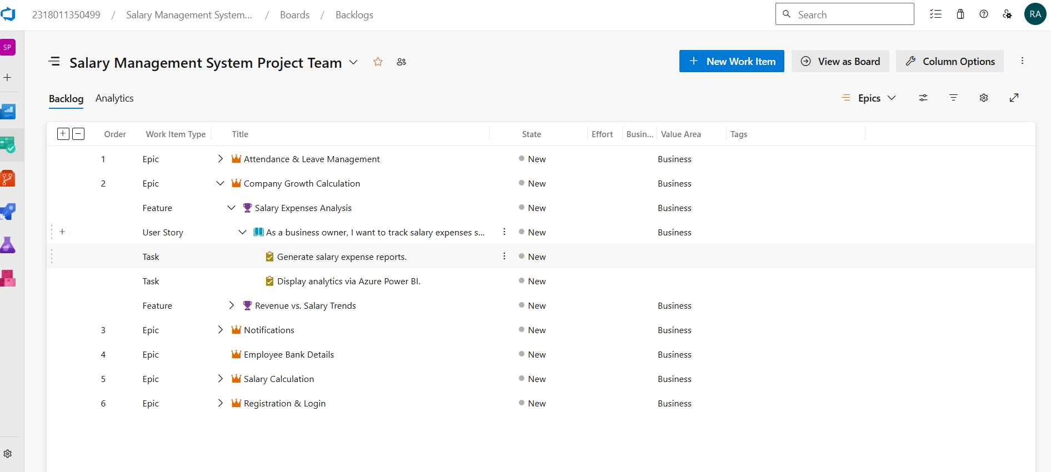

**1.Fill in Epics**

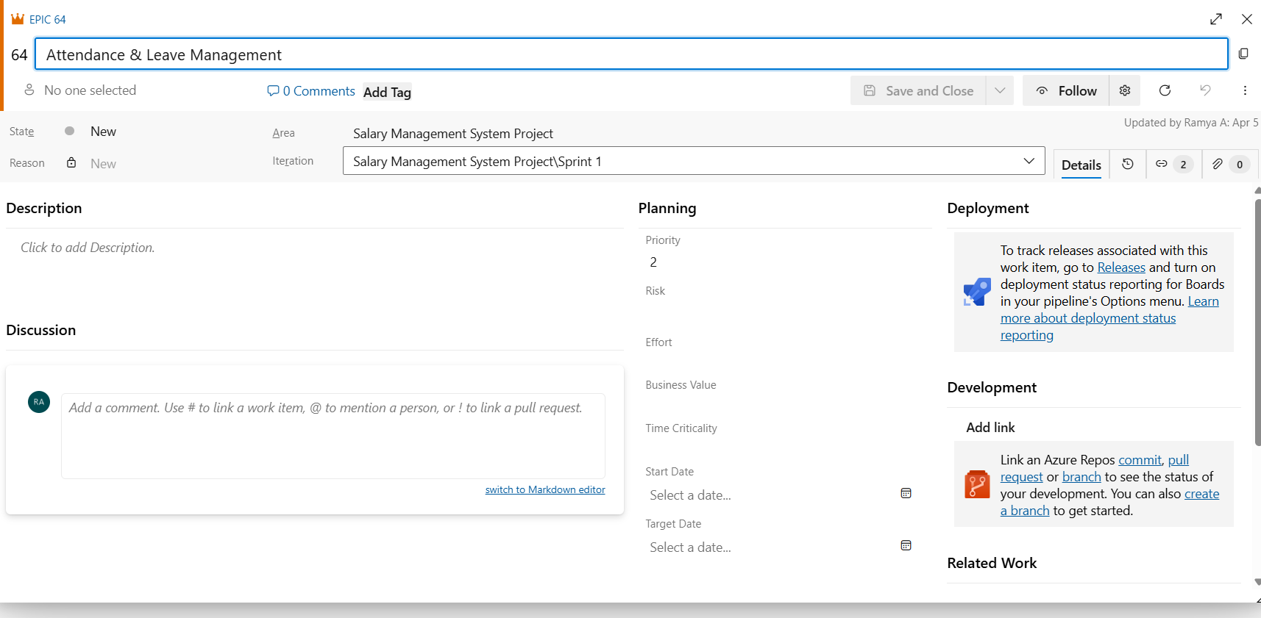

**2.Fill in Features**

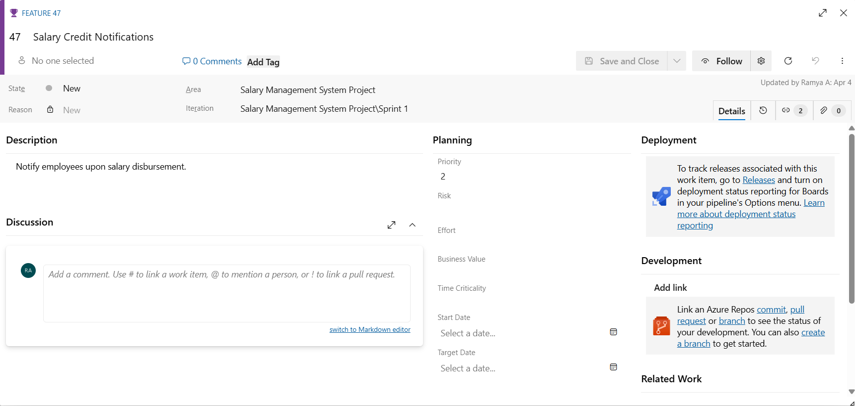

### **3.Fill in User Story Details**

