Create a web form that accepts a user's name and age Write a Servlet to process the form data and display it
back on the browser.
EXP:4

AIM:
Create a web form that accepts a user's name and age. Write a Servlet to process the form data and display it back on the browser.

CODE:
USER.HTML
<!DOCTYPE html>
<html>
<head>
<meta charset="ISO-8859-1">
<title>Insert title here</title>
</head>
<body>
<form action="/Mohan_109/Signin" >
<label for="name" >USER-NAME</label>
<input type="text" name=name placeholder="Enter the User-name" required>
<br>
<br>
<label for="age">AGE
</label>
<input type="text" name=age placeholder="Enter the Age" required>
<br>
<input type = "submit" value= "signin">
</form>
</body>
</html>

DISPLAYUSER.JAVA

package com.mohan.servlet;

import java.io.IOException; import java.io.PrintWriter;

import javax.servlet.ServletException; import javax.servlet.annotation.WebServlet; import javax.servlet.http.HttpServlet;
import javax.servlet.http.HttpServletRequest; import javax.servlet.http.HttpServletResponse;

/**
* Servlet implementation class Signin 4*/
@WebServlet("/Signin")
public class Signin extends HttpServlet {
private static final long serialVersionUID = 1L;

/**
* @see HttpServlet#HttpServlet()
*/
public Signin() { super();
// TODO Auto-generated constructor stub
}

/**
* @see HttpServlet#doGet(HttpServletRequest request, HttpServletResponse response)
*/
protected void doGet(HttpServletRequest request, HttpServletResponse response) throws ServletException, IOException {
String a = request.getParameter("name");
int b = Integer.parseInt (request.getParameter("age")); PrintWriter p = response.getWriter();
if(b>=1)
{

}
else
{

}

}
p.println("User-name: "+ a);
p.print("Age: "+ b);

p.print("Invalid credentials!");

/**
* @see HttpServlet#doPost(HttpServletRequest request, HttpServletResponse response)
*/
protected void doPost(HttpServletRequest request, HttpServletResponse response) throws ServletException, IOException {
// TODO Auto-generated method stub doGet(request, response);
}

}

OUTPUT:

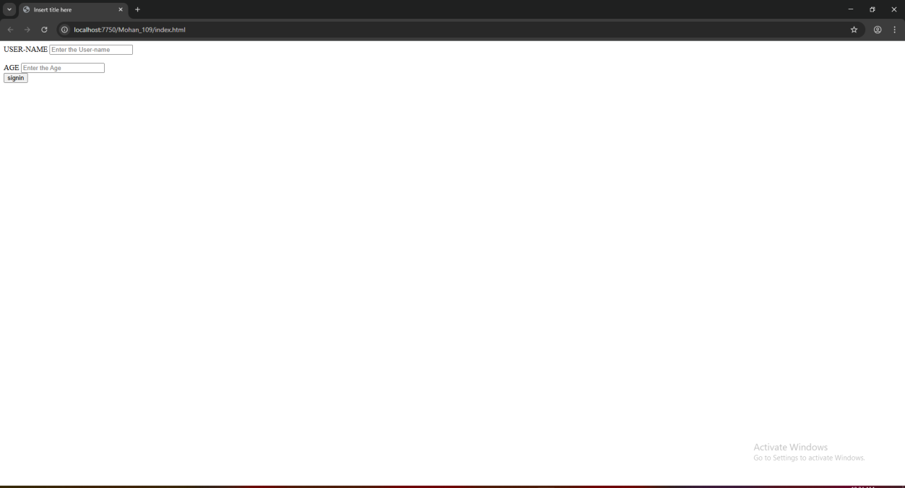



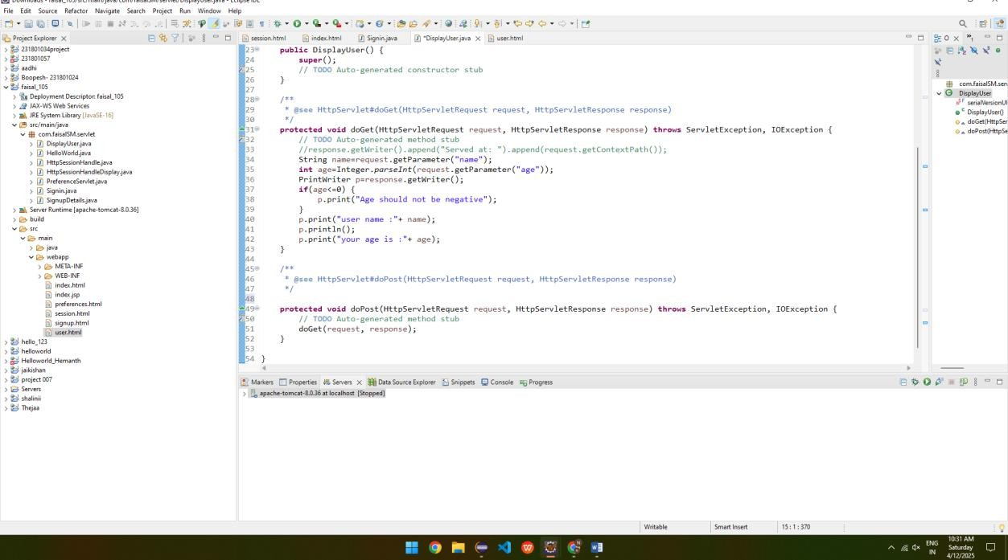

RESULT:
Validating the username and age is is done successfully and displayed in the browser.

