EXP:03 | Java Servlet Program to Display 'HelloWorld!' in Browser

AIM:
To write a servlet program that prints "HelloWorld!" and displays it in the browser when accessed.

CODE:
#HelloWorld.java
package com.faisalSM.servlet; import java.io.IOException; import java.io.PrintWriter;
import javax.servlet.ServletException; import javax.servlet.annotation.WebServlet; import javax.servlet.http.HttpServlet;
import javax.servlet.http.HttpServletRequest; import javax.servlet.http.HttpServletResponse; @WebServlet("/HelloWorld")
public class HelloWorld extends HttpServlet {
private static final long serialVersionUID = 1L;

public HelloWorld() { super();
}
protected void doGet(HttpServletRequest request, HttpServletResponse response)
throws ServletException, IOException {
PrintWriter p = response.getWriter(); p.println("HelloWorld!");
}
protected void doPost(HttpServletRequest request, HttpServletResponse response) throws ServletException, IOException {
doGet(request, response);

}
}

OUTPUT:
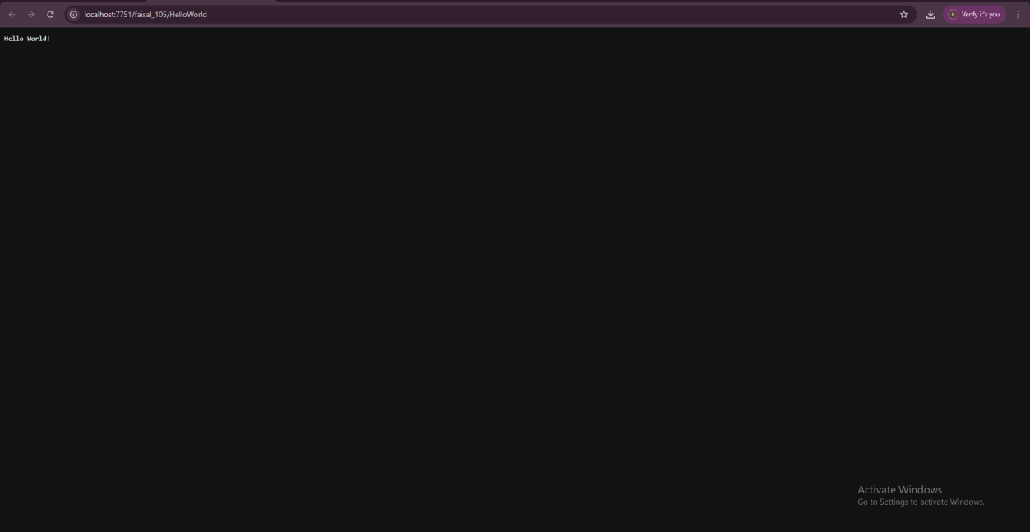

RESULT:
The servlet program successfully compiled and executed. It printed "HelloWorld" in the browser, demonstrating the use of a basic servlet using the doGet() method.

