EXP NO 1: WINDOWS FUNDAMENTALS 1 SOMILA. SA

231901052

DATE: 29/01/2025

AIM:

WINDOWS FUNDAMENTALS 1

To complete and explore the tasks in windows fundamentals 1.

PROCEDURE: Complete the tasks as per the instructions given in the respective tasks.

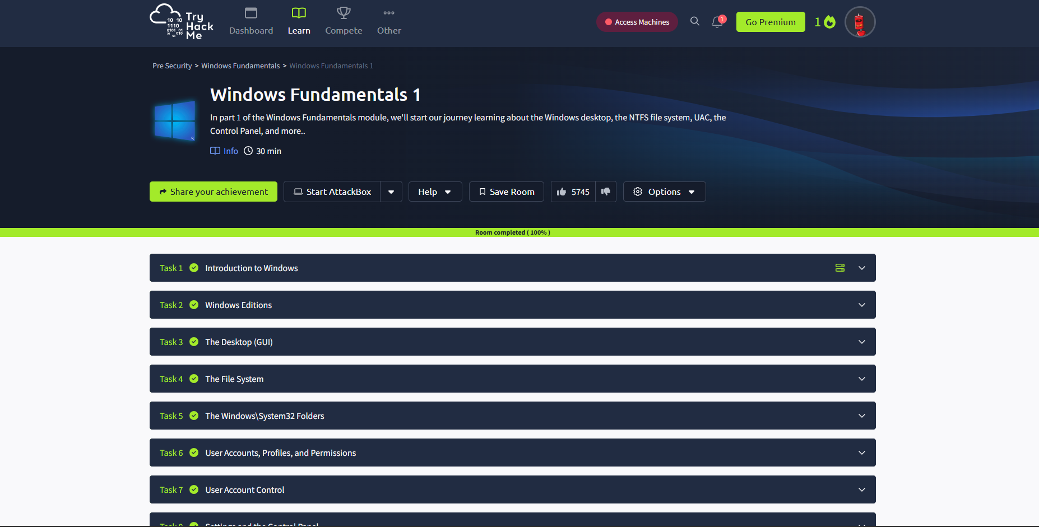

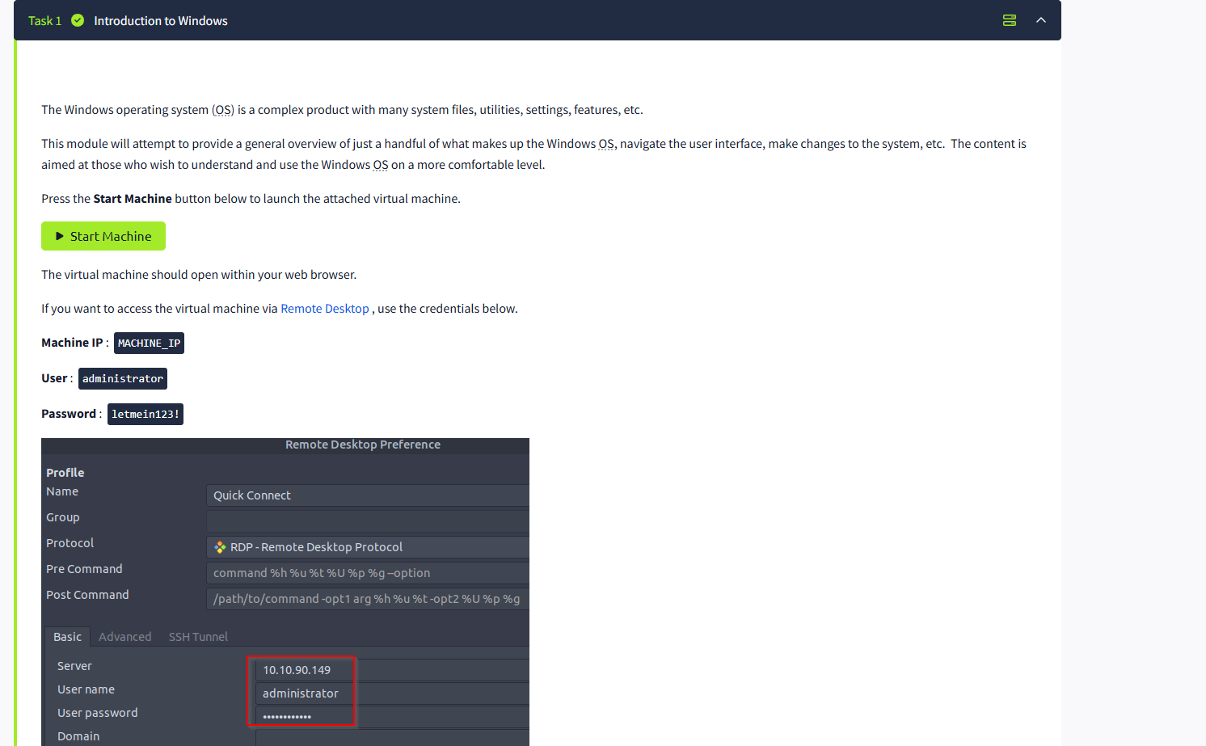

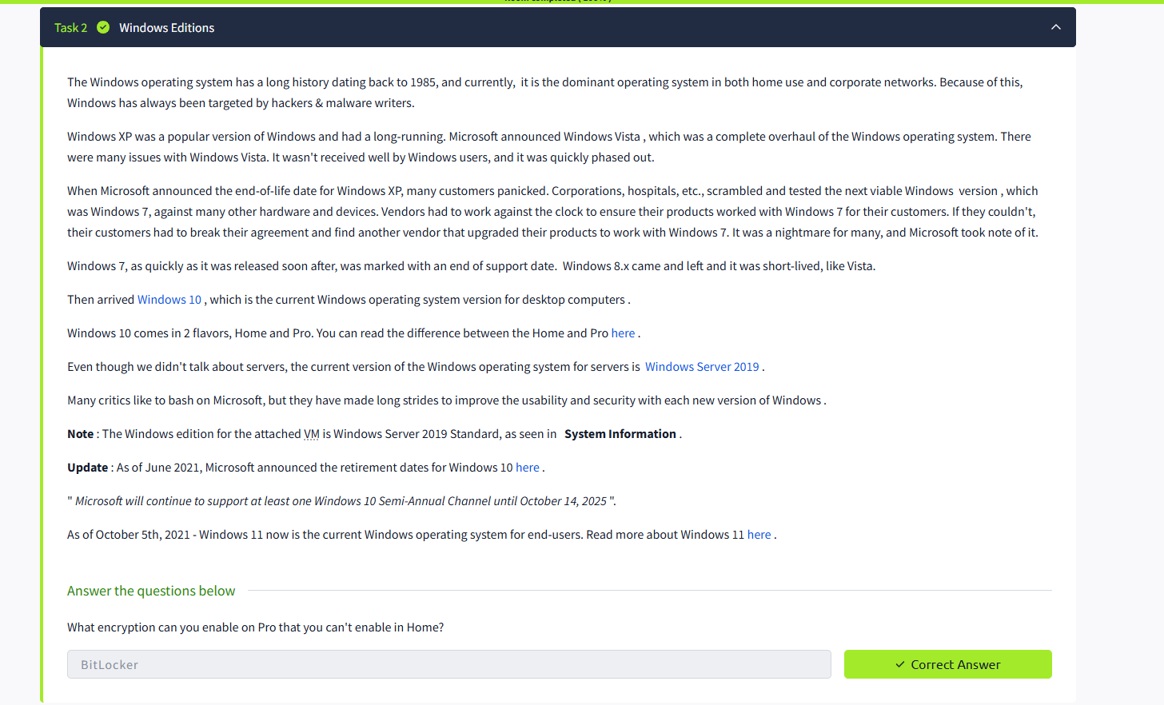

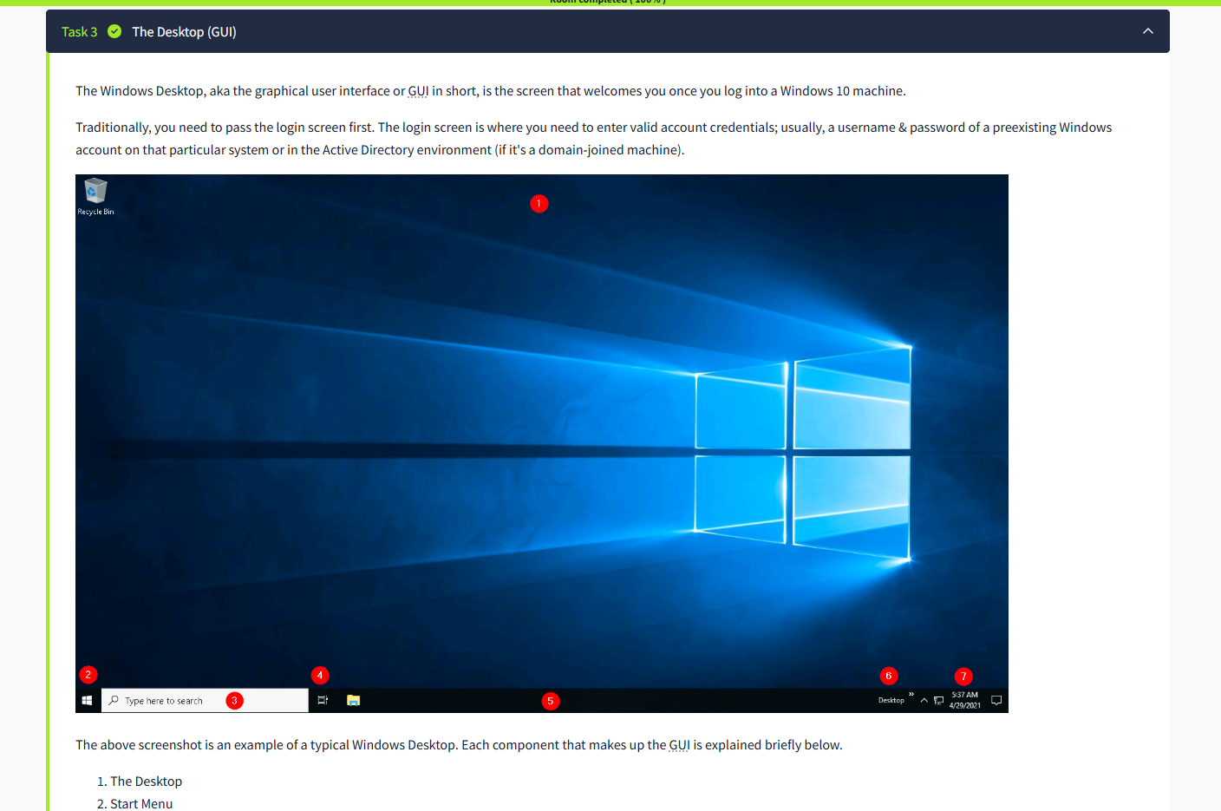

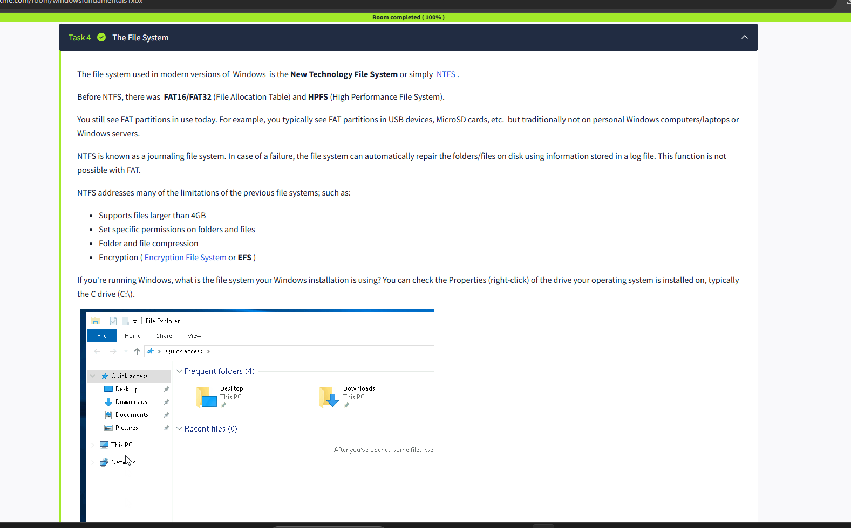

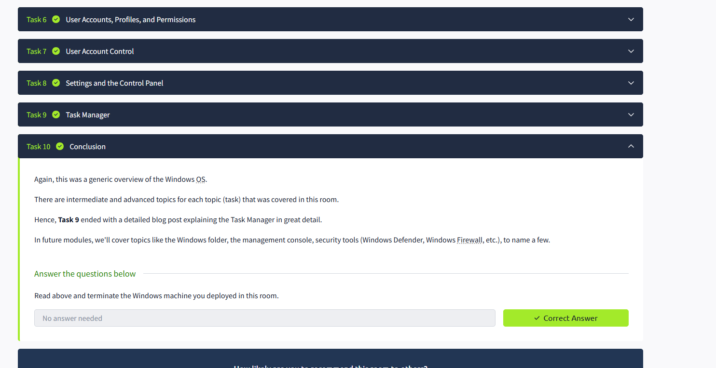

RESULT: The tasks in Windows fundamentals 1 has been completed successfully.