WINDOWS FUNDAMENTALS 2

SOMILA.SA

231901052

EX.NO:01 Date:12-02-2025

AIM: In part 2 of the Windows Fundamentals module, discover more about System Configuration, UAC Settings, Resource Monitoring, the Windows Registry and more.

PROCEDRE:

• Task 1 Introduction

• Task 2 System Configuration

• Task 3 Change UAC Settings

• Task 4 Computer Management

• Task 5 System Information

• Task 6 Resource Monitor

• Task 7 Command Prompt

• Task 8 Registry Editor

• Task 9 Conclusion TASKS:

Task 1:

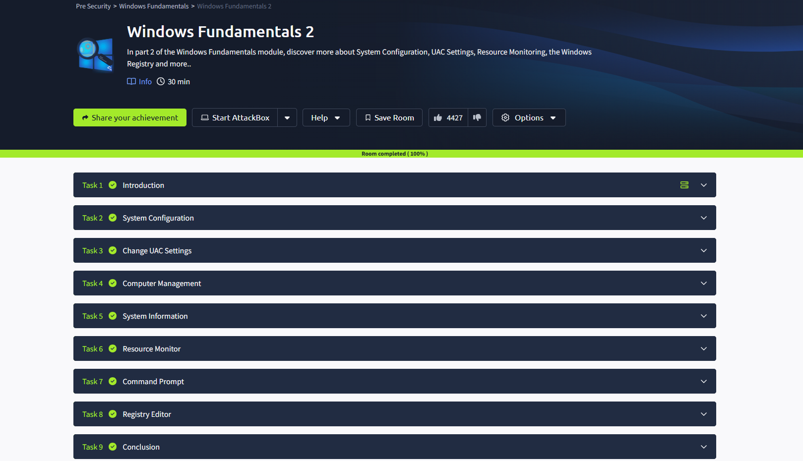

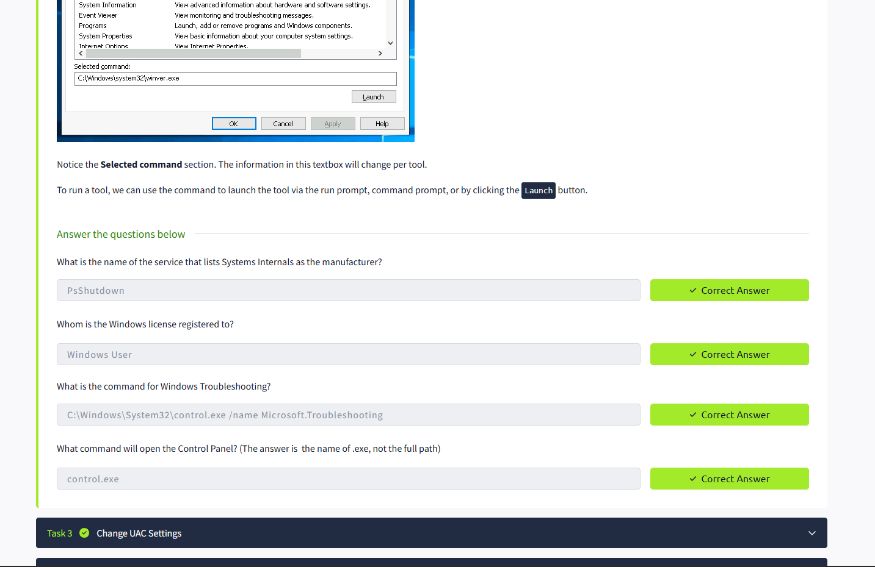

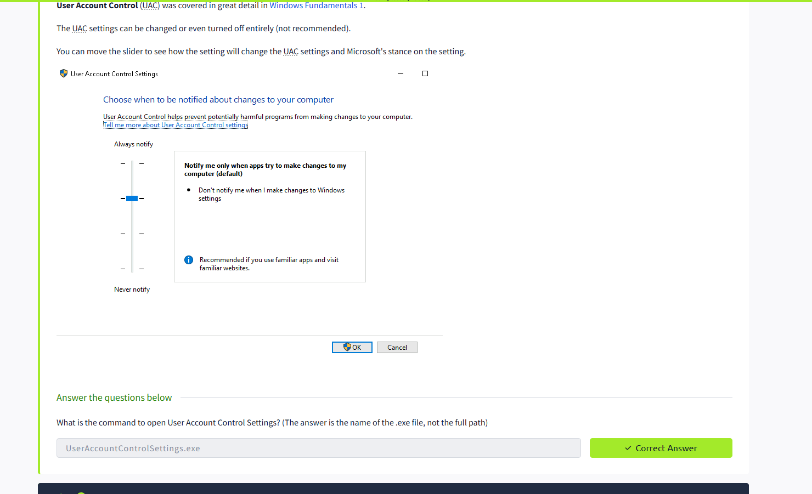

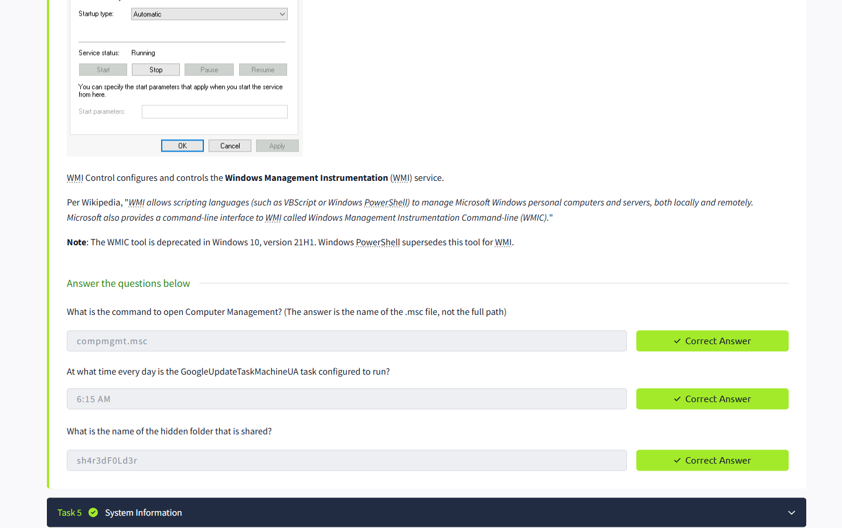

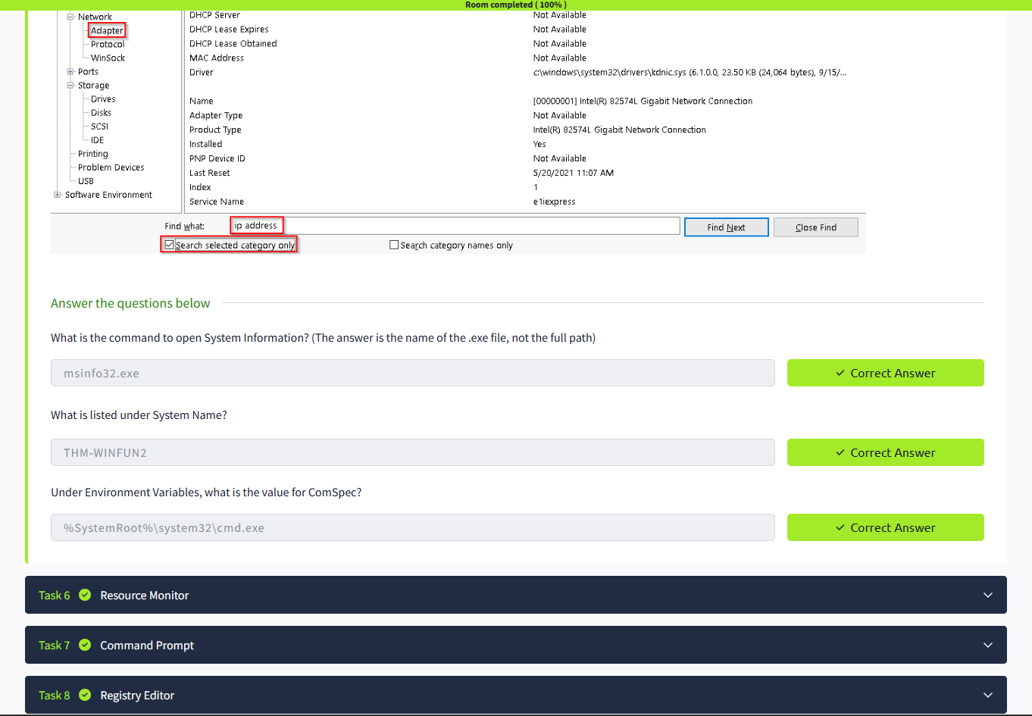

RESULT: Thus the windows fundamentals 2 successfully completed in tryhackme platform.