We use AirTest software for testing the Test1.0 and Test 2.0.

**Test1.0**

Test Content:This is a functional test, mainly to check whether the applet can add courses normally and whether it can be saved normally

Test Result:Testing successfully.

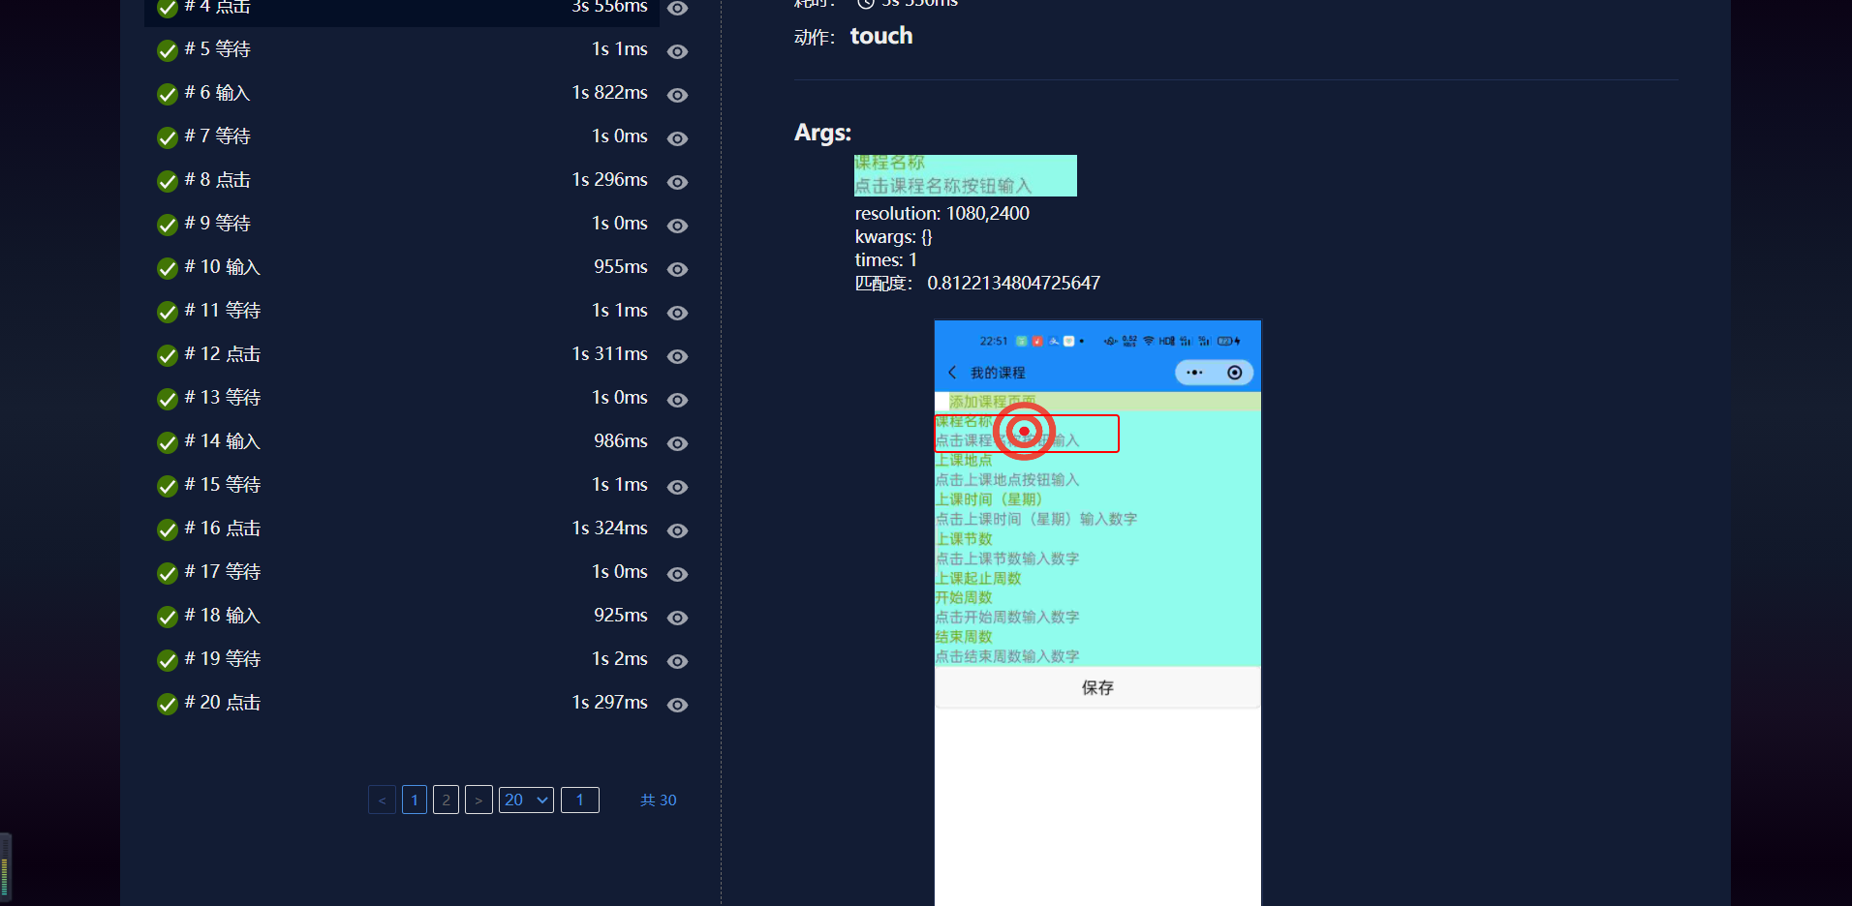

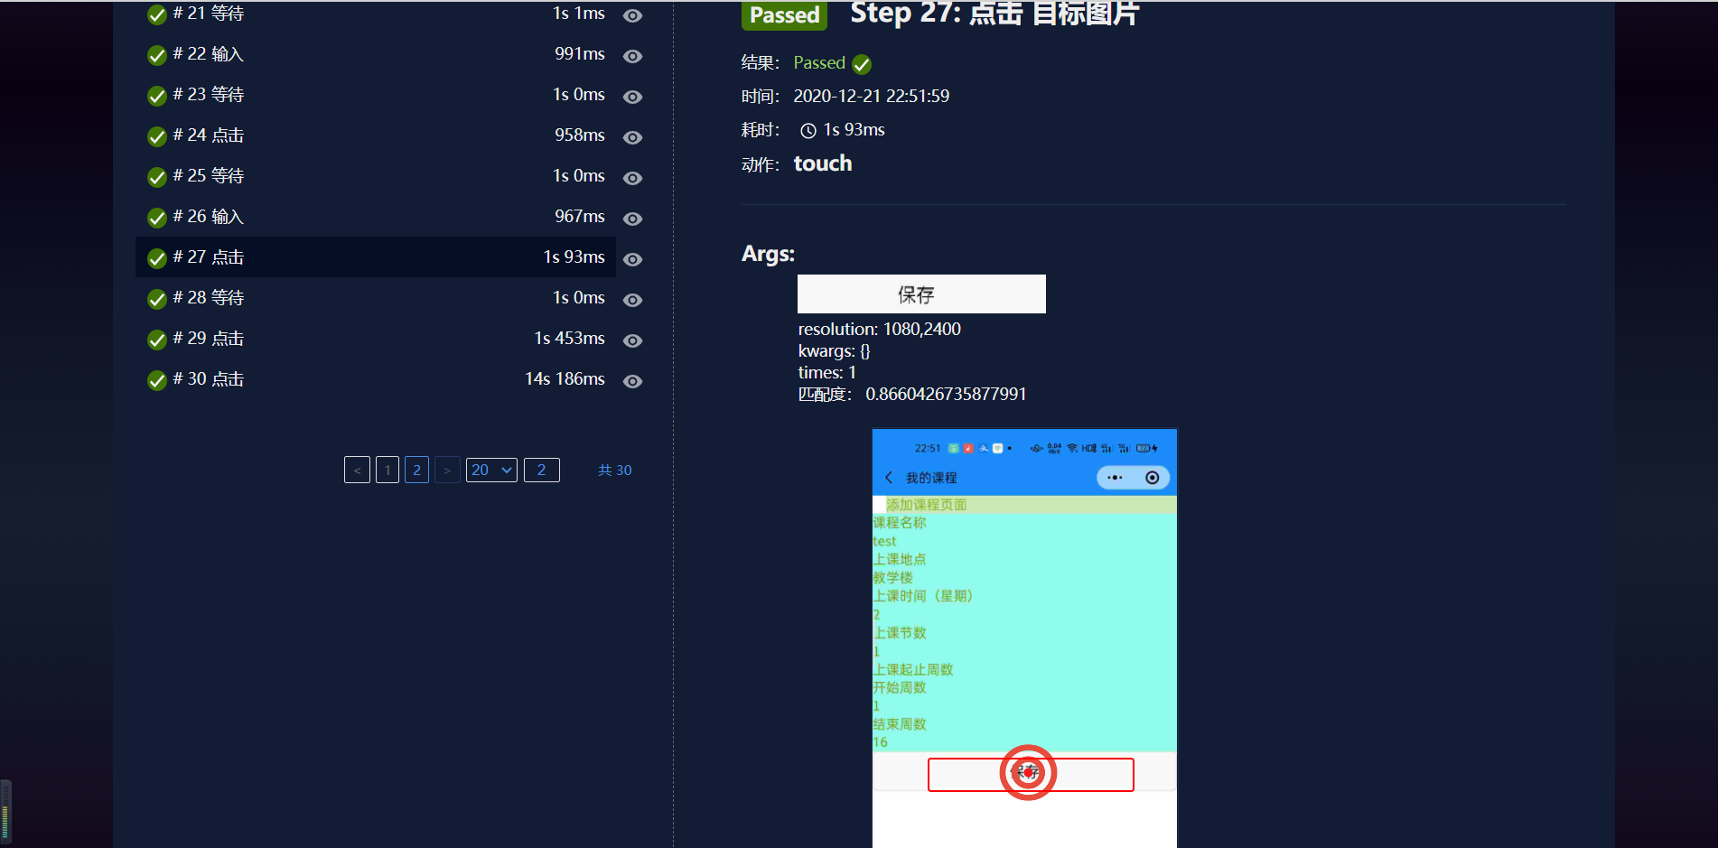

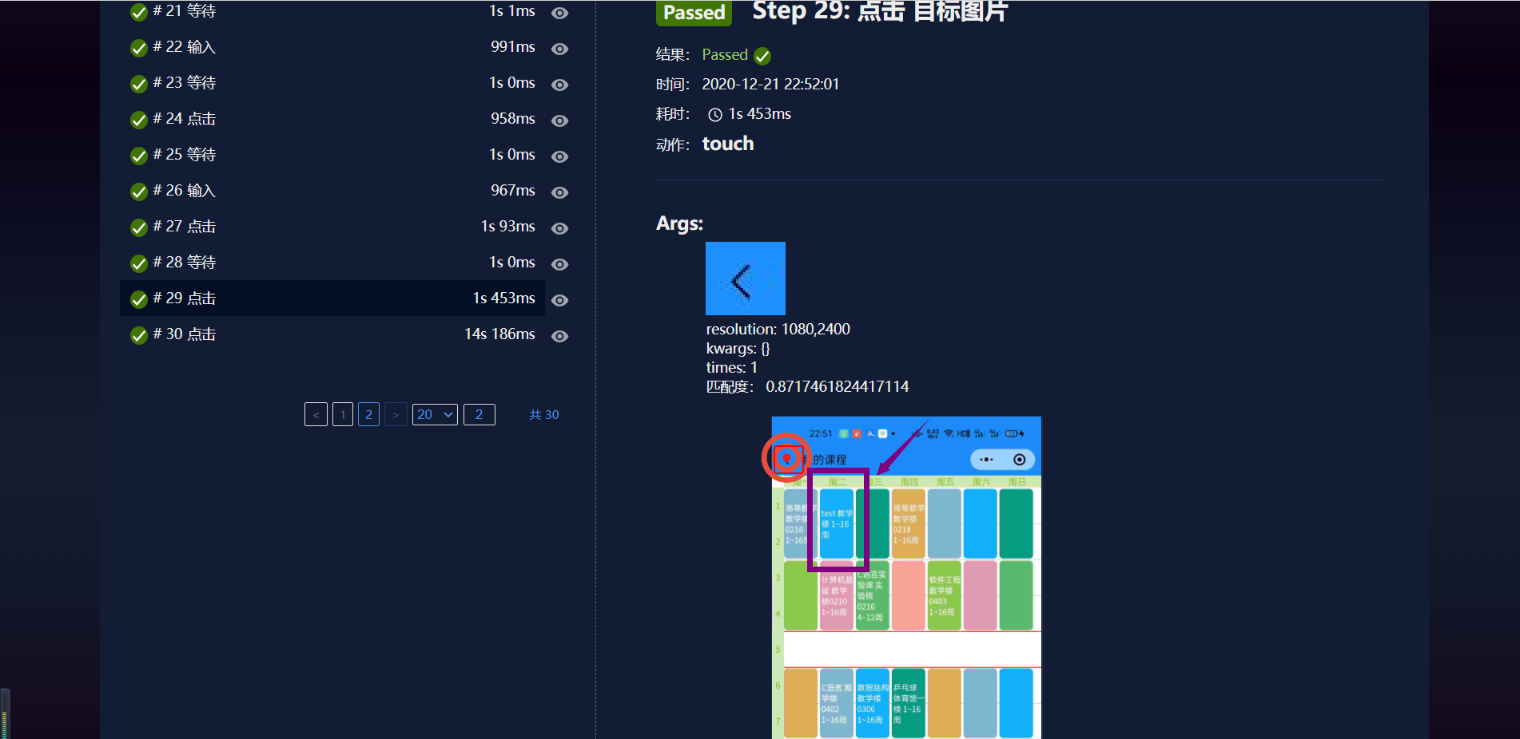

**Test2.0**

Test Content: This is a functional test,test whether the applet can add multiple course information

Test Result: Cannot add, the applet can only save the latest course information entered, and the previously entered course information is cleared.

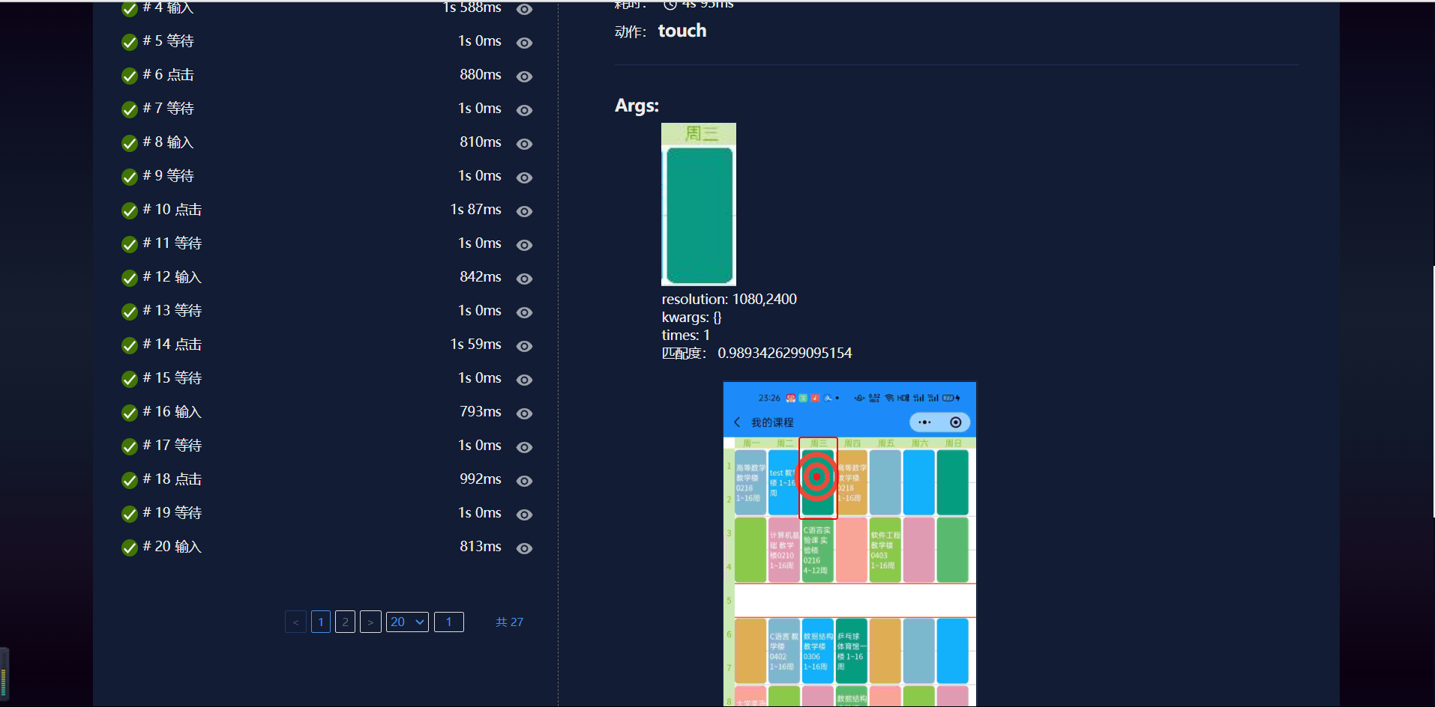

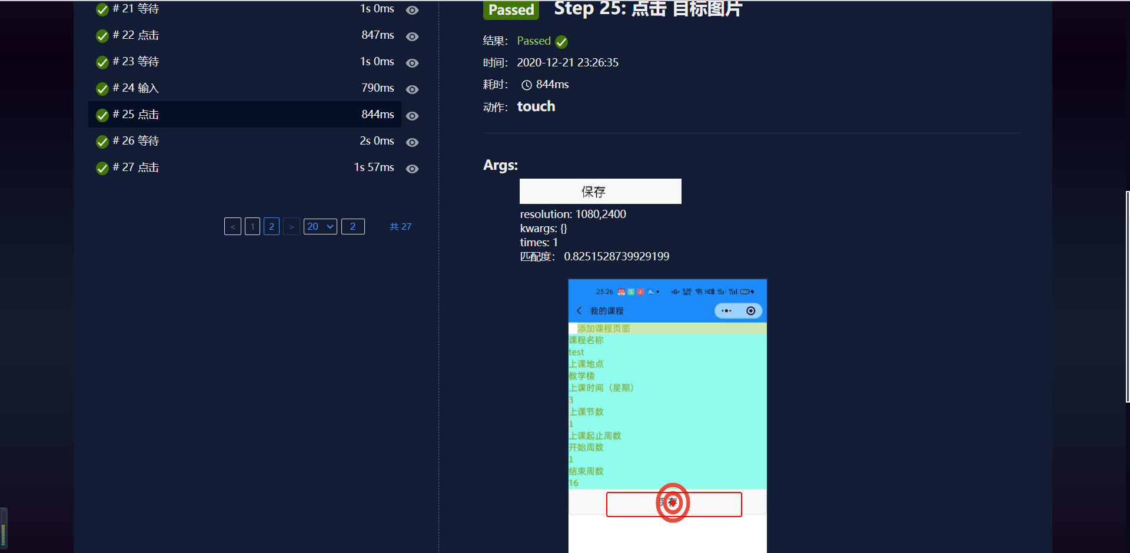

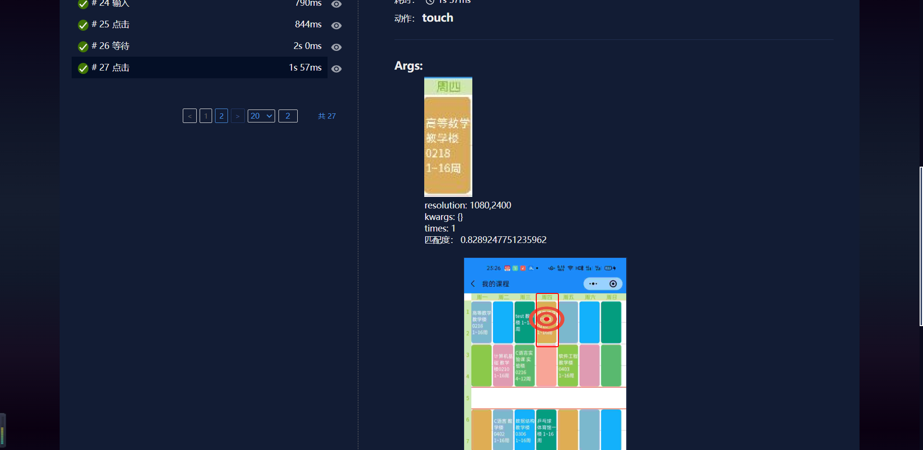

**Test3.0**

**Test Content: This is a performance test**

1.Enter the log information before and after entering the filling interface.

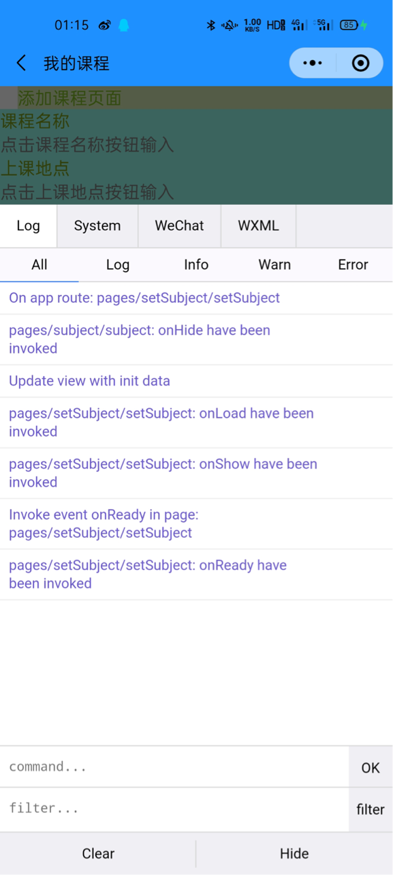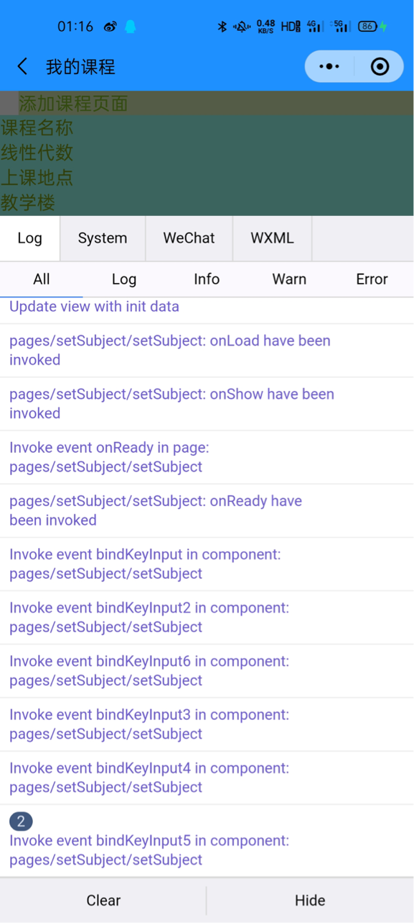

2.After clicking Save,the update is successful,the log information is correct and there is no error report.

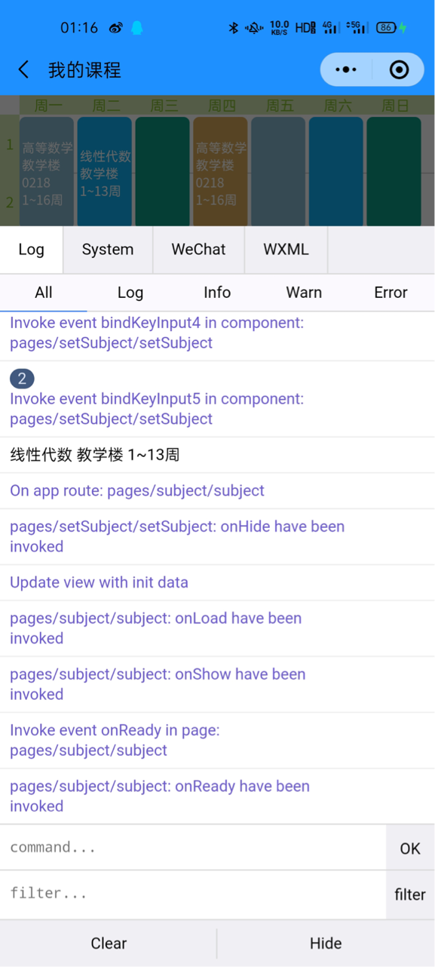

3.Set the course information to be empty and an error will be reported in the log after saving.

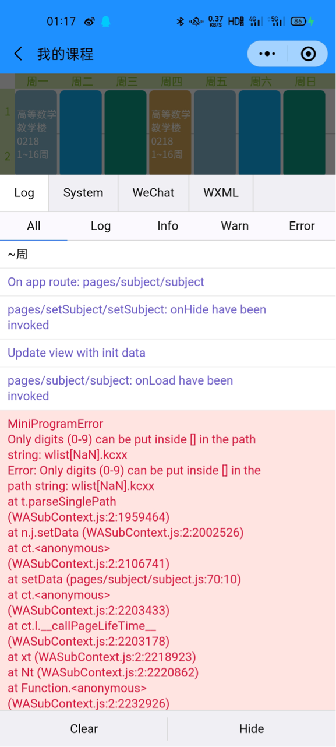

4.The applet can run under 4G.

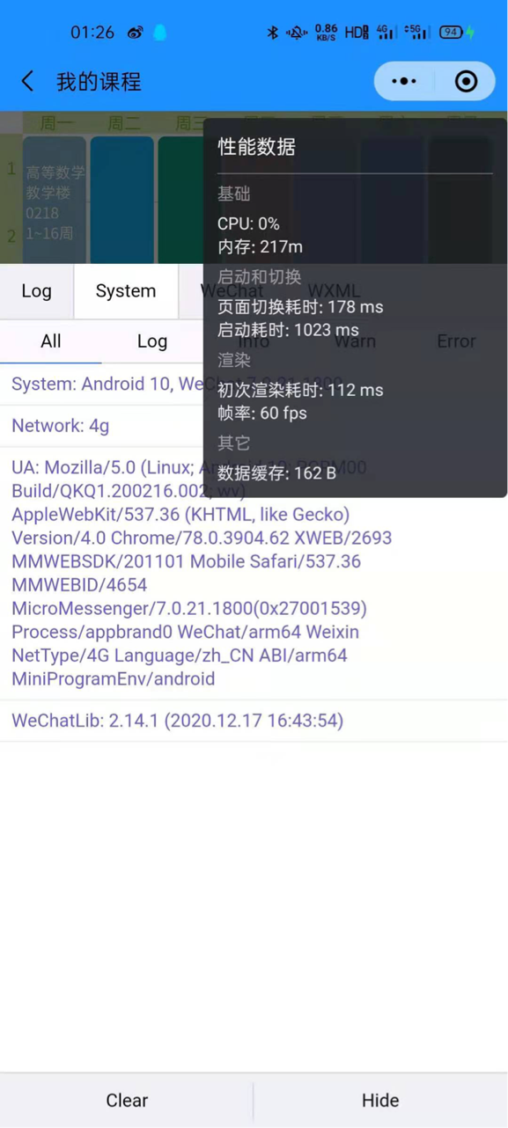

5.They are the performance data after clicking to enter the course information and clicking to import the course information. After several tests,the performance time probably fluctuates in the figures in the figure.

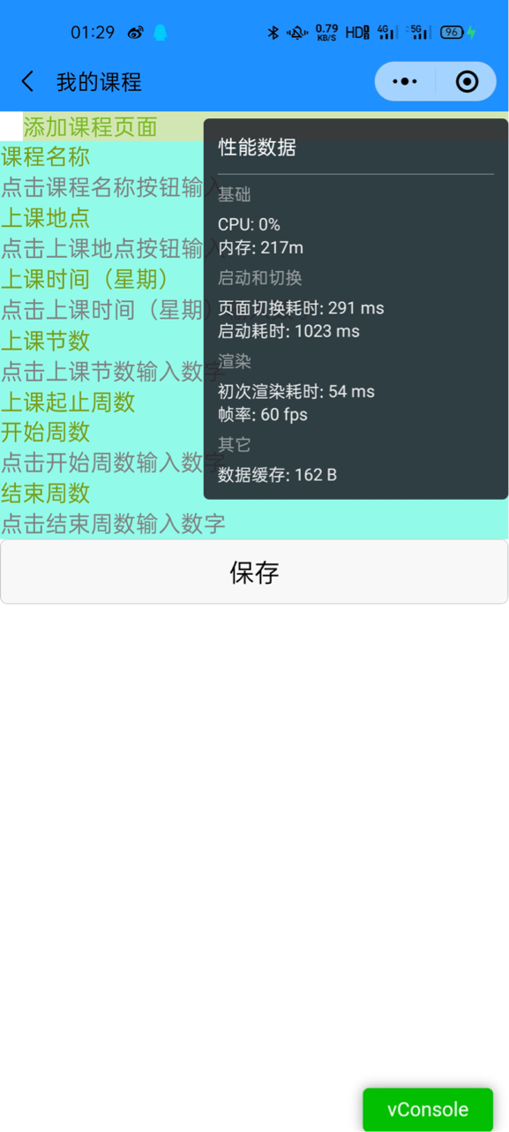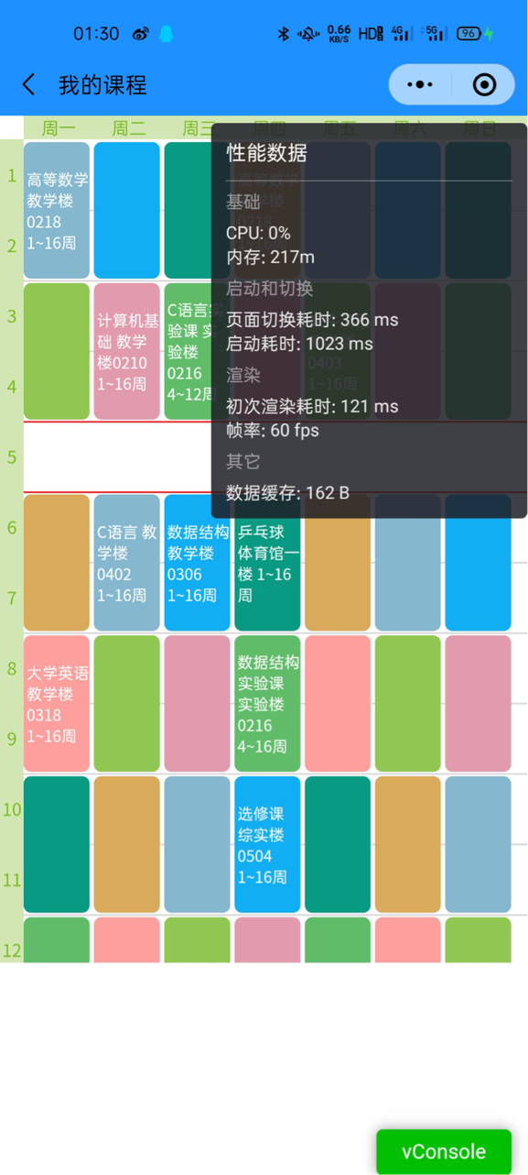

6.Configuration of the applet under WiFi.

