FRESHYSTORE

Vegetable Inventory Management System

System Overview Report | May 2025

# Executive Summary

FRESHYSTORE is a comprehensive web-based vegetable inventory management system that enables efficient operations for both inventory operators and customers. The system provides complete lifecycle management of vegetable inventory from procurement to sales, featuring real-time inventory tracking, freshness monitoring, and an integrated customer storefront.

# FRESHYSTORE

# System Purpose & Functionality

### Operator Interface

* Add and manage vegetable inventory
* Track freshness and expiry dates
* Upload product images
* Manage seller relationships
* Monitor buying vs selling costs
* Sort and filter inventory data

### Customer Interface

* Browse available vegetables
* View product details and images
* Shopping cart functionality
* Multi-language support
* Product categorization
* Real-time availability

# Technology Architecture

* Angular Framework
* TypeScript
* Responsive Web Design
* Component-based Architecture
* Spring Boot (Java)
* MySQL Database
* RESTful API
* JPA/Hibernate ORM

## Key System Components

|  |  |  |
| --- | --- | --- |
| Component | Purpose | Key Features |
| Login System | User authentication | Role-based access (Operator/Customer) |
| Inventory Management | Vegetable data operations | CRUD operations, image upload, sorting |
| Customer Storefront | Shopping interface | Product browsing, cart, multilingual |
| Seller Management | Vendor relationship | Seller details, contact management |

# Data Management

## Vegetable Information

* Unique identification system
* Name and category classification
* Freshness duration tracking
* Cost management (buying/selling)
* Purchase and expiry dates
* Image storage and display
* Seller relationship linkage

## Seller Information

* Seller identification and naming
* Registration date tracking
* Contact information management
* Relationship with vegetables
* Historical data preservation

# System Workflow

## Typical Operation Flow:

1. User Login: System determines user role (operator or customer)
2. Data Loading: Relevant information is fetched from database
3. User Interaction: Forms, browsing, or management operations
4. Data Processing: Backend validates and processes requests
5. Database Updates: Information is stored or retrieved from MySQL
6. User Feedback: System provides confirmation and updated displays

# System Benefits

* Efficiency: Streamlined inventory management reduces manual processes
* Quality Control: Freshness tracking prevents spoilage and waste
* Customer Experience: Modern web interface improves user satisfaction
* Data Accuracy: Centralized database ensures consistent information
* Scalability: Modern architecture supports business growth
* Cost Management: Detailed cost tracking improves profitability
* Multi-user Support: Simultaneous operator and customer access

# Technical Advantages

## Frontend Benefits

* Modern Angular framework
* Responsive design for all devices
* Component reusability
* TypeScript for code reliability

## Backend Benefits

* Robust Spring Boot framework
* Reliable MySQL database
* RESTful API standards
* Secure data handling

**Interfaces**



**Figure 1.0 LOGO**

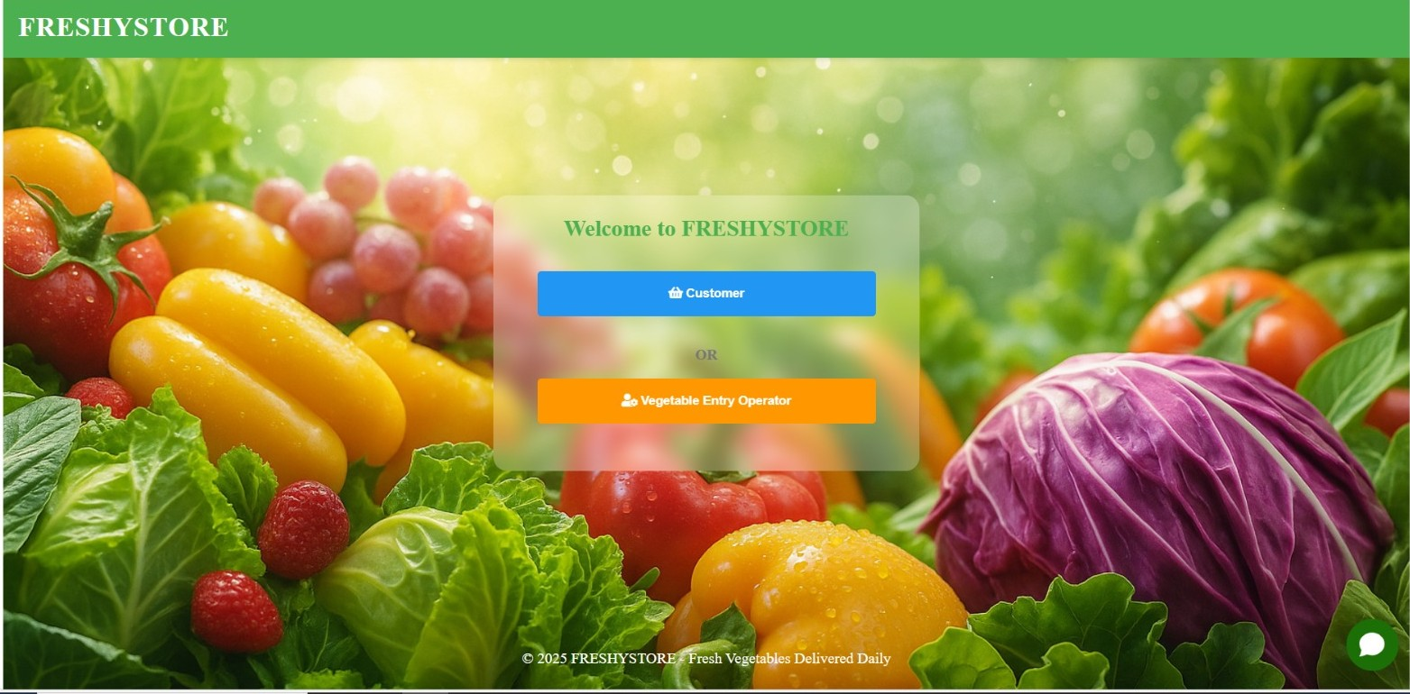

**Figure 1.1 login interface**

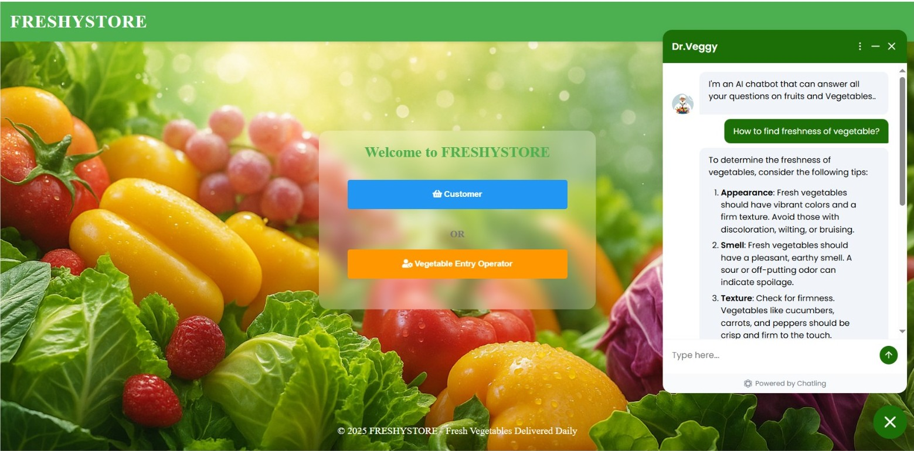

**Figure 1.2 chat bot**

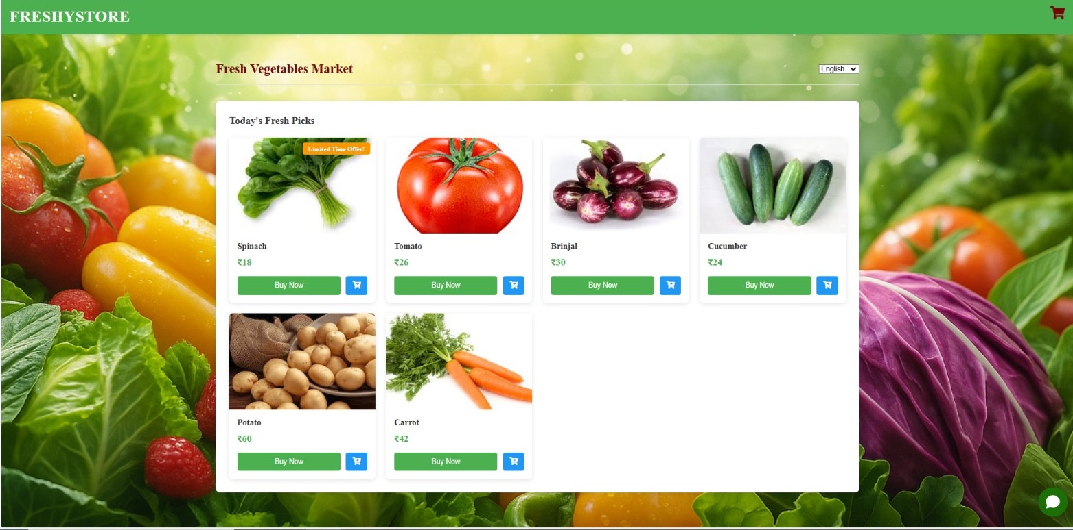

**Figure 1.3 Adding items**

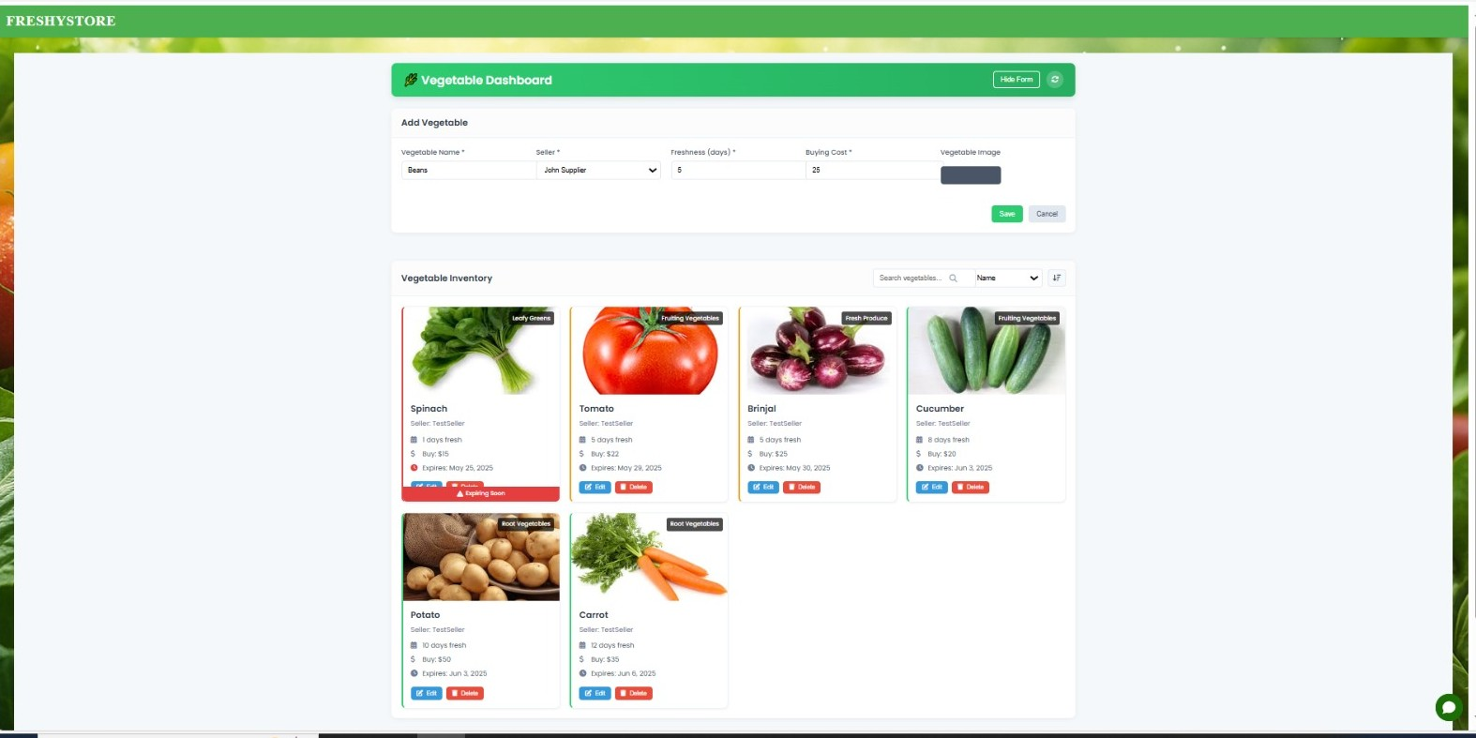

**Figure 1.4 Dashboard**