NUnit-Handson
Title
Hands-On: Unit Testing Using NUnit Framework
Aim
To create and execute unit test cases using the NUnit framework.
Program
Calculator Class (Class1.cs)
namespace CalculatorApp
{
public class Calculator
{
public int Add(int a, int b)
{
return a + b;
}
public int Subtract(int a, int b)
{
return a - b;
}
}
}
NUnit Test Cases (UnitTest1.cs)
using NUnit.Framework;
using CalculatorApp;
namespace CalculatorApp.Tests
{
public class Tests
{
[Test]
public void Add_ReturnsCorrectSum()
{
var calculator = new Calculator();

var result = calculator.Add(10, 20);

Assert.That(result, Is.EqualTo(30));
}
[Test]
public void Subtract_ReturnsCorrectDifference()
{
var calculator = new Calculator();

var result = calculator.Subtract(10, 4);

Assert.That(result, Is.EqualTo(6));
}
}
}
OUTPUT-
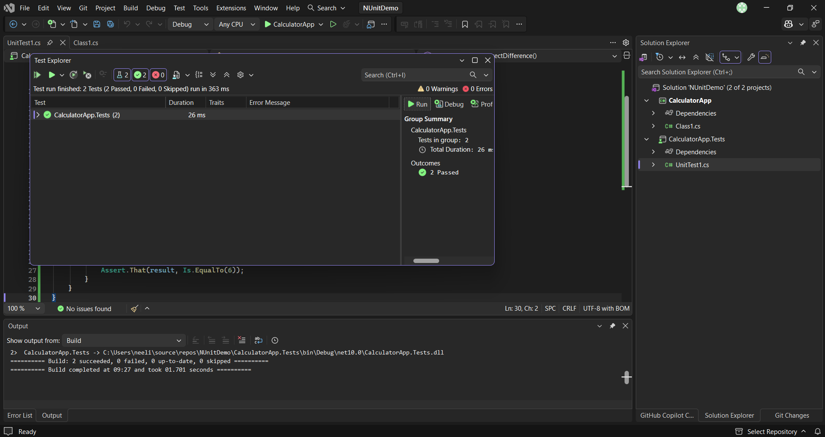
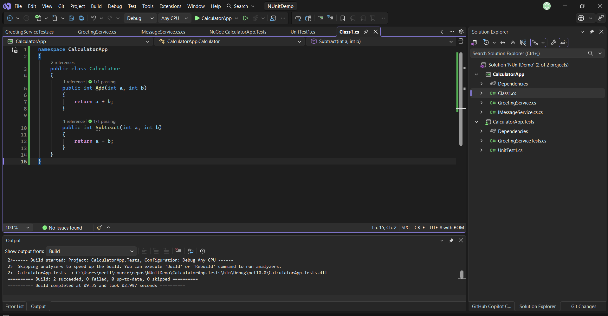
Result-
Successfully created and executed unit test cases using the NUnit framework.

