NUnit-Handson
Title
Hands-On: Unit Testing Using NUnit Framework
Aim
To create and execute unit test cases using the NUnit framework.
Program
StudentMarksApp (Class1.cs)
namespace StudentMarksApp
{
public class StudentMarks
{
public int Total(int m1, int m2)
{
return m1 + m2;
}

public int Average(int m1, int m2)
{
return (m1 + m2) / 2;
}
}
}
NUnit Test Cases (UnitTest1.cs)
using NUnit.Framework;
using StudentMarksApp;

namespace TestProject1
{
public class Tests
{
[Test]
public void Total_ReturnsCorrectTotal()
{
var marks = new StudentMarks();

var result = marks.Total(80, 90);

Assert.That(result, Is.EqualTo(170));
}

[Test]
public void Average_ReturnsCorrectAverage()
{
var marks = new StudentMarks();

var result = marks.Average(80, 90);

Assert.That(result, Is.EqualTo(85));
}
}
}
OUTPUT-
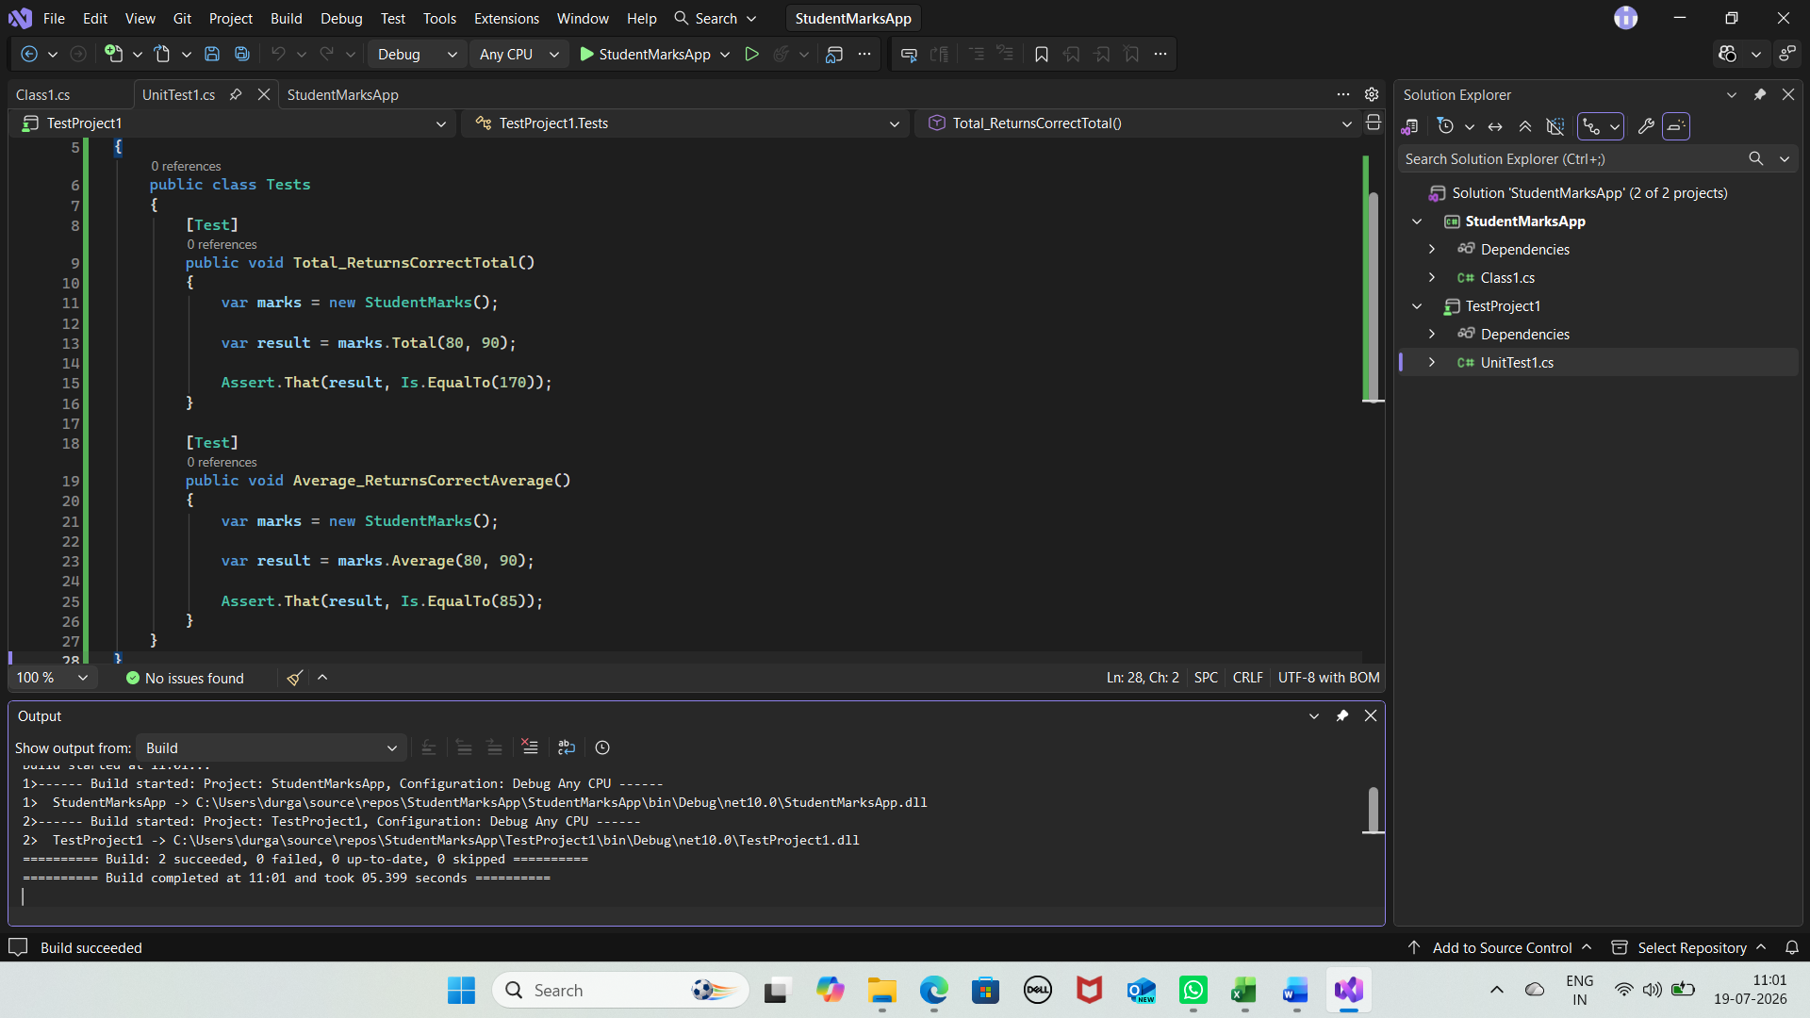
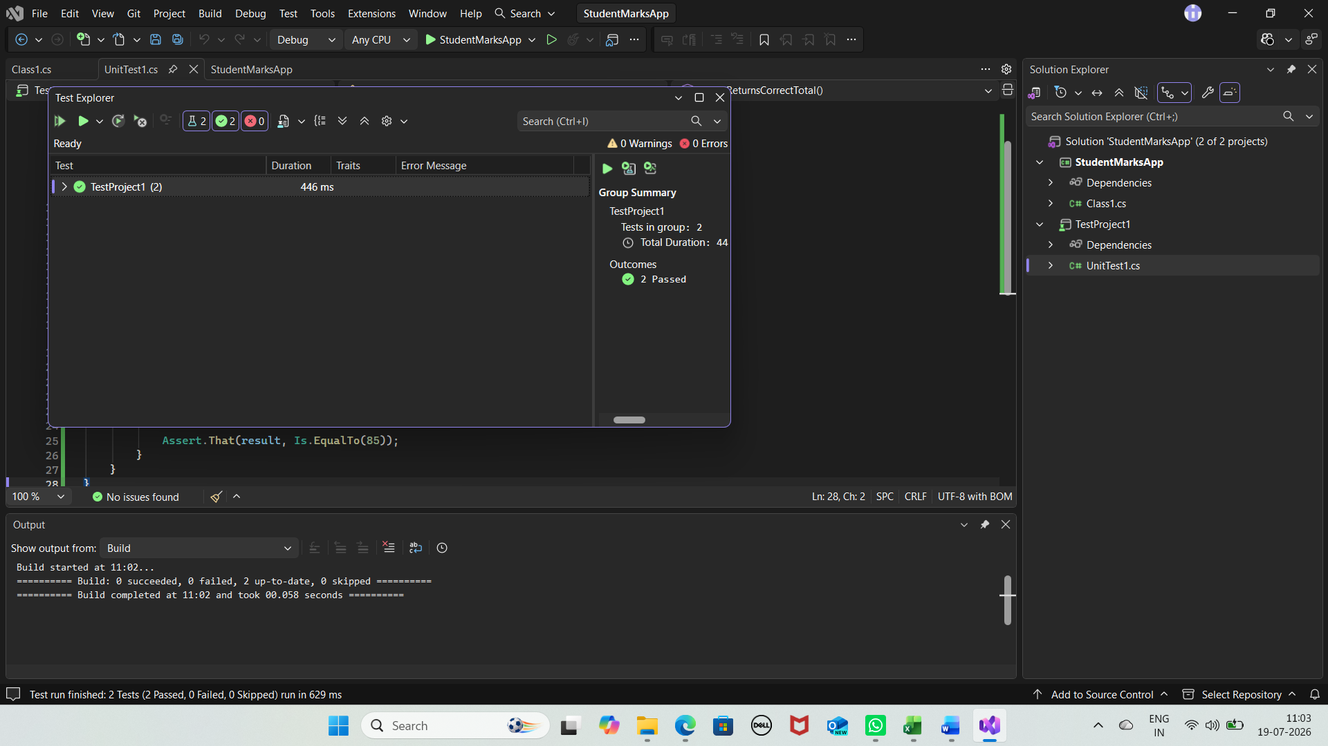
Result-
Successfully created and executed unit test cases using the NUnit framework.

