# TUTORIAL CO1: Probability – Addition, Multiplication, and Bayes' Theorem

## Introduction

**Probability is the chance that something will happen. We write it as P(A), where A is an event.  
- P(A) = 1 means it will surely happen  
- P(A) = 0 means it will never happen  
- P(A) = 0.5 means maybe it will happen**

## Question 1: What is the Addition Rule in Probability?

**Answer:  
The Addition Rule is used to find the probability that event A or event B happens.**

**Formula:  
P(A ∪ B) = P(A) + P(B) − P(A ∩ B)**

**Explanation:  
If A and B can happen at the same time, we subtract the overlap so it’s not counted twice.**

**Math Example:  
P(A) = 0.6 (chance of rain)  
P(B) = 0.5 (chance of thunder)  
P(A ∩ B) = 0.3 (chance of both rain and thunder)  
P(A ∪ B) = 0.6 + 0.5 − 0.3 = 0.8**

**Python Code:**

**P_A = 0.6  
P_B = 0.5  
P_A_and_B = 0.3  
  
P_A_or_B = P_A + P_B - P_A_and_B  
print("P(A ∪ B) =", P_A_or_B)**

**Output:  
P(A ∪ B) = 0.8**

## Question 2: What is the Multiplication Rule in Probability?

**Answer:**

**The Multiplication Rule is used to find the probability that both A and B happen, written as P(A ∩ B).**

**There are two types of multiplication rules:**

**Case 1: Independent Events  
Events that do not affect each other.**

**Formula:  
P(A ∩ B) = P(A) × P(B)**

**Example:  
P(A) = 0.6 (winning a toss)  
P(B) = 0.5 (winning a dice game)  
P(A ∩ B) = 0.6 × 0.5 = 0.3**

**Python Code:**

**P_A = 0.6  
P_B = 0.5  
  
P_A_and_B = P_A * P_B  
print("P(A ∩ B) =", P_A_and_B)**

**Output:  
P(A ∩ B) = 0.3**

**Case 2: Dependent Events  
Events where the outcome of A affects the outcome of B.**

**Formula:  
P(A ∩ B) = P(A) × P(B | A)**

**Example:  
P(A) = 0.4 (drawing red card first)  
P(B | A) = 0.3 (drawing second red card after first)  
P(A ∩ B) = 0.4 × 0.3 = 0.12**

**Python Code:**

**P_A = 0.4  
P_B_given_A = 0.3  
  
P_A_and_B = P_A * P_B_given_A  
print("P(A ∩ B) =", P_A_and_B)**

**Output:  
P(A ∩ B) = 0.12**

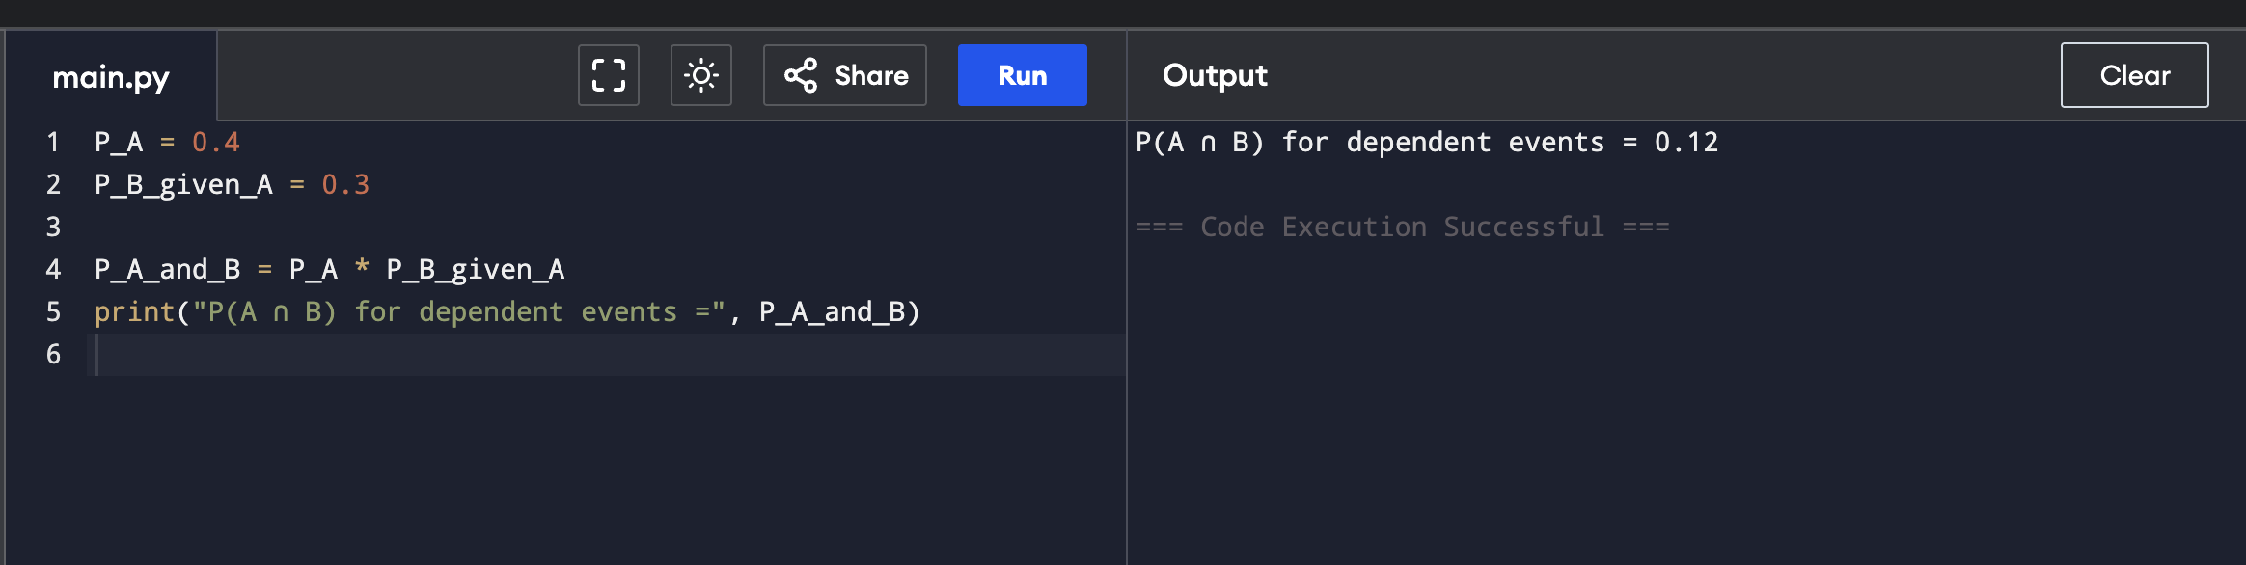

## Question 3: What is Bayes' Theorem in Probability?

**Answer:  
Bayes’ Theorem helps to find the reverse probability — the chance of event A happening given that B has already happened.**

**Formula:  
P(A | B) = [P(B | A) × P(A)] / P(B)**

**Explanation:  
It is useful when we already know the result (B), and want to find out the real cause (A).**

**Math Example:  
P(A) = 0.01 (has disease)  
P(B | A) = 0.95 (test positive if sick)  
P(B) = 0.05 (test positive overall)  
P(A | B) = (0.95 × 0.01) / 0.05 = 0.19**

**Python Code:**

**P_A = 0.01  
P_B_given_A = 0.95  
P_B = 0.05  
  
P_A_given_B = (P_B_given_A * P_A) / P_B  
print("P(A | B) =", P_A_given_B)**

**Output:  
P(A | B) = 0.19**

