Enterprise Role-Based Access Control (RBAC) and Identity Auditor
P. Varun Reddy, K. Chandana, and Pardhava Nandan
Department of Computer Science and Engineering
Koneru Lakshmaiah Education Foundation, Andhra Pradesh, India
Under the guidance of Dr. K. Swanthana
Team 16 | Engineering Capstone Project – 1

Abstract
Enterprise applications are used by employees with different responsibilities, and each employee requires a suitable level of access to organizational resources. Role-Based Access Control (RBAC) simplifies authorization by assigning permissions to roles and assigning roles to users. However, access permissions may remain unchanged when an employee changes a department or job responsibility. Over time, users can accumulate unnecessary or outdated permissions, a condition commonly known as privilege creep. Such permissions increase the possibility of unauthorized access and make periodic access reviews difficult.
This paper presents the design and implementation of an Enterprise Role-Based Access Control (RBAC) and Identity Auditor. The system combines user and role administration with permission-based authorization, identity auditing, privilege-creep identification, and access-risk classification. The application is implemented using Java and Spring Boot, with Spring Security and JSON Web Tokens (JWT) for authentication and authorization. BCrypt is used for password hashing, MySQL stores user, role, permission, and audit information, and Spring Data JPA/Hibernate supports database operations. The system records security-related activities and evaluates identity risk using contextual factors such as elevated privileges, excessive permissions, unused privileges, unfamiliar devices or IP addresses, unusual login times, failed attempts, and repeated unauthorized access. A risk score is classified into Low, Medium, High, or Critical categories to support review and investigation. The implemented functions include registration, login, user management, role and permission management, access decisions, audit logging, privilege monitoring, and risk classification. The project demonstrates how RBAC administration and identity auditing can be brought together in one application to support least-privilege access and improve the visibility of enterprise access risks.
Keywords: Role-Based Access Control, Identity Auditing, Privilege Creep, Least Privilege, Access Risk Assessment, Spring Security, JWT.

1. Introduction
Enterprise organizations depend on applications that store and process information belonging to different departments. Employees, administrators, analysts, and other users do not require the same level of access. For example, an employee may need to view a report, while a security administrator may need to manage users, roles, and permissions. Providing every user with unrestricted access creates unnecessary security exposure. Therefore, access must be assigned according to job responsibilities and organizational policies.
Role-Based Access Control is a widely used approach for managing authorization. Instead of assigning every permission separately to every user, permissions are grouped into roles. Users are then assigned one or more roles. This arrangement makes access administration easier and provides a consistent way to enforce authorization rules. However, the initial role assignment is not sufficient on its own. Employee responsibilities change, temporary assignments end, and accounts may retain permissions that are no longer required.
The accumulation of unnecessary permissions is referred to as privilege creep. A user who changes roles may retain access from a previous role. Similarly, an account may continue to hold privileges that have not been used for a long period. If these conditions are not reviewed, the organization may have difficulty identifying which users possess sensitive access and why that access is required.
The proposed Enterprise RBAC and Identity Auditor addresses this issue by combining role-based authorization with identity and permission auditing. It maintains user-role-permission relationships, records relevant activities, evaluates access-related risk factors, and presents risk classifications that can guide further review. The system is intended for enterprise applications, internal platforms, and organizational systems in which access must be managed and reviewed.

1.1 Problem Statement
Traditional RBAC implementations mainly focus on assigning roles and enforcing permissions. They may not provide sufficient ongoing visibility into excessive, unused, or outdated access. Manual access reviews can also become time-consuming when an organization has many users and permissions. The problem addressed in this work is the lack of a unified mechanism that manages RBAC assignments while auditing identities, identifying privilege-related risks, and presenting understandable risk information.

1.2 Objectives and Contributions
- Design a centralized user-role-permission model for enterprise access management.
- Provide secure registration and login with password hashing and token-based authentication.
- Enforce authorization by checking the permissions associated with a user's assigned role.
- Record identity and security activities for later auditing.
- Identify excessive or unused privileges and support privilege-creep review.
- Calculate contextual access-risk scores and classify accounts into risk levels.
- Provide administrative views for users, roles, permissions, and risk information.

2. Related Work
Research on RBAC includes role engineering, role mining, permission optimization, and the management of changing organizational requirements. These areas are relevant because an enterprise access-control system must represent job responsibilities in a manageable way while avoiding unnecessary permission assignments.
Currey et al. [1] discuss trade-offs involved in RBAC configuration, including the relationship between privilege complexity and the effort required to manage roles. Their work highlights that role configuration is not only a matter of granting access; the structure and complexity of the role model also affect administration.
Abolfathi et al. [2] study scalable role mining for large organizations. Role mining aims to derive useful role structures from user-permission assignments. Scalability is important when the number of users and permissions grows, although role generation alone does not necessarily provide continuous auditing of each identity after roles have been assigned.
Blundo et al. [3] examine role-mining heuristics under permission-role-usage cardinality constraints. Their work considers constraints that influence the structure of generated roles. Blundo and Cimato [4] further consider user-distribution cardinality constraints in role mining. These studies contribute to the organization of role-permission relationships, while the present project focuses on monitoring the ongoing suitability of assigned access.
Research on minimal-noise role mining and role interpretability [5] considers how role structures can remain understandable while handling noisy permission data. Zhu et al. [6] present a matrix-factorization and constraints-based role-mining approach. Durdağ and Coşkunçay [7] investigate role reconfiguration through role clustering. These approaches address role discovery or reconfiguration. The project described in this paper complements that direction by focusing on identity auditing, privilege-risk visibility, and review of permissions that may no longer be necessary.

2.1 Research Gap
The literature reviewed in the project proposal indicates that several approaches concentrate on generating, optimizing, or reconfiguring roles. These techniques are useful for designing an RBAC structure, but they do not by themselves guarantee that existing user assignments remain appropriate as organizational responsibilities change. The project therefore focuses on combining RBAC administration with identity auditing and risk assessment in one application.
Existing approach | Observed limitation | Project response
Traditional RBAC | Primarily manages predefined roles and permission assignments. | Audits identities and their assigned permissions.
Role mining | Focuses on discovering or optimizing roles. | Reviews whether current access remains appropriate.
Constraint-based role design | Uses constraints for role construction but may not identify stale access. | Checks excessive and unused privileges.
Periodic manual reviews | Can be time-consuming and may miss changes between reviews. | Maintains audit records and risk-oriented account views.
Separate IAM and audit functions | Access administration and audit visibility may be separated. | Combines RBAC, auditing, and risk classification in one platform.

3. System Model and Design

3.1 System Overview
The proposed application follows a layered web-application design. The React.js frontend provides the user interface for authentication and administrative operations. The Spring Boot backend exposes REST APIs and contains the business logic. Spring Security is used to apply authentication and authorization rules, while JWT supports authenticated requests. MySQL stores the application data, and Spring Data JPA/Hibernate provides object-relational mapping.
The main entities are users, roles, permissions, and audit records. A user can be associated with a role, and a role can contain multiple permissions. The authorization layer checks whether the authenticated user has the permission required for a requested operation. The auditing and risk modules use identity and activity information to identify conditions that may require an access review.

3.2 Main Components
Component | Responsibility
AuthController | Handles registration and login APIs.
UserService | Manages user accounts and authentication-related operations.
RoleService | Creates and manages roles and role assignments.
PermissionService | Maintains permissions and access rights.
RBACService | Handles role-based access-control operations.
AuditLogService | Records user and security activities.
PrivilegeAuditService | Identifies excessive and unused privileges.
RiskAssessmentService | Calculates and classifies user access risk.
AccessControlService | Validates whether a requested action is permitted.
ReportService | Generates security and compliance reports.

3.3 Access-Control Model
The authorization model uses three principal elements: users (U), roles (R), and permissions (P). A user-role relationship assigns one or more roles to a user, while a role-permission relationship defines the operations allowed by that role. For an authenticated user, the set of effective permissions is obtained from the permissions associated with the user's assigned roles. A requested operation is allowed only when the required permission is present; otherwise, the system returns a deny decision.
This model separates identity management from permission definition. Administrators can create roles and configure the permissions associated with each role rather than manually defining every access rule for every individual account. The project interface includes example roles such as ADMIN, SECURITY_ANALYST, and EMPLOYEE, with different permission sets.

3.4 Overall Processing Flow
The processing flow implemented in the project is: User → Authentication → RBAC → Audit → Risk Analysis → Report. A user first authenticates. The backend then applies role-based authorization to the requested operation. Relevant activity is recorded for auditing, and identity or permission conditions are evaluated by the risk module. The resulting information can be reviewed through the administrative interface and reports.

4. Proposed Methodology

4.1 Requirement Analysis and RBAC Design
The first stage identifies the user categories, roles, permissions, resources, and security requirements. Roles are defined according to the type of work performed by a user. Permissions represent individual operations, such as reading user information, creating users, managing roles, viewing audit logs, viewing risk assessments, and exporting reports. User-role and role-permission mappings are maintained to support consistent authorization.

4.2 Authentication and Authorization
The application provides registration and login functionality. Passwords are protected using BCrypt hashing rather than being stored as plain text. After successful authentication, JWT is used to support authenticated communication with protected backend endpoints. Spring Security applies authorization rules so that an operation can be performed only when the authenticated identity has the required access permission. The access-control service produces an ALLOW or DENY decision based on the permission check.

4.3 Identity Auditing
Identity auditing records relevant user and security activities. The audit information supports later examination of account actions and access events. Spring AOP is included in the project technology design for monitoring and recording application activities. The AuditLogService is responsible for recording the events used by the auditing module. Maintaining these records provides a basis for reviewing access behaviour and investigating suspicious or unexpected activity.

4.4 Privilege-Creep Detection
Privilege creep occurs when a user retains permissions that are no longer necessary for their current responsibilities. The project includes privilege auditing to identify excessive and unused privileges. Unused access is considered in relation to a defined period; the risk model identifies a privilege that has not been used for more than 30 days as a risk condition. The audit module can flag such access for review. The purpose is to support least-privilege management by helping administrators identify permissions that may need to be modified or removed.

4.5 Risk Assessment Model
The project uses contextual factors to estimate the risk associated with an identity or its access. Each condition contributes a predefined number of points. The factors documented in Review-2 are presented in Table 2. The score is used to classify an account and guide the recommended response.
Context factor | Condition | Risk contribution
User privilege | Admin / elevated privilege | +25
Excessive permissions | More permissions than required | +25
Unused privilege | Unused for 30+ days | +20
IP address | Unknown IP | +5
Device | Unknown device | +20
Login time | 11 PM–6 AM | +15
Failed attempts | One failed attempt | +5
Session activity | Suspicious | +25
Unauthorized access | Access denied repeatedly | +30
Role assignment | Incorrect / high-risk role | +25

The risk levels and actions defined by the project are shown in Table 3. Low-risk accounts are monitored, while Medium-risk accounts require permission review. High-risk accounts require immediate review, and Critical-risk accounts require immediate investigation and access restriction.
Risk level | Risk score | Classification criteria | Recommended action
Low | 0–20 | Normal access and no major security issues | Monitor
Medium | 21–40 | Unused privileges or minor suspicious activity | Review permissions
High | 41–60 | Excessive privileges, repeated failed attempts, or suspicious access | Immediate review
Critical | 61+ | Highly privileged account with multiple security risks | Immediate investigation and access restriction

The project review material specifies the factor weights and classification bands but does not provide a complete mathematical normalization formula or a detailed rule for handling every possible combination of factors. Accordingly, this paper reports the scoring factors and thresholds as implemented in the project documentation and does not assume an additional formula.

4.6 Reporting and Administrative Review
The administrative interface presents user identities, assigned roles, account status, and risk scores. Role and permission management screens allow administrators to inspect role definitions and the permissions associated with them. The risk-auditing view presents the risk classification and reasons associated with an account. These views help an administrator understand why an account has been flagged and decide whether further investigation or permission review is required.

5. Implementation and Technology
Category | Technology | Purpose
Programming language | Java | Backend application logic.
Backend framework | Spring Boot | REST APIs and application services.
Security | Spring Security | Authentication and authorization.
Authentication | JWT | Token-based authenticated requests.
Password security | BCrypt | Password hashing.
Database | MySQL | Storage of users, roles, permissions, and audit records.
ORM | Spring Data JPA / Hibernate | Database access and entity mapping.
Auditing | Spring AOP | Monitoring and recording application activities.
Frontend | React.js | User interface and administrative dashboard.
API testing | Postman | Testing authentication and security APIs.
API documentation | Swagger / OpenAPI | API documentation and testing support.
Build tool | Maven | Dependency management and project build.

The implementation is organized into service-oriented modules. Controllers expose API endpoints, services contain the corresponding application logic, and the persistence layer communicates with MySQL. This separation makes the main functions easier to maintain and test. The frontend communicates with the backend through REST APIs.

5.1 Implemented Functionalities
- User registration and secure login.
- Password hashing using BCrypt.
- User and account management.
- Role creation, role assignment, and permission management.
- User-role-permission mapping and RBAC authorization.
- Privileged account monitoring and privilege-creep detection.
- Least-privilege access monitoring.
- Identity and access auditing with security-event logging.
- Risk assessment and risk classification.
- ALLOW / DENY access decisions.

6. Experimental Setup and Testing
The project review specifies Windows 10/11 as the development operating system. The application uses Java, Spring Boot, Spring Security, JWT, React.js, MySQL, and Spring Data JPA/Hibernate. The testing activities are organized around the principal security and administrative functions rather than a single performance benchmark.
Test area | Test activity | Expected behaviour
Registration | Submit valid user details. | A user account is created.
Login | Authenticate with valid and invalid credentials. | Valid credentials authenticate; invalid credentials are rejected.
Password protection | Inspect password handling in storage. | Passwords are stored as BCrypt hashes, not plain text.
Role assignment | Assign a role to a user. | The user-role mapping is maintained.
Permission management | Create or update role permissions. | The role reflects its configured permission set.
RBAC authorization | Request an operation with and without the required permission. | The system returns an ALLOW or DENY decision according to authorization.
Unauthorized access | Attempt to access a protected operation without permission. | The request is denied.
Privilege auditing | Review excessive or unused access conditions. | Potential privilege issues are identified for review.
Audit logging | Perform security-related activities. | Relevant activity is recorded in audit logs.
Risk assessment | Evaluate accounts against defined risk factors. | A risk score and risk category are presented.

6.1 Evaluation Scope
The available project review material confirms the test areas and shows screenshots of the implemented interface. It does not provide a complete test-case execution log, dataset size, measured execution times, detection accuracy, precision, recall, or comparison against another system. These measurements are therefore not claimed in this paper. A quantitative evaluation can be added after running a documented set of test cases and recording actual outcomes.

7. Results and Discussion
The implementation screenshots supplied in Project Review-2 show the main administrative functions of the application. The login interface provides an entry point for users with different roles. The user identity management view displays account names, email addresses, assigned roles, account status, and risk scores, along with administrative actions. The role and authorization policy view shows role definitions and their associated permissions. The permissions registry presents individual permission tokens and their descriptions. The privilege-creep and identity-risk view displays the evaluated accounts, risk scores, classifications, and reasons associated with the risk assessment.
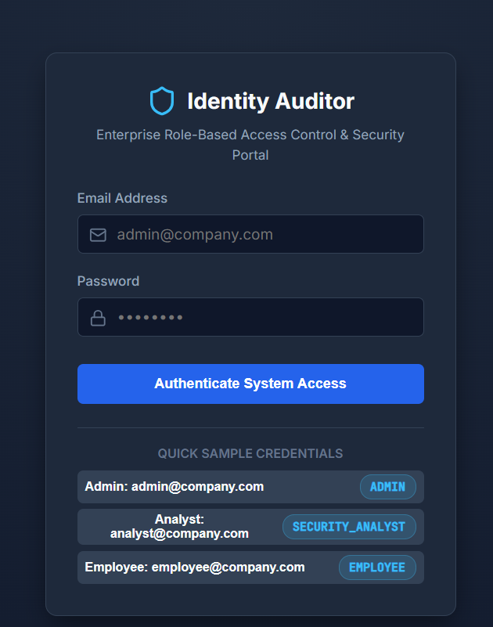
Figure 1. Login interface of the Enterprise RBAC and Identity Auditor.
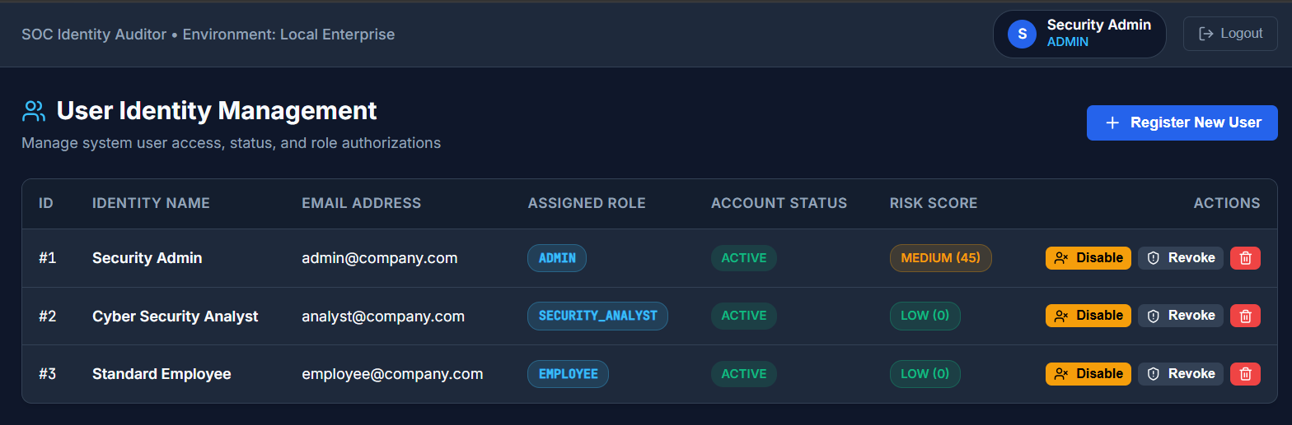
Figure 2. User identity management showing roles, account status, and risk scores.
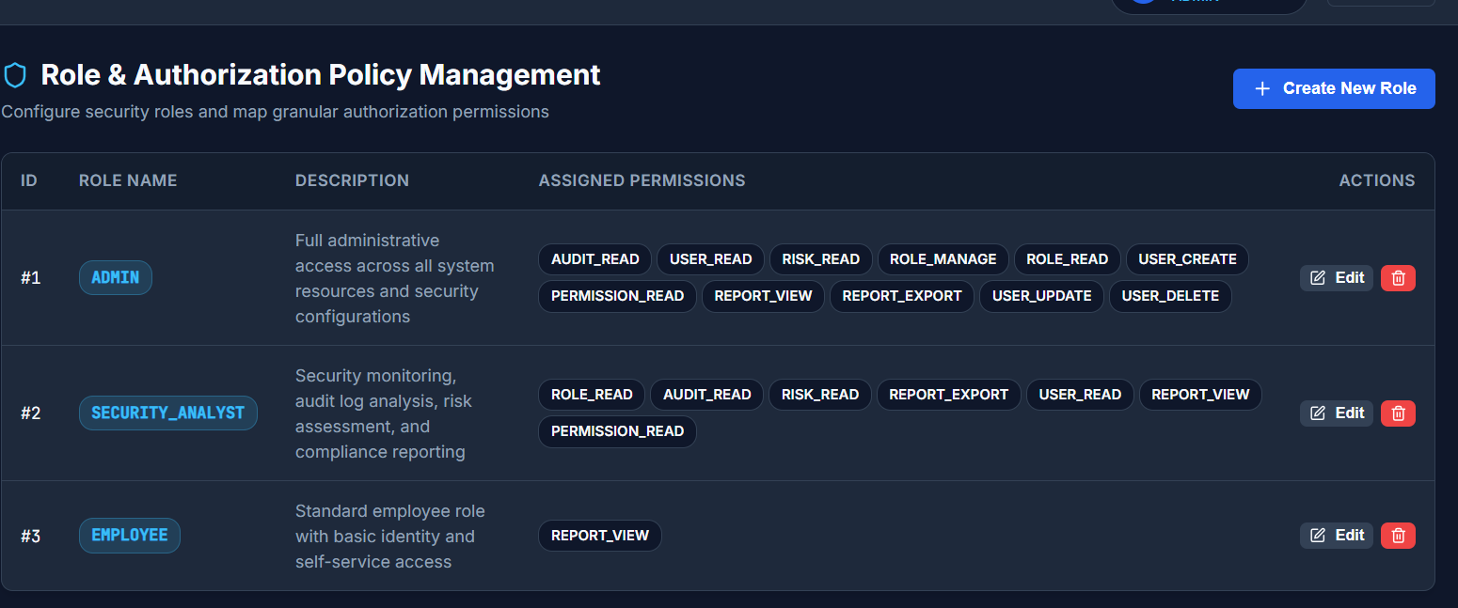
Figure 3. Role and authorization policy management.
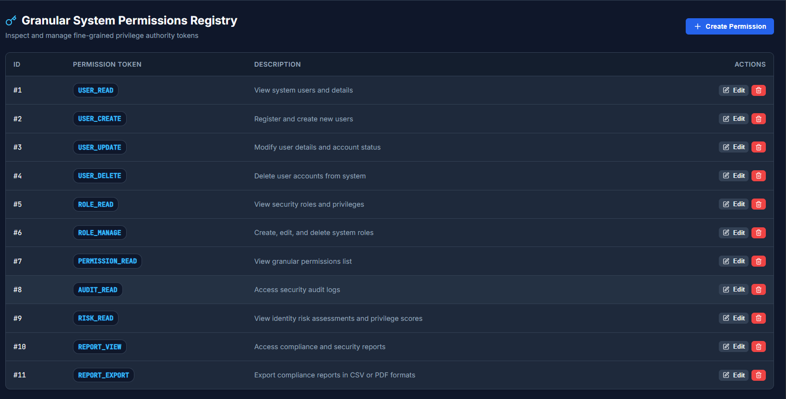
Figure 4. Permission registry containing granular permission tokens.
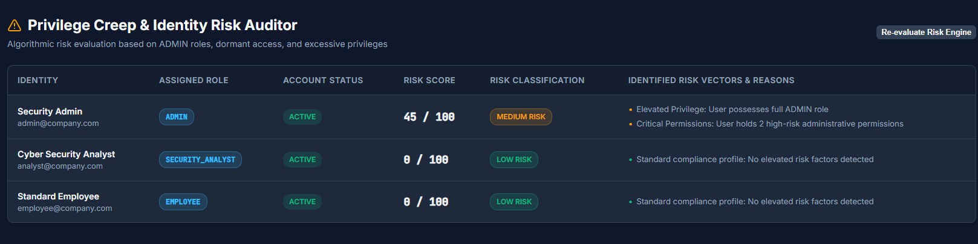
Figure 5. Privilege-creep and identity-risk audit view.
The screenshots provide evidence of the user interface and the functions represented in the project review. In the displayed example, the identity list includes an administrator, a security analyst, and an employee. The administrator is shown with a Medium risk score of 45, while the other two sample accounts are shown with Low risk scores of 0. These are example values visible in the demonstration interface; they should not be interpreted as results from a large-scale benchmark.
The role-management screen demonstrates that different roles can be associated with different permission sets. The permission registry separates individual actions into permission tokens, such as USER_READ, USER_CREATE, USER_UPDATE, USER_DELETE, ROLE_READ, ROLE_MANAGE, AUDIT_READ, RISK_READ, REPORT_VIEW, and REPORT_EXPORT. This structure supports more granular authorization than assigning unrestricted access to every account.
The risk-auditing screen presents both a score and explanatory risk reasons. Showing the reasons alongside the score is useful because an administrator can understand which access conditions contributed to the classification. In the example shown, the administrator account is marked as Medium risk and the view identifies elevated privilege and critical permissions as reasons. This makes the risk assessment more interpretable than displaying a score alone.

7.1 Discussion
The implemented system brings together functions that are often treated as separate administrative activities: account management, role and permission configuration, authorization, activity auditing, and risk review. The role-permission model supports structured access assignment. Audit records provide a history of relevant activity, while the risk module helps administrators prioritize accounts that may require attention. The combination is intended to support the principle of least privilege by making unnecessary or risky access easier to identify.
The current project evidence is primarily functional. The screenshots demonstrate the interface and sample account classifications, while the review document lists the test categories. A stronger experimental study should measure how reliably the system detects seeded privilege issues, how many false alerts are produced, and how long auditing and risk evaluation take as the number of users and permissions increases.

7.2 Limitations and Future Work
- Conduct a larger evaluation using a documented dataset of users, roles, permissions, and access events.
- Measure precision, recall, false-positive rate, and detection time for privilege-creep and risk alerts.
- Define and document the exact risk-score aggregation and normalization procedure, including score boundaries and treatment of repeated events.
- Evaluate the system with larger user and permission populations to understand scalability.
- Add scheduled or event-driven reviews so that changes in job responsibilities trigger timely access reassessment.
- Extend recommendations so that administrators receive clear, auditable suggestions for removing or modifying unnecessary permissions.
- Evaluate report completeness and the usability of the dashboard with representative administrative tasks.

8. Conclusion
This paper presented an Enterprise Role-Based Access Control and Identity Auditor designed to manage enterprise identities and permissions while providing visibility into access-related risks. The system combines user and role management, permission-based authorization, secure authentication, identity auditing, privilege-creep monitoring, and risk classification. It is implemented with Java, Spring Boot, Spring Security, JWT, BCrypt, React.js, and MySQL.
The project demonstrates the integration of RBAC administration and identity auditing within a single application. Its risk model considers elevated privileges, excessive or unused permissions, unfamiliar IP addresses and devices, unusual login times, failed attempts, suspicious sessions, repeated unauthorized access, and high-risk role assignments. The resulting classifications provide administrators with a way to prioritize access reviews. The current review evidence demonstrates the implemented functions and sample interface outputs. Further quantitative testing is required before making claims about detection accuracy, performance, or scalability.
The next stage of work is to evaluate the system using a clearly defined test dataset, record actual test outcomes, and measure the effectiveness of privilege-creep detection and risk assessment. These steps will provide stronger evidence of the system's usefulness in enterprise identity and access management.

References
[1] J. Currey, R. McKinstry, A. Dadgar, and M. Gritter, “Informed Privilege-Complexity Trade-Offs in RBAC Configuration,” in Proceedings of SACMAT, 2020, doi: 10.1145/3381991.3395597.
[2] M. Abolfathi et al., “A Scalable Role Mining Approach for Large Organizations,” in Proceedings of ACM IWSPA, 2021, doi: 10.1145/3445970.3451154.
[3] C. Blundo et al., “Role Mining Heuristics for Permission-Role-Usage Cardinality Constraints,” The Computer Journal, 2022, doi: 10.1093/comjnl/bxaa186.
[4] C. Blundo and S. Cimato, “Role Mining under User-Distribution Cardinality Constraint,” Journal of Information Security and Applications, 2023, doi: 10.1016/j.jisa.2023.103611.
[5] “An Improved Minimal-Noise Role Mining Algorithm Based on Role Interpretability,” Computers & Security, 2023, doi: 10.1016/j.cose.2023.103100.
[6] F. Zhu et al., “MFC-RMA: Matrix Factorization and Constraints-Role Mining Algorithm,” Symmetry, 2024, doi: 10.3390/sym16081008.
[7] O. Durdağ and A. Coşkunçay, “Reconfiguring Role-Based Access Control via Role Clustering,” IEEE Access, 2025, doi: 10.1109/ACCESS.2025.3563057.

