

University of Sciences and Technology of Oran « Mohamed Boudiaf »
Faculty of Natural and Life Sciences
Departement of AppliedMolecularGenetics
Discovering Open Source Softwares

- LARABI FATIMA ZOHRA / Groupe ( 03 )
- MEFTAH LYNA HIBAT ERRAHMENE / Groupe ( 03 )
- CHAFI DJAMILA / Groupe ( 02 )

Mini-projet
- Introduction
The aim of this mini-projectis to get more familiar with the basic terminal commands that we've already gone over.
The best way to learn Linux and get more comfortablewithit to practice and force yourself to start using it.

- Tools used in this session
If you do have a Linux system installed in your machine, make use of your system terminal. If you are awindows user, we highly recommend the use of ubuntu (please follow the steps in TP).

- File names under Linux
Make sure you separate your command name, arguments and options using spaces
Each option ispreceded by - (examples: -l, -r, -lh)
Linux is case-sensitive: A and a are different

- Some useful links
http://www.linuxcommand.org/
http://manuals.bioinformatics.ucr.edu/home/linux-basics
http://www.ee.surrey.ac.uk/Teaching/Unix/

- Task 1: instructions
- Open a terminal in your computer.
- What directory are you located in when you open the terminal?
- Which command could you use to check that?
- What does this command return?
- What are the possible options that can be used with this command? How can you check that?

- Task 1: Student’sanswer

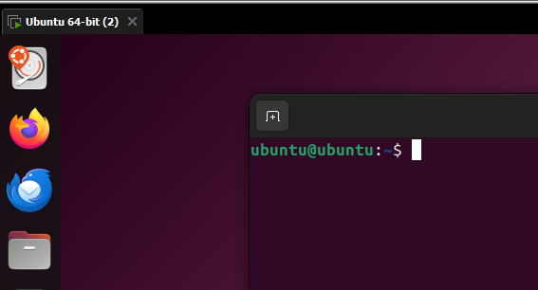
1/

2/ The directory i am located in when i opened the terminalIs : Home

3/The command I used to check is : cd ~

4/ This command make you return “Home “

5/ Other possible options with this command :
- Use it when you want to go from file to another by returning “Home” and going to the wanted file.

*I can check that I am “Home” by seeing the sign showed in the picture ubuntu@ubuntu:~$

- Task 2: Create your own files
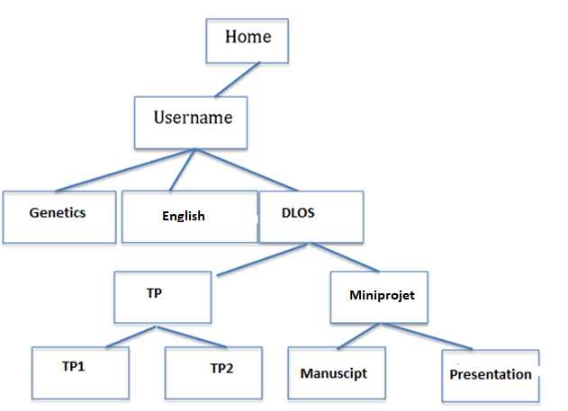

- Task 2: instructions

- Create the above file structure under your home directory using the terminal and write the different command lines to do so.
- Move to the directory Genetics.
- Create a sub-directory “ProkaryoticGenetics" inside Genetics.
- Type the command cd prokaryoticgenetics. What happened? Please explain?
- Remove the directory “ ProkaryoticGenetics"
- Move to the directory “TP” using one single command line.
- List the content of the directory and display the modification date, the owner name, etc.
- Remove the directory “TP2”
- Create a directory “FastaFile" under “TP1” without moving to the DLOS directory.
- Type a single command without specifying any path to move to your home directory.

- Task 2: Student’sanswer

1/ The different command to do the file structure above :
ubuntu@ubuntu:~$ mkdir Username
ubuntu@ubuntu:~$ cd Username
ubuntu@ubuntu:~/Username$ mkdir Genetics
ubuntu@ubuntu:~/Username$ mkdir English
ubuntu@ubuntu:~/Username$ mkdir DLOS
ubuntu@ubuntu:~/Username$ cd DLOS
ubuntu@ubuntu:~/Username/DLOS$ mkdir TP
ubuntu@ubuntu:~/Username/DLOS$ cd TP
ubuntu@ubuntu:~/Username/DLOS/TP$ mkdir TP1
ubuntu@ubuntu:~/Username/DLOS/TP$ mkdir TP2
ubuntu@ubuntu:~/Username/DLOS/TP$ cd ..
ubuntu@ubuntu:~/Username/DLOS$ mkdir MiniProjet
ubuntu@ubuntu:~/Username/DLOS$ cd MiniProjet
ubuntu@ubuntu:~/Username/DLOS/MiniProjet$ mkdir Manuscript
ubuntu@ubuntu:~/Username/DLOS/MiniProjet$ mkdir Presentation

2/
ubuntu@ubuntu:~/Username/DLOS/MiniProjet$ cd ~
ubuntu@ubuntu:~$ cd Username/Genetics
ubuntu@ubuntu:~/Username/Genetics$

3/
ubuntu@ubuntu:~/Username/Genetics$ mkdir ProkaryoticGenetics
ubuntu@ubuntu:~/Username/Genetics$
4/

ubuntu@ubuntu:~/Username/Genetics$ cd ProkaryoticGenetics
ubuntu@ubuntu:~/Username/Genetics/ProkaryoticGenetics$
*What happened is that we got inside the sub-directory “ProkaryoticGenetics
5/
ubuntu@ubuntu:~/Username/Genetics/ProkaryoticGenetics$ cd ~
ubuntu@ubuntu:~$ rmdir Username/Genetics/ProkaryoticGenetics
ubuntu@ubuntu:~$

6/
ubuntu@ubuntu:~$ cd Username/DLOS/TP
ubuntu@ubuntu:~/Username/DLOS/TP$

7/

ubuntu@ubuntu:~/Username/DLOS/TP$ ls –l
total 0
drwxrwxr-x 2 ubuntu ubuntu 40 Dec 22 19 :31 TP1
drwxrwxr-x 2 ubuntu ubuntu 40 Dec 22 19 :31 TP2

8/
ubuntu@ubuntu:~/Username/DLOS/TP$ rmdir TP2
ubuntu@ubuntu:~/Username/DLOS/TP$

9/
ubuntu@ubuntu:~/Username/DLOS/TP$ cd TP1
ubuntu@ubuntu:~/Username/DLOS/TP/TP1$ mkdir FastaFile
ubuntu@ubuntu:~/Username/DLOS/TP/TP1$

10/

ubuntu@ubuntu:~/Username/DLOS/TP/TP1$ cd ~
ubuntu@ubuntu:~$

- Task 3 : Get to extract basic information from a fasta like file
- Task 3: instructions (pleasesee the TP1 File/ Slide 53)
- Createa simple fasta file named "testfasta" under TP1containing few randomsequences

A fasta file is as following:
>seqname
ATCGAGGGGGTTTTGAAGA
>seqname
ATCGTGTGTCAAAA
More information about fasta files format: https://en.wikipedia.org/wiki/FASTA_format
- Count how many lines do you have in your -testfasta? Which command allowedyou to do that?
- Count how many sequences do you have in your fasta. Which command allowedyou to do that

- Task 3: Student’sanswer
1/
ubuntu@ubuntu:~$ cd Username/DLOS/TP/TP1/FastaFile
ubuntu@ubuntu:~Username/DLOS/TP/TP1/FastaFile$ touch testfasta.
ubuntu@ubuntu:~Username/DLOS/TP/TP1/FastaFile$
2/ There are ( 04 ) lines in my testfasta.
-The command that allowed me to do that is the command “Bash”
wc –l testfasta.

3/ There are ( 02 ) sequences in my testfasta.
-The command that allowed me to do that is the command “grep”
grep –c “^> “ testfasta.
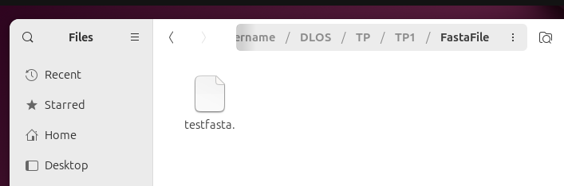
( 01 )

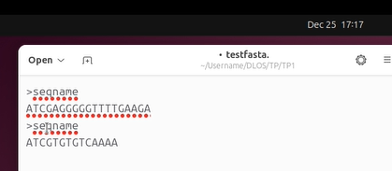

( 02 )
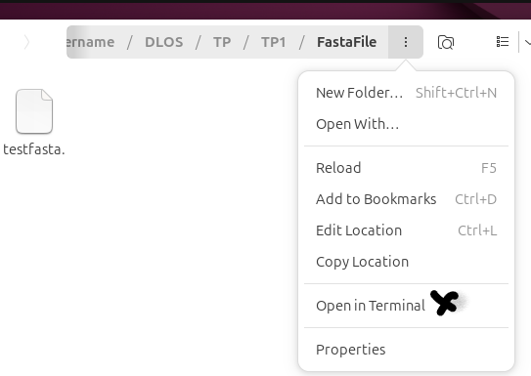

( 03 )

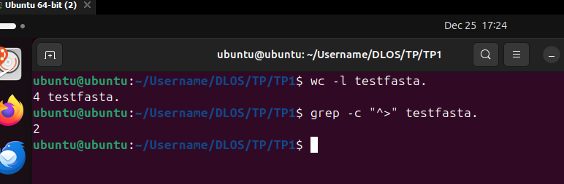

( 04 )

- Task 4 : Set up a private repository on GitHub for your miniproject and provide the access link to your collaborators.

- Task 4: Student’sanswer

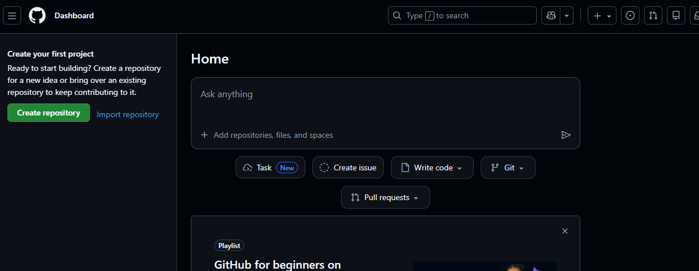

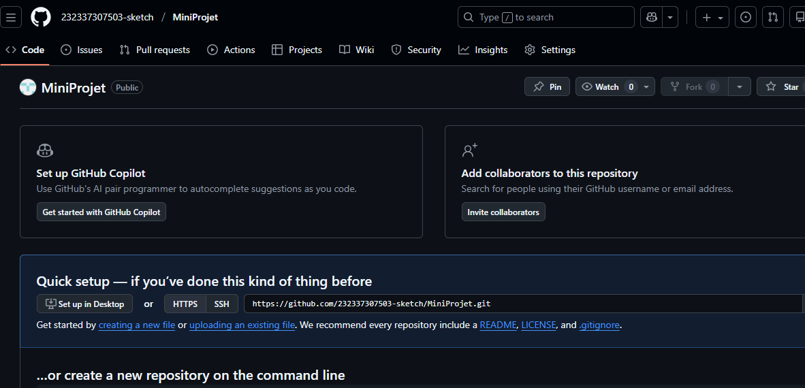

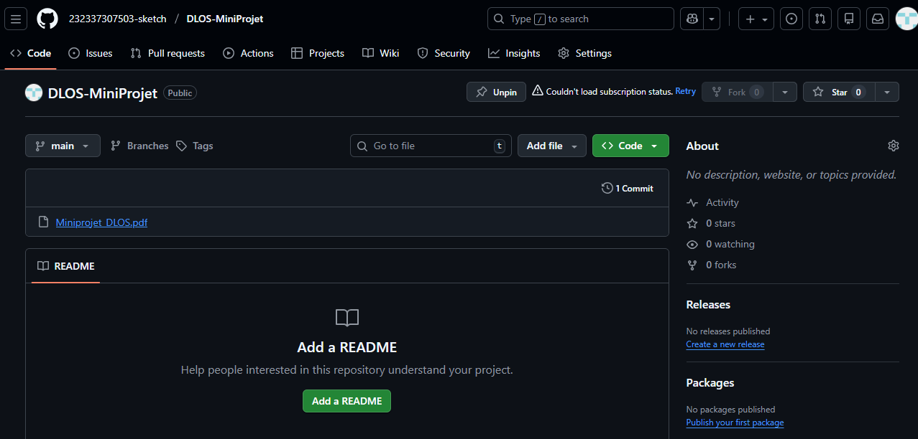
https://github.com/232337307503-sketch/DLOS-MiniProjet

