1、执行以下SQL，获取ID值：

|  |
| --- |
| SELECT id FROM `dsc_shop_config` WHERE `code` = 'extend_basic'; |

如图：

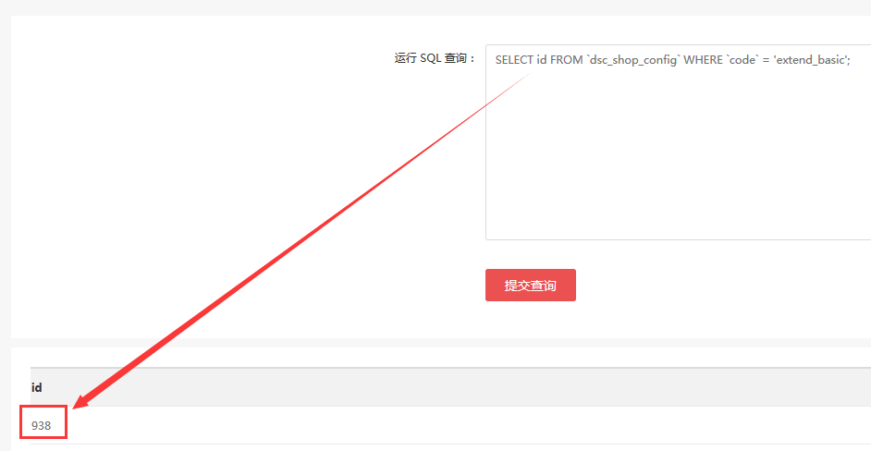

例如：获取值为 938

将获取的值填写入以下SQL语句中：

|  |
| --- |
| INSERT INTO `dsc_shop_config` ( `parent_id` , `code` , `type` , `store_range` , `value` , `sort_order` ) VALUES ( 942, 'bonus_adv', 'select', '0,1', 1, 1 ); |

2、执行以下SQL，获取ID值：

|  |
| --- |
| SELECT id FROM `dsc_shop_config` WHERE `code` = 'goods_picture'; |

如图：

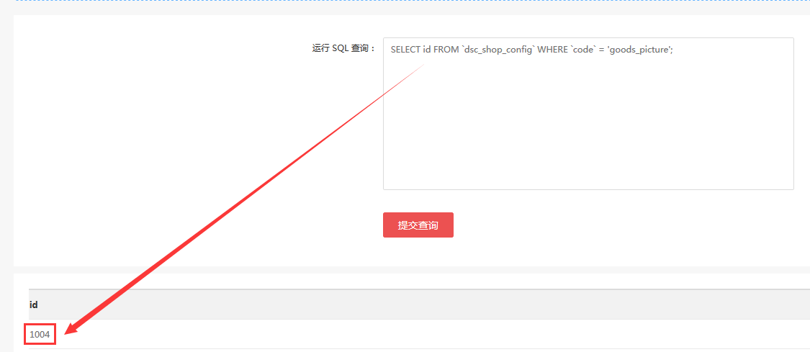

例如：获取值为1004

将获取的值填写入以下SQL语句中：

|  |
| --- |
| UPDATE `dsc_shop_config` SET `parent_id` = '1004', `shop_group` = 'goods' WHERE `code` IN ('two_code_links', 'two_code_mouse'); |