**Ayesha saaed**

**233054**

**Web-lab**

**Lab-02**



***LAB 02***

***Joining Frontend and Backend of Webpage***

# Step 1: Create a front-end folder

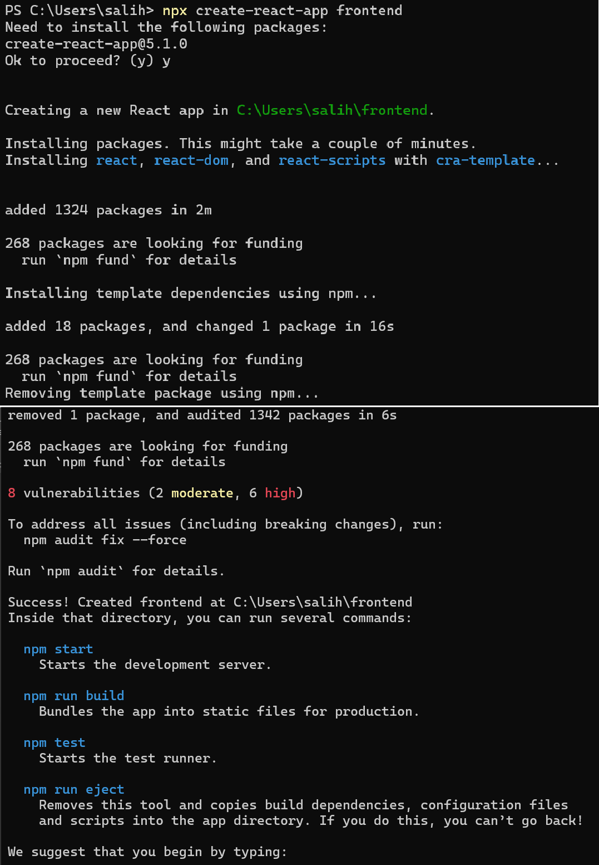



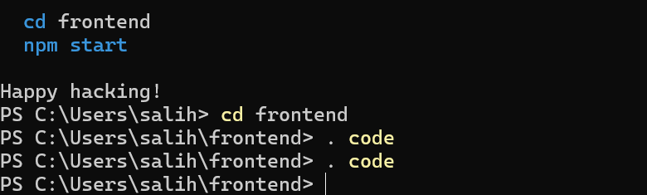

After opening in vs code, make your frontend

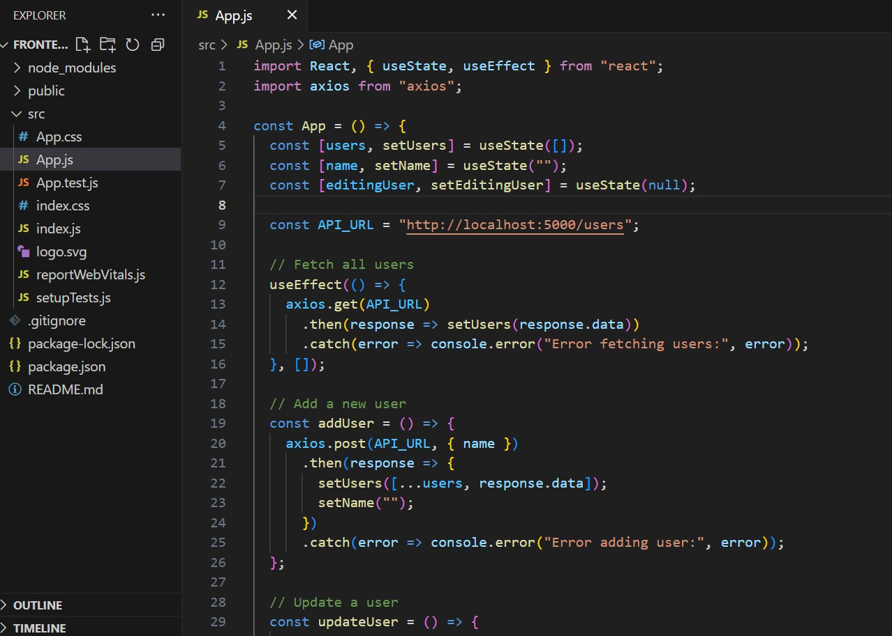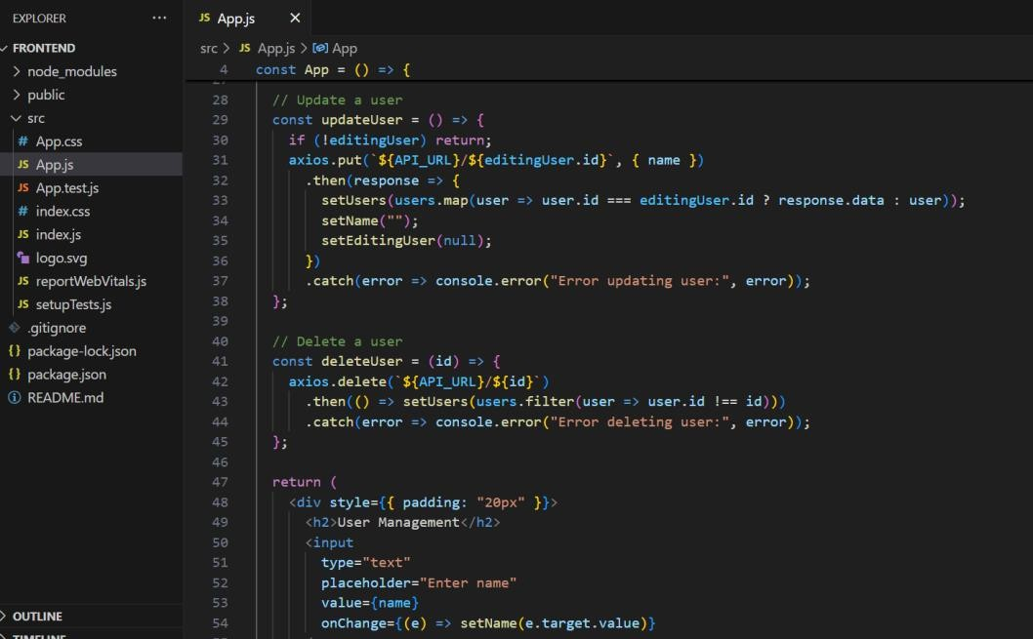



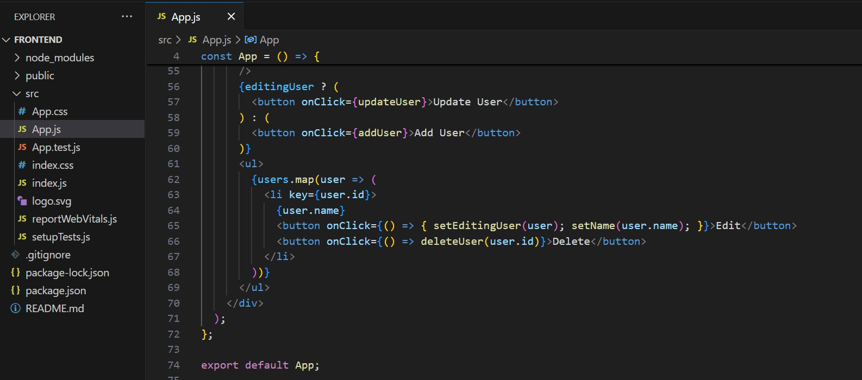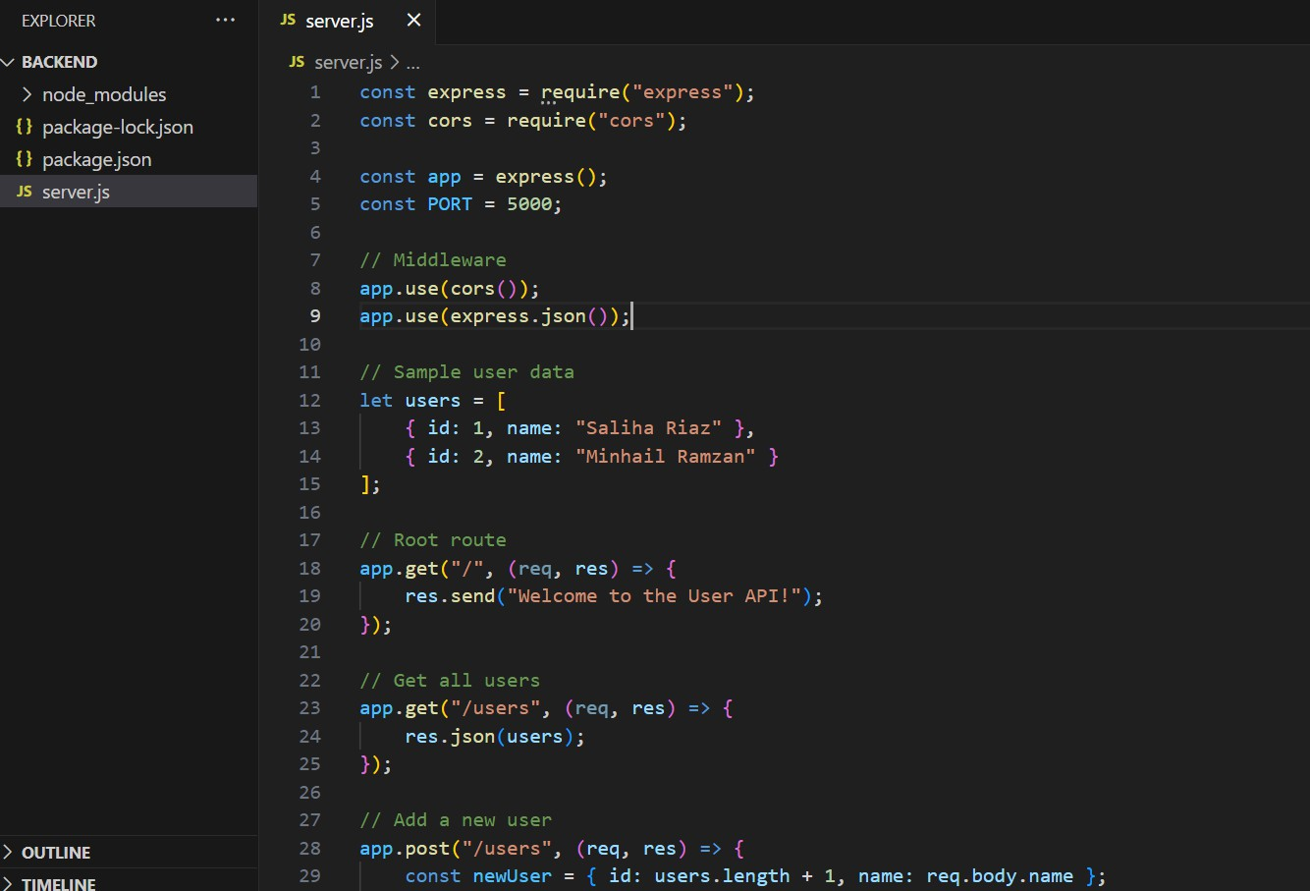Step 2: Open backend folder and make server.js file that contains the backend of above front web page



# A screen shot of a computer program AI-generated content may be incorrect.Output:

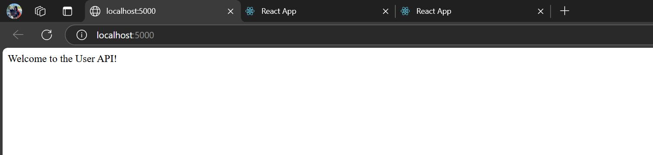Backend page checking its running or not

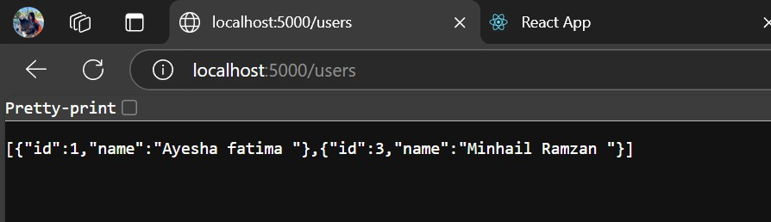

Frontend Page Output:

We can add edit and delete users but stores in backend when we attach database to our backend

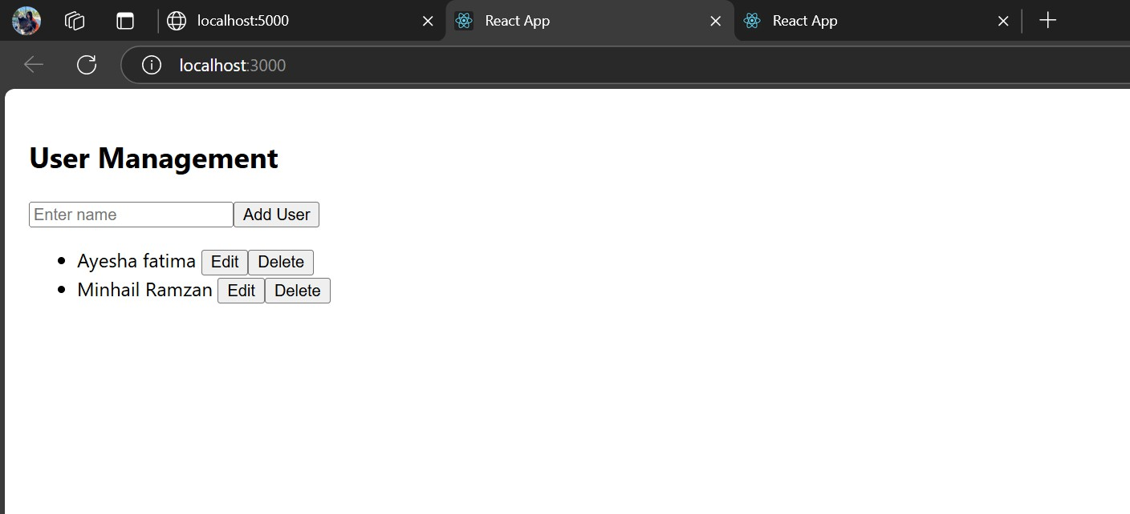

Adding Users:

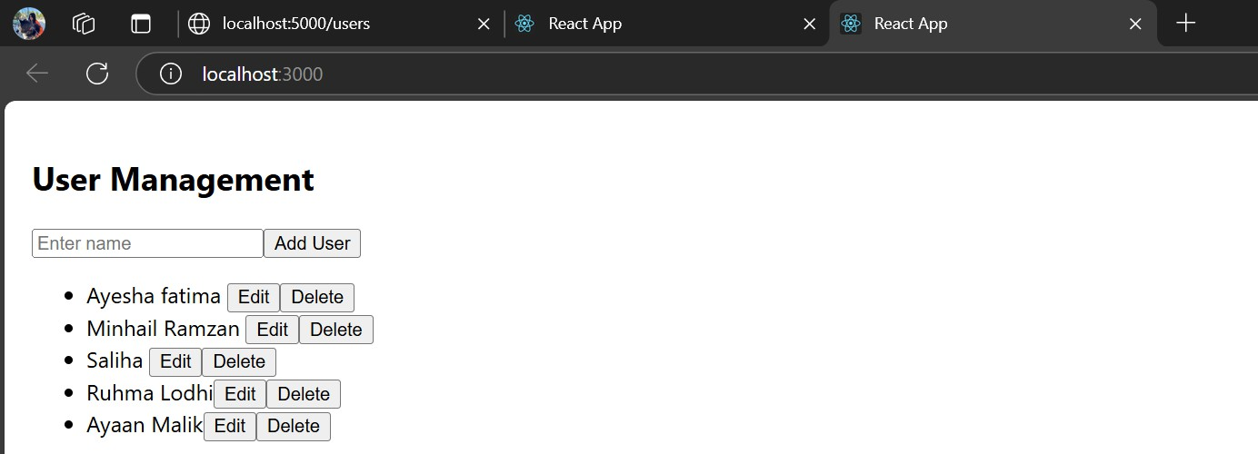

Delete Users:

