H.T No
Regulations:
A18

Sreenidhi Institute of Science and Technology
(An Autonomous Institution)
Code No: 7C304 Date: 26-July-2021(AN)

B.Tech II-Year I- Semester Covid-19 Special External Examination, July-2021 (Regular)
PROBABILITY THEORY AND STOCHASTIC PROCESS (ECE)

Time: 3 Hours Max.Marks:70

Note: a) No additional answer sheets will be provided.
b) All sub-parts of a question must be answered at one place only, otherwise it will not be valued.
c) Missing data can be assumed suitably.

ANSWER ANY 5 OUT OF 8 QUESTIONS. EACH QUESTION CARRIES 14 MARKS.

Bloom's Cognitive Levels of Learning (BCLL)

Remember | L1 | Apply | L3 | Evaluate | L5
Understand | L2 | Analyze | L4 | Create | L6

 |  |  | BCLL | CO(s) | Marks
1. | a) | Two boxes B1 and B2 contain 100 and 200 transistors respectively. Box B1 has 15 defective transistors and B2 has 10 defective transistors. Suppose one box is selected at random and one transistor is picked at random.  What is the probability that it is defective? | L4 | CO1 | [7M]
 | b) | State and explain the laws of probability. | L1 | CO1 | [7M]
2. | a) | A random variable X is Gaussian with 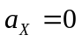 and 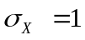. What is the probability that |X| > 2? | L3 | CO2 | [7M]
 | b) | Find the density function whose characteristic function is exp(-|t|). | L5 | CO2 | [7M]
3. | a) | The Joint probability density function of two random variables X and Y is  f_{xy}(x,y) = C(2X+Y) 0 ≤ X ≤ 1, 0 ≤ Y ≤ 2  Find (i) the value of ‘C’ (ii) marginal distribution functions of X and Y | L3 | CO3 | [7M]
 | b) | If X and Y are two independent random variables and Z = X+Y, relate their mean values m_{X}, m_{Y} and m_{Z}. | L4 | CO3 | [7M]
4. | a) | With neat sketches explain the classification of random process based on time t and amplitude of random variable X. | L2 | CO4 | [7M]
 | b) | Consider a random process X(t)=A Cost, where is a constant and A is a random variable uniformly distributed over (0,1). Find the auto correlation and auto covariance of X(t). | L3 | CO4 | [7M]
5. | a) | A random process is given as X(t) = At, Where ‘A’ is uniformly distributed random variable in the interval (0, 4). Find whether X(t) is wide sense stationary or not? | L3 | CO5 | [7M]
 | b) | For a stationary ergodic process having the autocorrelation function shown in below fig. Find (i)E[X(t)] (ii) E[X²(t)] (iii) σ_{x}²  R_{xx}(τ)  50  20  -10 0 10 τ | L4 | CO5 | [7M]
6. | a) | List out the properties of band-limited random process. | L1 | CO6 | [7M]
 | b) | Find the mean square value of the output response for a system having  h(t)=e^{-t} u(t) and input of white noise N_{o}/2. | L5 | CO6 | [7M]
7. | a) | Consider the experiment of tossing a coin three times. What is the probability that heads appear at the first two tosses. | L2 | CO1 | [5M]
 | b) | Let Y=X². Find f_{Y}(y) if X is N(0,1). | L3 | CO2 | [5M]
 | c) | Let (X, Y) be a bivariate random variable. f(x, y) is the joint Probability Mass function. Find P(X≤ 2, Y ≤ 3).  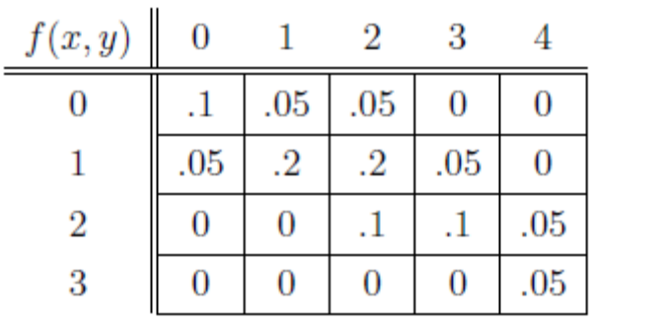 | L4 | CO3 | [4M]
8. | a) | Given a random process X(t)=Ysinωt, where Y is a random variable uniformly distributed in the range (-1, 1). Is the process ergodic. | L2 | CO4 | [7M]
 | b) | Write notes on the following terms:  i) Thermal noise ii) Narrowband noise. | L1 | CO5 | [7M]

-- 00 -- 00 –

