四．实验结果与分析

2

**源程序：**

# include <stdio.h>

# include <stdlib.h>

int main()

{

FILE *fp;

int n, sum = 0, mult = 1;

if ((fp=fopen("Datafile.dat", "r+"))==NULL){

printf("Can't open file!\n");exit(0);

}

while(fscanf(fp, "%d", &n)!=EOF){

sum = sum+n;

mult = mult*n;

}

fprintf(fp, "%d %d", sum, mult);

fclose(fp);

return 0;

}

1. 8 error(s) 3 warnings
2. (8): error C2440: “=”: 无法从“FILE *”转换为“FILE”

(5): FILE *fp;

1. (8): error C2143: 语法错误: 缺少“;”(在“==”的前面)

(8): if ((fp=fopen("Datafile.dat", "r"))==NULL)

1. (13): error C4700: 使用了未初始化的局部变量“sum”、“mult”

(6): int n, sum = 0, mult = 1;

1. 方法：单步调试

改错汇总：

错误行号：8 正确语句：if ((fp=fopen("Datafile.dat", "r+"))==NULL)

错误行号：12 正确语句：while(fscanf(fp,“%d”, &n)!=EOF)

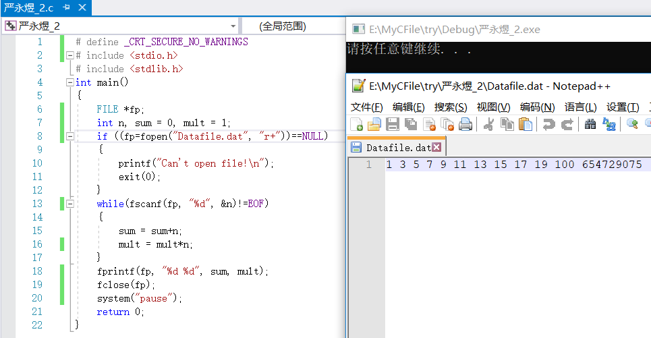

3-1

**源程序：**

# include <stdio.h>

int main()

{

int n;

char file[2][30], ch;

FILE *fout, *fin;

printf("输入明文文件名: ");

scanf("%s",file[0]);

printf("输入n的值: ");

scanf("%d",&n);

printf("输入密文文件名: ");

scanf("%s",file[1]);

if ((fin=fopen(file[0],"r"))==NULL||(fout=fopen(file[1],"w+"))==NULL){

printf("Cannot open file\n");

exit(0);

}

while (~(ch=fgetc(fin))) fputc(ch+n,fout);

rewind(fout);

printf("加密成功后的密文为: ");

while(~(ch=fgetc(fout))) putchar(ch);

putchar(10);

fclose(fin);

fclose(fout);

return 0;

}

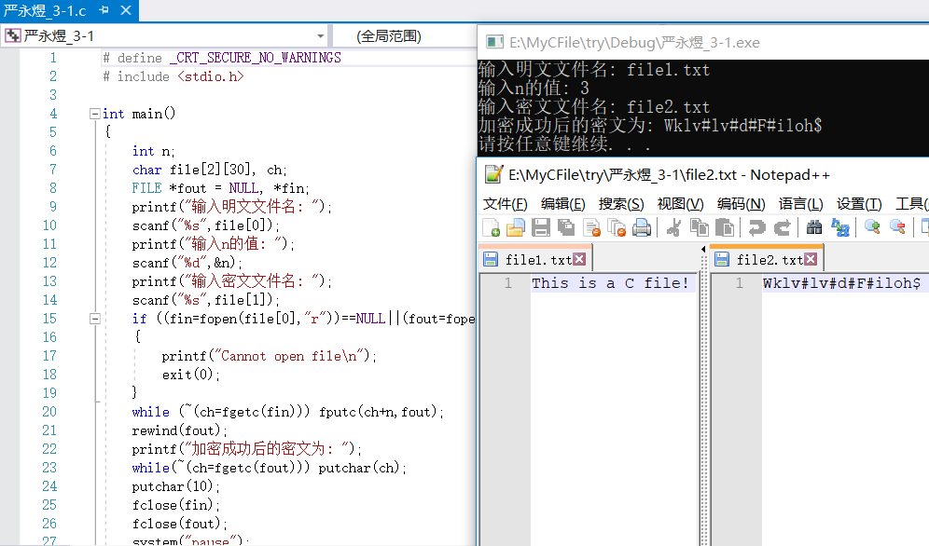

3-2

**源程序：**

# include <stdio.h>

# define N 10

struct Student

{

char num[10];

char name[10];

char phone[20];

char addr[50];

}students[N];

void save()

{

FILE *fp;

if ((fp=fopen("student.txt","w"))==NULL)

{

printf("Cannot open file\n");

return;

}

for (int i=0;i<N;i++)

{

fprintf(fp,"%-10s%-10s%-20d%-50s\n",students[i].num,\

students[i].name,students[i].phone,students[i].addr);

printf("%-10s%-10s%-20d%-50s\n",students[i].num,students[i].name,\

students[i].phone,students[i].addr);

}

fclose(fp);

}

int main()

{

int i;

printf("Please enter data of %d students:\n",N);

for (i=0;i<N;i++)

{

scanf("%s%s%s%s",students[i].num,students[i].name,\

students[i].phone,students[i].addr);

}

save();

return 0;

}

