四．实验结果与分析

2

源程序：

# include <stdio.h>

int main()

{

int i, x, n;

int a[10];

printf("输入数组元素的个数: ");

scanf("%d", &n);

printf("输入数组%d 个元素: ", n);

for (i = 0; i < n; i++) scanf("%d", &a[i]);

printf("输入 x: ");

scanf("%d", &x);

for (i = 0; i < n; i++)

if (a[i] == x) break;

if (i == n) printf("没有找到与%d 相同的元素!\n", x);

else printf("和%d相同的数组元素是 a[%d] = %d\n", x, i, a[i]);

return 0;

}

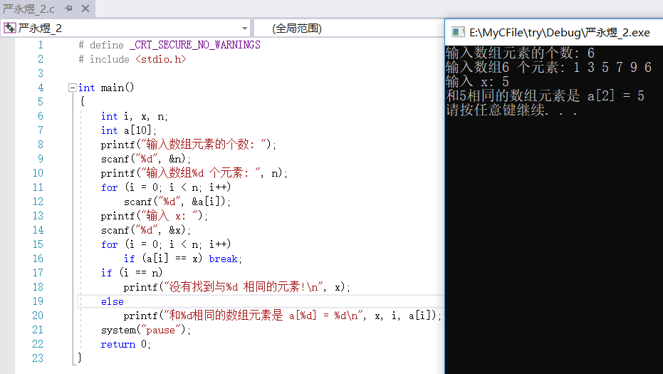

1. 0 error(s) 0 warning(s)
2. 错误
3. 方法：根据debug判断程序语法与逻辑错误。

错误行号：11 正确语句：scanf("%d", &a[i]);

错误行号：15 正确语句：if (a[i] == x) break;

错误行号：16 正确语句：if (i == n)

3-1

源程序：

# include <stdio.h>

# define swap(a,b) {int t=a;a=b;b=t;}

int main()

{

int n, i, sign;

int a[10];

printf("Input n: ");

scanf("%d", &n);

printf("Input %d integers: ", n);

for (i = 0; i < n; i++) scanf("%d", &a[i]);

for (i = 1, sign = 0; i < n; i++) if (a[i] > a[sign]) sign = i;

swap(a[sign], a[0]);

for (i = 1, sign = 0; i < n; i++) if (a[i] < a[sign]) sign = i;

swap(a[sign], a[n - 1]);

printf("After swap: ");

for (i = 0; i < n - 1; i++) printf("%d ", a[i]);

printf("%d\n", a[n - 1]);

system("pause");

return 0;

}

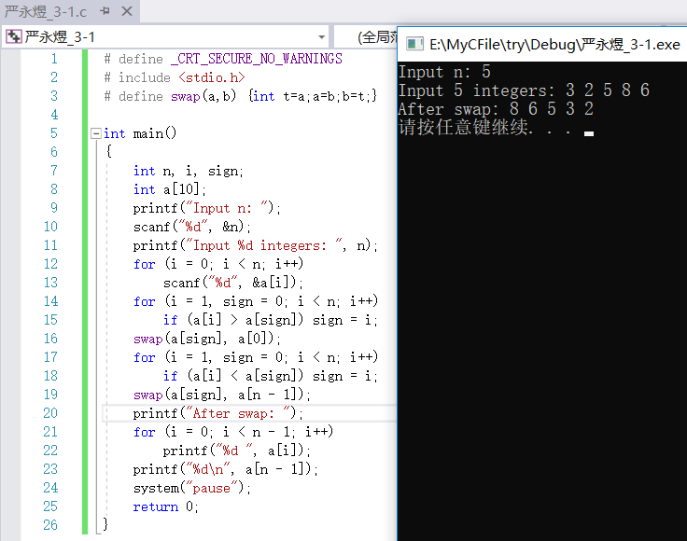

3-2

源程序：

# include <stdio.h>

int main()

{

int n, i;

int a[10];

printf("Input n: ");

scanf("%d", &n);

printf("Input %d integers: ", n);

for (i = 0; i < n; i++)

scanf("%d", &a[i]);

for (i = 0; i < n - 1; i++)

{

if (i % 3 == 2) printf("%d\n", a[i] / a[i + 1]);

else printf("%d\t", a[i] / a[i + 1]);

}

system("pause");

return 0;

}

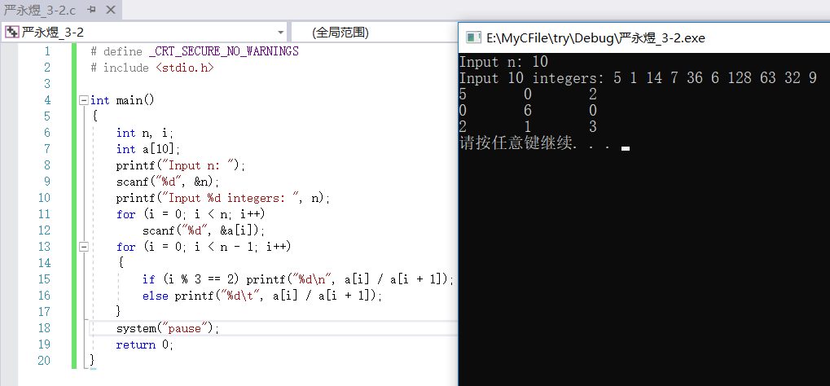

3-3

源程序：

# include <stdio.h>

int main()

{

int n, i, j, sum = 0;

int a[6][6];

printf("Input n: ");

scanf("%d",&n);

printf("Input array:\n");

for (i = 0;i < n; i++)

for (j = 0;j < n; j++)

{

scanf("%d",&a[i][j]);

sum += a[i][j];

}

for (i = 0;i < n; i++) sum -= a[i][i];

for (i = 0;i < n; i++) sum -= a[i][0];

for (i = 0;i < n; i++) sum -= a[n-1][i];

sum += a[0][0] + a[n-1][n-1] + a[n-1][0];

printf("sum=%d\n",sum);

return 0;

}

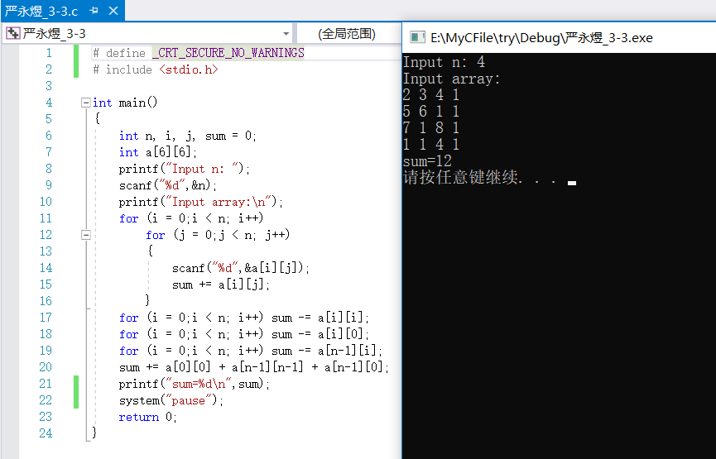

3-4

源程序：

# include <stdio.h>

int n, a[6][6];

int judge(int i, int j)

{

int m;

for (m = 0;m < n;m++) if (a[i][m] > a[i][j]) return 0;

for (m = 0;m < n;m++) if (a[m][j] < a[i][j]) return 0;

return 1;

}

int main()

{

int i, j, sign = 0;

printf("Input n: ");

scanf("%d",&n);

printf("Input array:\n");

for (i = 0;i < n; i++) for (j = 0;j < n; j++) scanf("%d",&a[i][j]);

for (i = 0;i < n; i++) for (j = 0;j < n; j++) if (judge(i,j) == 1) {

printf("a[%d][%d]=%d 是鞍点!\n",i,j,a[i][j]);

sign = 1;

break;

}

}

if (sign == 0) printf("没有鞍点!\n");

return 0;

}

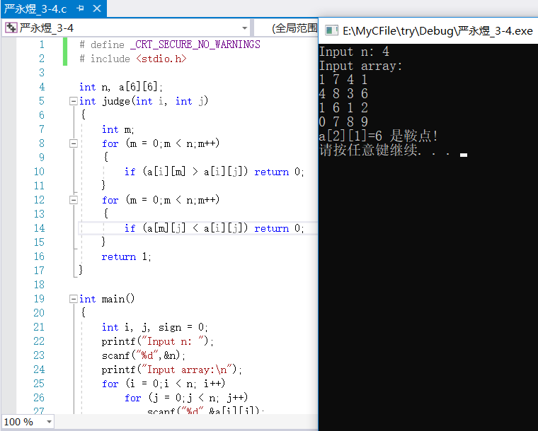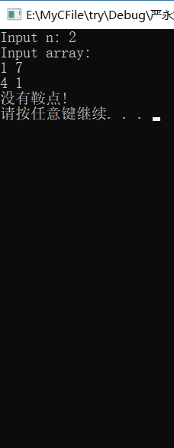

3-5

源程序：

# include <stdio.h>

# include <string.h>

int main()

{

char a[90];

int i, j, flag, sign = 0;

printf("Input a string: ");

scanf("%[^\n]%*c",a);

printf("结果是：");

for (i = 0; i < strlen(a); i++)

{

if (a[i]>='a' && a[i]<='z')

{

for (j = 0,flag = 1;j < i;j++) if (a[i] == a[j]) flag = 0;

if (flag == 1) {printf("%c",a[i]);sign = 1;}

}

}

if (sign == 0) printf("Not Found!");

printf("\n");

return 0;

}

