四．实验结果与分析

2-1

源程序：

# include <stdio.h>

# define PI 3.14159265358979323846

int main()

{

int r;

double c,s;

printf("请输入一个整数r: ");

scanf("%d",&r);

c = 2*PI*r;

s = PI*r*r;

printf("周长c=%.6lf, 面积s=%.6lf\n",c,s);

return 0;

}

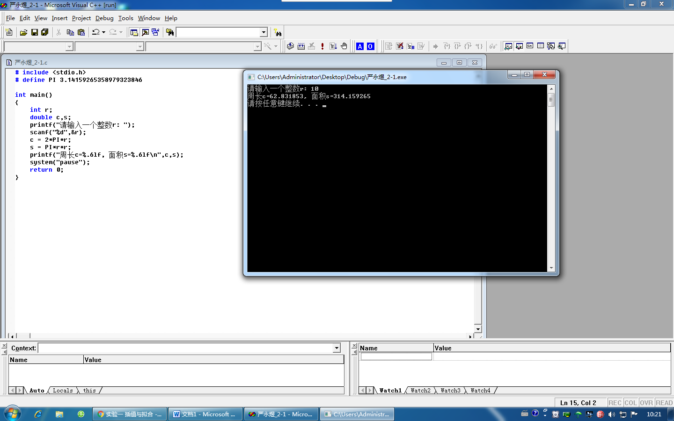

遇到的问题：输出数据有微小差异

解决方法：提高π精度

2-2

源程序：

# include <stdio.h>

int main()

{

int n;

printf("Enter x:");

scanf("%d",&n);

if ((n % 3 != 0)&&(n % 5 != 0)&&(n % 7 != 0)) printf("不能被3、5、7任一个数整除\n");

else if (((n % 3 != 0)&&(n % 5 != 0)&&(n % 7 == 0))||

((n % 3 != 0)&&(n % 5 == 0)&&(n % 7 != 0))||

((n % 3 == 0)&&(n % 5 != 0)&&(n % 7 != 0)))

printf("能被其中一个数整除\n");

else if (((n % 3 != 0)&&(n % 5 == 0)&&(n % 7 == 0))||

((n % 3 == 0)&&(n % 5 == 0)&&(n % 7 != 0))||

((n % 3 == 0)&&(n % 5 != 0)&&(n % 7 == 0)))

printf("能被其中两数整除\n");

else printf("能同时被 3、5、7 整除\n");

return 0;

}

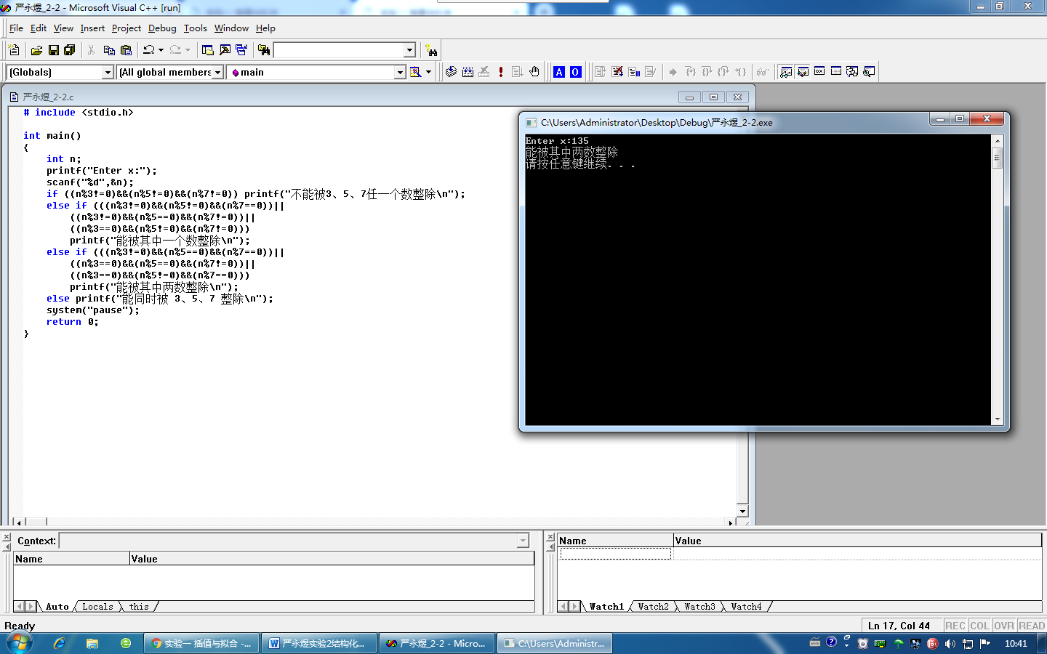

2-3

源程序：

# include <stdio.h>

int main()

{

int n;

printf("Input integer number n:");

scanf("%d",&n);

switch(n)

{

case 1 : printf("Today is Monday!\n");break;

case 2 : printf("Today is Tuesday!\n");break;

case 3 : printf("Today is Wednesday!\n");break;

case 4 : printf("Today is Thursday!\n");break;

case 5 : printf("Today is Friday!\n");break;

case 6 : printf("Today is Saturday!\n");break;

case 7 : printf("Today is Sunday!\n");break;

default : printf("Input data error!\n");

}

return 0;

}

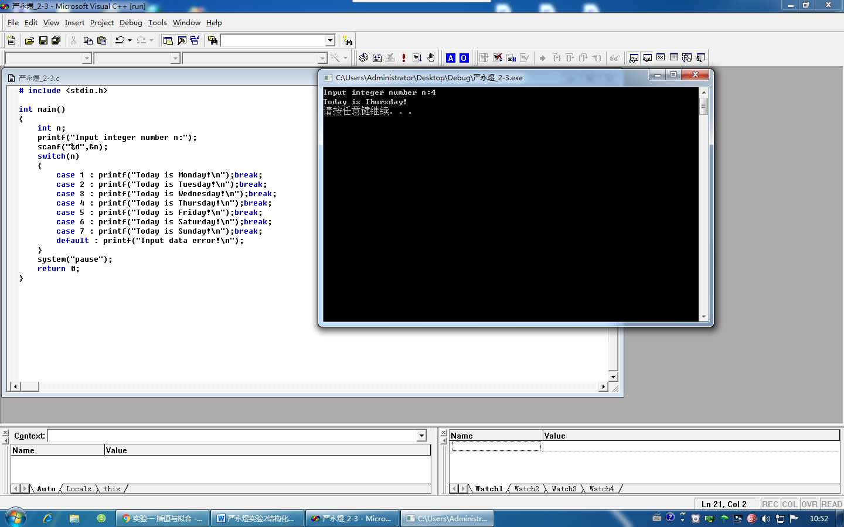

2-4

源程序：

# include <stdio.h>

int main()

{

int n, i, m;

double e=1, each, grade;

printf("Input n:");

scanf("%d",&n);

for (I = 1;I <= n;i++)

{

grade = 1;

for (m = i; m > 0; m--) grade *= m;

each = 1 / grade;

e += each;

}

printf("e=%.4lf\n",e);

return 0;

}

