四．实验结果与分析

2

**源程序：**

# include <stdio.h>

int main()

{

int min, x, y, *pmin, *px, *py;

scanf("%d%d", &x, &y);

px = &x;

py = &y;

pmin = &min;

*pmin = *px;

if (*pmin > *py) *pmin = *py;

printf("min=%d\n", min);

return 0;

}

1. 2 error(s) 4 warnings
2. (10): error C2065: “min”: 未声明的标识符

(4): int min,x,y,*pmin,*px,*py;

1. (8)(9)(10): warning C4047: “=”:“int”与“int *”的间接级别不同

(8): px = &x;

(9): px = &y;

(10): pmin = &min;

1. 错误行号：11 正确语句：if (*pmin > *py);

错误行号：12 正确语句：*pmin = *py;

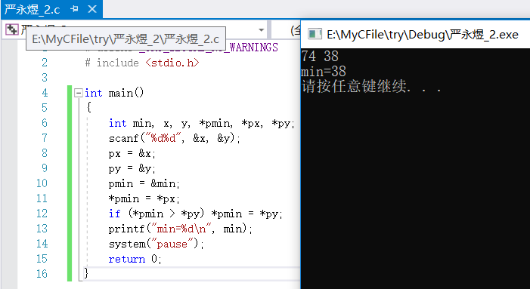

3-1

**源程序：**

# include <stdio.h>

int tran(int year, int *month, int *day){

int cases=0;

if ((year%4==0 && year%100!=0)||(year%400==0)){

if (*day>0&&*day<=31) cases=12;

else if (*day>31&&*day<=60) cases=11;

else if (*day>60&&*day<=91) cases=10;

else if (*day>91&&*day<=121) cases=9;

else if (*day>121&&*day<=152) cases=8;

else if (*day>152&&*day<=182) cases=7;

else if (*day>182&&*day<=213) cases=6;

else if (*day>213&&*day<=244) cases=5;

else if (*day>244&&*day<=274) cases=4;

else if (*day>274&&*day<=305) cases=3;

else if (*day>305&&*day<=335) cases=2;

else if (*day>335&&*day<=366) cases=1;

else cases=-1;

switch(cases){

case 1: *month+=1;*day-=30;

case 2: *month+=1;*day-=31;

case 3: *month+=1;*day-=30;

case 4: *month+=1;*day-=31;

case 5: *month+=1;*day-=31;

case 6: *month+=1;*day-=30;

case 7: *month+=1;*day-=31;

case 8: *month+=1;*day-=30;

case 9: *month+=1;*day-=31;

case 10: *month+=1;*day-=29;

case 11: *month+=1;*day-=31;

case 12: *month+=1;break;

default: return -1;

}

}

else{

if (*day>0&&*day<=31) cases=12;

else if (*day>31&&*day<=59) cases=11;

else if (*day>59&&*day<=90) cases=10;

else if (*day>90&&*day<=120) cases=9;

else if (*day>120&&*day<=151) cases=8;

else if (*day>151&&*day<=181) cases=7;

else if (*day>181&&*day<=212) cases=6;

else if (*day>212&&*day<=243) cases=5;

else if (*day>243&&*day<=273) cases=4;

else if (*day>273&&*day<=304) cases=3;

else if (*day>304&&*day<=334) cases=2;

else if (*day>334&&*day<=365) cases=1;

else cases=-1;

switch(cases){

case 1: *month+=1;*day-=30;

case 2: *month+=1;*day-=31;

case 3: *month+=1;*day-=30;

case 4: *month+=1;*day-=31;

case 5: *month+=1;*day-=31;

case 6: *month+=1;*day-=30;

case 7: *month+=1;*day-=31;

case 8: *month+=1;*day-=30;

case 9: *month+=1;*day-=31;

case 10: *month+=1;*day-=28;

case 11: *month+=1;*day-=31;

case 12: *month+=1;break;

default: return -1;

}

}

return 1;

}

int main(){

int year, day, month=0, *m=&month, *d=&day, isTrue=0;

printf("请输入Julian历法的日期(年，第几天): ");

scanf("%d,%d",&year,&day);

isTrue = tran(year,m,d);

if (isTrue==1) printf("现代历法的日期是:%d年%d月%d日\n",year,month,day);

else printf("您输入的Julian日期有误!\n");

return 0;

}

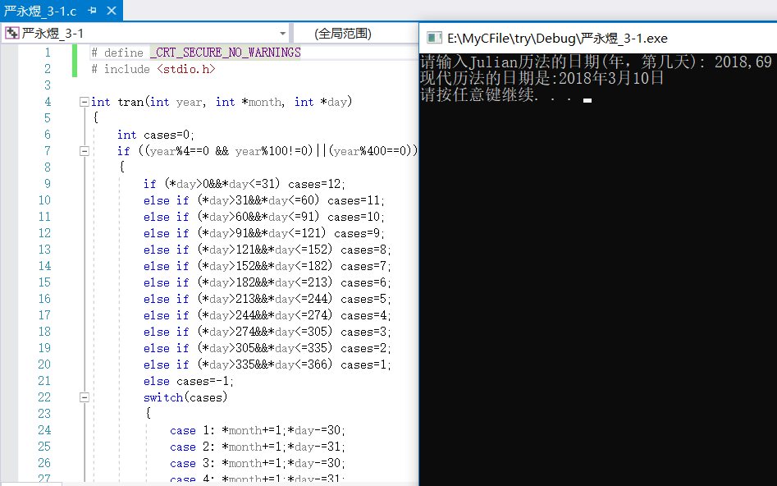

3-2

**源程序：**

# include <stdio.h>

int search(int list[], int n, int x)

{

for (int i=0;i<n;i++) if (*(list+i)==x) return i;

return -1;

}

int main()

{

int list[10],n,x,i,result;

printf("Input n: ");

scanf("%d",&n);

printf("Input %d integers: ",n);

for (i=0;i<n;i++) scanf("%d",list+i);

printf("Input x: ");

scanf("%d",&x);

result = search(list,n,x);

if (result==-1) printf("Not found\n");

else printf("Index=%d\n",result);

return 0;

}

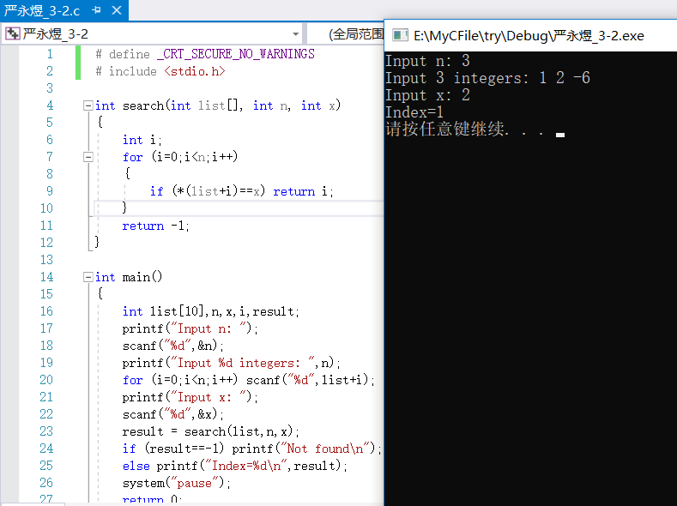

3-3

**源程序：**

# include <stdio.h>

# include <string.h>

int Duplicate(char str[],char dest[],int n)

{

char *p=str+n-1,*q=dest;

if (n>strlen(str)) return -1;

for (;*p!='\0';p++,q++) *q=*p;

return strlen(dest);

}

int main()

{

char str[100],dest[100]={'\0'};

int n,num;

printf("Input a string: ");

scanf("%[^\n]",str);

printf("Input a integer: ");

scanf("%d",&n);

num = Duplicate(str,dest,n);

printf("Output is: %s, %d characters.\n",dest,num);

return 0;

}

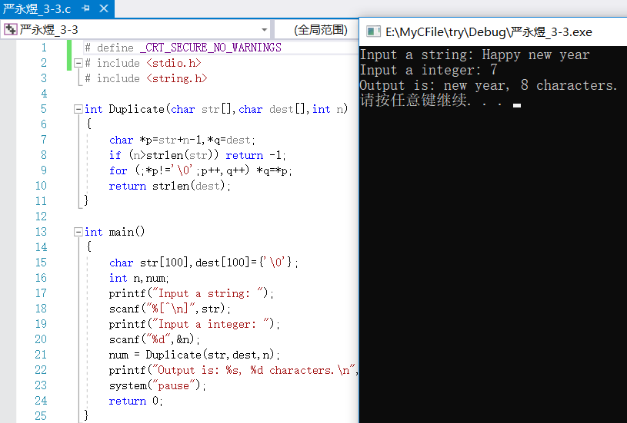

3-4

**源程序：**

# include <stdio.h>

void average(int score[][4])

{

int i,num,sum=0;

printf("Please enter the class num: ");

scanf("%d",&num);

for (i=0;i<5;i++) sum += *(*(score+i)+num-1);

printf("The average score of class %d is: %.2f\n",num,sum/5.0);

}

void fail(int score[][4])

{

int i,j,sum,num;

printf("Students failed:\n");

for (i=0;i<5;i++)

{

num = 0;

sum = 0;

for (j=0;j<4;j++)

{

sum += *(*(score+i)+j);

if (*(*(score+i)+j)<60) num+=1;

}

if (num > 1) printf("Num.%d score:%d %d %d %d average:%.2f\n",\

i+1,*(*(score+i)+0),*(*(score+i)+1),*(*(score+i)+2),*(*(score+i)+3),sum/4.0);

}

}

void passed(int score[][4])

{

int i,j,sum,num;

printf("Students passed:\n");

for (i=0;i<5;i++)

{

sum = 0;

num = 4;

for (j=0;j<4;j++)

{

sum += *(*(score+i)+j);

if (*(*(score+i)+j)>85) num -= 1;

}

if (num==0||sum/4.0>90) printf("Num.%d score:%d %d %d %d average:%.2f\n",\

i+1,*(*(score+i)+0),*(*(score+i)+1),*(*(score+i)+2),*(*(score+i)+3),sum/4.0);

}

}

int main()

{

int i, score[5][4];

printf("Please input the score.Each student in one line:\n");

for (i=0;i<5;i++) scanf("%d%d%d%d",&score[i][0],&score[i][1],&score[i][2],&score[i][3]);

average(score);

fail(score);

passed(score);

system("pause");

return 0;

}

