四．实验结果与分析

2

**源程序：**

# include <stdio.h>

double fact(int n);

int main()

{

double sum=0;

for (int i=1;i<=10;i++) sum += fact(i);

printf("1!+2!+...+10!=%lf\n",sum);

return 0;

}

double fact(int n)

{

double result=1;

for (int i=1;i<=n;i++) result=result*i;

return result;

}

1. 3 error(s) 1 warnings
2. (4): error C2143: 语法错误: 缺少“;”(在“{”的前面)
3. (10): warning C4474: printf: 格式字符串中传递的参数太多
4. (15): error C2449: 在文件范围内找到“{”(是否缺少函数头?)

④ (20): error C2106: “=”: 左操作数必须为左值

1. 赋值运算等号左侧应为变量而非值
2. ① (21): warning C4716: “fact”: 必须返回一个值

② ③ (9): error C4700: 使用了未初始化的局部变量“sum”

错误行号：21 正确语句：return result;

错误行号：9 正确语句：double sum = 0;

1. 运行结果为：1!+2!+...+10!=1511.000000 是否正确：错误

错误行号：20 正确语句：for (i=1;i<=n;i++) result=result*i;

错误行号：8 正确语句：for (i=1;i<=10;i++)

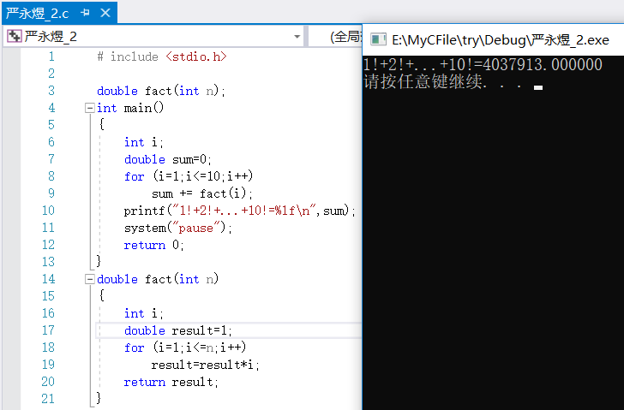

3-1

**源程序：**

# include <stdio.h>

int YesNo(int n)

{

if (n % 3 == 0) return 1;

else if (n % 5 == 0) return 1;

return 0;

}

int main()

{

int n, sum=0;

printf("Input integers: ");

while (~scanf("%d",&n),n > 0)

{

if (YesNo(n) == 1) sum += n;

}

printf("The sum of the numbers that meet condition is %d\n",sum);

return 0;

}

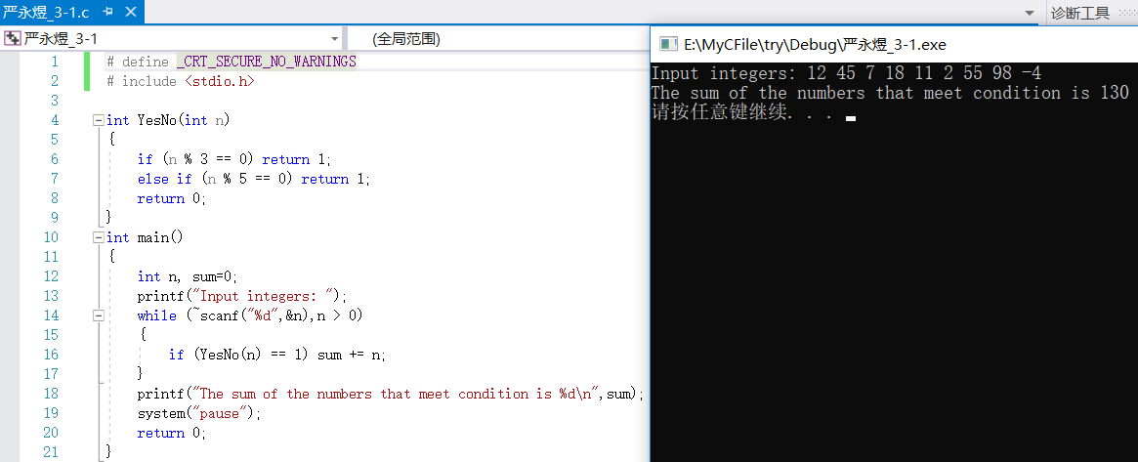

3-2

**源程序：**

# include <stdio.h>

int Is(int n)

{

int i=n,j,sum=0;

while (i>0)

{

j=i%10;

sum += j*j*j;

i /= 10;

}

if (sum == n) return 1;

return 0;

}

int main()

{

int m,n,i;

printf("Input m: ");

scanf("%d",&m);

printf("Input n: ");

scanf("%d",&n);

for (i=m;i<=n;i++)

if (Is(i) == 1) printf("%d\n",i);

return 0;

}

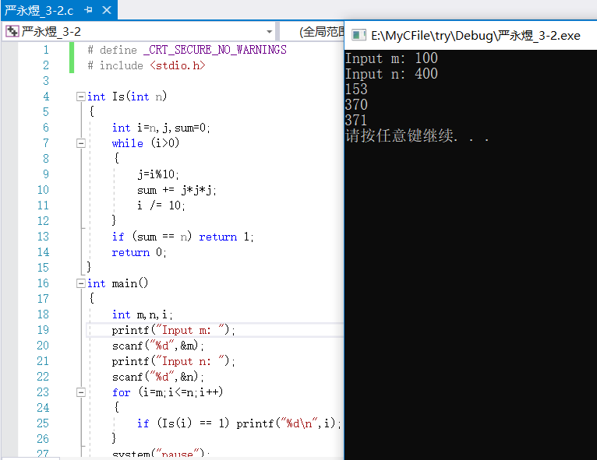

3-3

**源程序：**

# include <stdio.h>

int a[10000];

void Dectoother(int n,int m)

{

int count=0;

while (n>0)

{

a[count] = n % m;

n /= m;

count++;

}

for (count--;count>-1;count--) printf("%d",a[count]);

printf("\n");

}

int main()

{

int n,m;

printf("输入数n和拟转换的进制数m: ");

scanf("%d%d",&n,&m);

Dectoother(n,m);

return 0;

}

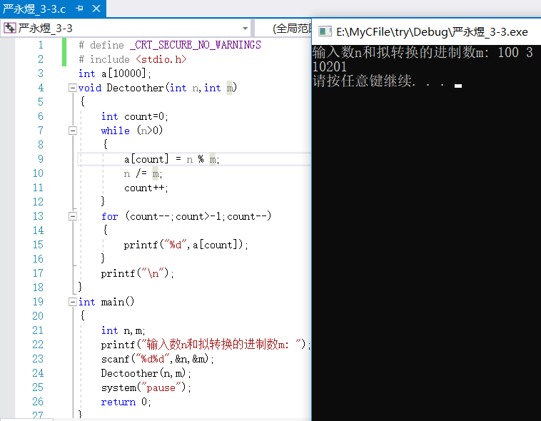

3-4

**源程序：**

**3-4.c:**

# include <stdio.h>

**文件包含：**

# include "fun.c"

**连接：**

extern int Add(int a,int b), Sub(int a,int b), Mul(int a,int b);

extern double Div(int a,int b);

int main()

{

int a,b;

char c;

scanf("%d%c%d",&a,&c,&b);

if (c=='+') printf("%d+%d=%d\n",a,b,Add(a,b));

else if (c=='-') printf("%d-%d=%d\n",a,b,Sub(a,b));

else if (c=='*') printf("%d*%d=%d\n",a,b,Mul(a,b));

else if (c=='/') printf("%d÷%d=%.6lf\n",a,b,Div(a,b));

system("pause");

return 0;

}

**fun.c:**

int Add(int a,int b)

{

return a+b;

}

int Sub(int a,int b)

{

return a-b;

}

int Mul(int a,int b)

{

return a*b;

}

double Div(int a,int b)

{

return a*1.0/b;

}

