Resource Document
Entire System Layout 1
Mixer Sub-System 2
Mixer Testing 2
Voltage 2
Resistance 3
Analogue In 4
Analogue In Testing 4
Resistor Ladder 5
Resistor Ladder Testing 5
Comparator Chain 5
Comparator Chain Testing 6
Priority Encoder Layout 6
Priority Encoder Testing 7
Seven Segment Testing 8

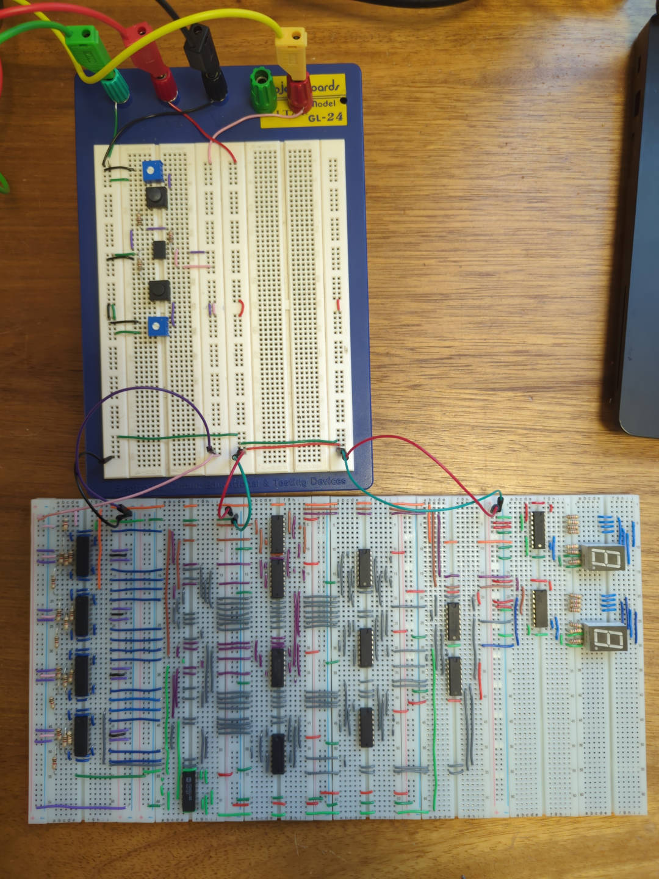
Entire System Layout
This is a photo of the entire system.

Mixer Sub-System
This is a photo of the mixer sub-system in the original layout.
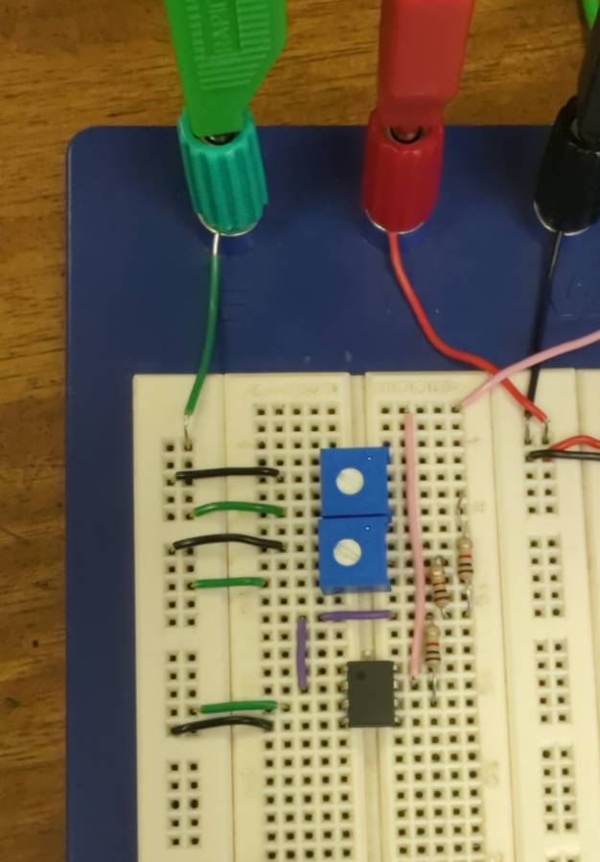

Mixer Testing

Voltage
Here I was testing the functionality of the mixer sub-system with a voltmeter. The voltmeter is reading the output from one of the inputs to the mixer.
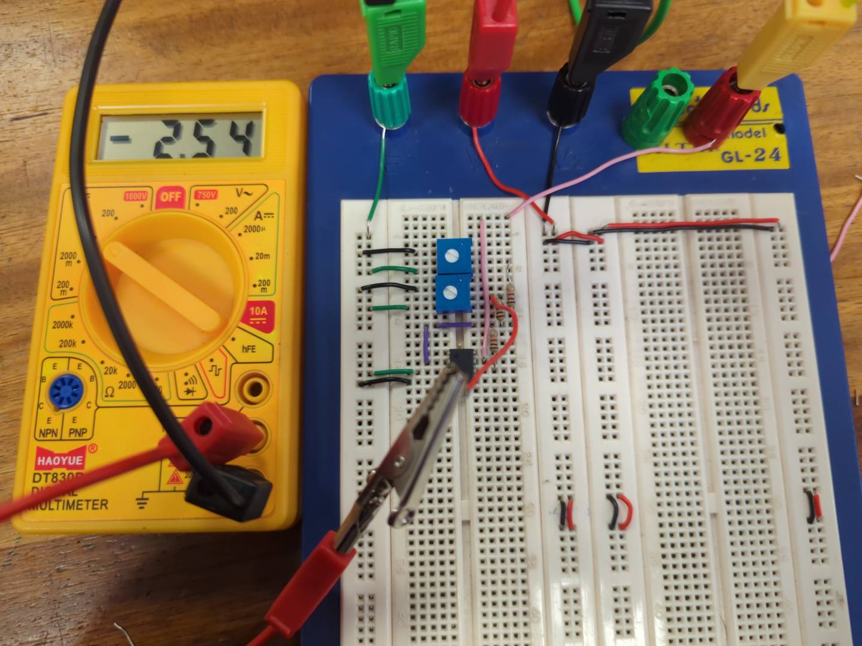

Resistance
Here I am measuring the resistance of the “R1” resistor within the mixer sub-system.
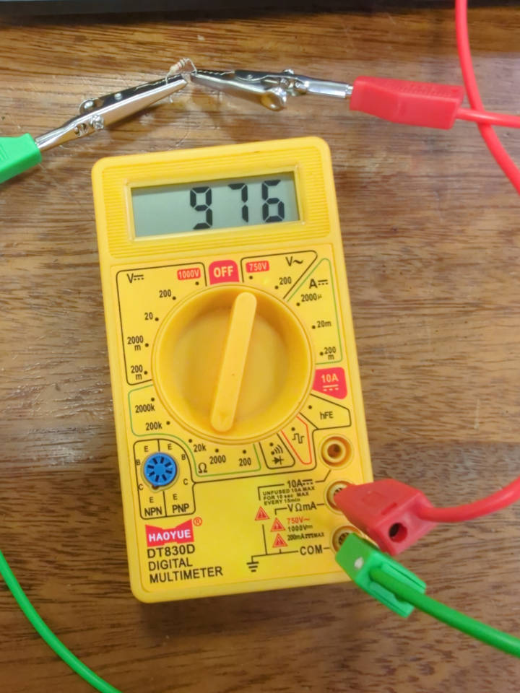

Analogue In
This is the circuit layout of the analogue input sub-system.
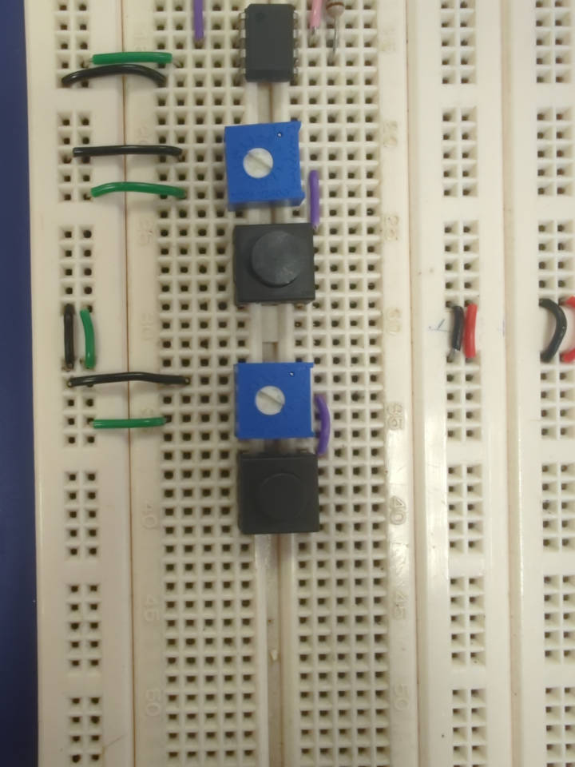

Analogue In Testing
Here I am using a voltmeter to test the functionality of the the analogue input sub-system. It should be noted that the push-to-break switches had to be replaced with push-to-make switches in the physical circuit, due to a lack of the former component.
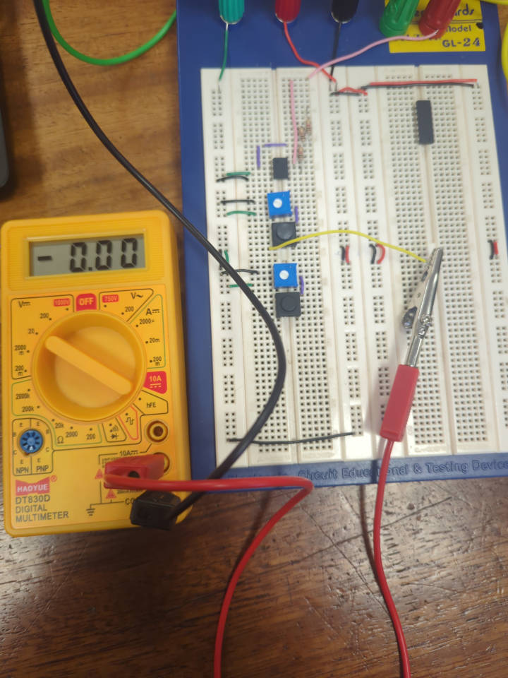

Resistor Ladder
This is the circuit layout of the resistor ladder sub-system.
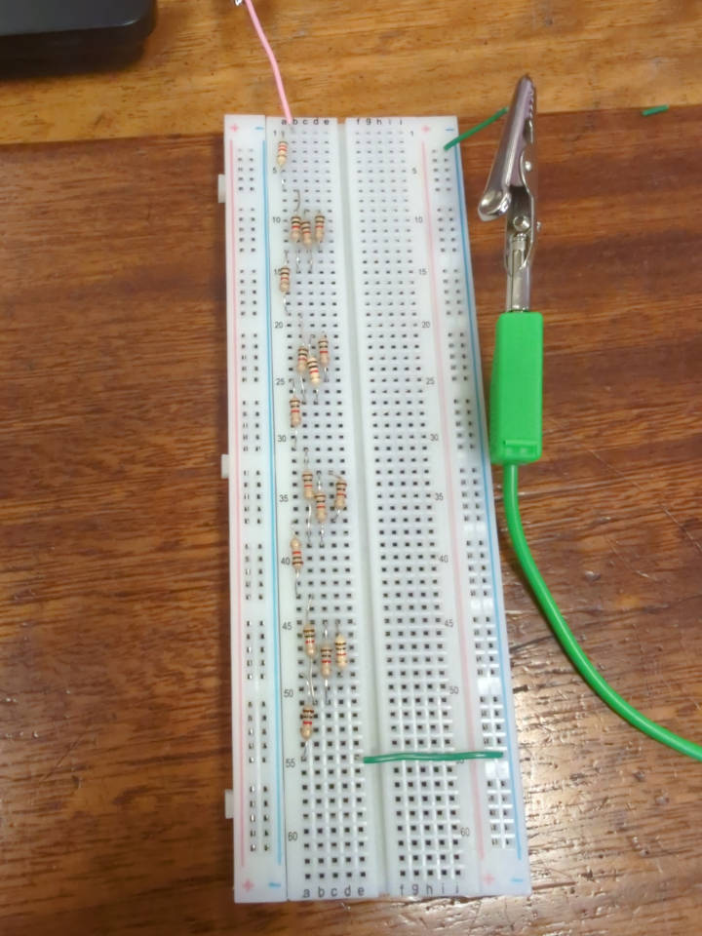

Resistor Ladder Testing
Here I am measuring the voltage drop over the 8.2KΩ resistor, before the resistor ladder.
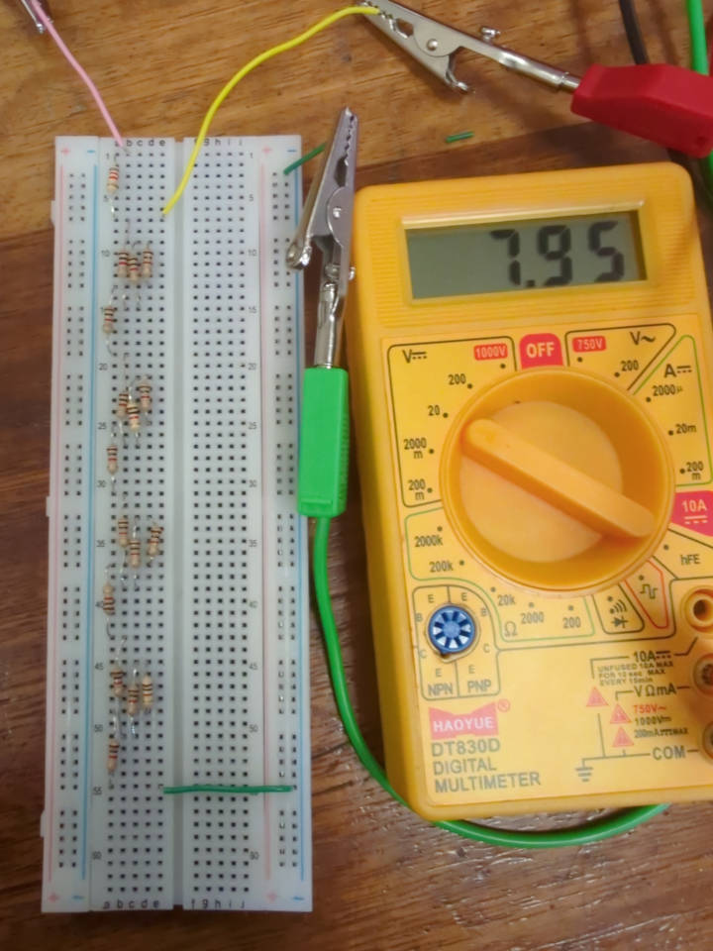

Comparator Chain
Here is the layout of the comparator chain sub-system.
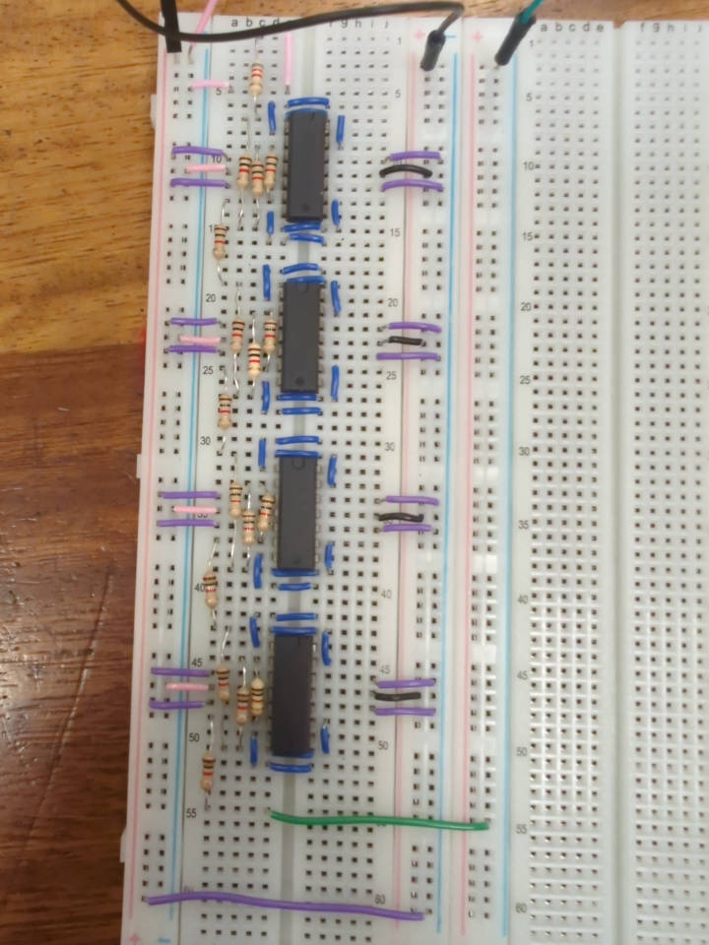

Comparator Chain Testing
Here I am testing that the “Vout” from the operational amplifier is at negative/positive saturation at the correct input voltages.
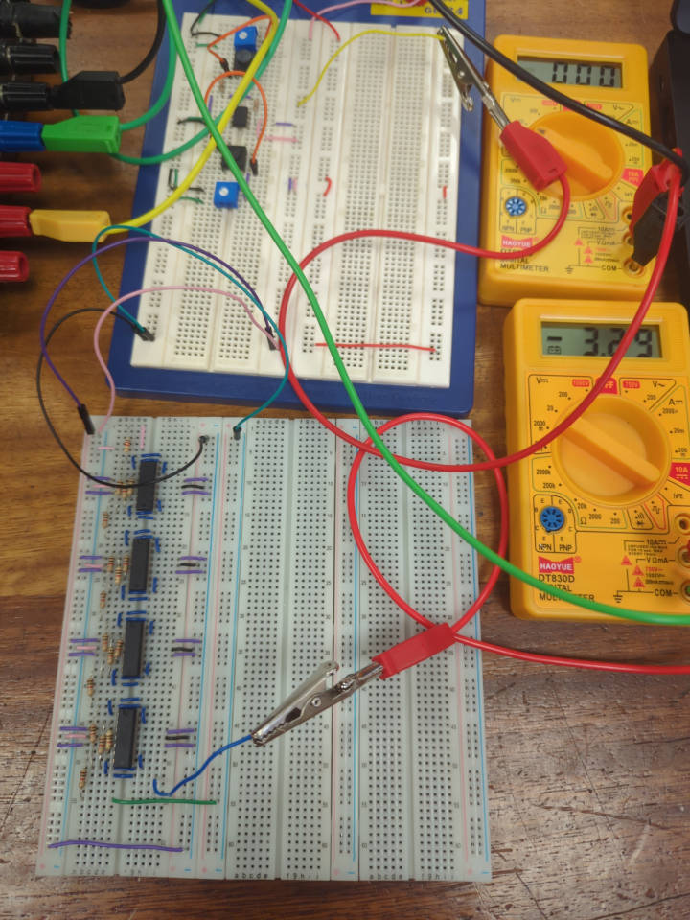

Priority Encoder Layout
This is the layout of the priority encoder sub-system. There are a few minor wiring differences in this photo to the entire system photo, as some of the connections were wired incorrectly. This was discovered during testing after this photo was taken.
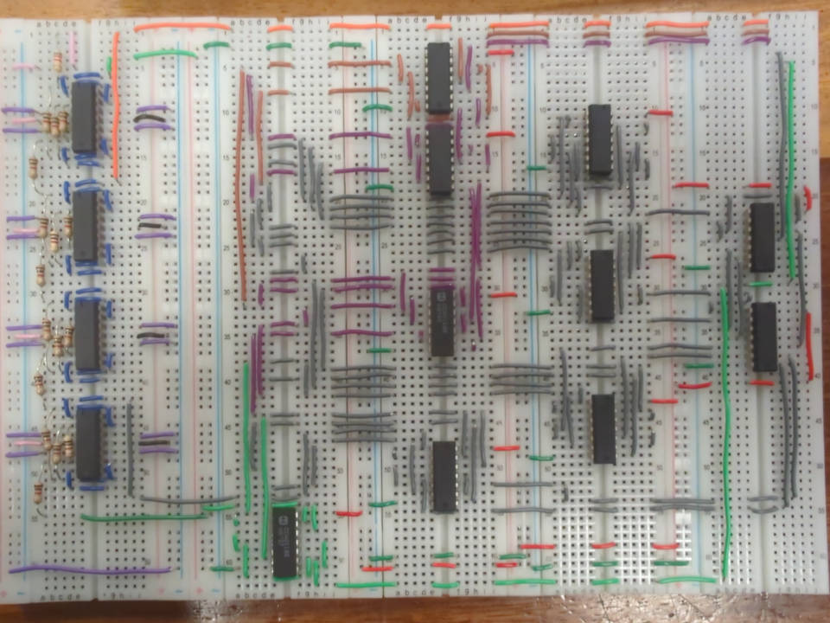

Priority Encoder Testing
Here I am testing that the priority encoder outputs the correct outputs given certain inputs. I first tested this with a voltmeter, but I switched to using an oscilloscope due to the number of outputs that I was measuring.
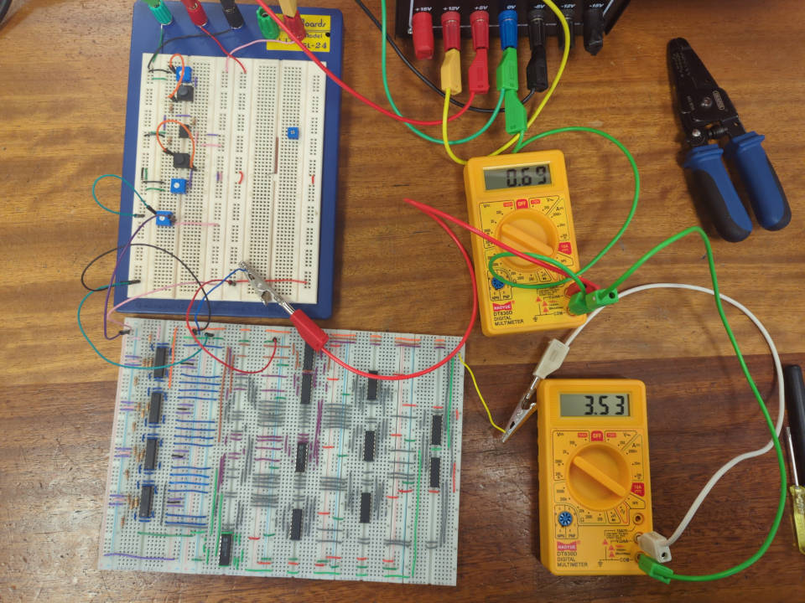
This is the testing I did with the oscilloscope. The voltmeter shows the value of “Vin” to the ADC sub-system.
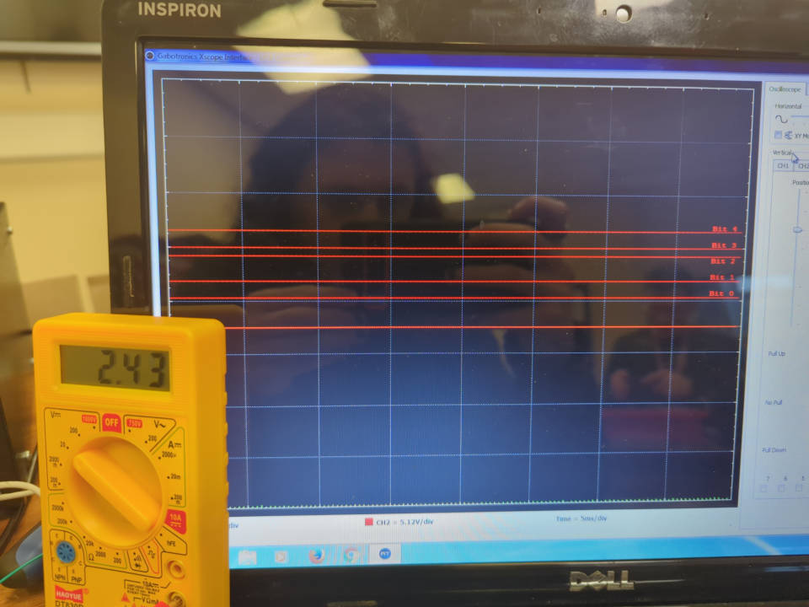

Seven Segment Testing
In this image I am testing that the seven segment display sub-system, is functioning correctly by arranging the blue jumper wires to a binary coded decimal input and observing that the displayed numbers are correct.
