System Planning

Problem
What, why, who, where.
Research of a specific example.

Specification
At least 4 qualitative and 4 quantitative system specifications (a list of 8).
Electronic parameters (e.g. time, frequency, current, voltage, power (inc. tolerances)

System Development

Mixer
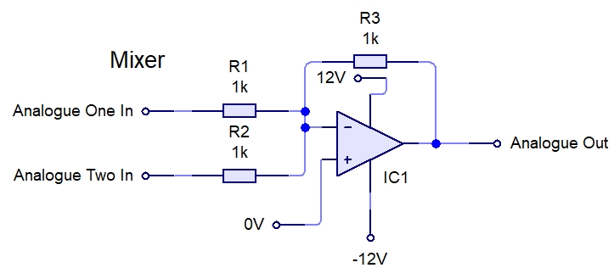

Test Diagram
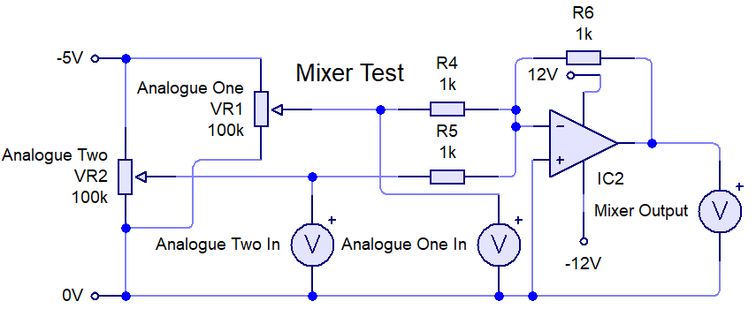

Test Table
The expected outcome of the test is predicted using the equation: , where is analogue input one and is analogue input two.
Test Number | Test Inputs | Expected Outcome | Measured Outcome
1 | Analogue One: 0V  Analogue Two: 0V | Mixer Output: 0V | Mixer Output:
2 | Analogue One: -2V  Analogue Two: 0V | Mixer Output: 2V | Mixer Output:
3 | Analogue One: 0V  Analogue Two: -2V | Mixer Output: 2V | Mixer Output:
4 | Analogue One: -2V  Analogue Two: -2V | Mixer Output: 4V | Mixer Output:

Test procedure
1) Ensure that the circuit is created as shown in the diagram.
2) Adjust the potentiometer for Analogue One until the voltage measured from Analogue One In is at the required voltage for the test.
3) Adjust the potentiometer for Analogue Two until the voltage measured from Analogue Two In is at the required voltage for the test.
4) Measure & record the voltage from Mixer Output.
5) Repeat from step 2 for all the tests.

Test Review

System Realisation

Evaluation

