Custom.css Test Result

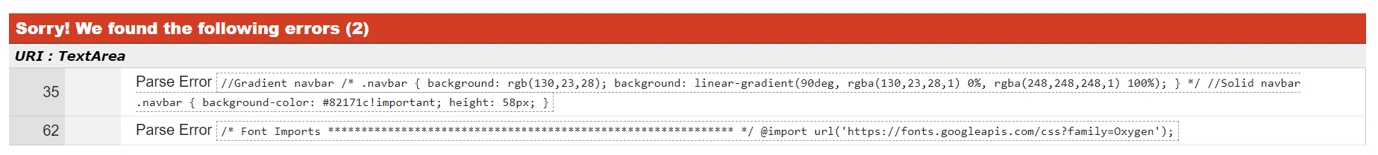

Calendar.css Test Result

