Shop with furniture

REPORT

Friday 11:30 lab

Date: 03.06.2022

**Team:**

Jakub Wandelt – 234772(leader)

Wiktoria Królikowska – 234762

Mateusz Idec – 234755

Artur Pietrzak -

Information Technology

IFE 4th semester

1. Project description

Our project is to implement a database containing information about a furniture store and more specifically, taking care of its orders. In this database the following business rules are given:

One employee can manage many orders.

One client can have many ongoing and/or finished orders.

One piece of furniture can be made of many materials.

One order can contain many products and/or packages.

Each package must be composed of more than one product.

Each product must be in stock, to buy it.

Availability of product packages depends on the availability of products of which they are composed of.

Every order has indication whether it’s finished (delivered) or not.

1. Entity Relationship Diagram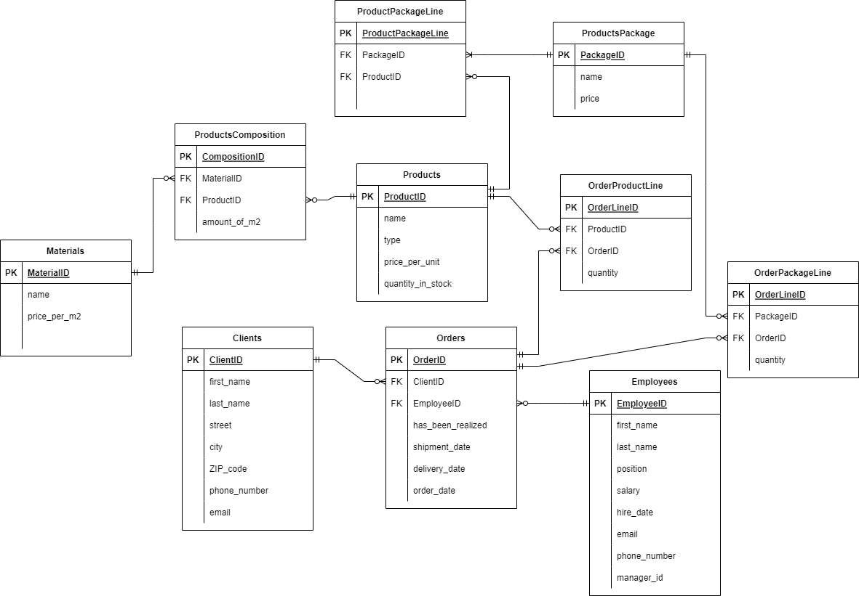
2. Description of each table

* Products

1. ProductID is an ID product

name is a name of given product

type is a type of furniture

price_per_unit is a price of one product

quantity_in_stock is actual amount of products in stock

1. Primary key - ProductID