Dual-Core Ibex RISC-V with Directory-Based MESI Cache Coherence and Crossbar
Two lowRISC Ibex RISC-V cores, each with a private write-back L1 data cache, kept coherent by a directory-based MESI protocol and connected to a 2-bank line-interleaved crossbar. Verified in simulation (Vivado xsim / Questa) from an isolated protocol test up to two real Ibex cores running software.
Note: This is an academic project for learning and research on cache coherence. It is simulation-only, uses small blocking caches and a limited address range, and has no synthesis, timing or silicon results, so it is unlikely to be suitable for real-world use as is.
Course project (Đồ án 1), University of Information Technology (UIT-VNU-HCM). Authors: Lê Đăng Huy, Bùi Hoàng Anh Huy · Advisor: Tạ Trí Đức

Motivation
The starting point was a dual-core Ibex system on a shared bus with a round-robin arbiter (shared_bus/). It has two problems:
- Bandwidth bottleneck. Every access is serialized through one bus.
- No cache coherence. With private caches, one core can read stale data another core already overwrote.
This project replaces the shared-bus data path with a cache-coherent subsystem and keeps the original design as a baseline.
Architecture
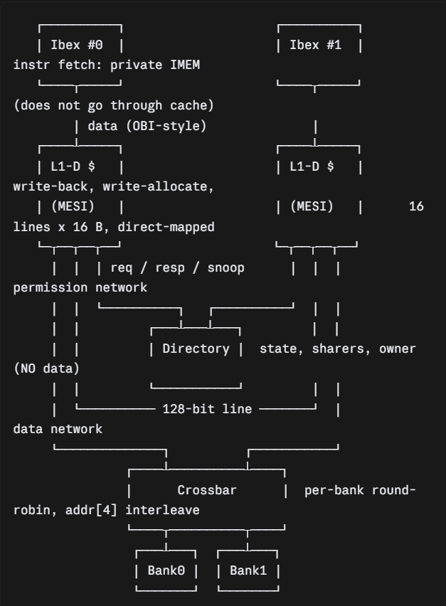
Key design decision: split the permission network from the data network
The directory only exchanges permissions (GetS, GetM, PutM, Invalidate, Forward, acks). It never holds or forwards line data. Line fills and writebacks travel cache ↔ crossbar ↔ bank as 128-bit transfers.
If data flowed through the directory, the directory would serialize everything and the crossbar would add nothing. With the split, two cores can access two different banks in parallel while the directory still guarantees coherence.
Components
Module | Role
ibex_coherence_pkg.sv | Shared types: MESI states, request/response/snoop messages, geometry parameters
ibex_l1_cache.sv | Blocking L1-D cache FSM with separate phases for miss/fill, writeback and snoop service
ibex_directory_controller.sv | Permission-only directory, round-robin arbitration between cores, invalidate/forward/recall paths
ibex_cache_bank_crossbar.sv | M×S line-granular crossbar, per-bank round-robin, bank = line_index[0], 1-cycle latency
ibex_coh_subsystem.sv | Wires 2 caches + directory + crossbar
ibex_dualcore_top_v3.sv | Two ibex_top cores + private IMEM + coherent subsystem
perf_monitor.sv | Bind-able performance counters (data transactions, snoops, contention, fairness)
Verification
Three levels, each one isolating a different class of bug:
Level | Testbench | What is checked | Result
Protocol, isolated | ibex_coherence_tb.sv | 2 OBI ports, no real cores. read → read → write → read on one address. MESI goes I→E→S→M; Core 1 must read Core 0's value | PASS (0x12345678)
Subsystem + crossbar | directed test | Cross-core read-back through crossbar; second address mapped to bank 1 | PASS
Full system | ibex_dualcore_v3_tb.sv | 2 real Ibex cores run machine code. Core 0 stores 0xDEAD0000 to 0x20000, Core 1 stores 0xCAFE0000 to 0x20004, each then loads the other's word | PASS (reads 0xCAFE0000 / 0xDEAD0000)
Performance counters (subsystem-level directed scenarios, Verilator)
Measured with perf_monitor.sv using hand-written traffic, not real-core workloads. Treat these as characterization of the coherence cost, not as benchmark results.
Scenario | Cycles | Data txns | Snoops | Fairness (C0:C1)
True sharing (both cores write/read the same line) | 428 | 60 | 118 | 20 : 20
Read-only sharing (line stays in S) | 166 | 23 | 4 | 11 : 10
True sharing costs roughly 30× more snoops than read-only sharing for a similar number of accesses, which is the expected invalidate ping-pong. Round-robin arbitration stays fair in both cases.
Repository layout
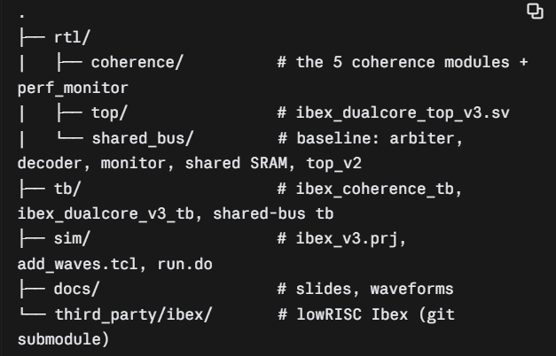
Running the simulation (Vivado xsim)
Requirements: Vivado 2025.2 (any recent xsim should work), lowRISC Ibex checked out under third_party/ibex.
sim/ibex_v3.prj lists files in compile order (packages first). Edit the absolute paths in it to match your checkout.
# from a Vivado Tcl shell
xvlog --relax -sv -prj ibex_v3.prj \
-i <ibex>/rtl \
-i <ibex>/vendor/lowrisc_ip/ip/prim/rtl \
-i <ibex>/vendor/lowrisc_ip/ip/prim_generic/rtl \
-i <ibex>/vendor/lowrisc_ip/dv/sv/dv_utils -L uvm

xelab --relax --debug typical --mt 2 -L xil_defaultlib -L uvm -L unisims_ver -L secureip \
--snapshot v3_snap xil_defaultlib.ibex_dualcore_v3_tb xil_defaultlib.glbl

xsim v3_snap -R
Notes that cost us time:
- Ibex resets its PC to {boot_addr[31:8], 8'h80}, so the test program is loaded at imem[32] (PC 0x80; Core 1 at 0x10080).
- The Vivado GUI project flow computed a wrong simulation hierarchy (wrong top, missing files). Driving xvlog/xelab/xsim directly with a .prj avoided this.
- Do not open files under *.sim/ in an editor while a simulation is running (Windows file lock makes xelab fail).
- xsim flattens generate-block hierarchy, so internal cache signals are not visible in its waveform. Questa (sim/run.do, +acc) keeps the hierarchy.
Known limitations
- Blocking caches. One outstanding transaction per core, so throughput is bounded by miss latency.
- Small direct-mapped L1 (16 lines). No replacement policy, no prefetch.
- No address decoder. Every data access goes through the cache. The directory/crossbar cover 256 lines × 16 B = 4 KiB; higher addresses wrap onto the same lines (the 0x2000x test addresses rely on this wrap). Instruction fetch bypasses the cache.
- No atomics. Ibex is built as RV32IMC (no A extension), so software synchronization is flag-based, not spinlock-based.
- Verification gaps. Dirty-line eviction (PutM) and concurrent GetM from both cores to one line are not yet covered by dedicated tests. No formal verification. The disjoint-bank scenario (core 0 on bank 0, core 1 on bank 1) has not been characterized, so parallel-access gain from the crossbar is not yet quantified.
- Simulation only. No synthesis or timing results yet.
Future work
Non-blocking caches, more cores/banks, MOESI, a shared L2, AXI-based interconnect, peripherals and an interrupt controller to turn this into a full SoC, and synthesis/timing/utilization numbers.
Acknowledgements and license
Built on the lowRISC Ibex core (Apache-2.0). Add a LICENSE for your own RTL (Apache-2.0 keeps it consistent with Ibex).

