Project Team - Report

Plant Nursery Operations and Software Architecture
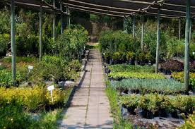
The successful design of our Plant Nursery Simulator comes from extensive research into the operational complexities of a commercial nursery and the specific, heterogeneous care requirements of diverse plant biomes. This research was foundational in defining the functional requirements of our system and justifying the strategic implementation of object-oriented principles and software Design Patterns to achieve a flexible, maintainable, and scalable architecture. Running a nursery, as a dynamic, living system, requires meticulous attention to two core areas: precise biological management and efficient logistical coordination. Biologically, plants are highly differentiated entities; they are not commodities. Their fundamental needs—including water, light, fertilizer, and soil pH—are strictly governed by their native ecological environment. For example:
- Desert Biome plants (like succulents or cacti) are xerophytic; they require infrequent, deep watering and well-draining soil to prevent root rot, which is a rapid path to the WiltingState. Over-watering is often more lethal than under-watering.
- Tropical Biome plants, in contrast, demand consistently moist soil (though not saturated) and often thrive with regular, nutrient-rich fertilization during their growth cycles to maintain health.
- Wetland/Aquatic Biome plants require a specialized environment, tolerating or even requiring saturated soil conditions and specific potting media (like the AquaticBasketPot or PeatSoilMix) to ensure their survival and progression to the MatureState.
Ignoring these inherent biological differences leads to plant mortality and financial loss. Therefore, the simulator must dynamically adapt its care routines based on the plant's defined biome. This need for dynamic, interchangeable behavior led directly to the implementation of the Strategy Pattern (CareStrategy), which decouples the care logic from the plant object itself, ensuring extensibility for future biomes. Logistically, a commercial nursery demands continuous, interconnected management across its lifecycle stages. Stock availability in the sales area is a direct and immediate result of plant health and maturation in the greenhouse. The transition of a plant from the GrowingState to the MatureState must instantaneously affect its sale status in the inventory. This complex, interdependent coordination—involving the monitoring of plants, the updating of inventory records, the assignment of staff to new tasks, and the fulfillment of customer orders—is managed through the strategic use of the Mediator and Observer patterns. These patterns were chosen specifically to reduce coupling and centralize control flow, thus providing the necessary organizational structure (the NurseryHub) to transform biological complexity into a coherent, object-oriented system.
This revision directly addresses the prompt by providing:
- Specific biological details: Mentioning xerophytic nature, root rot, demand for moist soil, and specialized media.
- Explicit linkage to design decisions: Tying the biological heterogeneity directly to the need for the Strategy Pattern.
- Enhanced operational context: Expanding on the necessary link between the dynamic "living system" and the logistical coordination handled by the Mediator/Observer patterns.

1. Nursery Operational Model and System Design

A comprehensive nursery operates as a tightly coupled system of four primary domains: Plant Lifecycle Management (Greenhouse), Inventory & Stock Control, Staff Coordination, and Customer Sales & Interaction. Our software architecture mirrors this reality by employing design patterns to manage communication and complexity between these domains:

A. Inter-Domain Communication and Decoupling
- Mediator Pattern: The NurseryHub (Mediator) was implemented to manage and centralize communication and event propagation between the key operational services: SalesService,InventoryService, and StaffServie. This pattern ensures that these services (Colleagues) interact indirectly through the Hub, significantly reducing the complex web of dependencies that would arise from direct communication, thereby enhancing system maintainability and flexibility.
- Observer Pattern: The plant lifecycle—monitoring state transitions (e.g., GrowingState to MatureState to WiltingState to DeadState)—directly impacts saleable stock. The Observer Pattern is utilized to monitor plant state changes (ServiceSubject). Upon a significant transition (like Matured or Wilted), the plant object notifies the NurseryHub, which, acting as an observer, triggers corresponding updates in the InventoryService (e.g., adding or releasing stock). This critical architectural decision ensures stock availability accurately reflects the dynamic reality of the greenhouse.

2. Plant Lifecycle Management and Biome-Specific Care
Effective plant care is paramount, as different species require vastly different approaches to watering, fertilizing, and environmental management.

A. Strategy Pattern for Plant Care
- Research Justification: Research confirms that care requirements are primarily dictated by a plant's native biome (e.g., desert, tropical, wetland). For instance, Desert plants require low, infrequent watering and excellent drainage to avoid fatal root rot, while Tropical plants demand consistent moisture and regular fertilization during active growth.
- Design Application: The Strategy Pattern provides a flexible solution to this highly variable requirement. A concrete Plant object delegates its care tasks (water(), fertilize(), sprayInsecticide()) to a specific CareStrategy object (e.g., DesertStrategy, WetlandStrategy). This implementation allows new biome-specific care routines to be introduced easily (fulfilling the extensibility requirement) without modifying the core Plant class, which remains focused on its state and attributes.

B. Factory and Flyweight for Efficient Plant Creation
- Abstract Factory Pattern: To ensure that plants, pots, and soil are consistently and correctly paired based on the target biome, a family of Abstract Factory classes (e.g., DesertFactory, TropicalFactory) is used. These factories are responsible for generating compatible products (e.g., a DesertFactory generates plants with high water sensitivity, along with a TerracottaPot and GrittyLimeSoilMix). This design enforces consistency and is a direct consequence of the research into correct planting media.
- Flyweight Pattern: Nurseries typically manage thousands of individual plants across a finite number of species. The Flyweight Pattern is used to reduce memory overhead by sharing intrinsic, common data across all instances of a species. The SpeciesFlyweight stores the constant attributes (SKU, Name, Biome, Base Cost), while the individual Plant objects maintain their unique, extrinsic state (e.g., health, moisture level, state). This directly addresses the non-functional requirement of scalability by optimizing memory usage.

3. Assumptions and Time Simulation
- Time Model: The simulation time is scaled such that 10 seconds of real-world time is equivalent to one simulated day of plant growth and operation. This allows for observable lifecycle progression and operational changes within the demo window.
- Seasons: Seasons are tracked using the host machine's time, and it is assumed that they directly influence the plant's growthRate parameter, reflecting the seasonal cycles of growth and dormancy found in nature.
- Plant-Biome Mapping: It is assumed that each plant is uniquely and permanently associated with a single biome, which entirely determines its optimal CareStrategy.
References:
- General Object-Oriented Design & Patterns: Gamma, E. et al. (1995). Design Patterns: Elements of Reusable Object-Oriented Software. Addison-Wesley.
- Nursery Management: Smith, M. Commercial Plant Production and Management.
- Frontiers in Pharmacology. (2024). Climate change and the sustainable use of medicinal plants: a call for “new” research strategies. (Discusses the need for effective strategies to preserve and increase plant populations against environmental factors).
- ResearchGate. (2025). Mechanisms and Strategies of Plant Microbiome Interactions to Mitigate Abiotic Stresses. (Explores how plants face extreme environmental conditions, known as abiotic stresses, that affect their growth and development, necessitating varied biological strategies).
- PMC. (2023). Editorial: The adaptation strategies of plants to alleviate important environmental stresses. (Documents the complex array of plant responses to various environmental pressures, such as drought, and highlights the potential of biochar and microorganisms to combat stress).
- Plant Care Biome-Specifics: Various online resources on xeriscaping and tropical horticulture.
- https://www.cs.up.ac.za/cs/lmarshall/TDP/TDP.html

Design Pattern Application
The Plant Nursery Simulator leverages 13 distinct design patterns to model the inherent complexity, heterogeneity, and dynamic workflows of a live nursery environment. The strategic selection of these patterns directly addresses the project's Functional Requirements (FRs) and ensures compliance with the necessary Non-Functional Requirements (NFRs).

1. Creational Patterns (4 Used: Singleton, Prototype, Factory Method, Template Method)
Creational patterns abstract the instantiation process, making the system independent of how its objects are created.

Pattern | Functional Requirement (FR) | Justification & Implementation | Non-Functional Requirement (NFR)
Singleton | FR 1: The plant lifecycle must progress through states (Seedling to Growing to Mature to Wilting to Dead) based on conditions and time[cite: 273, 274]. | Justification: Guarantees that only one instance of each PlantState class exists. This is critical as state objects are stateless and represent shared behavior, avoiding unnecessary object creation and memory use. Implementation: Applied to all concrete PlantState classes (DeadState, MatureState, etc.)[cite: 273, 274]. | Reliability: By using a single, universally accessed instance, the risk of inconsistent state logic or duplicate state objects is eliminated, supporting system Reliability[cite: 298].
Prototype | FR 5: For a specified biome, the factory must create the correct "Pot" and "SoilMix" subtypes[cite: 281]. | Justification: Avoids costly creation processes by cloning pre-configured components. This is vital for rapidly generating the complementary components (Pot, SoilMix) that constitute a plant kit when a new plant is created[cite: 281]. Implementation: The abstract classes (Pot, SoilMix) implement a virtual clone() method, which concrete products (TerracottaPot, AquaticSoilMix) use for self-replication. | Scalability: Enables fast, memory-efficient creation of numerous accessory objects during batch restock operations, contributing to performance and Scalability[cite: 297].
Factory Method | FR 5: For a specified biome, the factory must create the correct "Pot" and "SoilMix" subtypes[cite: 281]. | Justification: Defines an interface (PlantKitFactory) for creating objects but delegates the specific component instantiation (createPot, createSoilMix) to concrete subclasses (DesertFactory, TropicalFactory). This enforces biome-specific component matching[cite: 281, 282]. Implementation: The PlantKitFactory declares the abstract createPot() and createSoilMix() methods, implemented by concrete factory classes[cite: 281]. | N/A (Primarily a Functional Enabler)
Template Method | FR 6: "createPlant" must combine factory methods and inject state, strategy and flyweight into the Plant[cite: 283]. | Justification: Defines the immutable skeleton of the plant creation algorithm in the abstract PlantKitFactory (createPlant logic), but delegates the specific component instantiation steps to the concrete subclasses (the Factory Methods). This ensures consistent assembly while allowing for variation[cite: 283]. Implementation: The PlantKitFactory::createPlant() is the template method, which sequentially calls the abstract factory methods to get components and then constructs the final Plant object. | N/A (Primarily a Functional Enabler)

2. Structural Patterns (3 Used: Facade, Flyweight, Decorator)
Structural patterns focus on composing classes and objects into larger structures to build flexible and efficient systems.

Pattern | Functional Requirement (FR) | Justification & Implementation | Supporting Non-Functional Requirement (NFR)
Facade | FR 10: "NurseryFacade" must expose a single API for common workflows: create plant/order, customize a package, check stock, apply care, and subscribe to updates[cite: 291]. | Justification: Provides a simplified, high-level interface to the complex subsystems (Inventory, Sales, Command Invoker). This shields external users from the intricate internal dependencies and logic[cite: 291]. Implementation: NurseryFacade acts as the orchestrator, delegating calls like checkout() or waterPlants() to the relevant services. | Usability: Directly satisfies the Usability NFR by ensuring that common workflows are invocable through a single facade method, requiring "no subsystem knowledge" from the client[cite: 299].
Flyweight | FR 9: Species and care presets must be stored as flyweights identified by "SpeciesKey" to avoid duplication across plants[cite: 289]. | Justification: Essential for memory optimization by sharing intrinsic, immutable species data (SKU, Biome, GrowthRate) across a massive population of Plant objects[cite: 289]. Implementation: PlantFlyweight is the abstract interface; SpeciesFlyweight is the concrete flyweight storing the shared immutable properties. | Scalability: Supports the Scalability NFR by enabling the system to support "up to 10,000 plants" with linear tick time growth, as only extrinsic (unique) data is stored per plant instance[cite: 297].
Decorator | FR 7: The system must use the abstract factory to create variable parts of the Product (CustomPlantPackage)[cite: 285]. | Justification: Provides a flexible alternative to subclassing for extending sale item functionality. It wraps a SaleItem (PlantItem) to dynamically add costs and descriptions for customer customization options (e.g., premium pot upgrade, gift wrap) at runtime. Implementation: SaleItem is the component. SaleDecorator is the abstract decorator, with concrete decorators modifying the final cost() and description(). | N/A (Primarily a Functional Enabler, enhancing personalization beyond basic factory creation)

3. Behavioural Patterns (6 Used: Command, Iterator, Mediator, Observer, State, Strategy)
Behavioural patterns manage algorithms, the assignment of responsibilities, and communication between objects.
Pattern | Functional Requirement (FR) | Justification & Implementation | Supporting Non-Functional Requirement (NFR)
Command | FR 3 & FR 4: Staff must be able to issue care commands ("Water," "Fertilize") and inventory/sales commands ("Restock," "Purchase")[cite: 278, 279]. | Justification: Encapsulates staff actions as objects, supporting a robust command queue (ActionLog) and enabling the crucial undo/redo functionality (e.g., for Restock actions)[cite: 278, 279]. Implementation: Command is the abstract interface. Concrete commands like WateringCommand and Spray encapsulate the action. MacroCommand is the composite command. | Security: The pattern's separation allows the ActionLog to implement the Security NFR by validating the authenticated staff role before executing the command that mutates state, rejecting unauthorized calls[cite: 300].
Iterator | FR 8: The system must provide iterators over "PlantBed" and "Greenhouse" to traverse plants deterministically without exposing the internal structure[cite: 287]. | Justification: Allows for standardized traversal through collections of plants regardless of the underlying container, enabling efficient and reusable batch operations (e.g., watering all plants in a specific state)[cite: 287]. Implementation: The abstract Iterator interface is implemented by specialized iterators (GreenhouseIterator, StateIterator, SkuIterator). | N/A (Primarily a Functional Enabler)
Mediator | FR 12: "NurseryHub" must mediate interactions between "SalesService," "StaffService," and "InventoryService" and fan out assignments to all registered "StaffDashboard" instances[cite: 295]. | Justification: Centralizes complex interaction logic (OrderEvent, StockEvent, PlantEvent handling), significantly reducing coupling between the service colleagues. The NurseryHub is the single point of coordination[cite: 295]. Implementation: MessagingMediator is the abstract mediator. NurseryHub is the concrete mediator, orchestrating events between services. | Reliability: Centralized control helps enforce the NFR that events are delivered within the same processing tick, supporting guaranteed, non-blocking coordination[cite: 298].
Observer | FR 11: "Plant," "InventoryService," and "SalesService" must publish events ("PlantEvent," "StockEvent," "OrderEvent") to observers ("Nursery Hub," "StaffDashboard")[cite: 293]. | Justification: Establishes a crucial one-to-many dependency: the subject (e.g., Plant) notifies its observers (e.g., NurseryHub) when its state changes (e.g., reaches MatureState), decoupling the event source from its listeners[cite: 293]. Implementation: NurseryObserver is the abstract observer. The NurseryHub acts as an observer for plant events. | Reliability: The pattern's design is leveraged to ensure that all observers must be idempotent (part of the NFR), meaning duplicate event deliveries produce no additional side effects, thus stabilizing the system[cite: 298].
State | FR 1: The plant lifecycle must progress through states (Seedling to Growing to Mature to Wilting to Dead) based on conditions and time[cite: 273, 274]. | Justification: Allows a plant object to dynamically change its behavior (e.g., growth rate, reaction to care) when its internal state changes. This is the core model for the Plant Life Cycle[cite: 273, 274]. Implementation: PlantState is the abstract state. Concrete states (SeedlingState, MatureState, WiltingState) define the unique behavior and transitions (the Singleton pattern is used to instantiate them). | N/A (Primarily a Functional Enabler)
Strategy | FR 2: The system must select a watering strategy based on a plant's biome (e.g., Desert, Tropical, Indoor, Mediterranean, Wetland)[cite: 276]. | Justification: Encapsulates varying care algorithms (watering, fertilizing) into interchangeable objects. This is the structural solution to the plant heterogeneity problem, allowing for new biomes and care routines to be added easily[cite: 276]. Implementation: CareStrategy is the abstract interface. Concrete strategies (DesertStrategy, TropicalStrategy) implement the specific care logic. The Plant object holds a reference to its current strategy. | N/A (Primarily a Functional Enabler, supporting extensibility)

Class diagram

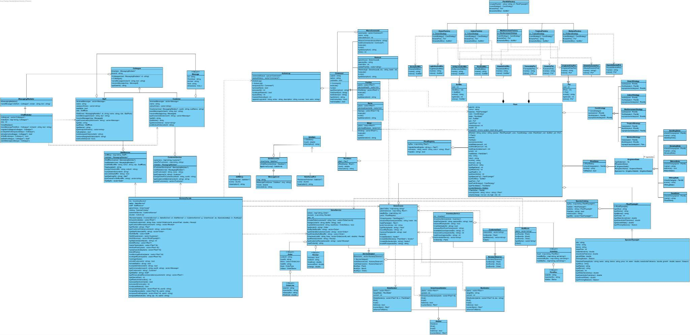
UML State Diagram
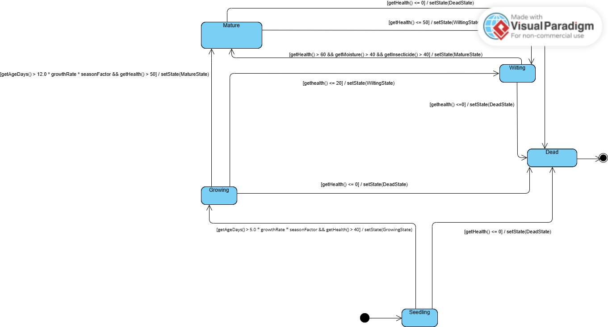

UML Activity Diagram

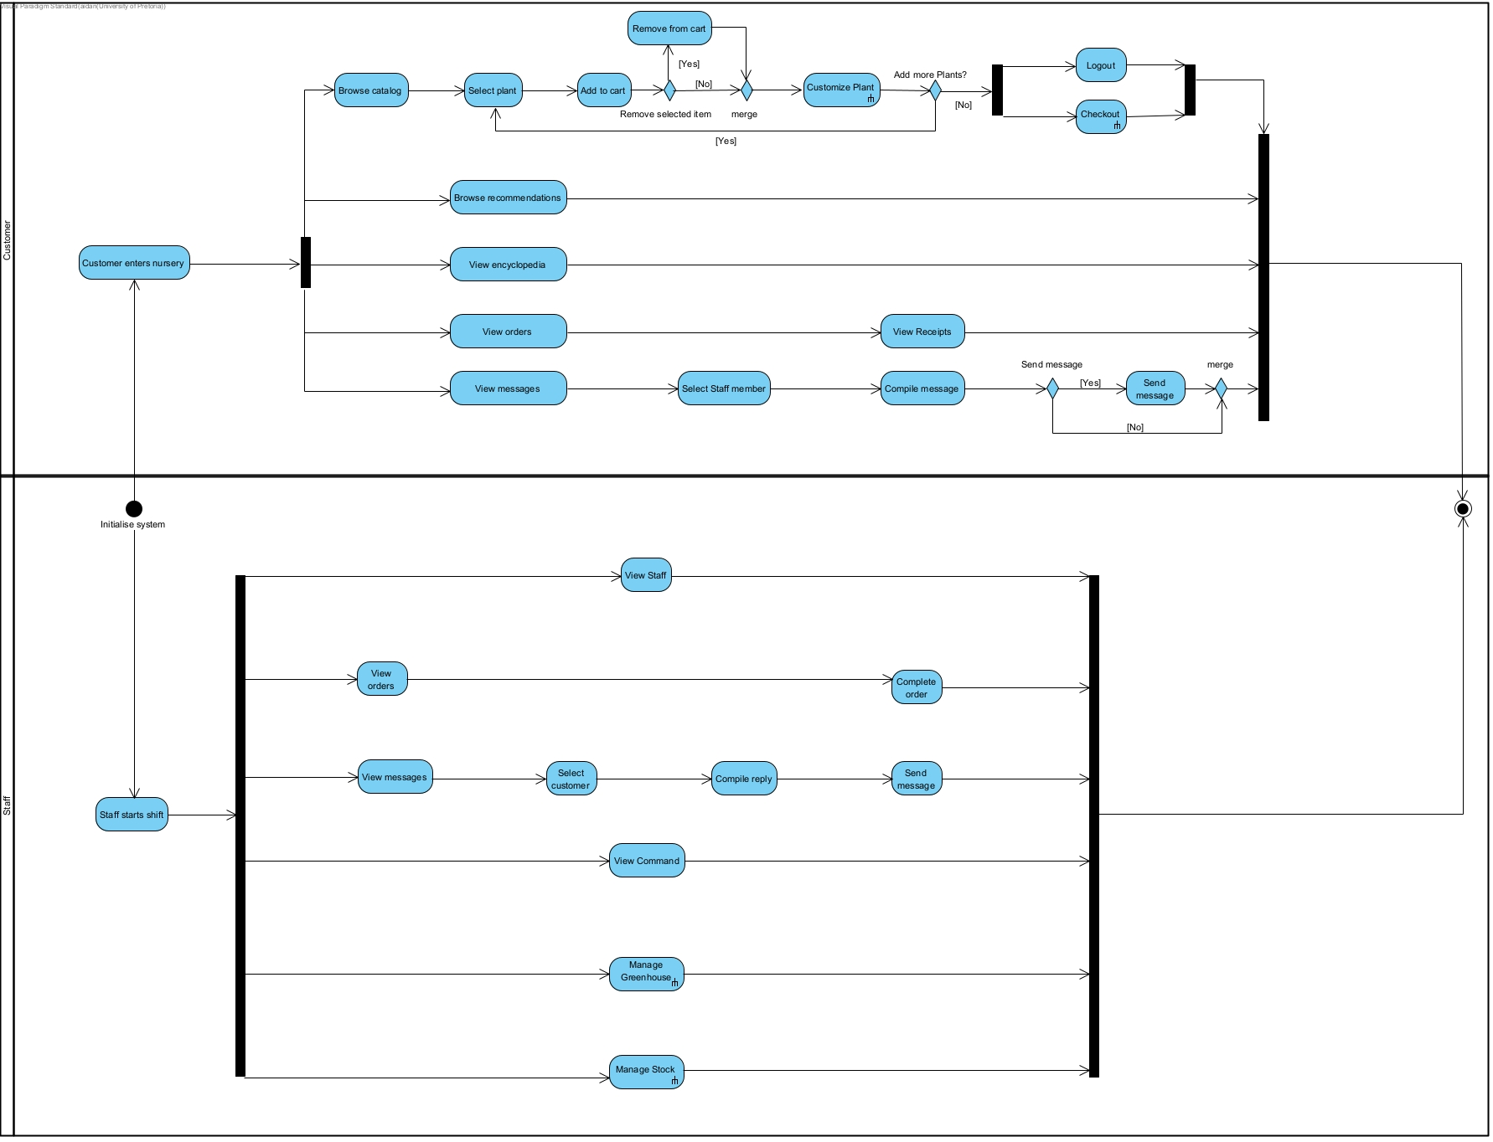
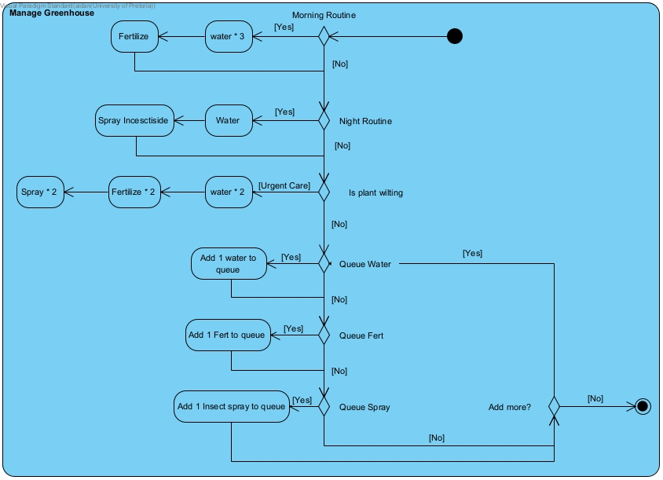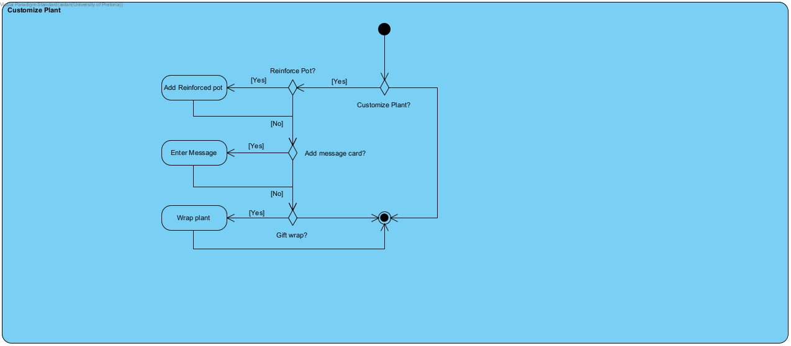
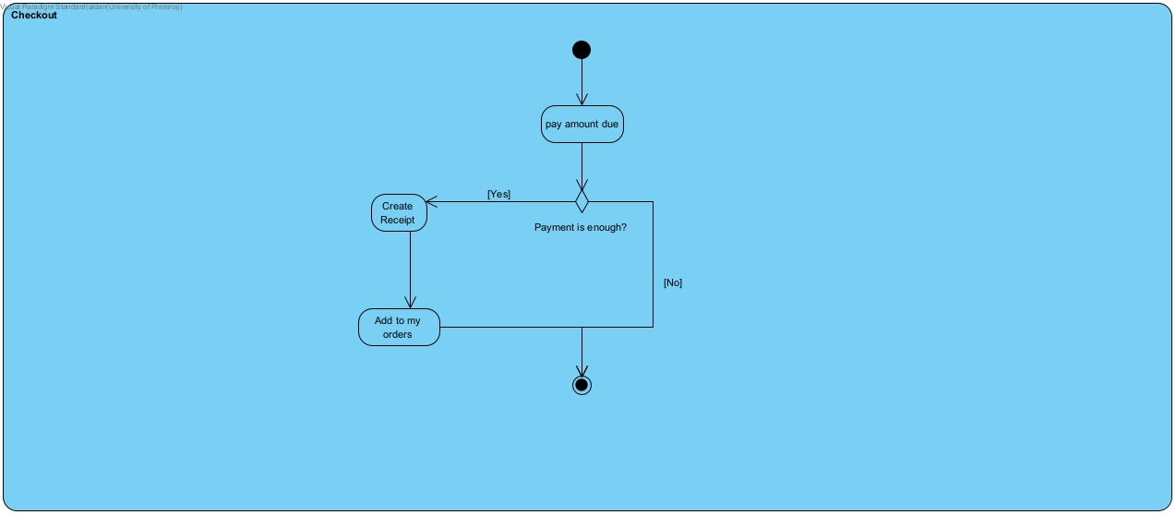
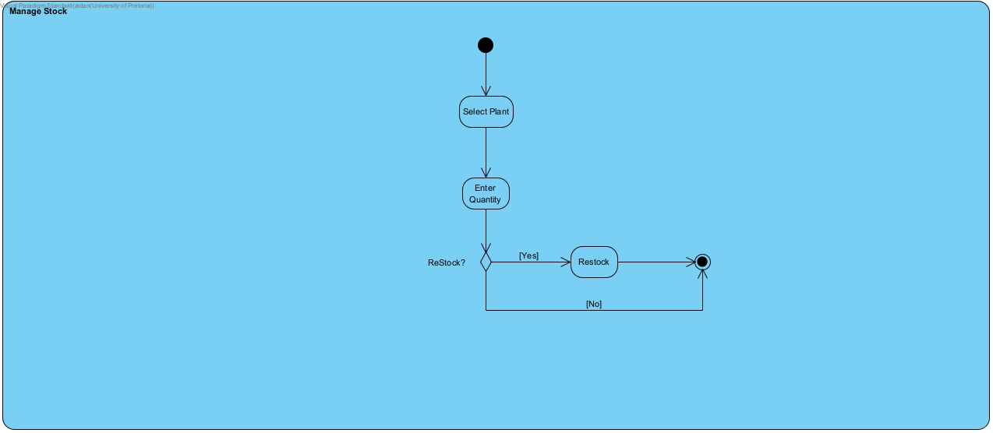
Communication Diagram

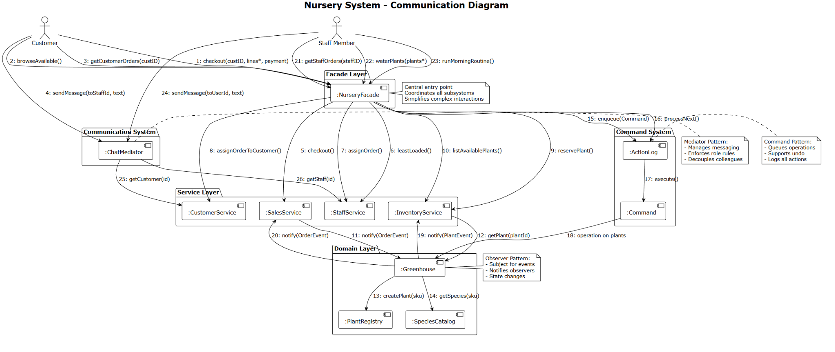

UML Sequence Diagram
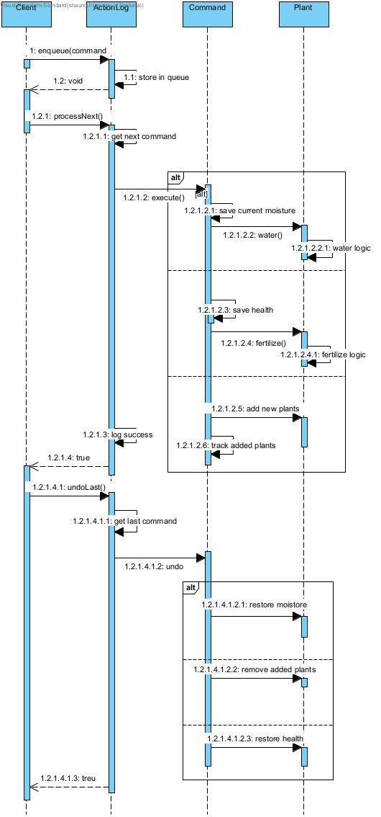

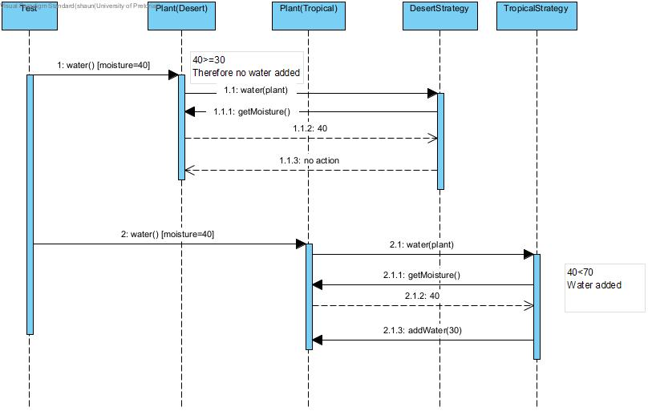

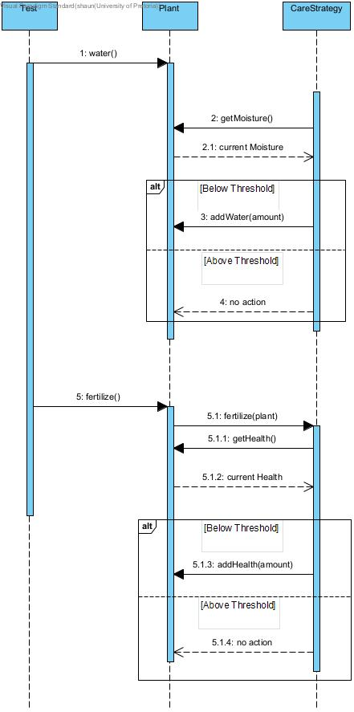
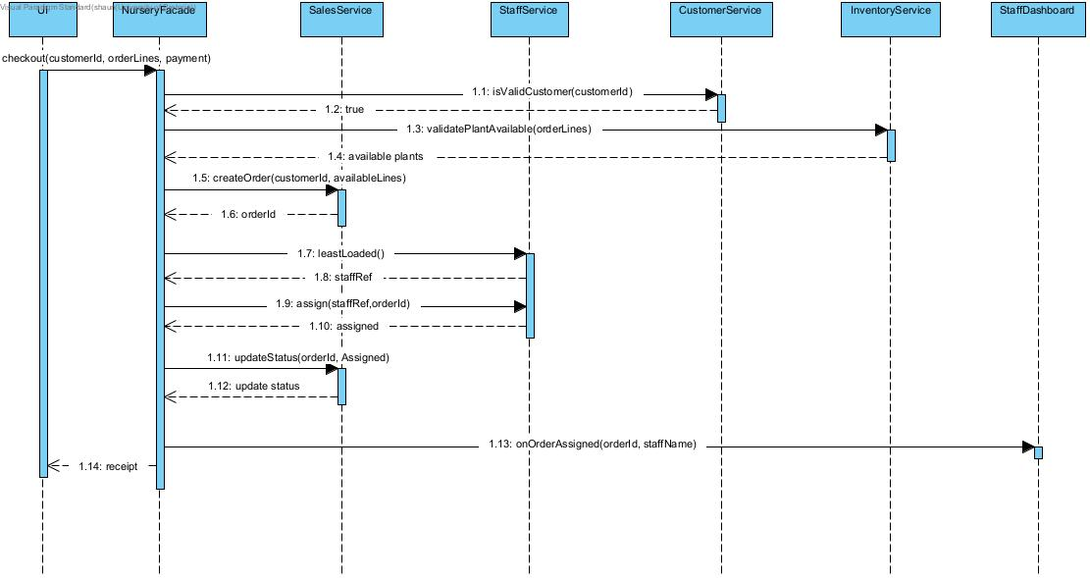

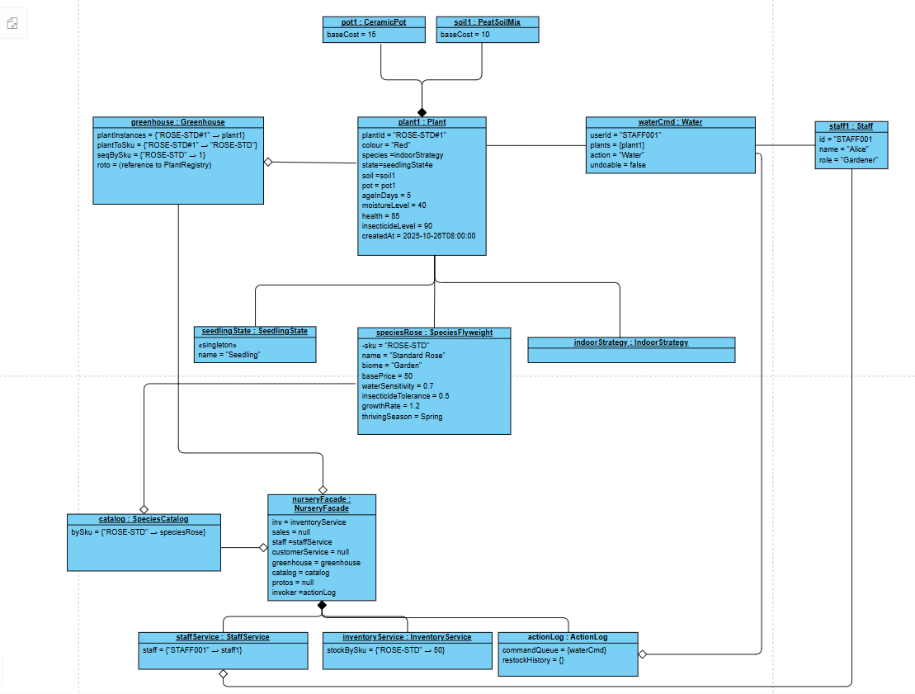
Object Diagram

